Skill 26.1 Exercise 1
Refer to the movies DataFrame below.
 | movie | production_budget | domestic_gross | worldwide_gross | mpaa_rating | genre
0 | Evan Almighty | 175000000.0 | 100289690.0 | 174131329.0 | PG | Comedy
1 | Waterworld | 175000000.0 | 88246220.0 | 264246220.0 | PG-13 | Action
2 | King Arthur: Legend of the Sword | 175000000.0 | 39175066.0 | 139950708.0 | PG-13 | Adventure
3 | 47 Ronin | 175000000.0 | 38362475.0 | 151716815.0 | PG-13 | Action
4 | Jurassic World: Fallen Kingdom | 170000000.0 | 416769345.0 | 1304866322.0 | PG-13 | Action

Suppose we want to compare the production_budgets for PG and R movies. Create two lists: one that has the production_budget for PG movies and another that has the production_budget for R movies.
budget_PG = movies[movies['mpaa_rating'] == 'PG']['production_budget']
budget_R = movies[movies['mpaa_rating'] == 'R']['production_budget']

Calculate the mean and median difference.
PG_mean = budget_PG.mean()
R_mean = budget_R.mean()
mean_diff = PG_mean - R_mean

PG_median = budget_PG.median()
R_median = budget_R.median()
median_diff = PG_median - R_median

Skill 26.2 Exercise 1
Refer to the movies DataFrame below.
 | movie | production_budget | domestic_gross | worldwide_gross | mpaa_rating | genre
0 | Evan Almighty | 175000000.0 | 100289690.0 | 174131329.0 | PG | Comedy
1 | Waterworld | 175000000.0 | 88246220.0 | 264246220.0 | PG-13 | Action
2 | King Arthur: Legend of the Sword | 175000000.0 | NaN | 139950708.0 | PG-13 | Adventure
3 | 47 Ronin | NaN | 38362475.0 | 151716815.0 | PG-13 | Action
4 | Jurassic World: Fallen Kingdom | 170000000.0 | 416769345.0 | NaN | NaN | Action

Filter the dataframe for the movies with an mpaa_rating of R and PG only. Store the results in a new dataframe, PG_R
PG_R = movies[(movies['mpaa_rating'] == 'PG') | (movies['mpaa_rating'] == 'R')]

Complete the spaces below to make side by side box plots for R and PG movies.
sns.boxplot(data = ,
x = ,
y = ,
hue = ,
legend = )
plt.show()

Below are the actual box plots for PG and R movies,

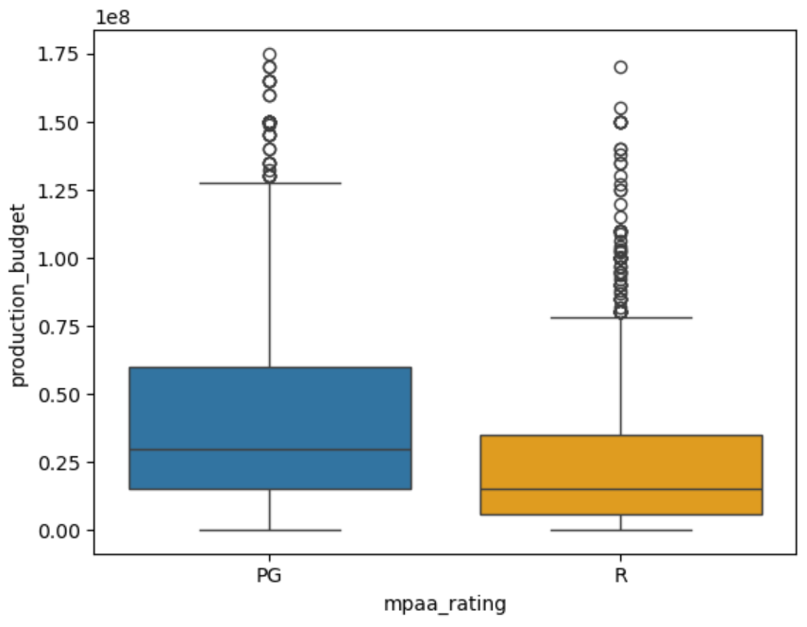
Based on the box plots, does movie rating appear to be associated with budget — that is, do PG and R movies have different budget distributions?
Yes, movie rating appears to be associated with budget. PG movies tend to have higher median budgets and greater variability compared to R movies, suggesting that budget distributions differ by rating.

Skill 26.3 Exercise 1
Refer to the lists previously created in Skill 26.1 Exercise 1. One has the production_budget for PG movies and the other has the production_budget for R movies. Complete the spaces below to make overlapping histograms.
plt.hist( , color="blue", label= , density= , alpha= )
plt.hist( , color="red", label= , density= , alpha= )
plt.legend()
plt.show()

plt.hist(budget_PG , color="blue", label="PG", density=True, alpha=0.5)
plt.hist(budget_R , color="red", label="R", density=True, alpha=0.5)

Below are the actual overlapping histograms for PG and R movie production budgets,

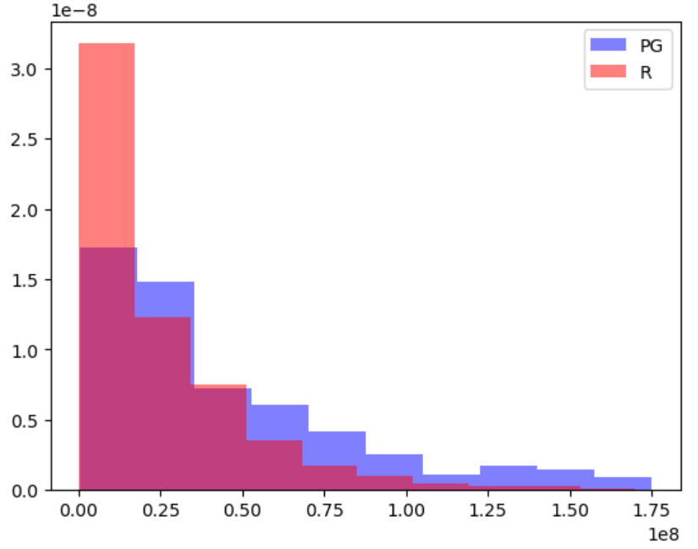

Based on the overlapping histograms, does production budget appear to be associated with movie rating? Support your answer with evidence from the graph.
The overlapping histograms show that both PG and R movies are right-skewed, with most budgets on the lower end. However, PG movies appear more likely to have higher budgets, while R movies are more concentrated in lower budget ranges. This suggests that production budget is associated with movie rating, although there is significant overlap between the two distributions.

Skill 26.4 Exercise 1
Refer to the movies dataframe from above
Complete the spaces below to make side by side box plots for all mpaa_ratings
sns.boxplot(data = ,
x = ,
y = ,
hue = ,
legend = )
plt.show()

Below are the actual box plots for all mpaa_ratings

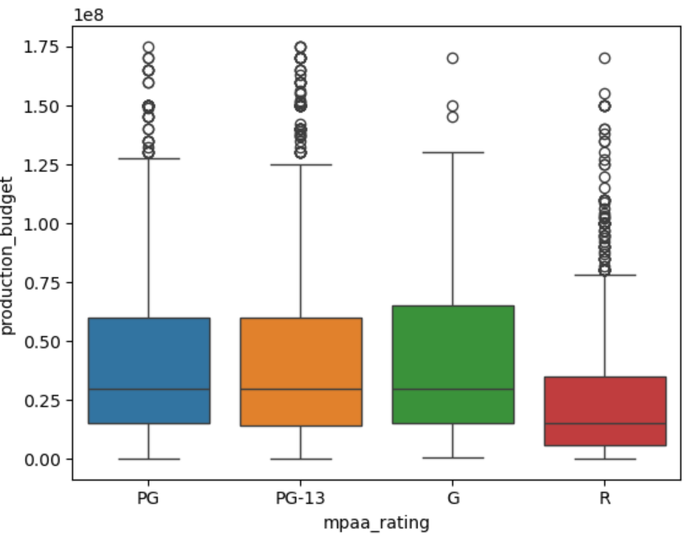
Based on the box plots, does movie rating appear to be associated with budget?
The box plots suggest that production budget is associated with movie rating. R-rated movies tend to have lower median budgets and less variability, while G, PG, and PG-13 movies generally have higher median budgets and more high-budget outliers. Although there is overlap among the groups, the difference between R and the other categories appears noticeable.

