Skill 27.1 Exercise 1
Refer to the cars dataframe below,
 | mpg | cylinders | displacement | horsepower | weight | acceleration | model year | car name
0 | 18.0 | 8 | 307.0 | 130 | 3504 | 12.0 | 70 | chevrolet chevelle malibu
1 | 15.0 | 8 | 350.0 | 165 | 3693 | 11.5 | 70 | buick skylark 320
2 | 18.0 | 8 | 318.0 | 150 | 3436 | 11.0 | 70 | plymouth satellite
3 | 16.0 | 8 | 304.0 | 150 | 3433 | 12.0 | 70 | amc rebel sst
4 | 17.0 | 8 | 302.0 | 140 | 3449 | 10.5 | 70 | ford torino

Complete the spaces below to make a scatter plot to see if there is an association between mpg and weight.
plt.scatter(x = , y = )
plt.xlabel(' ')
plt.ylabel(' ')
plt.show()

Below is the actual plot
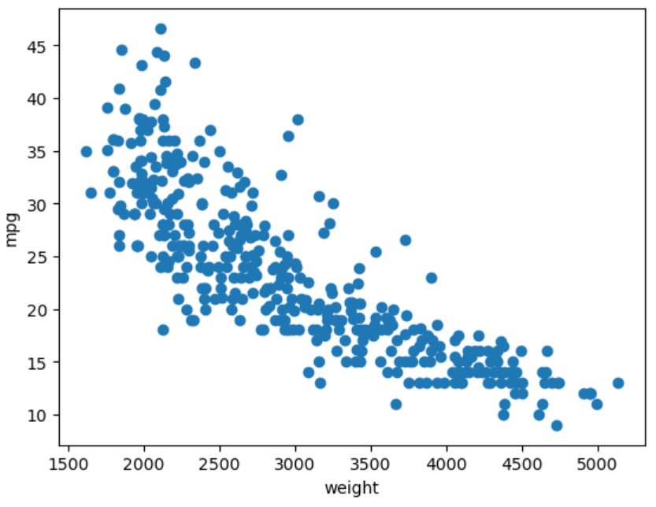

Based on the scatter plot, does vehicle weight appear to be associated with fuel efficiency (mpg)? Describe the direction and strength of the association.

Skill 27.2 Exercise 1
Refer to the cars DataFrame below.
 | mpg | cylinders | displacement | horsepower | weight | acceleration | model year | car name
0 | 18.0 | 8 | 307.0 | 130 | 3504 | 12.0 | 70 | chevrolet chevelle malibu
1 | 15.0 | 8 | 350.0 | 165 | 3693 | 11.5 | 70 | buick skylark 320
2 | 18.0 | 8 | 318.0 | 150 | 3436 | 11.0 | 70 | plymouth satellite
3 | 16.0 | 8 | 304.0 | 150 | 3433 | 12.0 | 70 | amc rebel sst
4 | 17.0 | 8 | 302.0 | 140 | 3449 | 10.5 | 70 | ford torino

Use the cov() method to calculate the covariance matrix for mpg and weight.
The actual matrix is as follows,

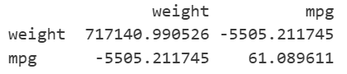

Identify which value in the matrix represents the covariance between weight and mpg. What does its sign tell you about their relationship?

Skill 27.3 Exercise 1
Below is the plot of the mpg and weight.


Use the pearsonr function from scipy.stats to calculate the correlation between mpg and weight and print the result.
from scipy.stats import pearsonr

The actual value is -0.831740933244335. Is this value consistent with the scatter plot?

Skill 27.4 Exercise 1
The plot below shows the relationship between hours of sleep and performance score on a task.
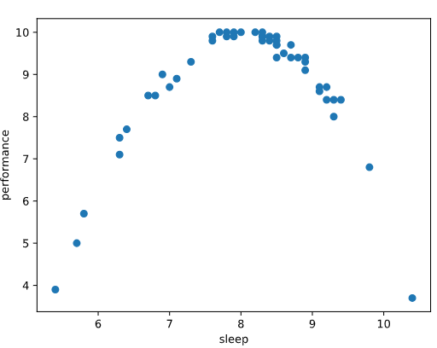
Describe the relationship between sleep and performance shown in the scatter plot.
Would correlation accurately reflect the strength of this relationship?
If the correlation were near zero, would that mean sleep and performance are unrelated? Why or why not?

