Skill 27.1 Exercise 1
Refer to the cars dataframe below,
 | mpg | cylinders | displacement | horsepower | weight | acceleration | model year | car name
0 | 18.0 | 8 | 307.0 | 130 | 3504 | 12.0 | 70 | chevrolet chevelle malibu
1 | 15.0 | 8 | 350.0 | 165 | 3693 | 11.5 | 70 | buick skylark 320
2 | 18.0 | 8 | 318.0 | 150 | 3436 | 11.0 | 70 | plymouth satellite
3 | 16.0 | 8 | 304.0 | 150 | 3433 | 12.0 | 70 | amc rebel sst
4 | 17.0 | 8 | 302.0 | 140 | 3449 | 10.5 | 70 | ford torino

Complete the spaces below to make a scatter plot to see if there is an association between mpg and weight.
plt.scatter(x = cars.weight, y = cars.mpg)
plt.xlabel('cylinders')
plt.ylabel('mpg')
plt.show()

Below is the actual plot
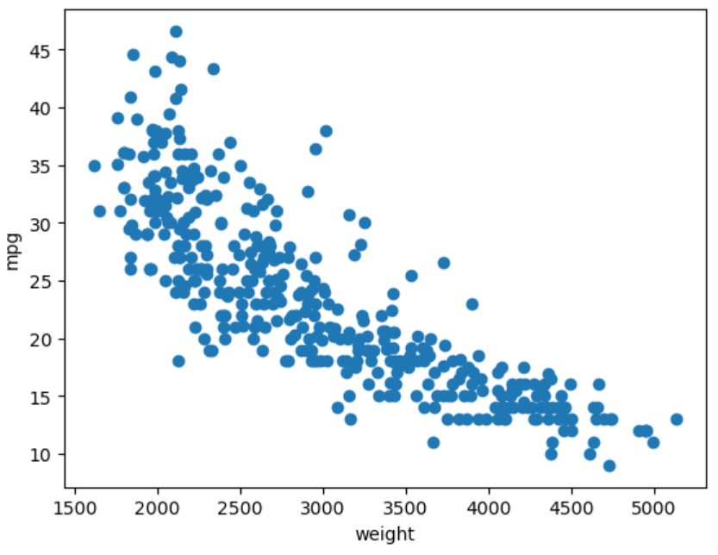

Based on the scatter plot, does vehicle weight appear to be associated with fuel efficiency (mpg)? Describe the direction and strength of the association.
Yes, vehicle weight appears to be strongly associated with fuel efficiency (mpg). The scatter plot shows a clear negative relationship: as vehicle weight increases, mpg tends to decrease. The points follow a fairly consistent downward trend, indicating that heavier vehicles generally have lower fuel efficiency. Because the points are closely clustered around this downward pattern, the association appears strong and approximately linear.

Skill 27.2 Exercise 1
Refer to the cars DataFrame below.
 | mpg | cylinders | displacement | horsepower | weight | acceleration | model year | car name
0 | 18.0 | 8 | 307.0 | 130 | 3504 | 12.0 | 70 | chevrolet chevelle malibu
1 | 15.0 | 8 | 350.0 | 165 | 3693 | 11.5 | 70 | buick skylark 320
2 | 18.0 | 8 | 318.0 | 150 | 3436 | 11.0 | 70 | plymouth satellite
3 | 16.0 | 8 | 304.0 | 150 | 3433 | 12.0 | 70 | amc rebel sst
4 | 17.0 | 8 | 302.0 | 140 | 3449 | 10.5 | 70 | ford torino

Use the cov() method to calculate the covariance matrix for mpg and weight.
cov_mat_weight_mpg = cars[['weight', 'mpg']].cov()

The actual matrix is as follows,

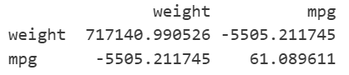

Identify which value in the matrix represents the covariance between weight and mpg. What does its sign tell you about their relationship?
The value is -5505.211745. The negative value tells us that there is a negative association between the variables. That is as the weight increases, the mpg goes down. Because we do not know the units, the magnitude is ambiguous.

Skill 27.3 Exercise 1
Below is the plot of the mpg and weight.


Use the pearsonr function from scipy.stats to calculate the correlation between mpg and weight and print the result.
from scipy.stats import pearsonr

mpg_weight_corr = pearsonr(cars.weight, cars.mpg)
print(mpg_weight_corr[0])

The actual value is -0.831740933244335. Is this value consistent with the scatter plot?
-0.83 indicates a strong negative linear relationship. This is consistent with the shape of the scatter plot

Skill 27.4 Exercise 1
The plot below shows the relationship between hours of sleep and performance score on a task.
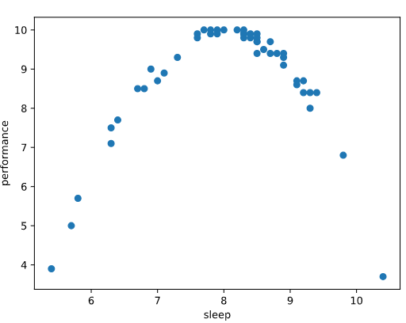
Describe the relationship between sleep and performance shown in the scatter plot.
The scatter plot shows an inverted U-shaped pattern, where performance increases as sleep increases up to about 8 hours, and then decreases as sleep continues to increase

Would correlation accurately reflect the strength of this relationship?
No, correlation would not accurately reflect the strength of this relationship. Correlation measures the strength of a linear relationship,

If the correlation were near zero, would that mean sleep and performance are unrelated? Why or why not?
No, a correlation near zero would not mean that sleep and performance are unrelated. It would only mean there is little to no linear relationship.

