Skill 31.1 Exercise 1
label each pair of events as independent or dependent and give a one-sentence reason
A coin is flipped twice. Event A: first flip is heads. Event B: second flip is heads.
A card is drawn from a deck, not replaced, then a second card is drawn. Event A: first card is a heart. Event B: second card is a heart
A card is drawn, replaced, shuffled, then a second card is drawn. Event A: first card is a heart. Event B: second card is a heart.
A spinner with equal sections is spun twice. Event A: first spin lands on blue. Event B: second spin lands on blue.
A bag has 4 green and 6 yellow marbles. Two marbles are drawn without replacement. Event A: first marble is green. Event B: second marble is green.

Skill 31.2 Exercise 1
label each pair of events as mutually exclusive or not mutually exclusive and give a short reason.
Event A: roll an even number or
Event B: roll an odd number

Event A: roll a number greater than 4 or
Event B: roll an even number

Event A: roll a 2 or
Event B: roll a number less than 4
Event A: roll a prime number or
Event B: roll an odd number

Skill 31.3 Exercise 1
Calculate the probability of rolling a prime number or rolling an odd number by completing the steps.
Step 1: Is this a mutually exclusive or not mutually exclusive?
Step 2: What is P(A)?

Step 3: What is P(B)?

Step 4: What is P(A and B)?

Step 5: What is P(A or B)?

Skill 31.4 Exercise 1
A bag contains 3 red marbles and 2 blue marbles. Two marbles are drawn without replacement.
Write a conditional probability expression (using notation) for each statement:
a. The probability that the second marble is red, given that the first marble is blue
b. The probability that the second marble is blue, given that the first marble is red
For each statement above, calculate the probability.

Skill 31.4 Exercise 2
A bag contains 3 red marbles and 2 blue marbles. Two marbles are drawn with replacement.
Write a conditional probability expression (using notation) for each statement:
a. The probability that the second marble is red, given that the first marble is blue
b. The probability that the second marble is blue, given that the first marble is red
For each statement above, calculate the probability.

Skill 31.5 Exercise 1
A bag has 3 red and 2 blue marbles. Two marbles are drawn without replacement. Write an expression for: The probability the first is red and the second is blue

Compute marble probabilities (without replacement). Using the same bag (3 red, 2 blue), two draws without replacement.

Calculate:
- P(Blue 1st and Blue 2nd)
- P(Blue 1st and Red 2nd)
Compute the probabilities with replacement using the same bag.

Skill 31.6 Exercise 1
Below is a two-draw probability tree for drawing marbles from a bag.

Given the distribution of blue and orange marbles below,

Complete the probabilities for each draw – assume no replacement. Then calculate the probability for ea
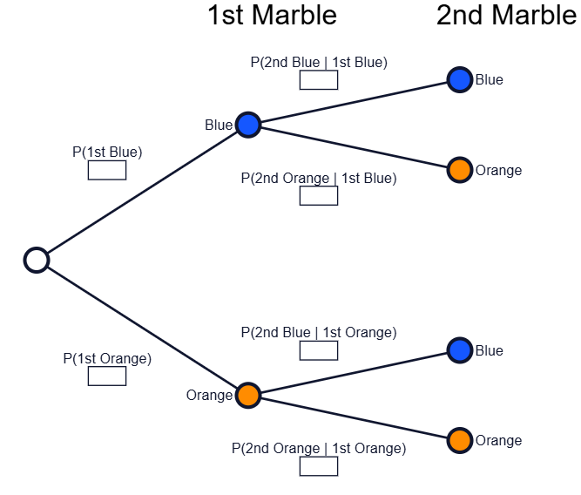

Skill 31.7 Exercise 1
Your phone uses a filter to label text messages as “Scam” or “Not Scam.” The filter is helpful, but it is not perfect. Suppose the following are true,

- 10% of all messages are actually scams (P(scam) = .10))
- 90% of all messages are not scams (P(not scam) = .90)
- If a message is a scam, the filter labels it a scam 80% of the time (P(label | scam) = .80)
- If a message is not a scam, the filter still labels it as a scam 15% of the time (P(label | not scam) = .15)

These outcomes are shown visually below.

Labeled scam (+)
P(+| scam) = .80
Scam (scam)
P(scam) = .10

Labeled scam (+)
P(+ | scam) = .15
Not scam (not scam)
P(not scam) = .90

If your phone labels a message as “Scam,” what is the probability that the message is actually a scam? This is, P(scam | +)
Consider 100 messages. Based on the probabilities above, how many are scams? How many are not scams?
Based on the probabilities above, how many of the scams are correctly labeled scam?
Based on the probabilities above, how many of the not scams are incorrectly labeled as scam?
What is the total messages that are labeled as scam?
What is P(scam | +). That is, out of the messages labeled as scam (+), how many were actually scams?

