Skill 30.1 Exercise 1
Refer to the code segment below,

import numpy as np
coin = ["H", "T"]
flips = np.random.choice(coin, size=20, replace=True)
num_heads = np.sum(flips == "H")
print(flips)
print("Heads:", num_heads)

What data type is stored in flips?
list

What are the only possible values?
H, T

How many flips are simulated?
20

If you set replace=False, would this code work with size=20? Why or why not?
No, because the value would not be replaced after each trial. Instead, the random value would be removed after each option. There would be nothing else to display after 2 trials.

Skill 30.2 Exercise 1
The graph below shows the PMF for flipping a fair coin 10 times.

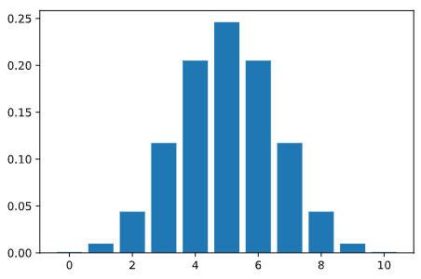
X = number of heads in 10 coin flips
What does X represent?
Number of heads on 10 flips

What is the probability of getting exactly 5 heads? 0 heads? 10 heads?
5 heads ~ .24, 0 heads ~ .01, 10 heads ~ .01

Skill 30.3 Exercise 1
A biased coin lands on heads with a probability p=0.60. You flip it n=10 times. Write a loop to calculate the probability of getting 0 to 10 heads using the pmf method below.

stats.binom.pmf(k, n, p)

for k in range(10 + 1):
prob = stats.binom.pmf(k, n, p)

Which outcome is most likely now: 5, 6, or 7 heads? Explain.
The expected number of heads is 10 * .6, or 6

Skill 30.4 Exercise 1
A six-sided die has a 1/6 probability of rolling a number 6. Use the pmf method below to show how you could calculate the probability of rolling between 1 and 3 sixes when you roll a fair die 8 times.

stats.binom.pmf(k, n, p)

n = 8
p = 1/6

prob = 0
for k in range(1, 4): # 1, 2, 3
prob += stats.binom.pmf(k, n, p)

Skill 30.5 Exercise 1
Use the cumulative distribution function below to show how you could calculate the following,

stats.binom.cdf(k, n, p)

The probability of observing 3 or fewer heads from 10 fair coin flips
prob_1 = stats.binom.cdf(3, 10, 0.5)

The probability of observing more than 5 heads from 10 fair coin flips
prob_2 = 1 - stats.binom.cdf(5, 10, 0.5)

The probability of observing between 2 (inclusive) and 5 (inclusive) heads from 10 fair coin flips
prob_3 = stats.binom.cdf(5, 10, 0.5) - stats.binom.cdf(1, 10, 0.5)

Skill 30.6 Exercise 1
The weather in the Galapagos islands follows a Normal distribution with a mean of 20 degrees Celcius and a standard deviation of 3 degrees.
Write code to calculate the probability that the weather on a randomly selected day will be between 18 to 25 degrees Celcius using the norm.cdf() method.
scipy.stats.norm.cdf(x, loc, scale)

- x: the value you want
- loc: the mean (default = 0)
- scale: the standard deviation (default 1)
stats.norm.cdf(25, 20, 3) - stats.norm.cdf(18, 20, 3)

Using the same information about the Galapagos Islands, write code to calculate the probability that the weather on a randomly selected day will be greater than 24 degrees Celsius.
1 - stats.norm.cdf(24, 20, 3)

