Skill 32.1 Exercise 1
Refer to the code segment below,

import numpy as np
coin = ["H", "T"]
flips = np.random.choice(coin, size=20, replace=True)
num_heads = np.sum(flips == "H")
print(flips)
print("Heads:", num_heads)

What data type is stored in flips?
What are the only possible values?
How many flips are simulated?
If you set replace=False, would this code work with size=20? Why or why not?

Skill 32.2 Exercise 1
The graph below shows the PMF for flipping a fair coin 10 times.

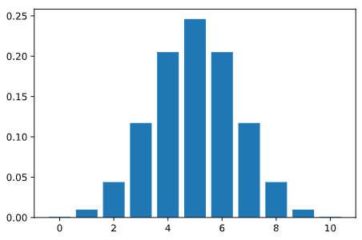
X = number of heads in 10 coin flips
What does X represent?
What is the probability of getting exactly 5 heads? 0 heads? 10 heads?

Skill 32.3 Exercise 1
A biased coin lands on heads with a probability p=0.60. You flip it n=10 times. Write a loop to calculate the probability of getting 0 to 10 heads using the pmf method below.

stats.binom.pmf(k, n, p)

Which outcome is most likely now: 5, 6, or 7 heads? Explain.

Skill 32.4 Exercise 1
A six-sided die has a 1/6 probability of rolling a number 6. Use the pmf method below to show how you could calculate the probability of rolling between 1 and 3 sixes when you roll a fair die 8 times.

stats.binom.pmf(k, n, p)

Skill 32.5 Exercise 1
Use the cumulative distribution function below to show how you could calculate the following,

stats.binom.cdf(k, n, p)

The probability of observing 3 or fewer heads from 10 fair coin flips
The probability of observing more than 5 heads from 10 fair coin flips
The probability of observing between 2 (inclusive) and 5 (inclusive) heads from 10 fair coin flips

Skill 32.6 Exercise 1
The weather in the Galapagos islands follows a Normal distribution with a mean of 20 degrees Celcius and a standard deviation of 3 degrees.
Write code to calculate the probability that the weather on a randomly selected day will be between 18 to 25 degrees Celcius using the norm.cdf() method.
scipy.stats.norm.cdf(x, loc, scale)

- x: the value you want
- loc: the mean (default = 0)
- scale: the standard deviation (default 1)
Using the same information about the Galapagos Islands, write code to calculate the probability that the weather on a randomly selected day will be greater than 24 degrees Celsius.

