Skill 31.1 Exercise 1
For each situation, decide whether a Poisson distribution, a binomial distribution, or a normal distribution would be most appropriate. Explain why or why not.
A basketball player takes 12 free throws. We want to model the number of shots they make.
Best choice: Binomial distribution
Why: This counts the number of successes out of a fixed number of trials. Each free throw is a trial, and each shot is either make or miss.
A hospital tracks the number of patients who arrive at the emergency room between midnight and 1:00 AM.
Best choice: Poisson distribution
Why: This is a count of how many times an event happens in a fixed time interval.

A teacher records the heights of students in a class.
Best choice: Normal distribution
Why: Height is a continuous measurement, and values often cluster around an average with fewer students much shorter or much taller.
A factory inspects 20 light bulbs and records how many are defective.
Best choice: Binomial distribution
Why: This is the number of successes or outcomes of interest, here defective bulbs, out of a fixed number of trials.
A city records the number of car accidents at a certain intersection each week.
Best choice: Poisson distribution
Why: This is a count of events occurring in a fixed interval of time.

The daily temperatures in a city during the month of April.
Best choice: Normal distribution
Why: Temperature is a continuous variable, and daily temperatures often vary around an average.

Skill 31.2 Exercise 1
The average number of calls in a call center between 9am and 10am is expected to be 15 calls.
Below is the Poisson distribution,

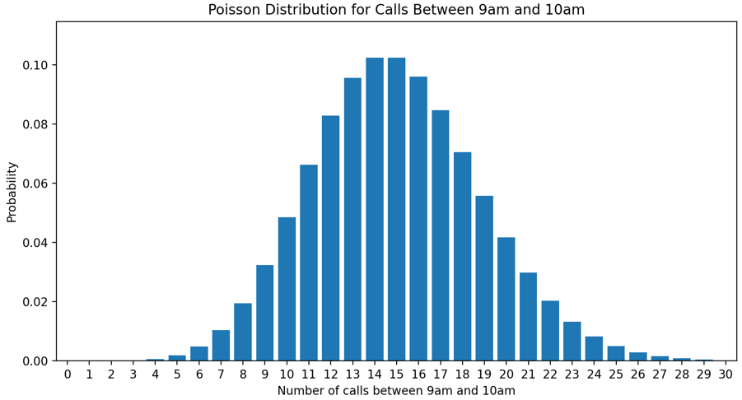
Use the poisson.pmf() method below to show how to calculate the probability of getting exactly 15 calls in this time frame.

stats.poisson.pmf(k, λ)

stats.poisson.pmf(15,15)

What is the probability we would get between 7 and 9 calls?
prob_7_to_9 = stats.poisson.pmf(7, 15) + stats.poisson.pmf(8, 15) + stats.poisson.pmf(9, 15)

Skill 31.3 Exercise 1
The average number of calls in a call center between 9am and 10am is expected to be 15 calls.
Below is the Poisson distribution,


Use the poisson.cdf() method below to show how to calculate the probability of observing more than 20 calls?

stats.poisson.cdf(k, λ)

prob_more_than_20 = 1 - stats.poisson.cdf(20, 15)

What is the probability of observing between 17 and 21 calls?
prob_17_to_21 = stats.poisson.cdf(21, 15) - stats.poisson.cdf(16, 15)

Skill 31.4 Exercise 1
The histogram below shows the distribution of 1000 random variates generated from a Poisson distribution.

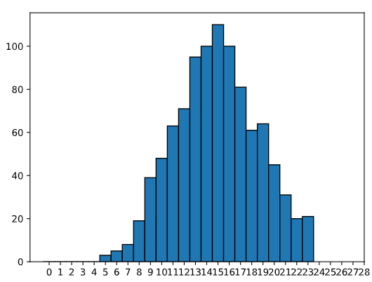

Based on the plot, what is the value of lambda, λ? How do you know?
15, because that is where the tallest bars are

If we made a plot with a different set of 1000 variates, would it look the same? Explain.
No, it would not look exactly the same.
It would look similar overall, but the bars would be a little different because the values are generated randomly each time.
Show how you could use the poisson.rvs() method below to simulate 1000 variates with the expected λ value identified above.
rvs = stats.poisson.rvs(λ, size = n)
rvs = stats.poisson.rvs(15, size = 1000)

What is stored in the variable rvs? What is the approximate value of the mean?
A list of possible values distributed around 15. Therefore the mean is about 15

Skill 31.5 Exercise 1
Refer to the histogram below which shows 1000 simulated values from a Poisson distribution.
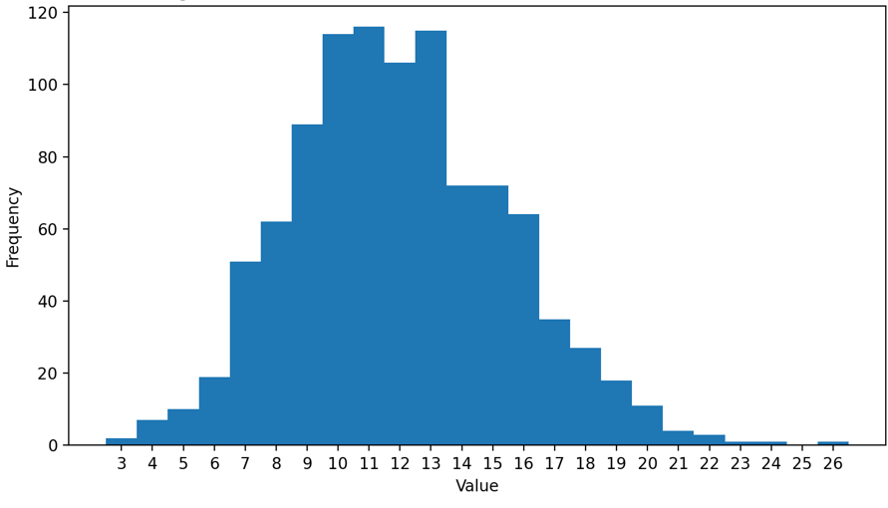
Based on the plot, what is the value of lambda, λ? How do you know?
λ≈12 because the histogram is centered around 12, and the most common values are close to 12. In a Poisson distribution, the mean and center are determined by
Based on the plot, what is the variance? How do you know?
The variance is about 12 because this is a Poisson distribution, and for a Poisson distribution the variance is equal to the lambda value. Since the graph is centered around 12, the lambda value is about 12, so the variance is also about 12.
Show how you could use the poisson.rvs() method below to simulate 1000 variates with the expected λ value identified above.

rvs = stats.poisson.rvs(λ, size = n)
rvs = stats.poisson.rvs(12, size = 1000)

Show how you could calculate the variance using the numpy.var() method.
import numpy as np

np.var(rvs)

Skill 31.6 Exercise 1
A certain basketball player has an 85% chance of making a given free throw and takes 20 free throws. What is the expected number of baskets made?
expected_baskets = .85 * 20

A student has a 98% chance of arriving early or on time to class. What is the expected number of times the student will arrive LATE in 180 school days?
expected_late = 180 * (1 - .98)

Skill 31.7 Exercise 1
A certain basketball player has an 85% chance of making a given free throw and takes 20 free throws. Calculate the variance.
variance_baskets = 20 * .85 * .15

A student has a 98% chance of arriving early or on time to class. What is the variance for the number of times the student will arrive LATE in 180 school days?
variance_late = .02 * .98 * 180

Skill 31.8 Exercise 1
A machine produces an average of 12 parts in the morning and 9 parts in the afternoon. Let X be the number of parts made in the morning and Y be the number made in the afternoon.
If E(X)=12 and E(Y)=9E, what is E(X+Y)?
The expected value is the sum of the expected values
21

A student guesses on a 20-question multiple choice quiz with 4 answer choices per question. Let X be the number of correct answers. The expected value is E(X)=5.
If the student takes 3 similar quizzes, what is E(3X)?
The expected value is 15 because taking three similar quizzes triples the average number of correct answers.
15

A class’s test scores have variance 16. The teacher adds 5 points to every score.
What is the new variance?
The variance stays 16 because adding the same amount to every score changes the center but does not change the spread.

Let X be the number of correct answers on a 10-question true/false quiz, where each question is worth 1 point. Pluska decides to weight the test by a factor of 5, what is the new variance?
The new variance is 62.5 because multiplying every score by 5 makes each distance from the mean 5 times larger, so the variance becomes 25 times larger.
For a binary distribution (T/F)
Old variance = .5 * 1 - .5 = .25 * 10 = 2.5
New variance = 5(.5) * 5(1-.5) = 6.25 * 10 = 62.5
A student rolls two fair dice. Let X be 1 if the first die lands on six and 0 otherwise, and let Y be 1 if the second die lands on six and 0 otherwise. Find the variance of X+Y
V(X) = 1/6 * (1 – 1/6) = .1389
V(Y) = 1/6 * (1 – 1/6) = .1389
.1389 + .1389 = .278

