Skill 33.1 Exercise 1
For each situation, decide whether a Poisson distribution, a binomial distribution, or a normal distribution would be most appropriate. Explain why or why not.
A basketball player takes 12 free throws. We want to model the number of shots they make.
A hospital tracks the number of patients who arrive at the emergency room between midnight and 1:00 AM.
A teacher records the heights of students in a class.
A factory inspects 20 light bulbs and records how many are defective.
A city records the number of car accidents at a certain intersection each week.
The daily temperatures in a city during the month of April.

Skill 33.2 Exercise 1
The average number of calls in a call center between 9am and 10am is expected to be 15 calls.
Below is the Poisson distribution,

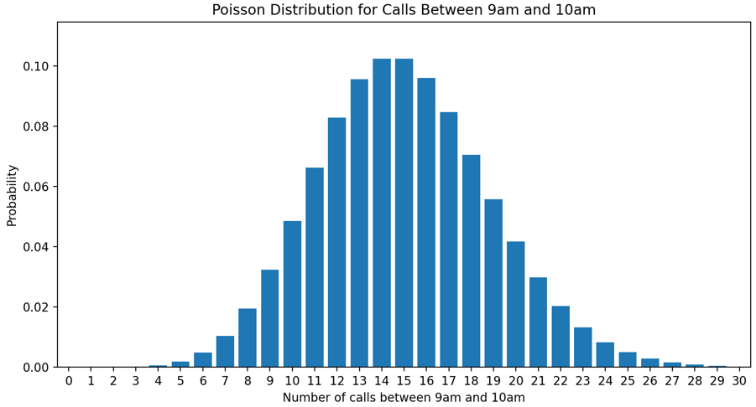
Use the poisson.pmf() method below to show how to calculate the probability of getting exactly 15 calls in this time frame.

stats.poisson.pmf(k, λ)

What is the probability we would get between 7 and 9 calls?

Skill 33.3 Exercise 1
The average number of calls in a call center between 9am and 10am is expected to be 15 calls.
Below is the Poisson distribution,


Use the poisson.cdf() method below to show how to calculate the probability of observing more than 20 calls?

stats.poisson.cdf(k, λ)

What is the probability of observing between 17 and 21 calls?

Skill 33.4 Exercise 1
The histogram below shows the distribution of 1000 random variates generated from a Poisson distribution.

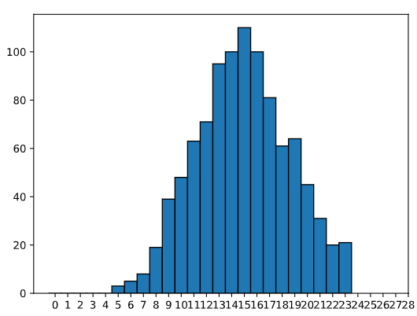

Based on the plot, what is the value of lambda, λ? How do you know?
If we made a plot with a different set of 1000 variates, would it look the same? Explain.
Show how you could use the poisson.rvs() method below to simulate 1000 variates with the expected λ value identified above.
rvs = stats.poisson.rvs(λ, size = n)
What is stored in the variable rvs? What is the approximate value of the mean?

Skill 33.5 Exercise 1
Refer to the histogram below which shows 1000 simulated values from a Poisson distribution.
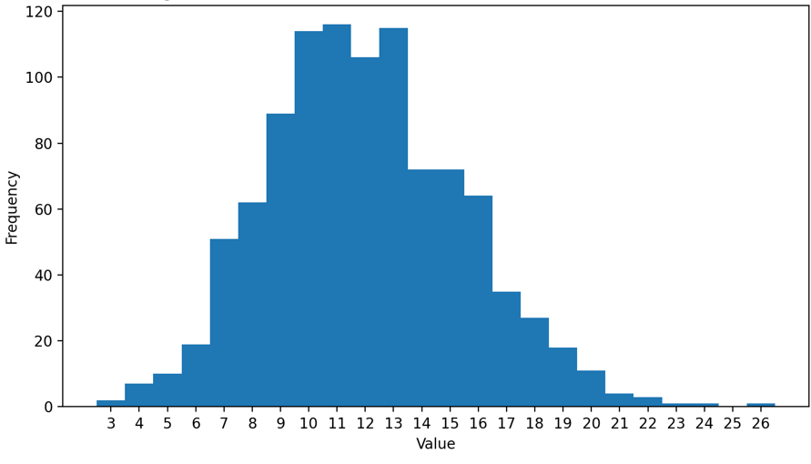
Based on the plot, what is the value of lambda, λ? How do you know?
Based on the plot, what is the variance? How do you know?
Show how you could use the poisson.rvs() method below to simulate 1000 variates with the expected λ value identified above.

rvs = stats.poisson.rvs(λ, size = n)
Show how you could calculate the variance using the numpy.var() method.
import numpy as np

Skill 33.6 Exercise 1
A certain basketball player has an 85% chance of making a given free throw and takes 20 free throws. What is the expected number of baskets made?
A student has a 98% chance of arriving early or on time to class. What is the expected number of times the student will arrive LATE in 180 school days?

Skill 33.7 Exercise 1
A certain basketball player has an 85% chance of making a given free throw and takes 20 free throws. Calculate the variance.
A student has a 98% chance of arriving early or on time to class. What is the variance for the number of times the student will arrive LATE in 180 school days?

Skill 33.8 Exercise 1
A machine produces an average of 12 parts in the morning and 9 parts in the afternoon. Let X be the number of parts made in the morning and Y be the number made in the afternoon.
If E(X)=12 and E(Y)=9E, what is E(X+Y)?
A student guesses on a 20-question multiple choice quiz with 4 answer choices per question. Let X be the number of correct answers. The expected value is E(X)=5.
If the student takes 3 similar quizzes, what is E(3X)?
A class’s test scores have variance 16. The teacher adds 5 points to every score.
What is the new variance?
Let X be the number of correct answers on a 10-question true/false quiz, where each question is worth 1 point. Pluska decides to weight the test by a factor of 5, what is the new variance?
A student rolls two fair dice. Let X be 1 if the first die lands on six and 0 otherwise, and let Y be 1 if the second die lands on six and 0 otherwise. Find the variance of X+Y

