Skill 32.1 Exercise 1
Pretend we are all-powerful and have a list of the weights of every Atlantic Salmon currently alive. We use those data to create the population histogram shown below.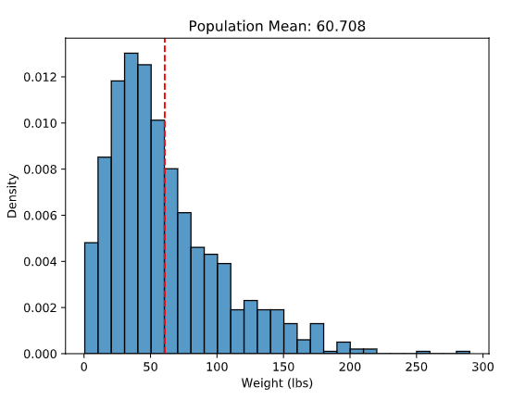
Two students take samples from the same population. One uses a sample size of 10 and the other uses a sample size of 200. Which sample mean would you generally trust more as an estimate of the population mean, and why?
I would generally trust the sample mean from the sample of 200 more. A larger sample is more likely to represent the population well, so the mean from 200 values will usually be closer to the population mean. Larger samples are also less affected by unusual or extreme values than smaller samples.
If you repeatedly take 1,000 samples of size 10 from this population and calculate the mean of each sample, what would you expect the distribution of those sample means to look like? Explain your reasoning.
I would expect the sample means to vary, because each sample of 10 fish would be different. Most of the sample means would be near the population mean, but with a sample size of 10 they would be fairly spread out, so some means would be noticeably higher or lower.

Skill 32.2 Exercise 1
Refer to the code below, which loads data about cod

population = pd.read_csv("cod_population.csv")
population = population['Cod_Weight']
sample_size = 50
sample_means = []

- Write a loop to take 500 random samples
- Inside the loop, use np.random.choice(population, sample_size, replace = False) to take a random sample of sample_size = 50.
- Calculate the mean of each sample and store it in sample_means.
for i in range(500):
samp = np.random.choice(population, sample_size, replace = False)
this_sample_mean = samp.mean()
sample_means.append(this_sample_mean)

Below is histogram that shows the distribution of the means of our cod samples,
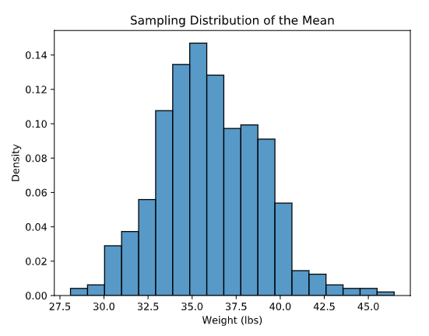
What value seems to be the center of this sampling distribution?
The center looks to be about 36 pounds because the tallest bars and most of the sample means are clustered around 35 to 37 pounds.
Why are the sample means not all exactly the same?
The sample means are not all the same because each random sample includes a different group of cod. Since the fish in each sample are slightly different, the mean changes a little from sample to sample.
If the sample size increased from 50 to 100, how would you expect this histogram to change?
If the sample size increased to 100, I would expect the histogram of sample means to become narrower and more concentrated around the true population mean. The sample means would vary less because larger samples usually give more consistent estimates.

Skill 32.3 Exercise 1
Pretend we are all-powerful and have a list of the weights of every Cod currently alive. We use those data to create the population histogram shown below.
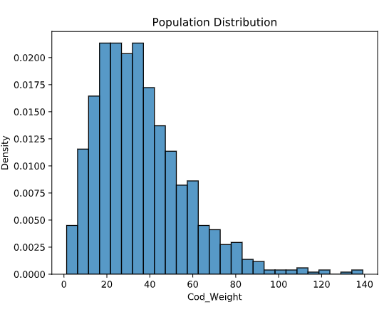
In the previous exercise we created a histogram that showed the distribution of 500 means for a population of 50. Below is the histogram, along with another that shows the distribution of 500 means for a population of 6.

population = 50 | population = 6
 | 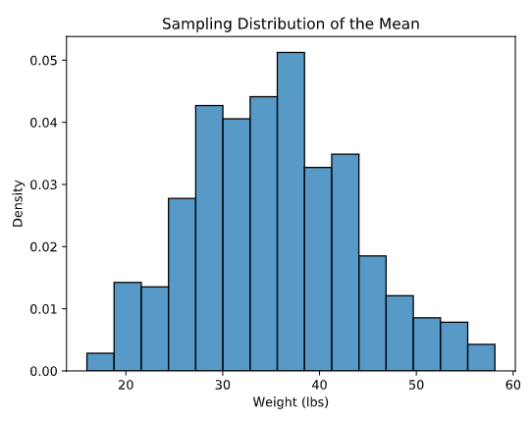

The population of cod weights is strongly right-skewed, but the sampling distribution of the mean for n = 50 looks much more symmetric. How does this illustrate the Central Limit Theorem
The Central Limit Theorem says that when the sample size is large enough, the sampling distribution of the sample mean will be approximately normal, even if the population itself is skewed. In these graphs, the population is right-skewed, but the distribution of sample means for n = 50 is much more bell-shaped, which shows the theorem in action.

Skill 32.4 Exercise 1
Refer to the graphs below,
This graph shows the population distribution, where the mean is 36 and the standard deviation is 30
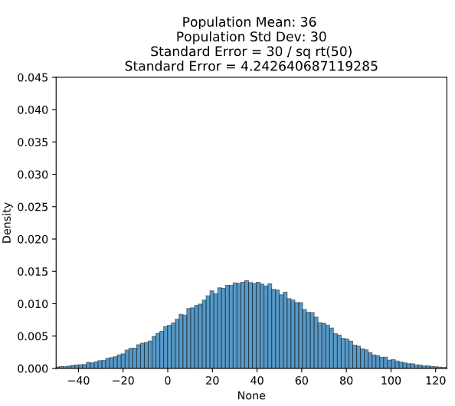
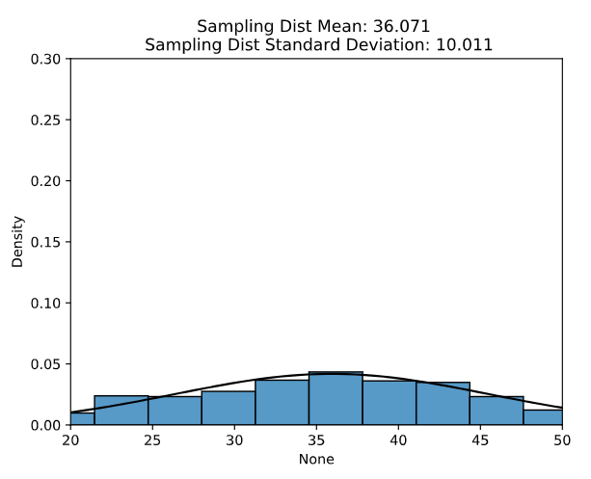 | 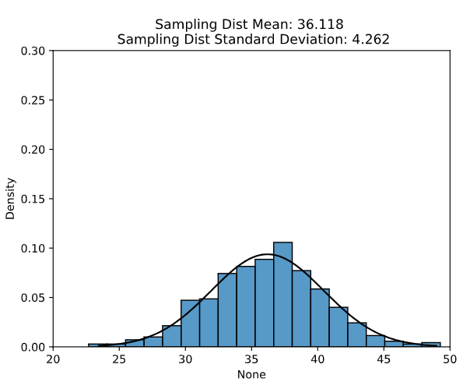
Refer to the bottom two graphs. Both sampling distributions are centered near 36. How does their spread differ, and what does that tell us about the effect of sample size on standard error? Which graph likely came from the larger sample size, and how can you tell?
Both sampling distributions are centered near 36, so in both cases the sample means are estimating the same population mean. However, the graph on the right has a much smaller spread than the graph on the left, which means its sample means vary less from sample to sample. This tells us that a larger sample size leads to a smaller standard error. The graph on the right likely came from the larger sample size because its distribution is narrower and more tightly clustered around 36.

Skill 32.5 Exercise 1
Consider a population with the following values,
2, 5, 7, 12
Where the minimum is 2.
Indicate all the possible samples of size 2 (without replacement)
2, 5 2, 7 2, 12 5, 7 5, 12 7, 12

What is the minimum value for each pair?
What is the average of the minimum values?
Is the minimum a biased indicator?
Calculate the mean for all the possible samples of size 2, then average theses.
Compare the mean for all the possible samples of size 2 to the mean of the original population.
Is the mean a biased indicator?

Skill 32.6 Exercise 1
We know that cod have an average weight of 36 lbs with a standard deviation of 20. We want to try to fit 25 cod fish into our same crate that can hold up to 750 lbs.
Calculate the standard error for a sample size of 25. Using the above information.
20/sqrt(25) = 4

Use the normal CDF to calculate the probability that a sample of 25 fish has a mean weight of 30 lbs (The minimum weight required to fit 25 in the crate)
stats.norm.cdf(x,mean,standard_error)

stats.norm.cdf(30,36,standard_error)

The value above is 0.066807201268. What does this communicate? And, would you try to fit 25 cod in the crate?
There is about a 6.7% chance that a random sample of 25 fish will have a mean weight of 30 pounds or less.

