Skill 33.1 Exercise 1
The International Baccalaureate Degree Programme (IBDP) is a world-wide educational program. Each year, students in participating schools can take a standardized assessment to earn their degree. Total scores on this assessment range from 1-45. Based on data provided here, the average total score for all students who took this exam in May 2020 was around 29.92. The distribution of scores looks something like this,

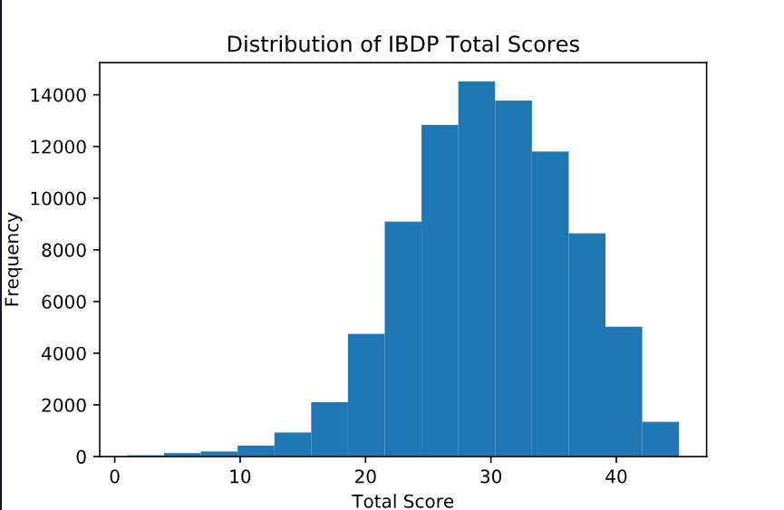

Statistics Academy offers a 5-week test-preparation program. A random sample of 100 students from the online prep program had an average score of 31.16. Does this sample result automatically prove that the prep program improved scores? Explain why or why not.
No. The sample average is higher, but sample means naturally vary from one sample to another. A higher sample mean could still happen just by chance, so this result needs more evidence before we can conclude that the program really improved scores.

Skill 33.2 Exercise 1
Refer to the previous exercise. The average IBDP score for all students was 29.92. A random sample of 100 students from the online prep program had an average score of 31.16.
Write the null hypothesis.
Null hypothesis: The mean IBDP score for students in the online prep program is 29.92.

Write the alternative hypothesis.
Alternative hypothesis: The mean IBDP score for students in the online prep program is greater than 29.92.

State the hypotheses symbolically and explain what each hypothesis is saying about the mean score of students in the online prep program.
H₀: μ = 29.92
This says that the mean score of students in the online prep program is the same as the overall student population. Any higher sample mean, such as 31.16, could be due to random sampling variation

Hₐ: μ > 29.92
This says the prep program students have a higher mean score than the overall student population.

Skill 33.3 Exercise 1
The average total score for all students who took the IBDP exam in May 2020 was around 29.92. The distribution of scores looks something like this,

Use np.random.choice() to generate a null distribution of sample means for samples of size 100. Do this by calculating the mean of 500 random samples from student_population without replacement.
import numpy as np
import pandas as pd
import matplotlib.pyplot as plt
import seaborn as sns

# loop 500 times to get 500 random sample means
for i in range(500):
# take a sample from the data:
samp = np.random.choice(student_population, 100, replace = False)
# calculate the mean of this sample:
this_sample_mean = np.mean(samp)
# append this sample mean to a list of sample means
sample_means.append(this_sample_mean)

Use the sns.histplot() method to create a histogram of the distribution.
# plot all the sample means to show the sampling distribution
sns.histplot(sample_means, stat='density')
plt.title("Sampling Distribution of the Mean")
plt.show()

The actual plot of the null distribution is shown below.
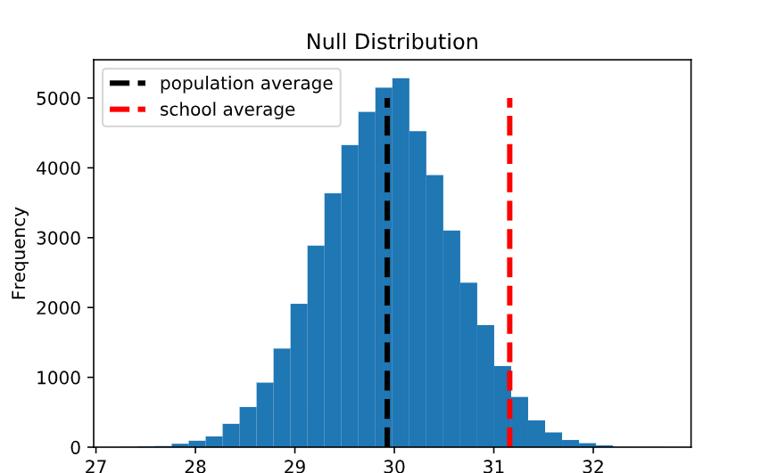
Does the school average appear common or unusual if the null hypothesis is true?
It looks unusual because it is not near the center of the null distribution. It is in the right tail, where there are fewer sample means.

What does this suggest about the claim that the prep program improved scores?
This suggests that the claim may be true because the school average is higher than what we would usually expect if the null hypothesis were true. The result gives evidence that the prep program may have improved scores.

Skill 33.4 Exercise 1
The average total score for all students who took the IBDP exam in May 2020 was around 29.92. The null distribution plot is shown below,
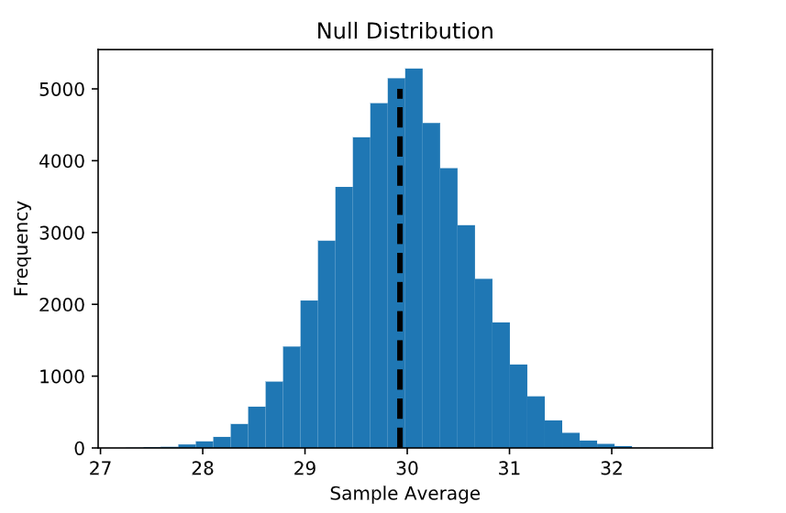
For each situation:

- Identify whether the test is left-tailed, right-tailed, or two-tailed
- shade the appropriate region of the null distribution on the graph
  - A sample mean of 31.16 is used to test whether test scores are higher than average.
  - A sample mean of 29.00 is used to test whether test scores are lower than average.
  - A sample mean of 31.16 is used to test whether test scores are different from average.
1. Right-tailed
Shade values at or above 31.16
2. Left-tailed
Shade values at or below 29.00
3. Two-tailed
Shade values at or above 31.16 and the matching values equally far below 29.92

Skill 33.5 Exercise 1
The code below loads the population of all student scores on the IBDP exam and calculates the population mean. A sample of 100 students from Statistics Academy is stored in a list called academy_sample.

Use the ttest_1samp() function to calculate and print the p-value for:
- a right-tailed test
- a two-tailed test
for the academy_sample.

data = pd.read_csv("IDBP_scores.csv", delimiter="\t")
pop_scores = data.scores
pop_mean = scores.mean()
academy_sample = [
18.7, 22.4, 24.1, 25.6, 26.3, 27.5, 28.1, 28.9, 29.4, 29.8,
30.1, 30.4, 30.7, 31.0, 31.2, 31.5, 31.7, 32.0, 32.2, 32.5,
32.7, 33.0, 33.2, 33.5, 33.7, 34.0, 34.2, 34.5, 34.7, 35.0,
20.3, 23.1, 24.8, 25.9, 26.7, 27.8, 28.4, 29.1, 29.6, 30.0,
30.3, 30.6, 30.9, 31.1, 31.4, 31.6, 31.9, 32.1, 32.4, 32.6,
32.9, 33.1, 33.4, 33.6, 33.9, 34.1, 34.4, 34.6, 34.9, 35.1,
21.0, 23.8, 25.1, 26.1, 26.9, 28.0, 28.6, 29.2, 29.7, 30.2,
30.5, 30.8, 31.0, 31.3, 31.5, 31.8, 32.0, 32.3, 32.5, 32.8,
33.0, 33.3, 33.5, 33.8, 34.0, 34.3, 34.5, 34.8, 35.0, 35.3,
19.6, 22.9, 24.5, 25.8, 26.5, 27.6, 28.3, 29.0, 29.5, 40.5
]

result = ttest_1samp(academy_sample, pop_mean, alternative="two-sided")
print(result.pvalue)
result = ttest_1samp(academy_sample, pop_mean, alternative="greater")
print(result.pvalue)
The actual p-values for the right-tailed and two-tailed tests are 0.031 and 0.062, respectively. Write a one-sentence interpretation of each result.
If the 100 students at Statistics Academy were randomly selected from the full population (which had an average score of 29.92), there is a 3.1% chance of their average score being 31.16 points or higher.

If the 100 students at Statistics Academy were randomly selected from the full population (which had an average score of 29.92), there is a 6.2% chance of their average score being 31.16 points or higher or (29.92 - 1.24) or lower.

Skill 33.6 Exercise 1
The p-value for the right-tailed test is 0.031, and the p-value for the two-tailed test is 0.062. Using a significance level of 0.05, determine whether each result is statistically significant. Then state whether you would reject or fail to reject the null hypothesis in each case.
Right-tailed test: p=0.031<0.05, so it is statistically significant and we reject the null hypothesis.
Two-tailed test: p=0.062>0.05, so it is not statistically significant and we fail to reject the null hypothesis.

