Skill 34.1 Exercise 1
For each situation, fill in the blanks
Situation | Type of data | Question being asked | Appropriate test | Why
A school counselor wants to know whether the average number of hours students sleep per night at her school is less than 7 hours. She surveys a random sample of students and records the number of hours each student slept last night. | Quantitative | Is the mean number of hours slept less than 7? | One-sample t-test | The data are numerical, and the claim is about the population mean
A company claims that 75% of customers are satisfied with their service. In a sample of 120 customers, 81 say they are satisfied. | Binary categorical | Is the proportion of satisfied customers different from 75%? | Binomial test | Each customer is either satisfied or not satisfied, so the outcome is binary and the claim is about a proportion
A teacher wants to test whether the average score on a statistics quiz this year is different from 78 points. She collects a random sample of quiz scores from her students. | Quantitative | Is the mean quiz score different from 78? | One-sample t-test | The data are numerical scores, and the question is about an average.
A wildlife researcher wants to know whether the proportion of tagged turtles that return to the same beach is greater than 60%. Out of 50 tagged turtles, 38 return to the same beach. | Binary categorical | Is the proportion of turtles that return greater than 60%? | Binomial test | Each turtle either returns or does not return, so the outcome is binary and the claim is about a proportion.
A nutritionist wants to investigate whether the average sugar content in boxes of cereal is more than 12 grams per serving. She randomly samples cereal boxes and records the sugar content of each one. | Quantitative | Is the mean sugar content greater than 12 grams? | One-sample t-test | The data are numerical measurements, and the claim is about a population mean.

Skill 34.2 Exercise 1
The Titanic dataset includes information about passengers, including whether they survived and their sex,
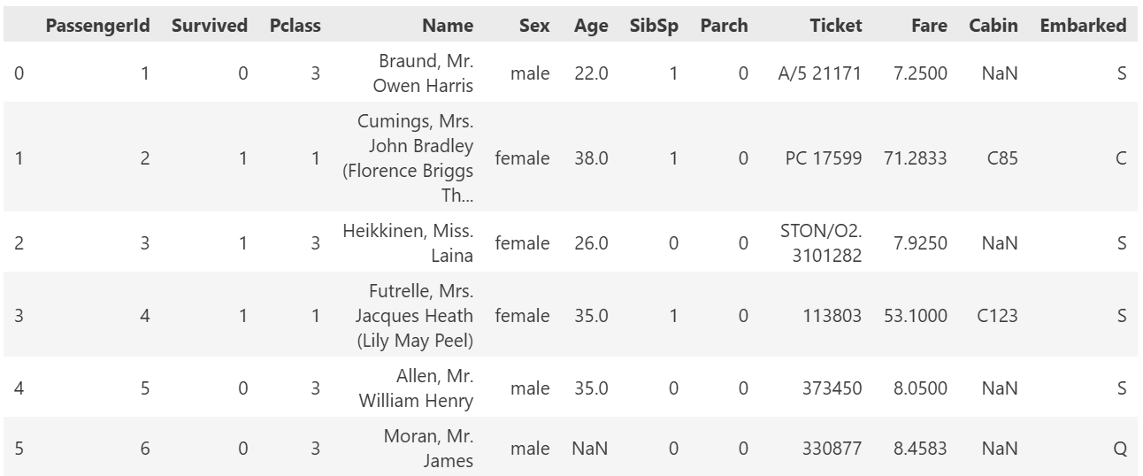For each situation,
- Identify the sample
- Identify what counts as a success
- Write code to calculate the
  - sample_size
  - num_successes
Was the survival rate of all Titanic passengers was lower than 40%?
Sample:
All passengers

Success:
Survived = 1

Code:
sample_size = len(titanic)
num_successes = len(titanic[titanic.Survived == 1])

Was the proportion of female passengers on the Titanic was greater than 60%?
Sample:
All passengers

Success:
Sex = female

Code:
sample_size = len(titanic)
num_successes = len(titanic[titanic.Sex == "female"])

Was the proportion of survivors who were female greater than 70%?
Sample:
Survived = 1

Success:
Sex = female and survived = 1

Code:
survivors = titanic[titanic.Survived == 1]
sample_size = len(survivors)
num_successes = len(survivors[survivors.Sex == "female"])

Skill 34.3 Exercise 1
For each of the situations in the previous exercise,

- Write code to simulate one trial using numpy.random.choice()
- Write code to simulate the entire sample
Was the survival rate of all Titanic passengers was lower than 40%. (sample_size = 891)
One trial
simulated_sample = np.random.choice([1, 0], size=1, p=[0.40, 0.60])

Entire sample
simulated_sample = np.random.choice([1, 0], size=891, p=[0.40, 0.60])

Was the proportion of female passengers on the Titanic was greater than 30%. (sample_size = 891)
One trial
simulated_sample = np.random.choice([1, 0], size=1, p=[0.30, 0.70])

Entire sample
simulated_sample = np.random.choice([1, 0], size=891, p=[0.30, 0.70])

Was the proportion of survivors who were female greater than 60%? (sample_size = 342)
One trial
simulated_sample = np.random.choice([1, 0], size=1, p=[0.60, 0.30])

Entire sample
simulated_sample = np.random.choice([1, 0], size=342, p=[0.60, 0.30])

Skill 34.4 Exercise 1
Assume that 60% of Titanic survivors were female. Write code that simulates10000 samples of 342 Titanic survivors under the null hypothesis p = 0.60, where a success means the survivor was female. Store the number of female survivors from each sample in a list called null_outcomes
null_outcomes = []
for s in range(10000):
simulated_sample = np.random.choice([1,0], size=342, p=[0.60, 0.40])
total = np.sum(simulated_sample)
null_outcomes.append(total)

The histogram shows a null distribution assuming that 60% of survivors were female. The red line shows the actual number of female survivors. Does the observed result appear unusual under the null hypothesis? Explain using the graph.
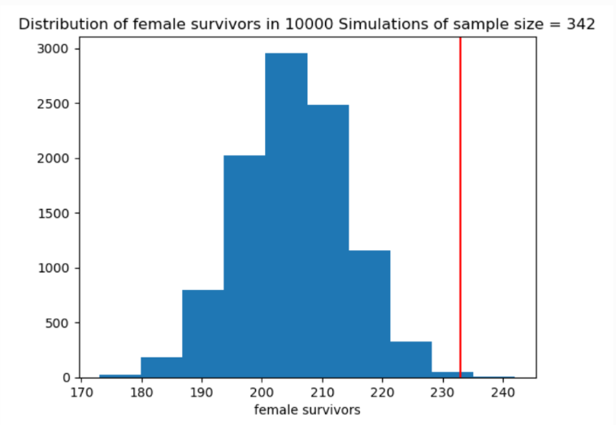

Yes. The null distribution is centered around about 205 female survivors, but the actual value is about 233, which is far to the right of most simulated outcomes. Because very few simulations produced a value that large, the observed result appears unusual under the null hypothesis.

Skill 34.5 Exercise 1
Use the np.percentile() function to calculate an interval covering the middle 95% of the values in null_outcomes. Save the output in a variable named null_95CI and print it out.
confidence_int = np.percentile(null_outcomes, [2.5,97.5])
print(confidence_int)

The middle 95% of the null distribution is from 188 to 223 female survivors. The observed value is about 233. Does this observed value appear unusual under the null hypothesis? Explain.
Since the actual value, 233, is greater than 223, it falls outside the 95% interval. This means the observed result is unusually high under the null hypothesis

Skill 34.6 Exercise 1
In a previous exercise, you wrote code to simulate 10,000 samples of 342 Titanic survivors under the null hypothesis p = 0.60, where a success means the survivor was female. The results of those simulations are stored in a list called null_outcomes. The actual number of female survivors was 233.
Using null_outcomes, calculate the p-value for this situation. In other words, calculate the proportion of simulated samples in which 233 or more survivors were female.
p_value = sum(x >= 233 for x in null_outcomes) / len(null_outcomes)
print(p_value)

The p-value is 0.0007. What does this tell us about how likely it would be to observe 233 or more female survivors if the true proportion were really 0.60?
A p-value of 0.0007 means there is about a 0.07% chance of getting a result this extreme or more extreme if the null hypothesis were true. This means the observed result is very unusual under the null hypothesis and provides strong evidence against the idea that only 60% of survivors were female.

Skill 34.7 Exercise 1
In a previous exercise, you wrote code to simulate 10,000 samples of 342 Titanic survivors under the null hypothesis p = 0.60, where a success means the survivor was female. The results of those simulations are stored in a list called null_outcomes. The actual number of female survivors was 233.
Using null_outcomes, calculate the two-sided p-value for this situation. In other words, calculate the proportion of simulated samples in which the number of female survivors was 233 or more or 177 or fewer. Note that 205 is the value we expect if 60 percent of the survivors were female.
values = sum((x >= 233) or (x <= 177) for x in null_outcomes)
p_value_two_sided = values / len(null_outcomes)
print(p_value_two_sided)

The p-value is 0.0023. What does this tell us about how likely it would be to observe 233 or more female survivors or 177 or fewer female survivors if the true proportion were really 0.60?
A p-value of 0.0035 means there is about a 0.35% chance of getting a result this extreme or more extreme if the true proportion of female survivors were really 0.60. This means that observing 233 or more female survivors, or 177 or fewer female survivors, would be very unlikely under the null hypothesis.

Skill 34.8 Exercise 1
The function below simulates a one-sided left-tailed test.

def simulation_binomial_test(observed_successes, n, p):
#initialize null_outcomes
null_outcomes = []

#generate the simulated null distribution
for i in range(10000):
simulated_sample = np.random.choice([1, 0], size=n, p=[p, 1-p])
total = np.sum(simulated_sample)
null_outcomes.append(total)

#calculate a 1-sided p-value
null_outcomes = np.array(null_outcomes)
p_value = np.sum(null_outcomes <= observed_successes)/len(null_outcomes)

#return the p-value
return p_value
In a previous exercise, we calculated the p-value by finding the proportion of simulated samples in which 233 or more survivors were female. Because the observed value is greater than the expected value of about 205, this is a right-tailed test. Explain how you would modify the function above so that it calculates a right-tailed p-value instead of a left-tailed p-value.
p_value = np.sum(null_outcomes >= observed_successes)/len(null_outcomes)

Show how you would call this function to estimate the p-value for observing 233 or more female survivors in a sample of 342 Titanic survivors, assuming the null probability is 0.60.
simulation_binomial_test(233, 342, .6):

Use Python’s built-in binomtest() function to calculate the p value and print it.
from scipy.stats import binomtest

p_value = binomtest(233, n = 342, p=0.60, alternative = "greater")
print(p_value.pvalue)

The value you returned by the simulation_binomial_test is different every time, however the value your returned by the built binomtest function is always the same. Explain.
simulation_binomial_test() gives slightly different answers because it estimates the p-value using random samples. Since the samples change each time, the estimate changes too. binomtest(), on the other hand, calculates the exact p-value mathematically, so the result is always the same for the same data.

