Skill 35.1 Exercise 1
For each situation, decide whether the mean or median is more appropriate and briefly explain why.
Situation | Mean/median | Explanation
The annual income of adults in New York | Median | Income is usually right-skewed because a small number of people earn much more than most others. Those very large incomes pull the mean upward, so the median better represents a typical income.
The heights of students at Timberline | Mean | Heights are usually fairly symmetric with no extreme outliers, so the mean is a reasonable measure of center.
The selling price of homes in New York | Median | Home prices are often right-skewed because a few very expensive homes raise the mean. The median gives a better sense of a typical home price.
The scores on a quiz in Pluska’s class | Mean | Quiz scores are often fairly clustered and not strongly affected by extreme values, so the mean is usually appropriate.
The number of Instagram followers | Median | Follower counts are often strongly right-skewed because a few people may have very large numbers of followers. The median better describes a typical user

Skill 35.2 Exercise 1
A real estate company wants to describe a “typical” home value in a city. They collect data on home values and create the histogram below.
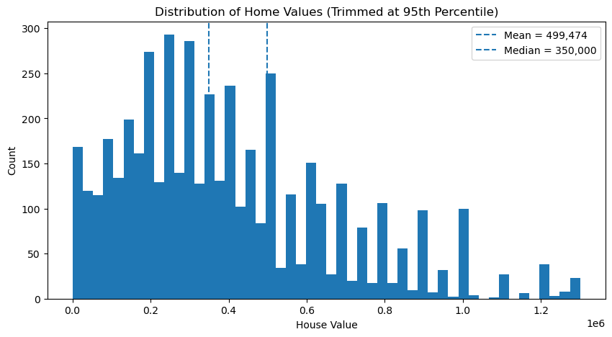
Based on the histogram, which statistic — the mean or the median — would be the more appropriate measure of center? Explain your reasoning
The median is more appropriate because the distribution is right-skewed. A small number of very expensive homes pull the mean upward, so the median better represents a typical home value.
Based on income data, city officials estimate that a typical home buyer in the city can afford a home worth $350,000. They want to investigate whether a typical home in the city is more expensive than what a typical buyer can afford.
Write an appropriate null hypothesis and alternative hypothesis for this situation.
H₀: the population median home value in the city is $350,000
Hₐ: the population median home value in the city is greater than $350,000

Skill 35.3 Exercise 1
A sample of homes has a median value above $350,000. Based on the histograms below, explain why that result alone is not enough to conclude that the population median home value is greater than $350,000.

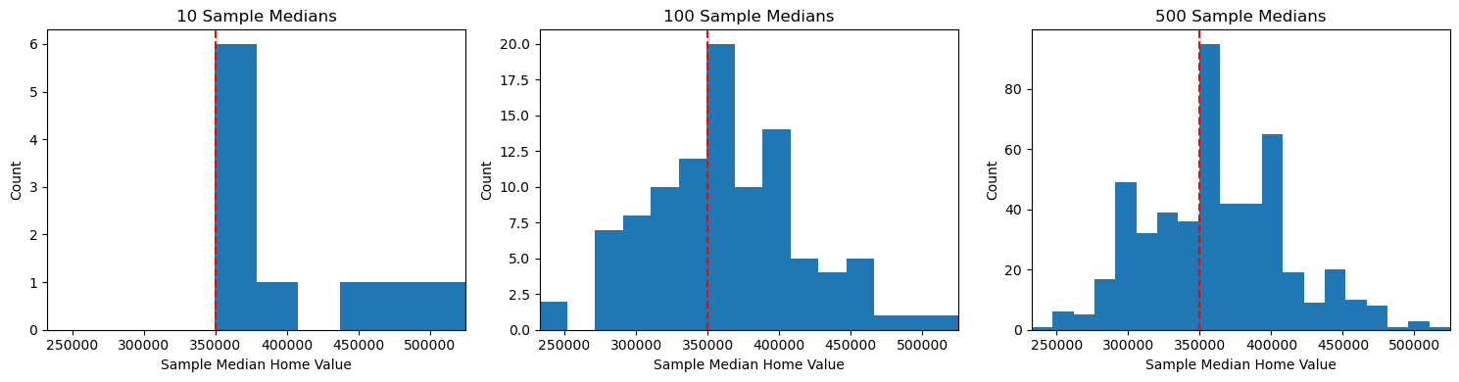

One sample median above $350,000 does not automatically mean the population median is greater than $350,000 because sample medians vary by random chance. The histograms show that different samples can produce different medians, even from the same population. To decide whether a sample median above $350,000 is meaningful, we need to compare it to the full distribution of sample medians

Skill 35.4 Exercise 1
Refer to the bootstrap function below,

import pandas as pd
import numpy as np

housing_data = pd.read_csv("housing.csv")

def bootstrap_median(original_sample, label, replications):
just_one_column = original_sample[label]
medians = []

for i in range(replications):
bootstrap_sample = np.random.choice(just_one_column,
size=len(just_one_column),
replace=True)
resampled_median = np.median(bootstrap_sample)
medians.append(resampled_median)

return medians
Explain what the line highlighted in red is doing.
This line makes a bootstrap sample by randomly choosing values from just_one_column. The new sample has the same size as the original sample, because size=len(just_one_column). Since replace=True, values can be picked more than once, which is what makes this a bootstrap sample.

The code snippet below loads the housing data frame and displays the first few rows,

housing_data = pd.read_csv("housing.csv")
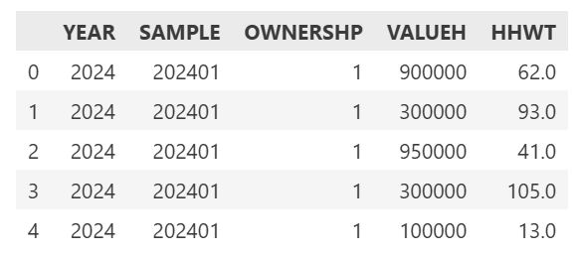

Write a line of code that uses the function to create 500 bootstrapped sample medians for home values
boot_medians = bootstrap_median(housing_data, "VALUEH", 500)

Below is a histogram of the samples
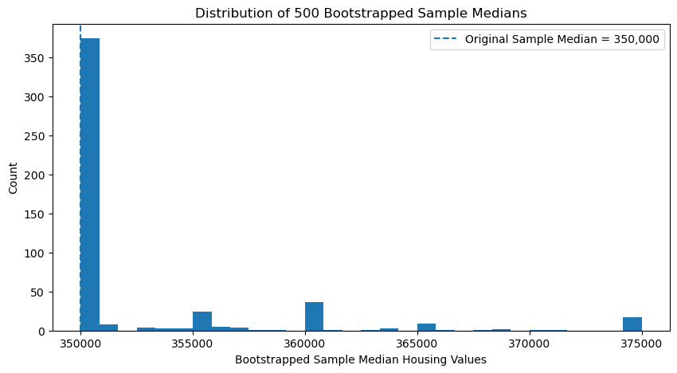
Why does the histogram have one very tall bar near $350,000 and only a few bars farther to the right?
The very tall bar near $350,000 shows that many of the bootstrapped samples had a median of $350,000. This happened because the original housing dataset has many values clustered around that amount, so repeated resampling often produces the same middle value. The smaller bars farther to the right show that some bootstrap samples had higher medians, but those happened less often.

What does this tell us about the original housing dataset?
It suggests that the original housing data have many home values near $350,000, and that this value sits near the center of the dataset. Because of this, the sample median is very stable and tends to stay at $350,000 in many bootstrap samples.

Suppose someone claimed that the population median home value was $360,000. Would this histogram make that claim seem more believable or less believable? Explain
This histogram would make that claim seem less believable. Most of the bootstrapped sample medians are centered near $350,000, not $360,000. Since values near $360,000 appear much less often, the graph suggests that a population median of $360,000 is not as consistent with the data as a median near $350,000.

Skill 35.5 Exercise 1
The histogram below shows a simulated distribution of 500 sample medians for home values under the null hypothesis that the population median is $350,000. An observed sample median of $370,000 is marked on the graph.
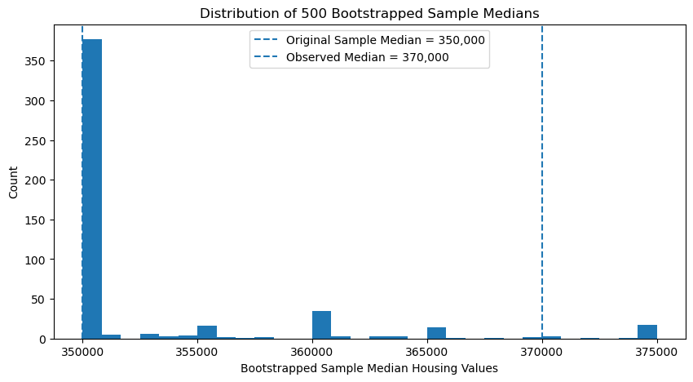
Looking at the histogram does a median of $370,000 seem unusual?
On the histogram, $370,000 is far to the right of where most of the bootstrapped sample medians are clustered. Most of the distribution is piled up near $350,000, and only a small number of simulated medians reach as high as $370,000.
The code segment below calculates the p value associated with an observed mean of $370,000.

observed_median = 370000
count = sum(1 for median in boot_medians if median >= observed_median)
p_value = count / len(boot_medians)
print(p_value)

The p_value is 0.044

Write a sentence interpreting the p-value in context.
The p-value of 0.044 means that about 4.4% of the simulated sample medians were greater than or equal to $370,000.

Is an observed sample median of $370,000 common or unusual under the null hypothesis?
Because this is a small proportion, the observed sample median appears unusual under the null hypothesis.

If the null hypothesis is that the population median home value is $350,000, what conclusion would you make?
This provides evidence that the population median home value may be greater than $350,000.

