Skill 37.1 Exercise 1
For each situation, decide whether the mean or median is more appropriate and briefly explain why.
Situation | Mean/median | Explanation
The annual income of adults in New York | Median
The heights of students at Timberline | Mean
The selling price of homes in New York | Median
The scores on a quiz in Pluska’s class | Mean
The number of Instagram followers | Median

Skill 37.2 Exercise 1
A real estate company wants to describe a “typical” home value in a city. They collect data on home values and create the histogram below.
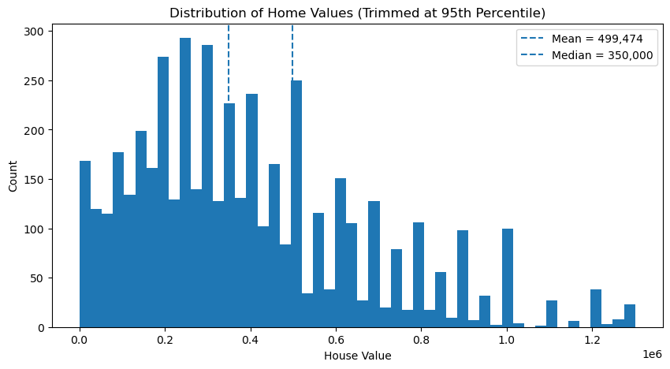
Based on the histogram, which statistic — the mean or the median — would be the more appropriate measure of center? Explain your reasoning
Based on income data, city officials estimate that a typical home buyer in the city can afford a home worth $350,000. They want to investigate whether a typical home in the city is more expensive than what a typical buyer can afford.
Write an appropriate null hypothesis and alternative hypothesis for this situation.

Skill 37.3 Exercise 1
A sample of homes has a median value above $350,000. Based on the histograms below, explain why that result alone is not enough to conclude that the population median home value is greater than $350,000.

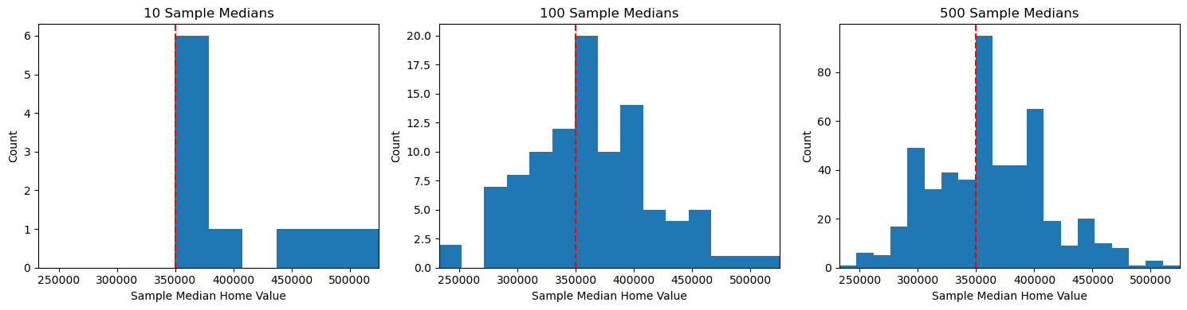

Skill 37.4 Exercise 1
Refer to the bootstrap function below,

import pandas as pd
import numpy as np

housing_data = pd.read_csv("housing.csv")

def bootstrap_median(original_sample, label, replications):
just_one_column = original_sample[label]
medians = []

for i in range(replications):
bootstrap_sample = np.random.choice(just_one_column,
size=len(just_one_column),
replace=True)
resampled_median = np.median(bootstrap_sample)
medians.append(resampled_median)

return medians
Explain what the line highlighted in red is doing.
The code snippet below loads the housing data frame and displays the first few rows,

housing_data = pd.read_csv("housing.csv")
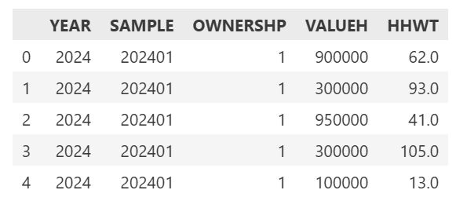

Write a line of code that uses the function to create 500 bootstrapped sample medians for home values
Below is a histogram of the samples
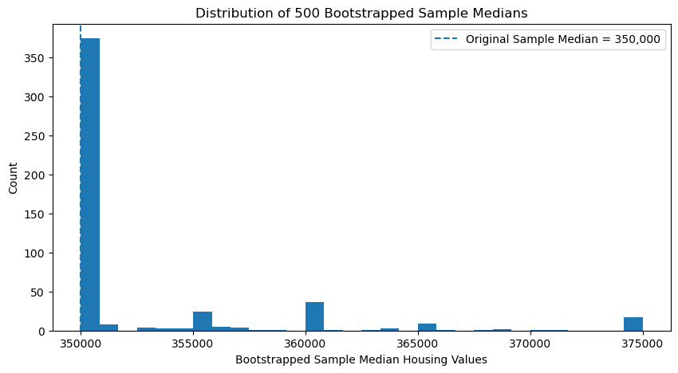
Why does the histogram have one very tall bar near $350,000 and only a few bars farther to the right?
What does this tell us about the original housing dataset?
Suppose someone claimed that the population median home value was $360,000. Would this histogram make that claim seem more believable or less believable? Explain

Skill 37.5 Exercise 1
The histogram below shows a simulated distribution of 500 sample medians for home values under the null hypothesis that the population median is $350,000. An observed sample median of $370,000 is marked on the graph.
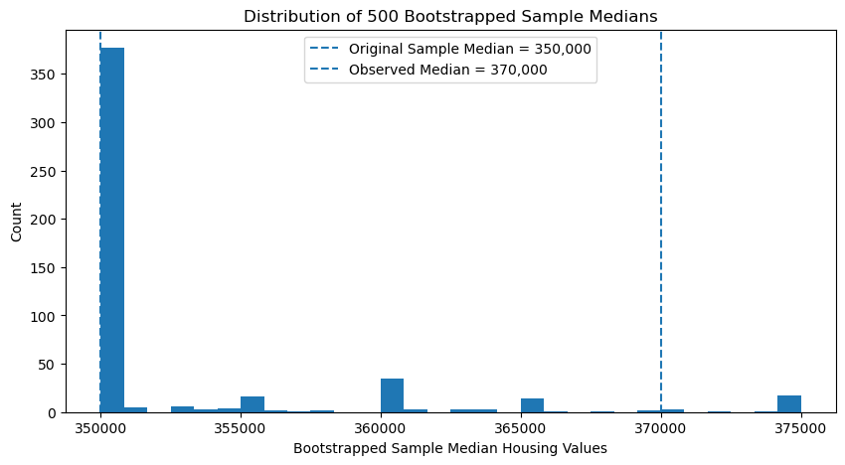
Looking at the histogram does a median of $370,000 seem unusual?
The code segment below calculates the p value associated with an observed mean of $370,000.

observed_median = 370000
count = sum(1 for median in boot_medians if median >= observed_median)
p_value = count / len(boot_medians)
print(p_value)

The p_value is 0.044
Write a sentence interpreting the p-value in context.
Is an observed sample median of $370,000 common or unusual under the null hypothesis?
If the null hypothesis is that the population median home value is $350,000, what conclusion would you make?

