Skill 36.1 Exercise 1
For each scenario, identify:

- the types of data being compared
- the best type of analysis (chi squared, pivot table, linear regression)

Scenario | Data Types Being Compared | Best Analysis
A teacher wants to know whether students who spend more hours studying tend to earn higher test scores. | quantitative vs. quantitative | Linear regression
A school administrator wants to compare the average number of absences for students in 9th, 10th, 11th, and 12th grade. | categorical vs. quantitative | Pivot table
A researcher wants to know whether favorite school subject is related to grade level. | categorical vs. categorical | Chi-squared
A store manager wants to know whether advertising spending is related to weekly sales revenue. | quantitative vs. quantitative | Linear regression
A principal wants to summarize the number of students in each lunch category (free, reduced, paid) by grade level. | categorical vs. categorical | Pivot table

For each type of analysis below, explain what kinds of questions it helps us answer.
- Chi-square test of association
- Pivot tables
- Linear regression
Chi-square test of association:
This analysis helps us answer questions about whether two categorical variables are related.

Pivot tables:
This tool helps us answer questions about how data can be organized, summarized, and compared across groups.

Linear regression:
This analysis helps us answer questions about the relationship between two quantitative variables.

Skill 36.2 Exercise 1
For each graph below and the error associated with the line. Indicate how you could change m and b to reduce the error and improve the fit of each line.
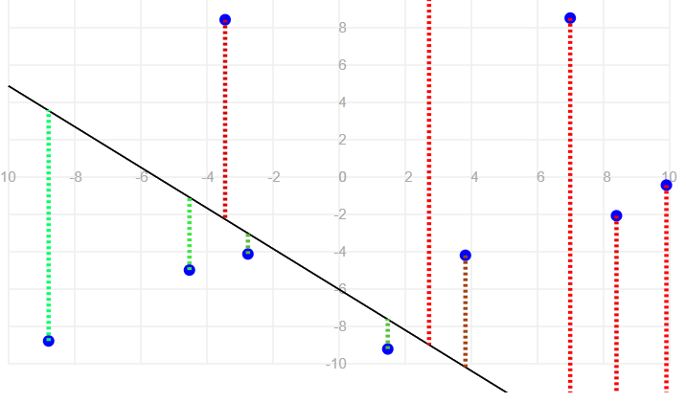  Total squared error: 363.68 | Decrease m and increase b
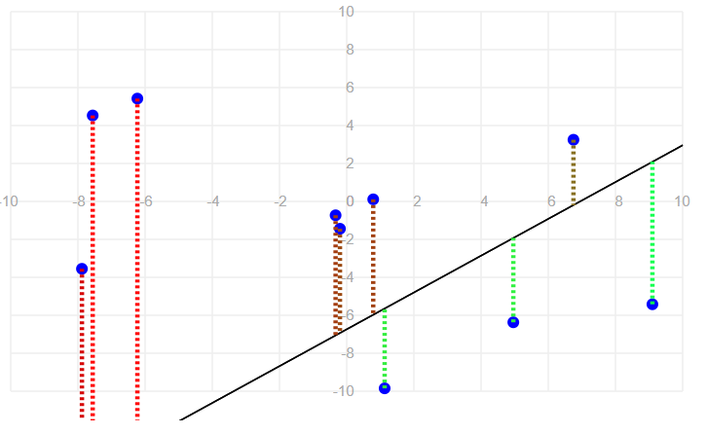  Total squared error: 1007.69 | Increase b and decrease m
Explain why those changes would reduce the overall error and improve the fit.
Graph 1:
Most of the points, especially on the right side, are above the line by a large amount. That suggests the line is too low overall
Also, the line appears to be slanting downward too sharply. On the far left, there is a point below the line, but on the right side, many points are far above it.
Graph 2:
The points on the left side tend to lie above the line, while several points on the right side lie below the line. This suggests that the line is too steep, so the slope should be decreased.
Also, around the center of the graph, the line appears to sit too low compared to several points. That suggests the y-intercept should be increased

Skill 36.3 Exercise 1
The code below loads data on study hours and student test scores.

import pandas as pd
import numpy as np
import matplotlib.pyplot as plt
import statsmodels.api as sm

students = pd.read_csv('study_hours.csv')
display(students.head())

Complete the code below to create a linear regression model that predicts student score using hours studied as a predictor.
model = sm.OLS.from_formula('score ~ hours', data=students)
results = model.fit()
print(results.params)

The fitted model produced these coefficients:
- Intercept = 58.36
- hours = 1.34
Write the equation for the best-fit line.
score =58.36+1.34(hours)

Skill 36.4 Exercise 1
Using your model from the previous exercise, show how you could calculate the predicted score for a student who spent 3 hours studying? Do not use the predict() function.
pred_3hr = 9.84811*3+43.016014

Using the predict() function, show how you could calculate the predicted score for a student who spent 5 hours studying?
newdata = {"hours":[5]}
pred_5hr = results.predict(newdata)

Skill 36.5 Exercise 1
In a previous example you created a linear regression model for hours studied and scores on a test. The fitted model produced these coefficients:
- Intercept = 58.36
- hours = 1.34
What does the slope tell us in context?
Rise/run = 1.34 so the score (rise) increases by 1.34 points for every additional hour studied

What does the y-intercept tell us in context?
If you don’t study (hours = 0) you will get a 58.36%

A store owner fits a linear regression model to predict sales from temperature. The fitted model produced these coefficients,
- Intercept = 58.36
- hours = 1.34
What does the slope tell us in context?
For each increase of 1 degree in temperature, predicted ice cream sales increase by about 8 units.

What does the y-intercept tell us in context?
At 0 degrees, the model predicts 120 ice creams sold.

Skill 36.6 Exercise 1
A regression model is used to predict study time and scores on an exam. Match each regression assumption to the best way to check it.
Assumption | Best Way to Check
The relationship is linear | Scatterplot of height vs. weight
The residuals are approximately normally distributed | Histogram of the residuals
The residuals are homoscedastic | Residual plot (residuals vs. fitted values)

A student fit a linear regression model and created the two plots shown below:

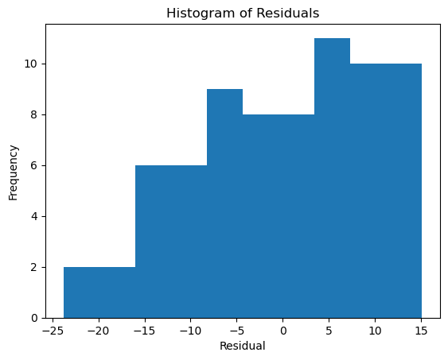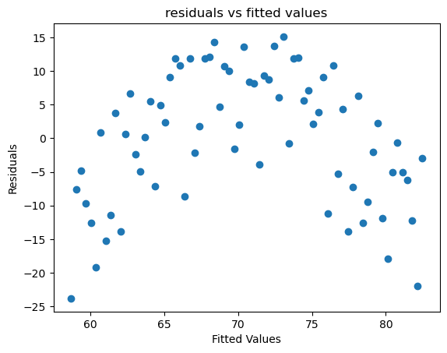
Based on the histogram, does the normality assumption seem reasonable? Explain
The normality assumption does not appear to be very reasonable. The histogram does not look approximately bell-shaped or symmetric. It looks uneven and somewhat skewed, so the residuals do not appear to be normally distributed.

Based on the residual plot, does the homoscedasticity assumption seem reasonable? Explain your answer.
The homoscedasticity assumption does not appear to be met. In the residual plot, the spread of the residuals changes across the fitted values, and there is a noticeable curved pattern rather than a random cloud centered around 0.

Based on these two plots, would you be cautious about using a linear regression model? Why or why not?
Yes, we should be cautious about using a linear regression model here. The residuals do not appear approximately normal, and the residual plot suggests non-constant spread and possible nonlinearity.

Skill 36.7 Exercise 1
In addition to hours and score, our data set from the previous exercise has a column called ate_breakfast (1 or 0).
Suppose the mean quiz scores are:

Students who did not eat breakfast: 66.8
Students who did eat breakfast: 74.1

What two points would the regression line pass through?
(0,66.8)
(1,74.1)

Write the regression equation.
74.1−66.8=7.3 = slope
score = 7.3(ate_breakfast) + 66.8

What does the slope mean in context?
The slope means that students who ate breakfast are predicted to score 7.3 points higher, on average, than students who did not eat breakfast.

What does the intercept mean in context?
The intercept means that students who did not eat breakfast are predicted to score 66.8.

