Skill 38.1 Exercise 1
For each scenario, identify:

- the types of data being compared
- the best type of analysis (chi squared, pivot table, linear regression)

Scenario | Data Types Being Compared | Best Analysis
A teacher wants to know whether students who spend more hours studying tend to earn higher test scores.
A school administrator wants to compare the average number of absences for students in 9th, 10th, 11th, and 12th grade.
A researcher wants to know whether favorite school subject is related to grade level.
A store manager wants to know whether advertising spending is related to weekly sales revenue.
A principal wants to summarize the number of students in each lunch category (free, reduced, paid) by grade level.

For each type of analysis below, explain what kinds of questions it helps us answer.
- Chi-square test of association
- Pivot tables
- Linear regression

Skill 38.2 Exercise 1
For each graph below and the error associated with the line. Indicate how you could change m and b to reduce the error and improve the fit of each line.
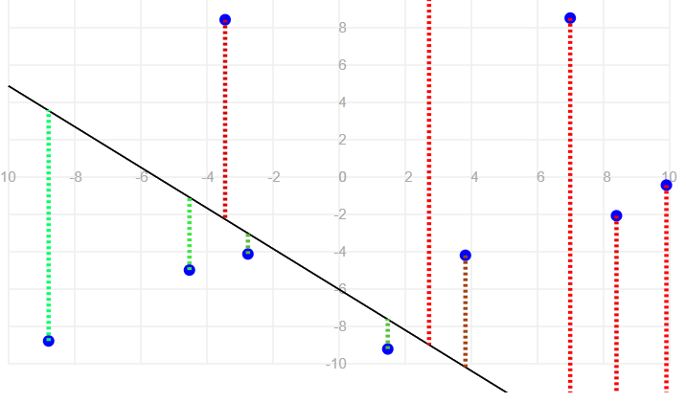  Total squared error: 363.68 | Decrease m and increase b
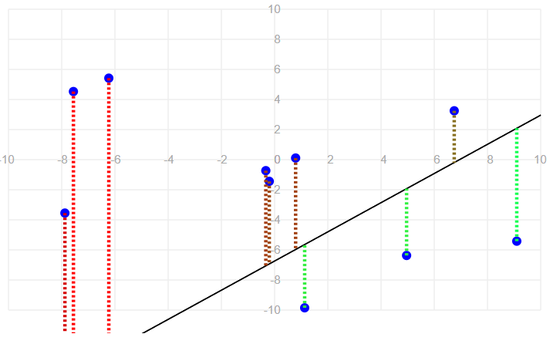  Total squared error: 1007.69 | Increase b and decrease m
Explain why those changes would reduce the overall error and improve the fit.
Graph 1:

Graph 2:

Skill 38.3 Exercise 1
The code below loads data on study hours and student test scores.

import pandas as pd
import numpy as np
import matplotlib.pyplot as plt
import statsmodels.api as sm

students = pd.read_csv('study_hours.csv')
display(students.head())

Complete the code below to create a linear regression model that predicts student score using hours studied as a predictor.
model = sm.OLS.from_formula('______________', data=_______________)
results = model.fit()
print(results.params)

The fitted model produced these coefficients:
- Intercept = 58.36
- hours = 1.34
Write the equation for the best-fit line.

Skill 38.4 Exercise 1
Using your model from the previous exercise, show how you could calculate the predicted score for a student who spent 3 hours studying? Do not use the predict() function.
Using the predict() function, show how you could calculate the predicted score for a student who spent 5 hours studying?

Skill 38.5 Exercise 1
In a previous example you created a linear regression model for hours studied and scores on a test. The fitted model produced these coefficients:
- Intercept = 58.36
- hours = 1.34
What does the slope tell us in context?
What does the y-intercept tell us in context?
A store owner fits a linear regression model to predict ice cream sales from temperature. The fitted model produced these coefficients,
- Intercept = 120
- temperature = 8
What does the slope tell us in context?
What does the y-intercept tell us in context?

Skill 38.6 Exercise 1
A regression model is used to predict study time and scores on an exam. Match each regression assumption to the best way to check it.
Assumption | Best Way to Check
The relationship is linear
The residuals are approximately normally distributed
The residuals are homoscedastic

A student fit a linear regression model and created the two plots shown below:

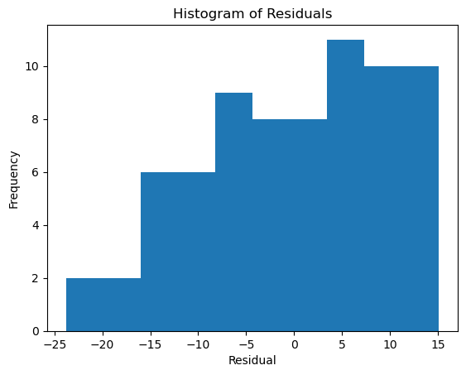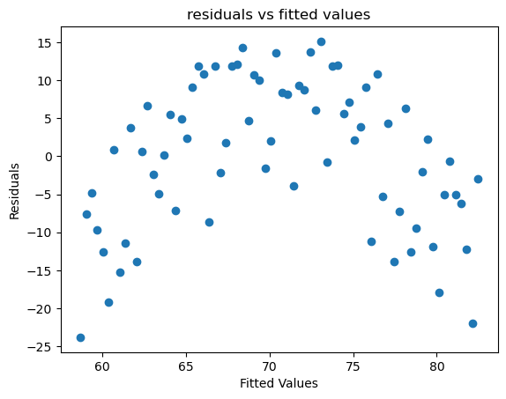
Based on the histogram, does the normality assumption seem reasonable? Explain
Based on the residual plot, does the homoscedasticity assumption seem reasonable? Explain your answer.
Based on these two plots, would you be cautious about using a linear regression model? Why or why not?

Skill 38.7 Exercise 1
In addition to hours and score, our data set from the previous exercise has a column called ate_breakfast (1 or 0).
Suppose the mean quiz scores are:

Students who did not eat breakfast: 66.8
Students who did eat breakfast: 74.1

What two points would the regression line pass through?
Write the regression equation.
What does the slope mean in context?
What does the intercept mean in context?

