Skill 9.1 Exercise 1
Refer to the image below to answer the following,
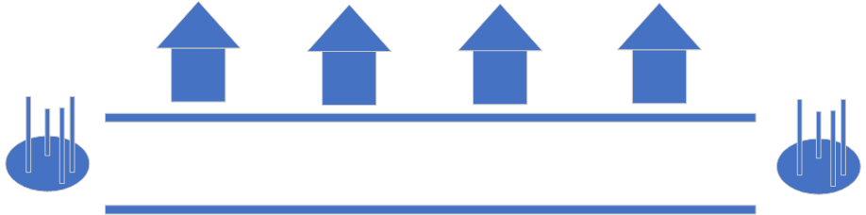




Indicate the address (index) of each house by writing it on the roof.
Who lives at index = 0?

Who lives at index = 2?

If the houses on the street represent a list, how long is the list?
Who lives at index = 4?

What is Marvin’s address?

What is Kyle’s address?

Skill 9.2 Exercise 1
Refer to the image below,
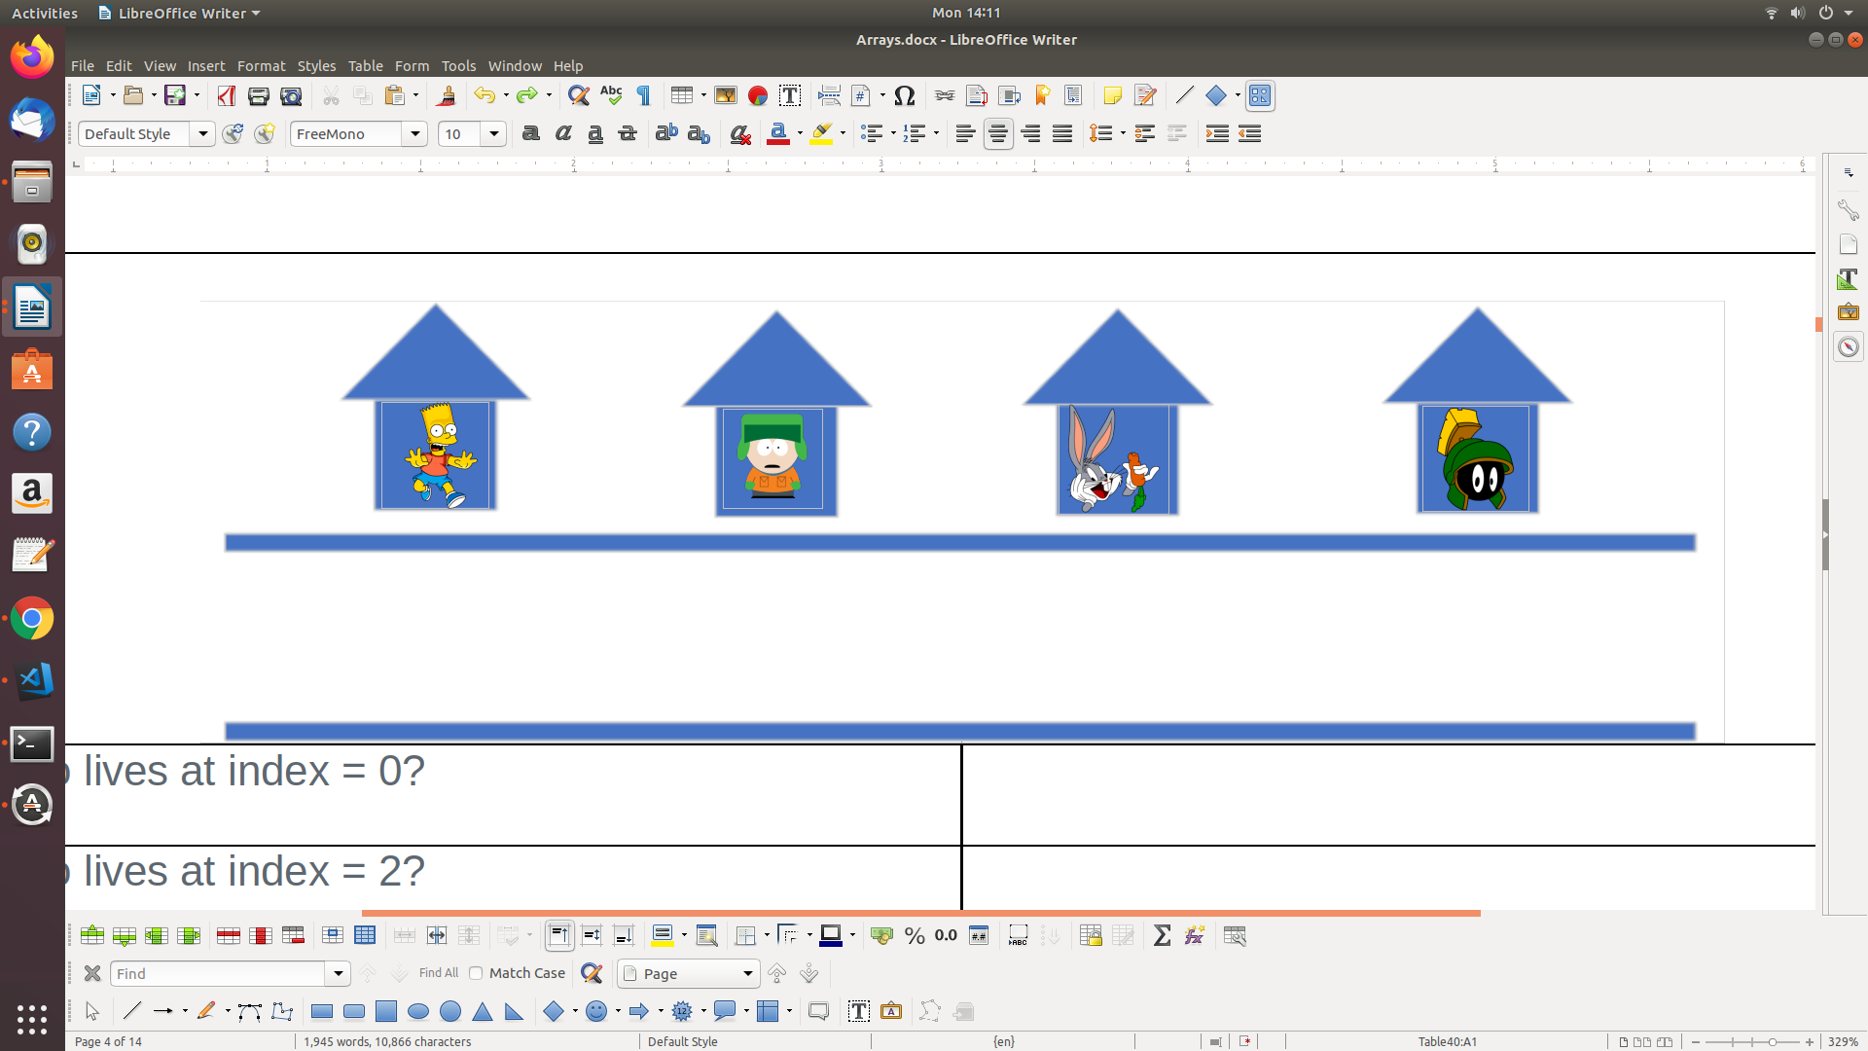
Write code that could be used to create a list called houses and populate the list with the people who live in the houses.

Skill 9.2 Exercise 2
Create a new list called bart_height_and_testscore that contains:
- The string "Bart" (to represent Bart’s name)
- The number 60 (to represent Bart’s height)
- The float 85.5 (to represent Bart’s score)
- The boolean True (to represent Bart passing the test)

Skill 9.2 Exercise 3
Create an empty list and call it orders. Don’t put anything in the list just yet.

Skill 9.3 Exercise 1
Jiho works for a gardening store called Petal Power. Jiho keeps a record of orders in a list called orders (declared above). Jiho just received two new orders for "tulips" and “roses”. Use append to add these to the orders list. Then print the results.

Skill 9.4 Exercise 1
Jiho is updating a list of orders. He just received orders for "lilac" and "iris".
Create a list called new_orders that contains the new orders.

orders = ["daisy", "buttercup", "snapdragon", "gardenia", "lily"]

Use + to create a new list called orders_combined that combines orders with new_orders.
The code below has an error, fix the error.
broken_prices = [5, 3, 4, 5, 4] + 4

Skill 9.5 Exercise 1
Refer to the employees list below,

employees = ["Michael", "Dwight", "Jim", "Pam", "Ryan", "Andy", "Robert"]

Use square brackets ([ and ]) to access the 4th employee from the list employees. Save it to the variable employee_four.

What is printed when the code below executes,

print(employees[8])

Skill 9.5 Exercise 2
Refer to the shopping_list list below,

shopping_list = ["eggs", "butter", "milk", "cucumbers", "juice", "cereal"]

Assign the last element in shopping_list to the variable last_element using a negative index.

Now select the element with index 5 and save it to the variable index5_element.
Print index5_element and last_element. What is printed?

Skill 9.6 Exercise 1
We have decided to start selling some of our garden produce. Word around our town has spread and people are interested in getting some of our delicious vegetables and fruit. We decided to create a waitlist to make sure we can sell to all of our new customers!

Define a list called garden_waitlist and set the value to contain our customers (in order): "Jiho", "Adam", "Sonny", and "Alisha".
"Adam" decided his fridge is too full at the moment and asked us to remove him from the waitlist and make space for one of our other townsfolk.

Replace "Adam" with our other interested customer "Calla".
Alisha realized she was already stocked with all the items we are selling. She asked us to replace her with her friend Alex who just ran out.

Replace Alisha with Alex using a negative index.

Skill 9.7 Exercise 1
We have decided to get into the grocery store business. Our manager Calla has decided to store all the inventory purchases in a list to help track what products need to be ordered.

Create a list called order_list with the following values (in this particular order):

"Celery", "Orange Juice", "Orange", "Flatbread"

We are in luck! We actually found a spare case of "Flatbread" in our back storage. We won’t need to order it anymore. Remove it from order_list using the remove() method.
Our store has grown to be a huge success! We decided to open a second store and require a new order list. Calla has done us the favor of putting one together.

Create a new list called new_store_order_list and assign it the following values (in order):

"Orange", "Apple", "Mango", "Broccoli", "Mango"

We are in luck again! We actually found a spare case of "Mango" in our back storage. We won’t be needing to place two orders anymore. Remove it from new_store_order_list using the remove() method.
What is printed when the code below executes,

new_store_order_list.remove("Onions")

Skill 9.8 Exercise 1
In the previous exercise, we got an error when we tried to remove “onions” from the new_store_order list below,

"Orange", "Apple", "Mango", "Broccoli", "Mango"

Use the in operator to check if onions is in the list. If it is found, then remove “onions”

Skill 9.9 Exercise 1
Consider the houses below, which can be represented as a list named houses.





Print the length of the list.
Kyle’s buddies, Stan and Kenny would like to move into the neighborhood. Add Stan and Kenny to the houses list.
Suppose you have no idea how many houses there are on the street. How might you access the person living in the last house? Do this two ways.

