Skill 11.1 Exercise 1
The image below represents a list of String type variables called houses. The value associated with each house corresponds to the name of the person who lives there.

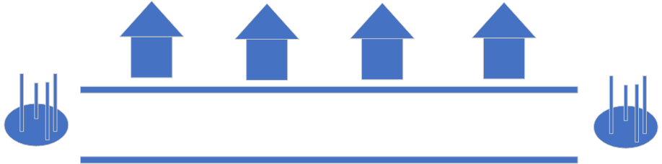
(a) Write code that could be used to declare and initialize the array, but does not populate it.

(b) Write the address of each house on the roof.
(c) Write code to add Wilma, Barney, Homer, and Marvin to the neighborhood.

(d) Fred builds a new house between Barney and Homer. Write code to add Fred to the neighborhood.

(e) Wilma decides to move. Write code to remove Wilma.

Skill 11.2 Exercise 1
Refer to the image below which represents a list called houses.
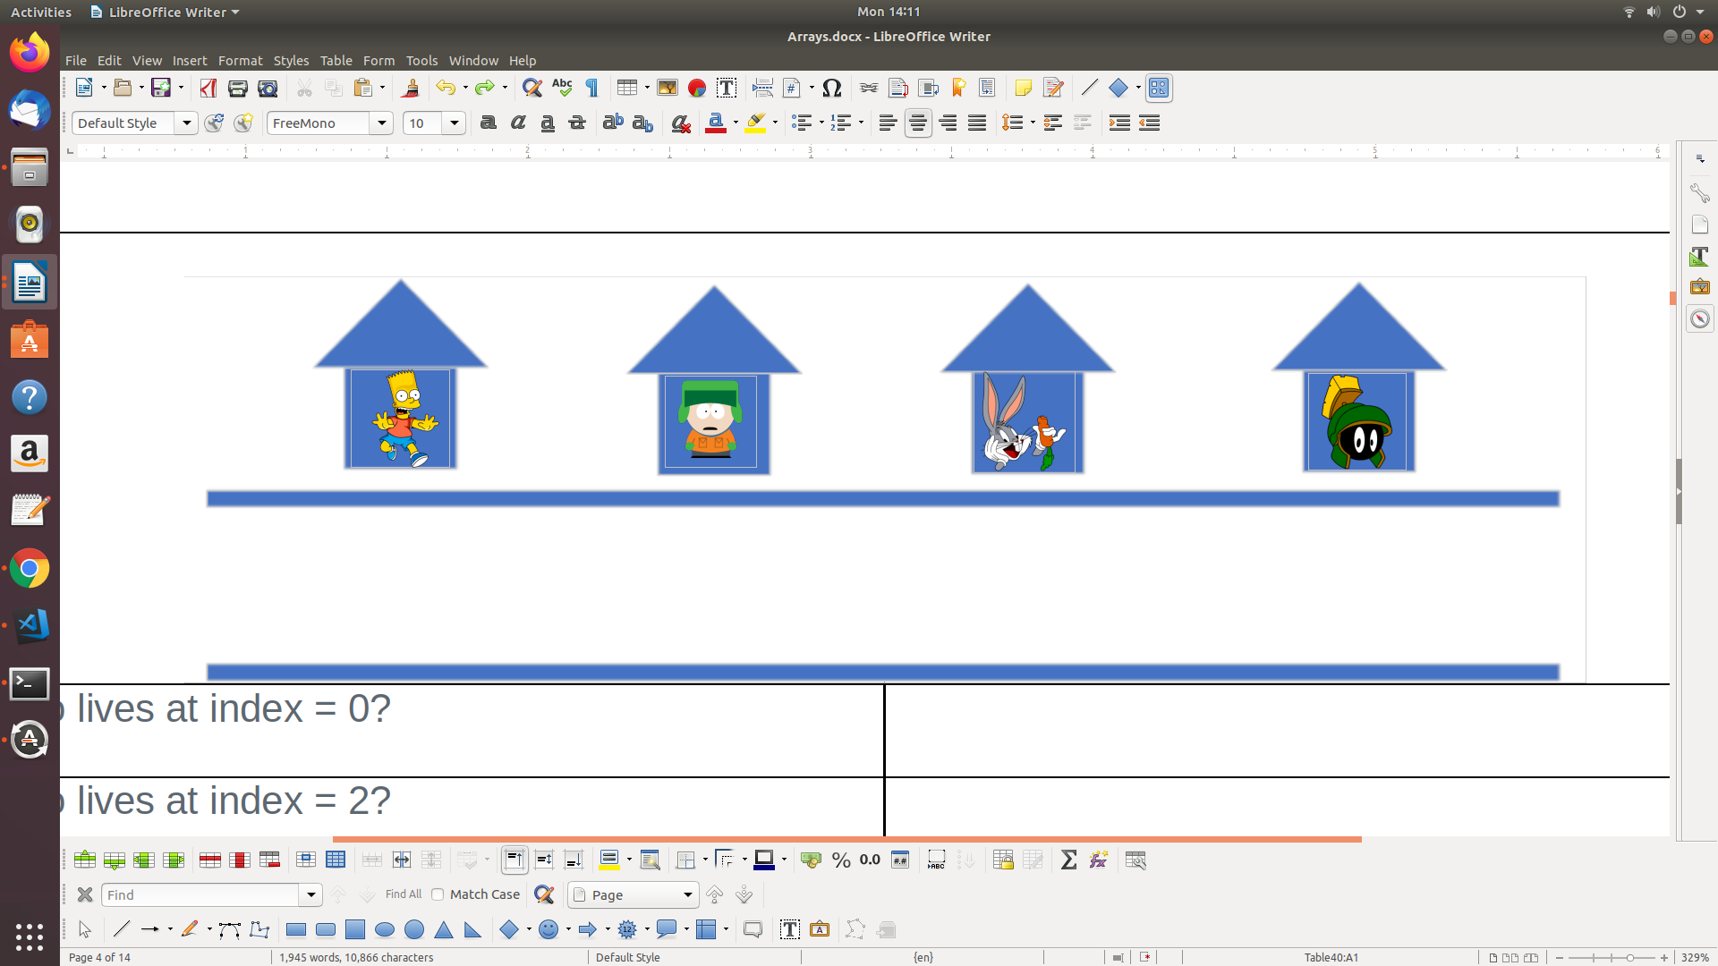

- Marvin moved out of the neighborhood. Remove him using the pop() function.

- Now Kyle has decided to move. Remove Kyle using the pop() function.
- Who is left in the neighborhood? Indicate the values in houses.
- What are the values in houses after the following code is executed?

houses.insert(0, houses.pop())

Skill 11.3 Exercise 1
(a) Create a list that contains all integers starting at 0 and up to 1000.
(b) Create a list that contains all the integers from -100 up to +100
(c) Create a list that contains all the odd numbers from 1 up to 1000
(d) Print the length of the range object created in part(c) (Note: Range objects do not need to be converted to lists in order to determine their length)

Skill 11.4 Exercise 1
Refer to the list below,
suitcase = ["shirt", "shirt", "pants", "pants", "pajamas", "books"]

- Select the first two items from the list and store these items in a new list called beginning.
- Create a new list called middle that contains the middle two items ( ["pants", "pants"] ) from suitcase.
- Create a new list called last_two_elements containing the final two elements of suitcase.
(d) Create a new list called slice_off_last_three containing all but the last three elements.

Skill 11.5 Exercise 1
Mrs. Wilson’s class is voting for class president. She has saved each student’s vote into the list votes.

votes = ["Jake", "Jake", "Laurie", "Laurie", "Laurie", "Jake", "Jake", "Jake", "Laurie", "Cassie", "Cassie", "Jake", "Jake", "Cassie", "Laurie", "Cassie", "Jake", "Jake", "Cassie", "Laurie"]

Use .count() to determine how many students voted for "Jake" and save the value to a variable called jake_votes.

Skill 11.6 Exercise 1
Refer to the image below which represents a list called houses.


- Write code that could be used to locate the address of Bugs.
- Now that we know where bugs lives, replace bugs with Homer

Skill 11.7 Exercise 1
Refer to the list below,
addresses = ["221 B Baker St.", "42 Wallaby Way", "12 Grimmauld Place", "742 Evergreen Terrace", "1600 Pennsylvania Ave", "10 Downing St."]

(a) Use sort() to sort addresses.
(b) Indicate what is printed. When the following code is executed. Explain.

sorted_addresses = addresses.sort(reverse = True)
print(sorted_cities)

Skill 11.7 Exercise 2
Refer to the code below,
games = ["Portal", "Minecraft", "Pacman", "Tetris", "The Sims", "Pokemon"]
games_sorted = sorted(games)
print(games)
print(games_sorted)
Indicate what is printed. Explain.

Skill 11.8 Exercise 1
In the game of hangman, a user is asked to guess letters that are contained in a secret word. The game begins by displaying the number of letters in the word as underscores. As the user guesses letters, the letters that are in the word are filled in. Below is an example,

Guess my word: ['_', '_', '_', '_', '_']
Guess a letter: E //user types the letter “E”
E is in the word
['E', '_', '_', '_', '_']

Complete the code below to create list of underscores required for the game.

secret_word = "EARTH"

