Dr H P Manyonga & Associates Inc.  Obstetricians and Gynaecologists  Practice Number: 0977357 | 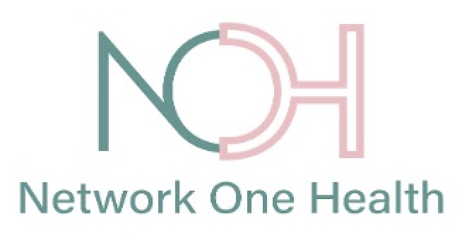

MEDICAL SERVICE AGREEMENT

Description:
By signing this form, you confirm that you have read, understood, and accepted the terms and conditions of the therapeutic contract entered into with Dr H P Manyonga & Associates Incorporated Practice (the Practice). The Practice offers maternity care for qualifying clients based on bundling individual costs into a single Global Fee determined by your Risk Category—Low or Intermediate. The fee covers out-of-hospital pregnancy care, natural birth (facility and professional fees), and routine postnatal visits. Admission to the Maternity Program is based on the Practice’s professional opinion that your pregnancy risk is Low and can be safely managed by the team. By signing, you accept the terms, conditions, and agree to pay the Global Fee outlined in this document.

Client Details
Reference Number:
Title and Name:
ID/Passport Number and Surname:
Date of Agreement:
Expected Date of Delivery (EDD):
Current Gestation (weeks):
Global Maternity Fee (R):
Settlement Time (months):
Monthly Installment

Agreement
- I (or my legal guardian, if under 18 years of age), hereby agree to follow the rules of the Maternity Programme, delivered by Dr H P Manyonga & Associates Inc. (the Practice) for a Global Fee based on my clinical needs. I understand that the Practice does not provide itemised or fee-for-service quotations.
- The Maternity Programme concludes six weeks after delivery.
- I agree to maintain payments as per the agreed payment plan aligned with my expected delivery date (EDD). Failure to comply will result in removal from the Programme.
- I will obtain medical aid coverage for my unborn child before 30 weeks of pregnancy based on my EDD. Failure to comply will result in removal from the Programme.
- I understand that the Paediatrician and hospital (in the event of NICU care) will claim from the medical aid for baby-related care.
- I accept liability for medical care not covered by the Global Fee (e.g. medication, wound care, blood transfusions, premature labour admissions, and out-of-plan visits).
- If I request an elective caesarean section without a medical reason, an additional fee of R27,600.00 will apply.
- If I am referred, removed, or leave the Maternity Programme, I acknowledge that I cannot deliver under the Practice’s conditions at the private hospital and will be liable for standard private hospital and provider fees.
- I indemnify the Practice against damages or injuries resulting from clinical conditions not identified before joining the Maternity Programme.
- I consent to the sharing of my medical information among team members involved in my care for coordination purposes.
- Should I act negligently or wilfully in a way that endangers myself or my baby, the Practice reserves the right to immediately remove me from the Programme without notice.

Cancellation of Services
- I may cancel participation at any time by submitting written notice to Network One Health at least 10 days before cancellation.
- A cancellation fee of R575.00 applies unless due to medical reasons (e.g., miscarriage or referral for complex pregnancy).
- If I cancel, I will be liable for services already rendered at normal rates, which will be deducted from any refund due.

Refunds
- The first assessment fee is non-refundable.
- If I exit before delivery, I will be refunded any excess paid per the Refund Schedule.
- No refunds apply after admission for labour.
- Refunds will be processed within 7–14 working days upon receipt of a valid cancellation request with certified ID and bank proof.

Terms and Conditions
- The Care Plan is personalised and may change with clinical needs, possibly affecting cost.
- Serious complications requiring hospital admission are not included in the Global Fee.
- Risk Category allocation rests solely with the Practice and may be revised if information is misrepresented.
- The first trimester genetic and anomaly scan (≤13 weeks 6 days) is not included and must be arranged separately.
- The 20–22 week anatomy scan may miss certain abnormalities; I indemnify the Practice against such outcomes.

Hospital Admissions
- If complications arise outside office hours, I will contact the Practice Midwife first during office hours, or the Hospital Maternity Unit after hours.
- Admissions for non-delivery reasons are billed at standard private hospital rates.
- Deliveries are covered only at the hospital where the Practice has a Services Agreement.
- If I deliver elsewhere, I accept full financial responsibility for associated costs.

Exclusions and Carve-outs
- The Global Fee excludes epidurals, private wards, and lodger accommodation.
- The Programme excludes newborn medical care — this must be arranged separately.
- High care or ICU admissions for mother or baby are not included and may result in transfer to a public facility.
- The Global fee exclude additional blood test (non-standard pathology and placenta histology)

Medical Aid for Baby
- I will ensure the baby is registered on a Medical Scheme by 28 weeks’ gestation.
- The baby must be registered within 5 days of birth for billing purposes.
- I will not cancel the medical aid for baby until all final billing is completed. If the medical aid is inactive I will pay the Paediatricians fee, Hospitalisation, pathology and x-rays done on my baby from my own pocket.

Complaints Process
- Complaints should be submitted to admin@networkonehealth.co.za.
- If unresolved, escalation may be made to the Practice Manager at marie@networkonehealth.co.za.

Acknowledgment and Confirmation
I confirm that I have read this Medical Service Agreement (or it has been read to me) in a language I understand. I understand my obligations, have had the opportunity to ask questions, and agree to the terms outlined herein.

Client Details:
Name:
Signature:

Date:
Signed At:

On behalf of Dr H P Manyonga & Associates:
Name:
Signature:
Date:
Signed At:

