Hemanta Pokharel

Dr. Lei Wang

GEOG 4057

April 17, 2025

Work with maps

**Manipulate the project in VS Code**

1. **Open the project and print some information**

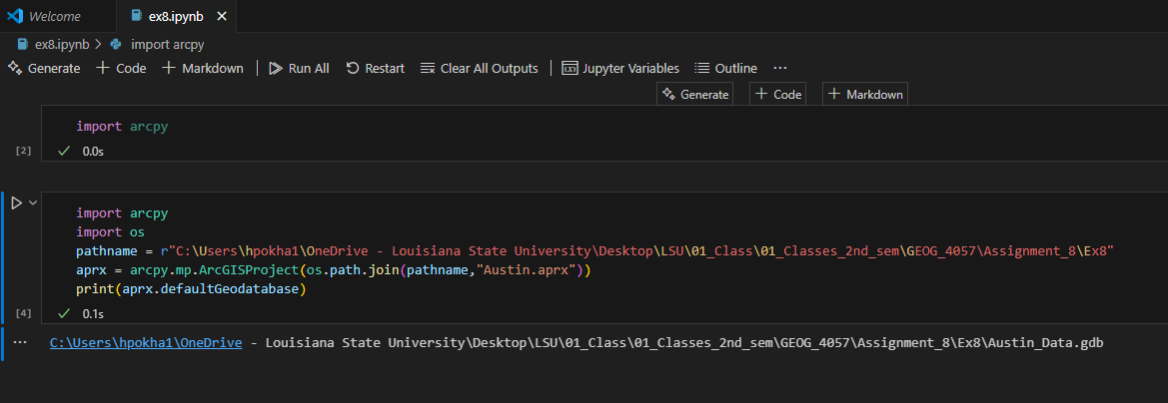

1. **Save a copy of the project (10 pnts)**

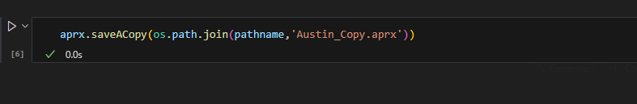

1. **Examine the new project file (10 pnts)**

Is everything the same as the original project? (Compare the difference in the file sizes) and why?

Ans: The original file is read only and the new file is editable. For the original read only file, ArcGIS Pro might have store extra internal metadata or safety buffers to protect the file from accidental edits.

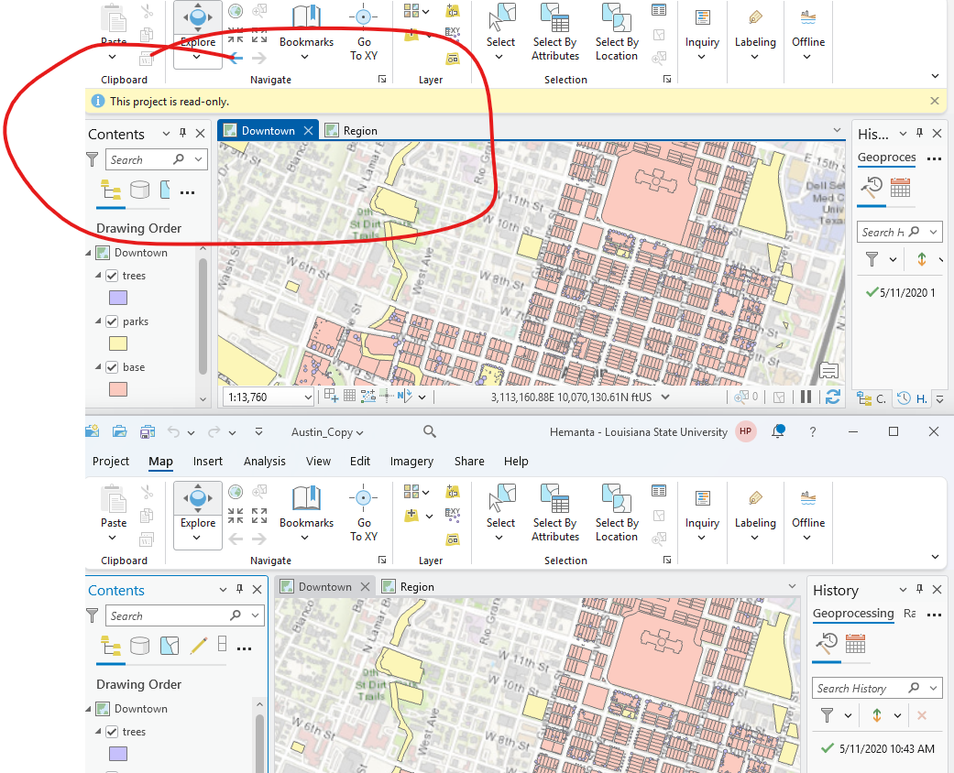

* Leave the ArcGIS Pro and the project opened because the following instructions will be based on this project
* Add the notebook you created for this exercise into the project - notebooks
* Open the added notebook

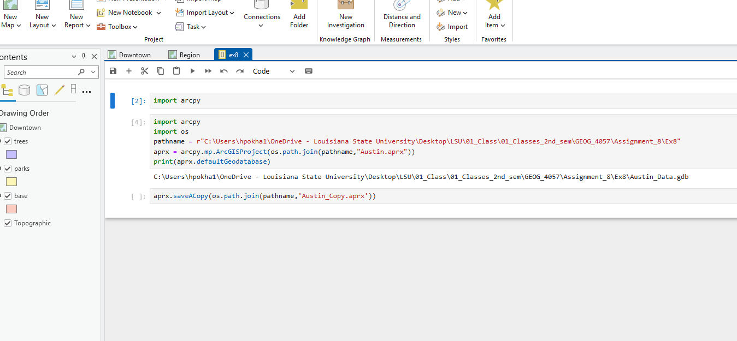

**Work with maps**

1. **print a list of maps in the project**

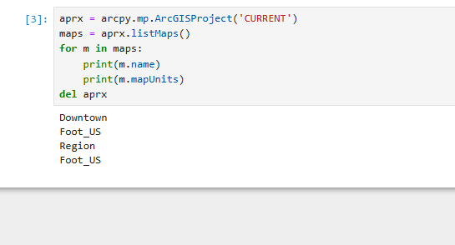

What does del do in the last line? Was the project file deleted?

Ans: Del line removes the objects and make the memory free after using the project and done with it. No, the project file wasn’t deleted.

1. **change the name of a map**

In the catalog pane the name of the map “region” is changed to “county”

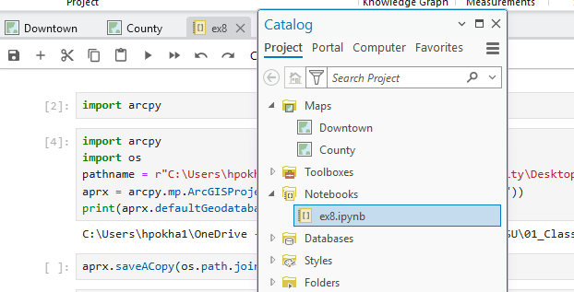

1. **list the layers in a map**

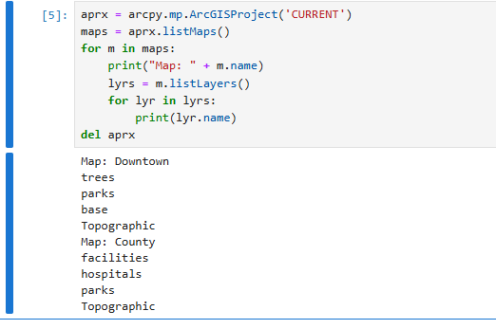

1. **Change the basemap**

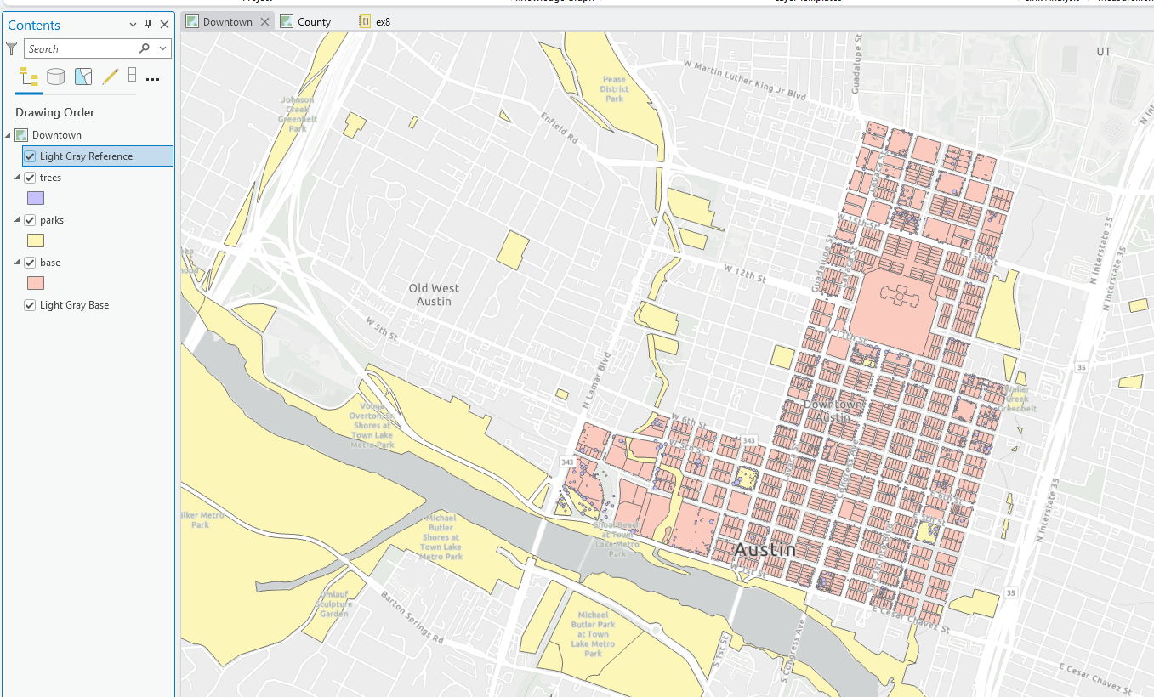

**Work with layers**

1. **change the symbology of layers**

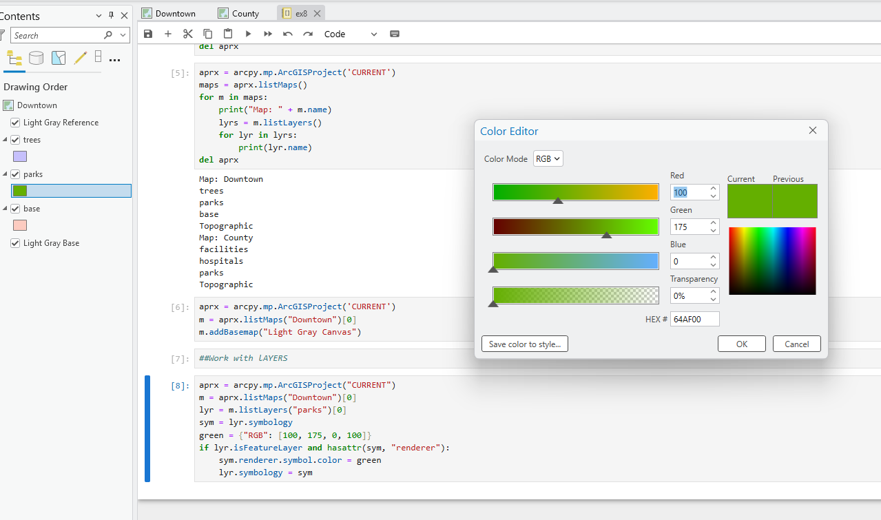

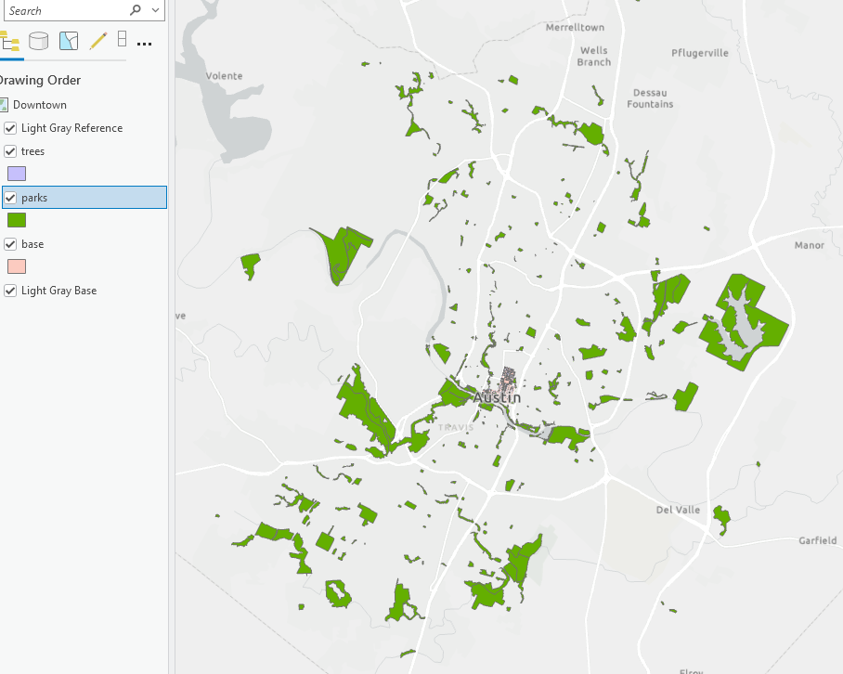

1. **What type is the 'green' variable? What do the numbers in the list mean? If you want to show a brown color, what numbers you would fill it with? Change it in the block and confirm the color is changed to brown.**

It is a dictonary and “RGB” is key. The numbers are value for RED, GREEN, BLUE, and TRANSPARENCY. In this case it is greenish coor with zero transparency (opaque).

It can be made brown with the code brown = {"RGB": [150, 75, 0, 100]}

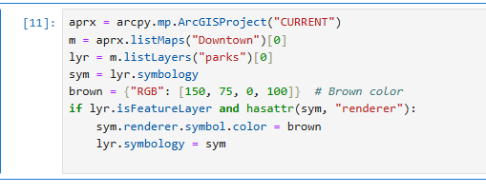

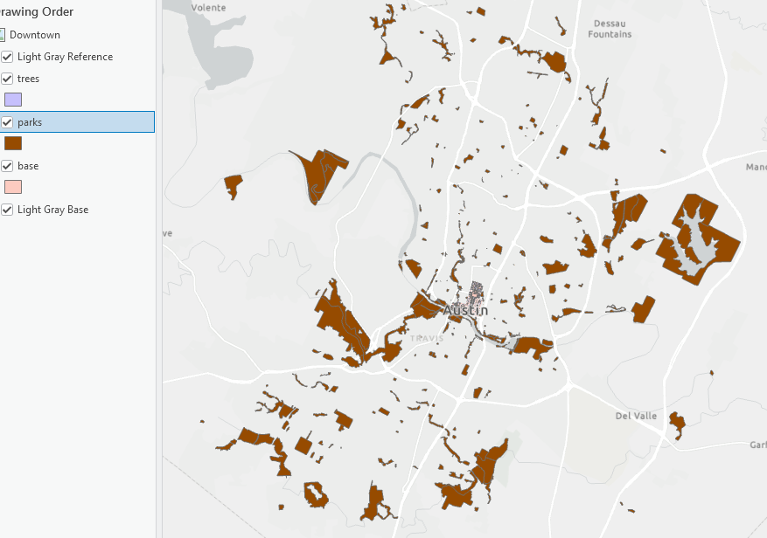

**Work with a layout**

1. **Add a layout to the project**

Create a layout and insert the map "Downtown" in the layout

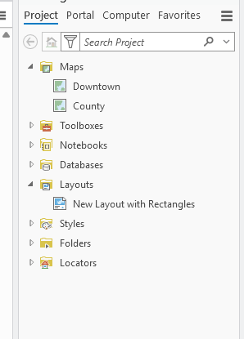

The size of the layout is 11 inches x 8.5 inches which is landscape US Letter size.

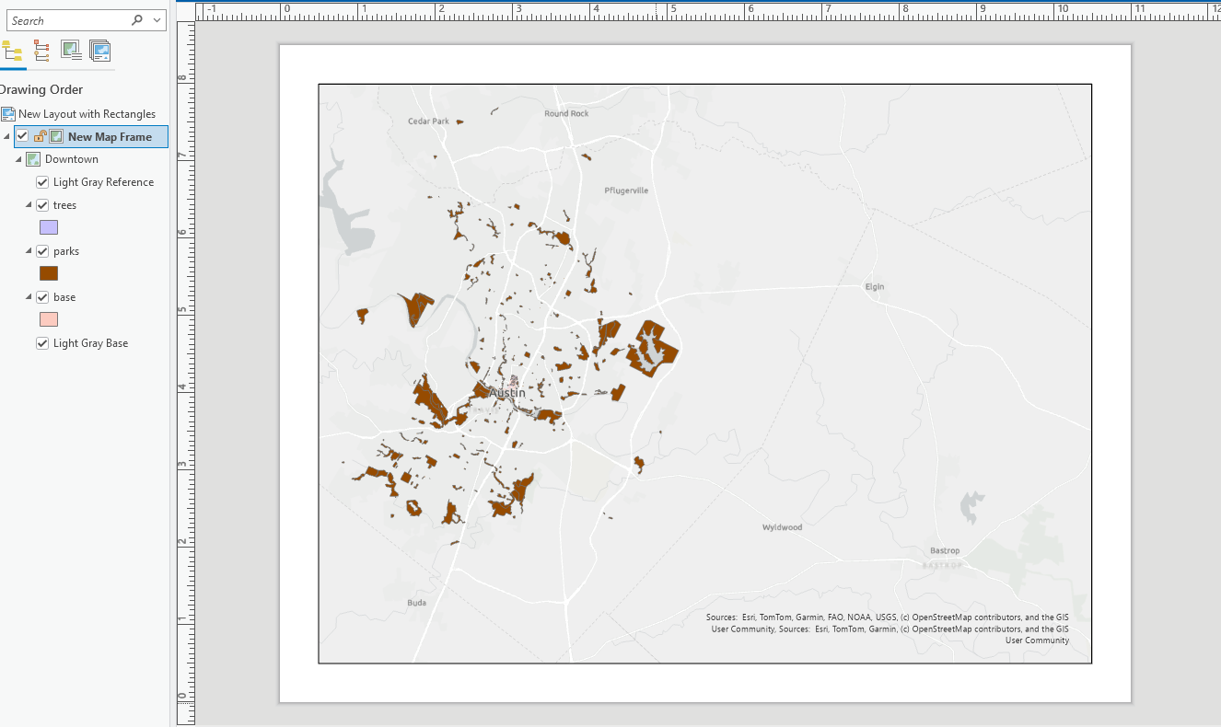

The size of the map frame is 10 inches x 7.5 inches. It start at the position lower left at (0.5,0.5) that means 0.5 inch margin all around.

The advantages of using cod eover the manual layout setup are:

* More precise control: color code can help have the exact color if we want.
* Automates repetitive tasks
* Saves time and reduces human error
* Great for bulk or dynamic map productionAdd layout elements

1. **Add layout elements**

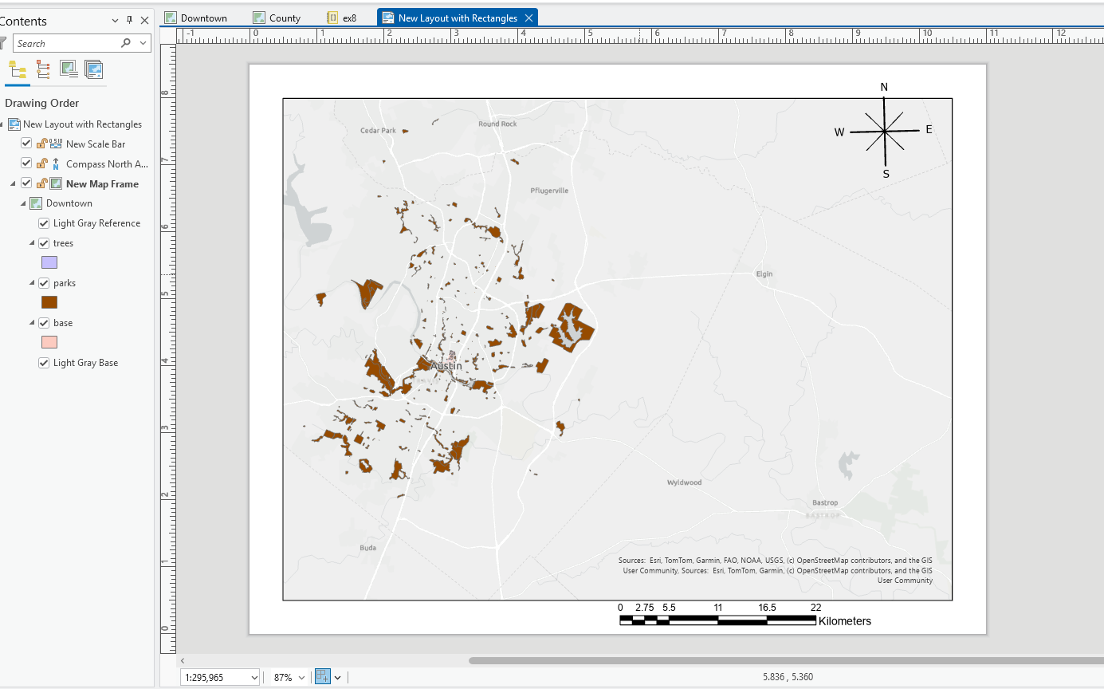

1. **Run the follow code to create a legend**

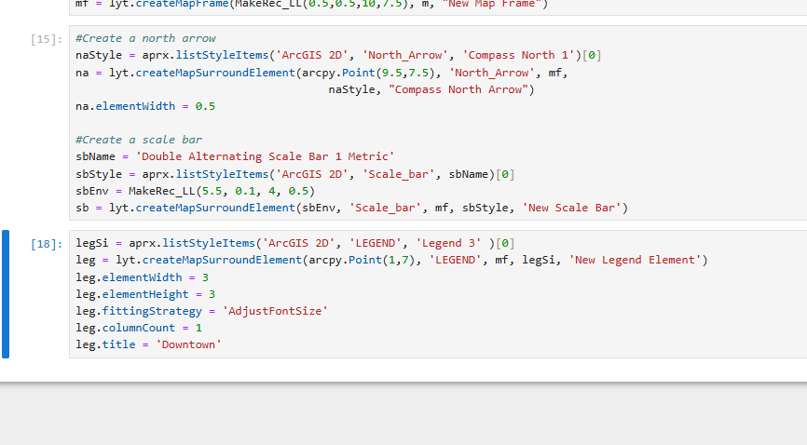

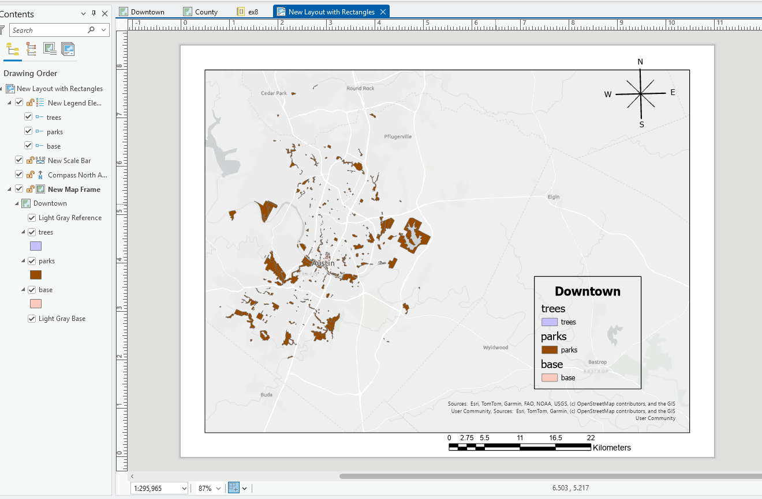

1. **Export the layout to a pdf**

