Holden Profit

CS500

Spring 2019

Instructor: Dr. Gary Herron

Project 2: Simple Diffuse BRDF Lighting

For the second project, a very simple version of the BRDF lighting model was used, giving the scene diffuse lighting. Combining that light from a given point on a surface to a random point on a random light (the explicit lighting) as well as the light received from other surfaces within a scene (the implicit lighting), one is able to give the scene a far more realistic lighting than Phong even without more advanced techniques employed. The images themselves become more clear and less filled with visual noise as the number of passes increase due to the use of more rays that have a better chance at making more accurate connections to various light sources.   
  
**Implicit Lighting Only**

Implicit lighting represents light bounced off the surface of other objects in the scene but not necessarily any from the light sources themselves. From a given intersection, through the use of Monte Carlo to help pick more relevant directions over others, a new ray is generated and fired with some offset from the surface normal. The newly struck object then contributes some of it’s own color to the accumulated color value.

**Implicit + Explicit Lighting**

Any given point on an object receives light from the objects around it, but that also includes light sources. To model the direct contribution of the scene’s light sources, an explicit ray is used. Given the existing intersection point and a random point on a random light, if there is no blocking geometry in the way, the light contributes it’s radiance to the source point. This results in a brighter and more accurately lit scene.

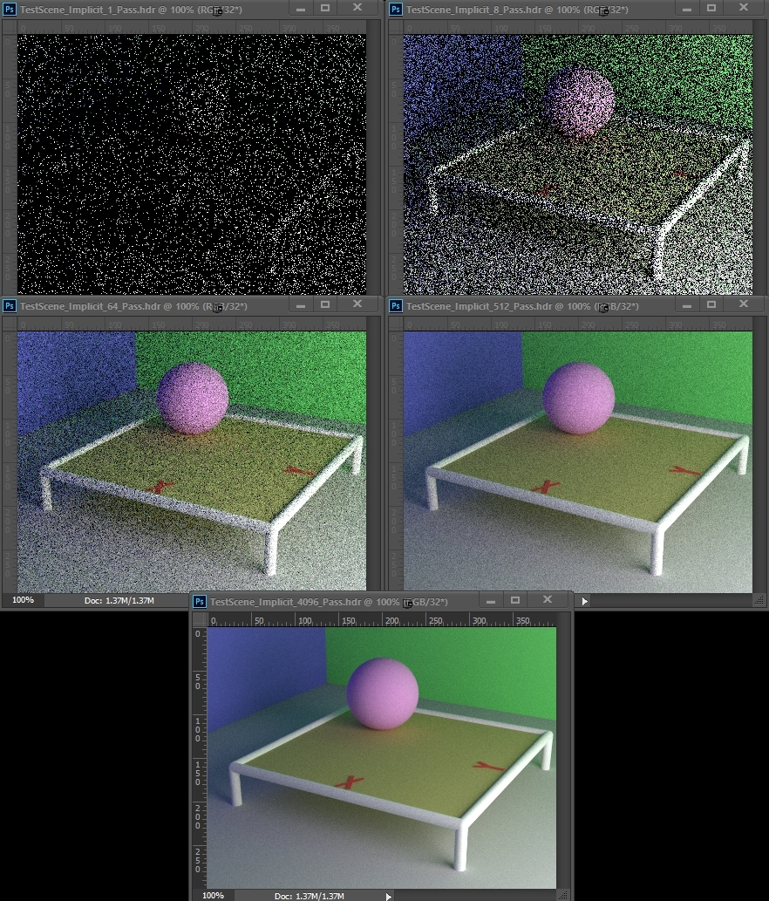

*Implicit Lighting Only*

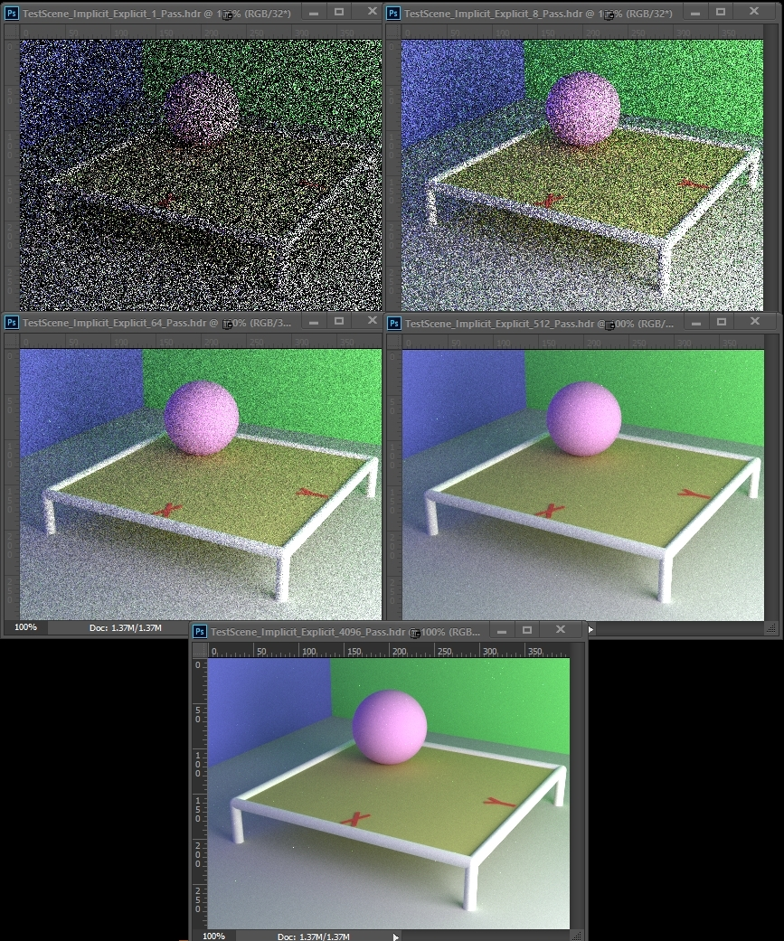

*Implicit + Explicit Lighting*

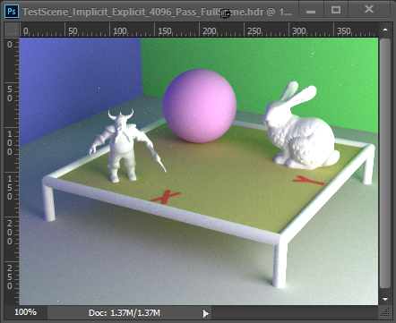

*Implicit + Explicit Lighting with Bunny and Dwarf Included*