Holden Profit

CS500

Spring 2019

Instructor: Dr. Gary Herron

Project 3: Micro-facet BRDF With Reflections

In the third project, the previous diffuse-only lighting equation is expanded to include the full micro facet BRDF for specular reflections. Using the Phong version of both the BRDF’s D and G terms as the test scene’s alpha values were best suited for such, the scene from the previous project was re-rendered minus the bunny and dwarf to save on render time. Rendering at 1 to 64 passes takes under a minute, 512 passes takes a few minutes, and 4096 passes takes roughly an hour.

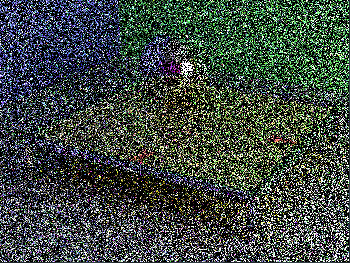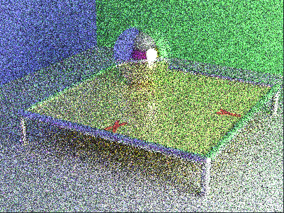

*Scene rendered at 1 pass and 8 passes*

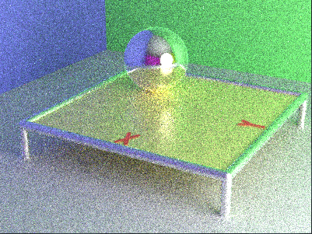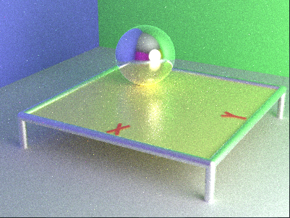

*Scene rendered at 64 passes and 512 passes*

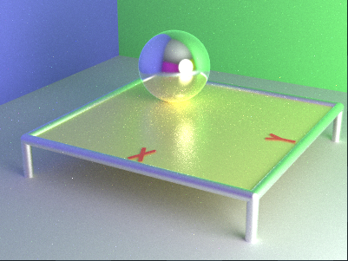

*The final version of the scene rendered with 4096 passes*