Holden Profit

CS500

Spring 2019

Instructor: Dr. Gary Herron

Project 4: Transmission and MIS

For project 4, translucent objects that refract light were introduced, adding a transmission color in addition to diffuse and reflection. Due to some unknown issue with my path tracer, or perhaps just RenderDoc, my images come out looking darker than the samples and definitely don’t converge very well, even at 4k passes and with multiple importance sampling. Without MIS, it takes roughly 40 minutes to do 4k passes, *with* MIS it took over 3 hours.

https://i.gyazo.com/214ddefca19a9a9148c71a896a96953d.png

Initially I was getting only black results for my transmission, which ended up coming from a negative F term. However, taking the absolute value of the L Dot H within the Fresnel function seems to have fixed that, but yields a darker transmission color than the samples.

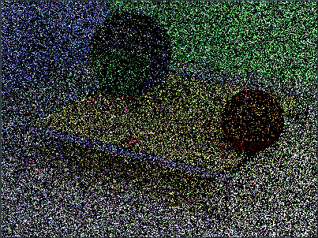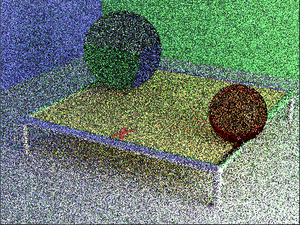

*1 and 8 passes with MIS*

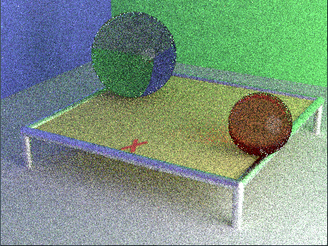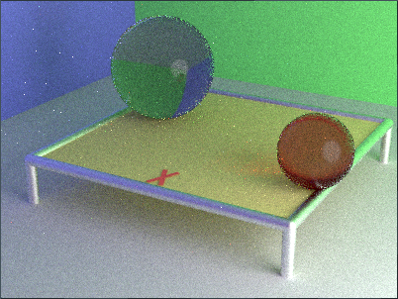

*64 and 512 passes with MIS*

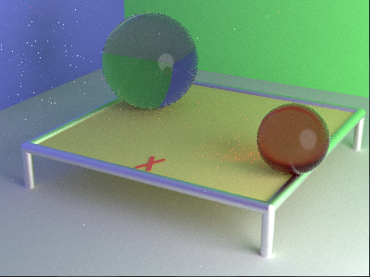

*4096 passes with MIS*