Project 2: Enhance Another Team’s Minesweeper

Software Architecture Document

Version 1.1

Revision History
Date | Version | Description | Author
06/OCT/2026 | 1.0 | Create initial document | Hannah Prosch
08/OCT/2026 | 1.1 | Added documentation for new feature functions | Hannah Prosch

Table of Contents
1. Introduction 4
1.1 Purpose 4
1.2 Scope 4
1.3 Definitions, Acronyms, and Abbreviations 4
1.4 References 4
1.5 Overview 4
2. Architectural Representation 4
3. Architectural Goals and Constraints 6
4. Use-Case View 6
4.1 Use-Case Realizations 8
5. Logical View 11
5.1 Overview 11
5.2 Architecturally Significant Design Packages 11
6. Interface Description 12
7. Quality 13

Software Architecture: New Features Document

Introduction
This document provides a look into how our team, Group 25, extended onto the original team’s Project 1: Minesweeper game. Here, diagrams and descriptions will be provided to help the reader understand the value they bring to the project, how they were designed, and how the player of the game will interact with them. In this opening section, the purpose and scope of the new features will be defined.

Purpose
The purpose of this document is to highlight the new features that were added to the original project. The intended audience for this document is for our team to build these additional features, and for any other teams in the future who may build upon this program or perform maintenance on it.

Scope
This document applies mainly to the architecture of the new features that were added. The previous team was missing some documentation that cannot be replicated (for example, their reasoning for structuring the Minesweeper game the way that they did), so detailed insights for the major architectural components of the overall program will not be discussed here.

Definitions, Acronyms, and Abbreviations
“Flipped” and “uncovered” may both be used to mean that a tile has not yet revealed what is underneath it (could be blank, a number, or a mine).
“Bomb” and “mine” may also be used interchangeably for a tile containing logic to end the game when uncovered.
“Tile” is used to describe the individual square on the 10x10 game board (of which there are 100 tiles).

References
Diagram.png (provided by the previous team, can be found in the GitHub Repository)

Overview
The following sections will discuss how the newly added features fit onto the existing Project 1: Minesweeper code, along with details on how these new features work. To aid in the reader’s understanding, diagrams have been provided. The focus will be on the Use-Case View, which can be found in section 4 below.

Architectural Representation
The documentation provided by the previous team illustrated how each of the major JavaScript functions worked along with the HTML file to bring the game play to life.
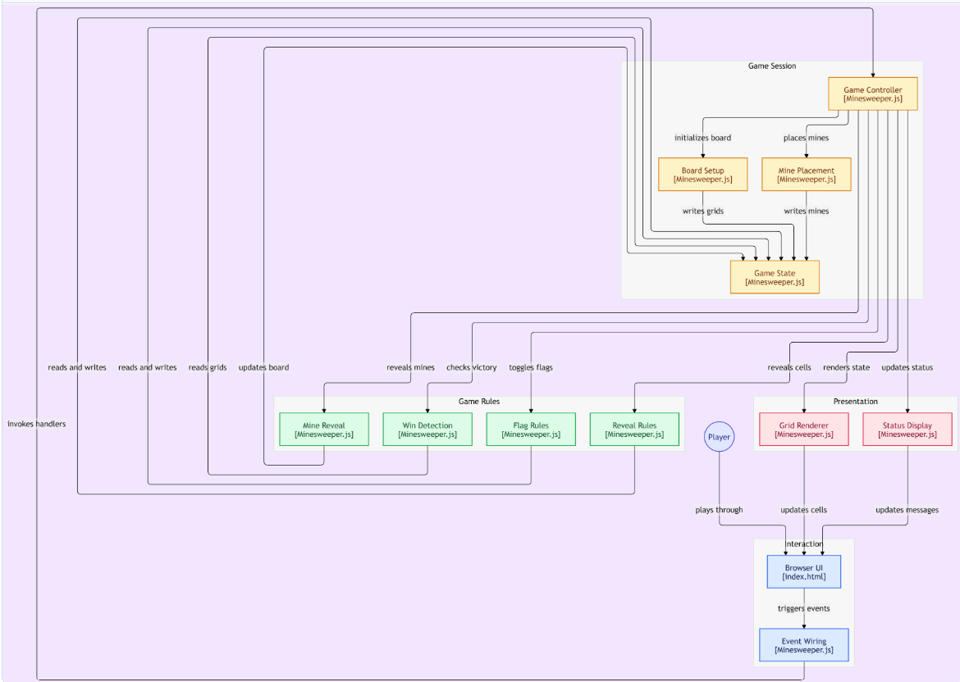
Fig. 1: Provided diagram from the first team.
The code provided by the previous team was written using HTML (with embedded CSS), and JavaScript. Together, these tools work to provide a smooth data flow between the user and the game play logic.
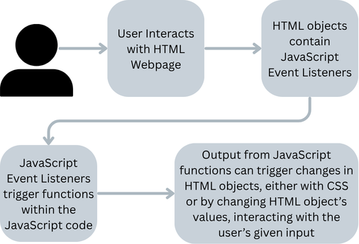
Fig. 2: High-level overview of the program’s data flow.
For the new features our team implemented, we utilized the same main structure, and added the additional features into the JavaScript and HTML files to extend them.

Architectural Goals and Constraints
Constraints for this project were working within the constraints of the code given to us. Although we do not know what the goals and constraints explicitly were from the previous team, the methods they used did promote portability. Because the game can run on only a web browser, it could potentially be publicly hosted so users could access and play the game from a computer over the internet, without the need to download any additional software.
Since the project was written with JavaScript and HTML with embedded CSS, a constraint our team put in place was to continue our additional features within those same programming formats.

Use-Case View
To play the Minesweeper game, the player will visit the HTML webpage. A menu of options is displayed, and the user can make the selections they prefer. The following settings can be adjusted:
Mines | The number of mines can be adjusted by dragging the slider, from 10 to 20 (inclusive)
Difficulty | The level of AI difficulty can be adjusted by dragging the slider, from Easy to Medium to Hard  - Easy: AI randomly uncovers a cell, avoiding cells that are already flipped or have a flag placed on them.  - Medium: AI will flag all hidden neighbors of a tile, if the number of hidden neighbors equals the number displayed on the tile it flipped. If the number of flagged neighbors on the revealed tile is equal to the tiles number, AI will uncover all of the hidden neighbors. If neither of these are applicable, AI will fall back to the Easy mode.  - Hard: AI applies rules from Medium level, while implementing a 1-2-1 Pattern Rule. If three side-by-side tiles (either vertically or horizontally) fit this pattern, AI deduces the two outer hidden neighbors are mines and the inner hidden tile can safely be flipped. If this doesn’t apply, AI will fall back to the Easy mode.
User Player | This button allows the user to play a regular Minesweeper game solo (default option)
Tag-Team | The user and AI take turns playing the game
AI Player | AI player solves the board instantaneously, without input from the user
The player can either keep the settings default to play a regular Minesweeper game or make their appropriate selections. A comprehensive flow chard is provided blow, showing how these options work within the structure of the game.
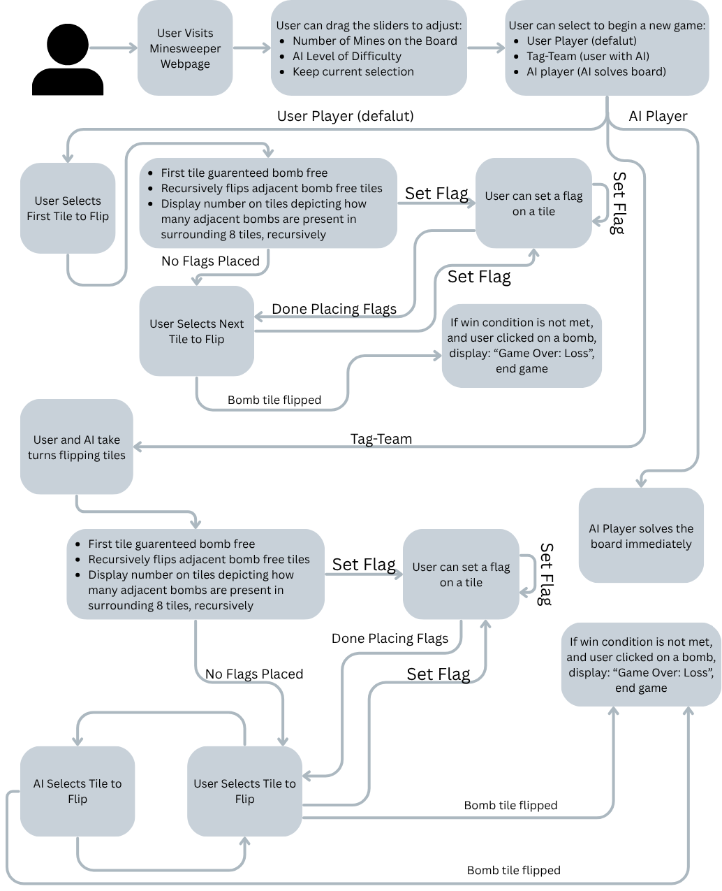
Fig. 3: Flow of the Game, with the added AI Features.
To start the game, the player may proceed by selecting the first tile they want to flip by left-clicking in it—the first tile is guaranteed to be bomb-free. The program recursively uncovers all the adjacent bomb-free tiles, displaying the number of bombs residing in the 8 immediately bordering tiles. At any time, the user can place a flag on a tile where they suspect there is a bomb by right-clicking on it. Depending on the mode the player selected, AI may take turns with the player or solve the board outright.
In the following Use-Case Realizations, we will outline the additional new features that were developed for the game.

Use-Case Realizations
New Feature 1
Name | Stopwatch
Actors | User/Player of the Minesweeper Game
Trigger | Upon starting a Minesweeper Game
Preconditions | Must have started a Minesweeper Game
Post Conditions | The game must have ended, either by the player winning or losing
Success Scenario | Stopwatch begins increasing upon the start of the game, continues to update the time live to the player, and ends the stopwatch once the game has reached completion
Alternative Flows | - The player could choose to open the Minesweeper page, but never start a game, causing the Stopwatch to never start  - The player could start a game, but close the webpage before winning or losing the game, ending the entire game without ending the Stopwatch

The first new feature we added was the Stopwatch, which allows a user to track their time spent playing each round of the game. Here is the Use Case Statement:
As a player, I want to track my time, so that I can know how quickly I solved this round of the game.
The time spent playing each round will be displayed to the user, counting upwards from 0. It will not be tracked or stored—instead, it will simply reset when the player begins a new game. The flow of this use case follows:
- Player visits the Minesweeper page
  - Player selects the number of mines to place on the board, and the level of difficulty
- Upon the game start, the Stopwatch feature will track and display the time for the user to see, as they are playing the game, counting up from 0.
- Once the game has ended, the stopwatch stops incrementing and is frozen with the final time.
Below, a UML Diagram was created, to help illustrate how the user can interact with this new Stopwatch feature.
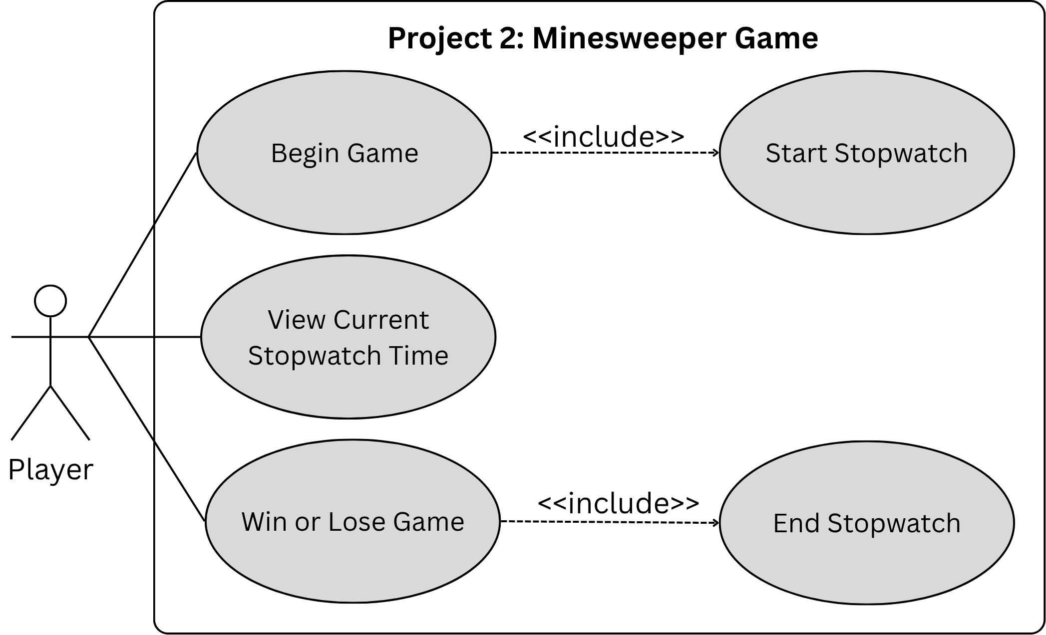
Fig. 4: UML diagram for the Use Case of the Stopwatch feature.
This Stopwatch feature will be triggered automatically when the player begins a new game. Throughout the game, the player can view the current time displayed on the stopwatch. Once the end of the game has been triggered by either a win or a loss, the stopwatch will stop incrementing.

New Feature 2
Name | Safe Reveal
Actors | User/Player of the Minesweeper Game
Trigger | Player chooses to use the Safe Reveal Feature (one time per game)
Preconditions | - Must have started a Minesweeper Game  - Not yet used the Safe Reveal in this game  - Player selects tile
Post Conditions | - Safe Reveal cannot be used again in this game  - The selected tile for the Safe Reveal is the center of the 3x3 grid  - For each tile in the corresponding 3x3 grid:  - Flag tile, if mine underneath  - Uncover tile, if no mine underneath  - Depending on the current state of the gameboard, there are 2 potential outcomes  - Player still has uncovered tiles without mines underneath, game play continues  - Player wins the game
Success Scenario | The Safe Reveal feature helps the player uncover a difficult section of the board and speed up game play
Alternative Flows | Player can decide not to enable the Safe Reveal feature

The second new feature we added was the Safe Reveal, which is a special action a user can take once per game to complete a difficult section of the board. Here is the use case statement:
As a player, I want to safely reveal a 3x3 grid so that I can powerup and complete a difficult section of the board quickly.
The Safe Reveal feature allows the user to select an uncovered tile of their choice to safely reveal that tile, along with the 8 tiles immediately surrounding it (in a 3x3 grid formation). To do this, the player clicks on the “Use 3x3 Reveal” button, then left clicks on the tile they want to select.
If any of the tiles contain a mine, they will be left covered, and a flag will be placed on them. If any of the tiles do not contain a mine, they will be uncovered. If the user selects a tile that is on the edge or corner of the gameboard, only the tile and the immediately surrounding tiles will be safely revealed—in this case, less than 9 tiles total will be safely revealed. The flow of this use case follows:
- Player visits the Minesweeper page
  - Player selects the number of mines to place on the board, and the level of difficulty
- At any point during the game, the user can choose to use the Safe Reveal feature only once. After selecting the “Use 3x3 Reveal” button and selecting the tile to apply the 3x3 grid Safe Reval, the game will proceed with the feature.
  - Any tiles within the Reveal grid containing a mine will remain covered, with a flag placed on them.
  - Any tiles within the Reveal grid without a mine will be uncovered.
- Depending on what point the user is in the game, there are two outcomes:
  - If there are still tiles without hidden mines to be uncovered, gameplay will continue.
  - If after the Reveal feature is run, and there are no mine-free tiles left to uncover, the player wins the game.
Next, a UML Diagram was created, to help demonstrate the three main actions the player can take, including how the Safe Reveal feature references the existing code to flip and flag tiles.
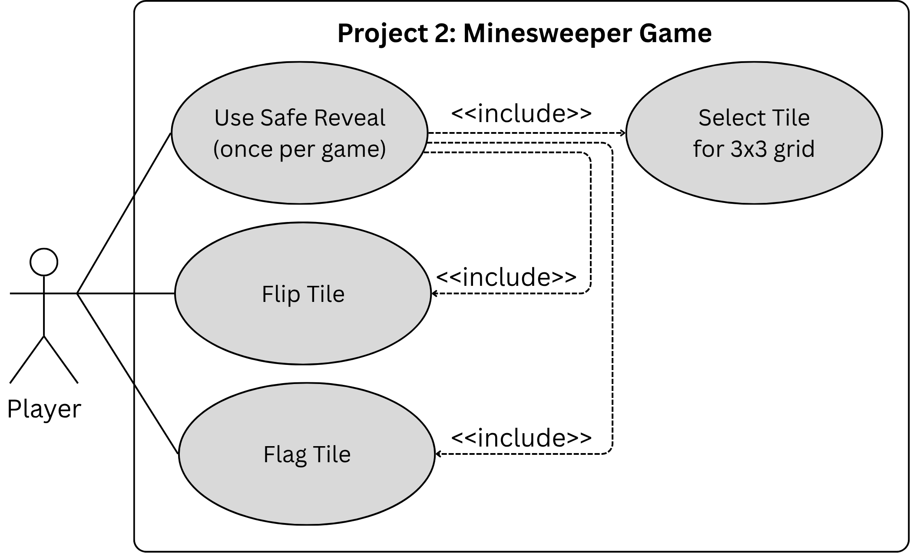
Fig. 5: UML diagram for the Use Case of the Safe Reveal feature.
This optional feature can decrease the amount of time needed for the player to complete the game, as well as helping them work through a difficult portion of the board.

Logical View
The functions within JavaScript are the main logic for this Minesweeper Project. In this section, we’ll briefly outline a few of the major functions, and what they accomplish to provide the game logic.

Overview
This project has a single JavaScript file, broken down into different functions.

Architecturally Significant Design Modules or Packages
Name | Responsibility
initializeBoard | Populate the gameboard helper, called by newGame
initializeMineGrid | Populate the gameboard helper, called by newGame
initializeFlagGrid | Populate the gameboard helper, called by newGame
placeMines | Randomly places the number of selected mines on the gameboard
revealTile | Helper used to flip a tile, also makes sure first tile selected does not contain a mine
checkWin | Checks whether each non-mine cell has been revealed
flagCell | Allows the user place flags
updateFlagCount | Updates the number of flags that have been placed
updateStopwatch | Tracks game duration
stopStopwatch | Ends the stopwatch
activateRevealAbility | Helper function to revealAbility, changes text on button to indicate usage
revealAbilityTile | Helper function to revealAbility
revealAbility | Used to run the Safe Reveal of the 3x3 grid, also calls checkWin
buildGrid | Aids in populating the gameboard
render | Updates the display based on the current state of the board and flagGrid
revealAllMines | Reveal all the hidden mines on the gameboard
handleReveal | Calls revealTile to check game if a mine was uncovered, calls revealAllMines if game is over, and checks the current game status
handleDoubleReveal | Reveals surrounding tiles when a numbered tile is double-clicked
handleFlag | Updates the flagGrid to track the flags placed, and the number of flags.
newGame | Starts a new game (default User Player)
hard | Implements the AI Hard Mode
medium | Implements the AI Medium Mode
easy | Implements the AI Easy Mode
aiPlayer | Implements the AI Gameplay mode, where AI solves the gameboard instantly
tagTeam | Implements the Tag-Team mode, where the user and AI take turns
updateDifficulty | Updates the text on the difficulty slider in index.html
userPlayer | Game mode for single user player (default)

Interface Description
The user interface for this project is through the HTML web page that the player accesses through the browser. The user interacts with the back end game logic through the following inputs.
The number of mines selected as input will output a 2-D gameboard with the specified number of mines placed randomly.
The input of the mode selected (default is User Player) determines how the game will be played. User Player allows the user to play the Minesweeper game with a single player. The Tag-Team mode will alternate turns with the user and the computer (AI), and the AI Player will solve the game by itself.
The input of AI difficulty will adjust how smart the AI player will be when the Tag-Team mode is selected (for details on these, see section 4).
The input of selecting the first tile will trigger the Stopwatch to begin counting up, and the input of a final tile flip that indicates the end of the game will cause the Stopwatch to end.
The input of selecting the Safe Reveal (3x3 Grid Reveal) prompts the user to select the input of the tile they want to apply this special feature to, to help get through difficult portions of the board.
Apart from the above, the remaining inputs from a standard Minesweeper game still apply. The input of selecting a tile to uncover can produce any of the following outputs, depending on which tile was selected and the current status of the board:
- If the tile has a mine hidden beneath it, the game ends, with a loss message displayed.
- If the tile does not have a mine under it, there are three outcomes:
  - If the tile does not have any adjacent tiles that are uncovered and bomb free, only the selected tile will be uncovered. A number will be displayed on the flipped tile, indicating the number of mines residing in the 8 tiles immediately surrounding it.
  - If the tile has adjacent tiles to it that are uncovered and do not have mines under them, they will be uncovered (recursively). A number will be displayed on each tile, indicating the number of mines residing in the 8 tiles immediately surrounding it.
  - If the tile selected to flip is the last of the remaining mine-free tiles to be uncovered, the user wins the game, with a win message displayed.

Quality
Measures were taken to provide additional documentation, including within the code by members of our team, within the Weekly Meeting Logs, and this Software Architecture: New Features document.
If this project were to be publicly hosted on the internet, it would be easy to use and portable.
Following the previous team’s work, this program should be straightforward to extend and maintain in the future, due to the separate files for user interface (HTML) and the backend (JavaScript).

