Project 3: Wordle

Software Architecture Document

Version 1.0

Revision History
Date | Version | Description | Author
23/OCT/26 | 1.0 | Creating initial document | Hannah Prosch

Table of Contents
1. Team Members 4
2. Project Synopsis 4
4. Architecture Description 4

Software Architecture Document

Team Members

Group 25 is comprised of the following team eight members:

- Christopher Brush
- Forest Denton
- Johney Makeen
- Wyatt Payne
- Ruben Pino-Martinez
- Hannah Prosch
- Ian (Eden) Rubelmann
- Daniel Van Dalsem

Project Synopsis

We are building a Wordle puzzle game that captures the existing functionality of the traditional game and adding some additional features that we invented.

Architecture Description

The dataflow of our Project 3: Wordle architecture will begin with a player interacting with a web browser. For this project, our team decided to select the Flask Framework, that in turn accesses a dictionary containing valid words that can be used within the Wordle game. A simple diagram of this dataflow follows.

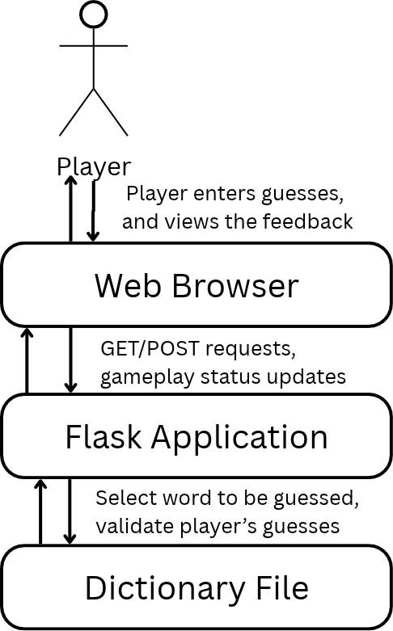
Fig. 1: High Level Data Flow Diagram
Our dataflow is as follows: once a player has started a game of Wordle, they will enter their first guess for the word using the keyboard. Using HTTP requests, the web browser can communicate the player’s guess to the Flask Application. The Flask Application in turn references the Dictionary File to determine whether the user made a valid guess, then communicates this with feedback to the player through changes made to the web browser with HTTP requests.

As demonstrated through the dataflow exploration above, the user will play the game through the web browser. Considering the individual components further, HTML specifically will provide the structure of the web page, CSS will be used to style it, and JavaScript will be used alongside HTML GET and POST requests to communicate with our backend components to interact with the game logic written in Python. The following diagram takes a closer look into how these various components will work together to bring the Wordle game to life.

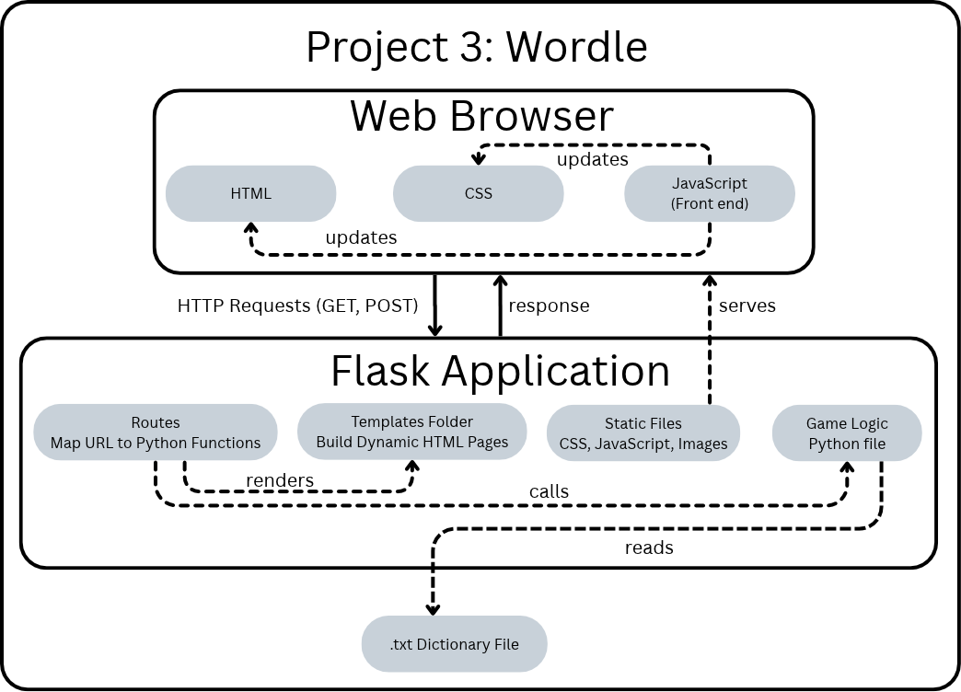
Fig. 2: Component Diagram of our Flask application.

Getting into further detail on the components, Routes allow us to map the URL to the functions in Python that need to be run in order to provide vital game logic. These routes also render our dynamic HTML pages, so that the appropriate changes can be displayed in the web browser to the player, based on their guesses and the current gameplay status. We believe that using Python as the backend game logic will allow us to have greater flexibility when working with the string comparisons needed for the Wordle game, as it is a versatile and powerful programming language.

From a use case view, the player has three main actions that they can take: to start a game, guess a word, and view the currently displayed game status. The relationships required in the backend are shown in the below diagram, along with the relationships between them.
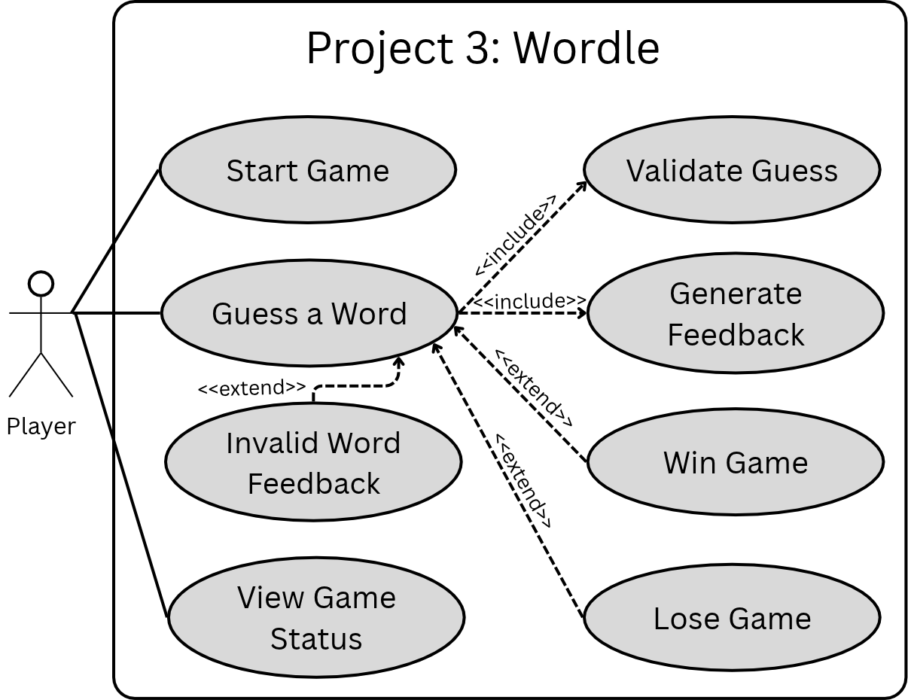
Fig. 3: Use Case UML Diagram.
As demonstrated above, this general use case diagram highlights the critical functionalities of the Wordle game, including the actions the player can take, and the functionality that the backend provides to make playing the game possible. The function to process a word guess from a user will communicate with other functions to validate the user’s guess and generate feedback for it. If the user enters a word that they have already guessed, a word that is not valid (not present in the dictionary file), or a word that does not match the target word, they will receive the appropriate feedback. If at any point the player wins the game by guessing the target word before running out of guesses, they will be notified of the win status. Likewise, if the player runs out of guesses, they will be notified that they lost the game, and the target word will be revealed.

