理解数据与机器学习准备
  - Packet A to D Evidence Pack
本材料用于课程学习与方法训练，不构成临床、患者照护、因果推断或部署建议。

问题 | 你要解决的问题 | 目标 | 对总答案的作用
Q1 | 对象、变量角色与测量尺度是什么？ | LO1 LO3 | 限定语义允许的处理
Q2 | 数据表示如何影响分析？ | LO2 | 确定结构与分析单位
Q3 | 维度、稀疏性与规模有何限制？ | LO2 LO8 | 决定表示或降维
Q4 | 如何审查数据质量与来源差异？ | LO4 LO6 | 形成修复或停止条件
Q5 | 不同距离和相似度保留什么含义？ | LO7 | 定义有意义的相似
Q6 | 如何定义混合数据的相似性？ | LO7 | 避免任意统一距离
Q7 | 抽样与聚合改变了什么？ | LO6 LO8 | 说明代表性与损失
Q8 | 如何变换数据并防止泄漏？ | LO5 LO8 | 规定拟合数据与时点
Q9 | 何时降维，如何检查信息损失？ | LO2 LO8 | 权衡信息与可解释性
Q10 | 如何形成可审计的数据准备流程？ | LO3 LO5 LO6 | 回答总问题与边界

一、问题和初始事实
总问题：一个研究团队获得多源生物医学数据后，应如何理解数据对象和变量、选择数据表示、审查数据质量、定义相似性，并完成抽样、变换和降维，使数据能够合理用于机器学习？哪些发现会要求修改或停止这一流程？
数据 | 作用 | 观察单位 | 规模 | 目标与缺失
Heart Disease | 主数据 | 历史患者记录 | 920 × 16 | num 0–4；缺失单元 1759
WDBC | 辅助数据 | FNA图像样本 | 569 × 30 | 恶性212 良性357；无缺失

尚缺证据清单
□ 每一行和每一列真正代表什么
□ 变量类型和测量尺度是否支持计划中的分析
□ 缺失 异常 站点和测量问题是否改变结论
□ 相似性的定义是否符合任务语义
□ 抽样 聚合和变换是否损失关键群体或信息
□ 降维和特征处理是否保留所需解释
□ 所有拟合型预处理是否只使用训练数据
□ 结论边界和停止条件是否明确

二、数据语义 结构和质量
对应 Q1–Q4。先观察事实，再解释可能原因；不要把缺失模式或站点差异直接解释成生物学机制。

B1 变量语义样例
变量 | 角色 | 尺度 | 分析含义
record_id | identifier | nominal | do not treat as a numeric feature
site | provenance metadata | nominal | stratify or audit site effects
age | feature | ratio continuous | median IQR correlation or model feature
sex | feature | binary nominal | contingency table or encoded feature
cp | feature | nominal multiclass | counts chi-square or one-hot encoding
trestbps | feature | ratio continuous | distribution comparison or numeric feature
chol | feature | ratio continuous | distribution transform or numeric feature
fbs | feature | binary nominal | proportion or binary feature
restecg | feature | nominal multiclass | counts or one-hot encoding
thalach | feature | ratio continuous | distribution comparison or numeric feature
exang | feature | asymmetric binary | Jaccard may be meaningful for symptom presence
oldpeak | feature | ratio continuous | robust summary transform or numeric feature
slope | feature | ordinal | ordered summary or explicit encoding
ca | feature | discrete count | count or categorical treatment
thal | feature | nominal | counts or one-hot encoding
num | target | ordinal outcome | ordinal or binary task after justified definition

B1a 四种测量尺度微型案例
变量 | 例值 | 尺度 | 理由 | 分析后果
collection_site | A B C | nominal | different labels without order | counts and stratification
disease_stage | I II III IV | ordinal | ordered but gaps are not assumed equal | ordered summaries or ordinal model
calendar_year | 2018 2019 2020 | interval | differences are meaningful but year zero is arbitrary | differences and trends not meaningful ratios
age_years | 20 40 60 | ratio | differences and a meaningful zero support ratios with context | numeric summaries after distribution check
mutation_count | 0 1 2 3 | discrete ratio | counted integer events | count distribution or justified transformation
blood_pressure | continuous measurement | continuous ratio | measured on a continuum within instrument resolution | numeric summaries and scale-aware distance

B2 数据结构案例
结构 | 生物医学例子 | 对象 | 分析后果
record data | patient × clinical variables | one patient record | row independence provenance and mixed scales
matrix data | sample × gene expression | one biospecimen | high dimension sparsity and batch structure
document data | clinical note × terms or embeddings | one note | tokenization frequency and note-to-patient linkage
transaction data | patient encounter × codes present | one encounter set | presence may matter more than joint absence
graph data | protein interaction network | node or edge | relationships violate an independent-row view
ordered data | longitudinal measurements or sequence | time point within a subject | order spacing and repeated-subject dependence

B3 数据特征
数据 | 行 | 特征 | 维度与稀疏 | 用途
Heart Disease | 920 | 14 | mixed; moderately low-dimensional; binary flags include many zeros | quality and mixed-type workflow
WDBC | 569 | 30 | numeric; feature redundancy; exact zero fraction 0.005 | PCA and feature selection; 21 pairs |r|>0.90

B4 质量审查
项目 | 缺失 | 缺失率 | 异常或重复 | 下一步
ca | 611 | 66.4 | not assessed | review by site and source semantics
thal | 486 | 52.8 | not assessed | review by site and source semantics
slope | 309 | 33.6 | not assessed | review by site and source semantics
fbs | 90 | 9.8 | not assessed | review by site and source semantics
oldpeak | 62 | 6.7 | 16 | review by site and source semantics
trestbps | 59 | 6.4 | 28 | review by site and source semantics
thalach | 55 | 6 | 2 | review by site and source semantics
exang | 55 | 6 | not assessed | review by site and source semantics
chol | 30 | 3.3 | 183 | review by site and source semantics
restecg | 2 | 0.2 | not assessed | review by site and source semantics
record_id | 0 | 0 | not assessed | check range and coding
age | 0 | 0 | 0 | check range and coding

质量问题 | 可观察信号 | 表格不能单独识别 | 下一步
explicit missing value | NA counts and site pattern | missing mechanism and collection reason | obtain codebook and collection metadata before imputation
implausible recorded zero | chol trestbps or thalach equals zero | whether zero means not measured device limit or entry error | recode only after source verification
outlier | IQR or robust distribution flag | error versus genuine extreme patient | inspect source and sensitivity; do not delete automatically
batch or site effect | distribution or missingness differs by site | biological population equipment or workflow cause | retain provenance and analyze by source
measurement noise | unexpected spread or disagreement | instrument and repeatability process | request replicate calibration or QC information
duplicate | identical rows or identifiers | repeated visit true duplicate or linked sample | resolve observation unit and linkage before removal
class imbalance | target distribution | decision prevalence and sampling frame | choose sampling and evaluation consistent with the question

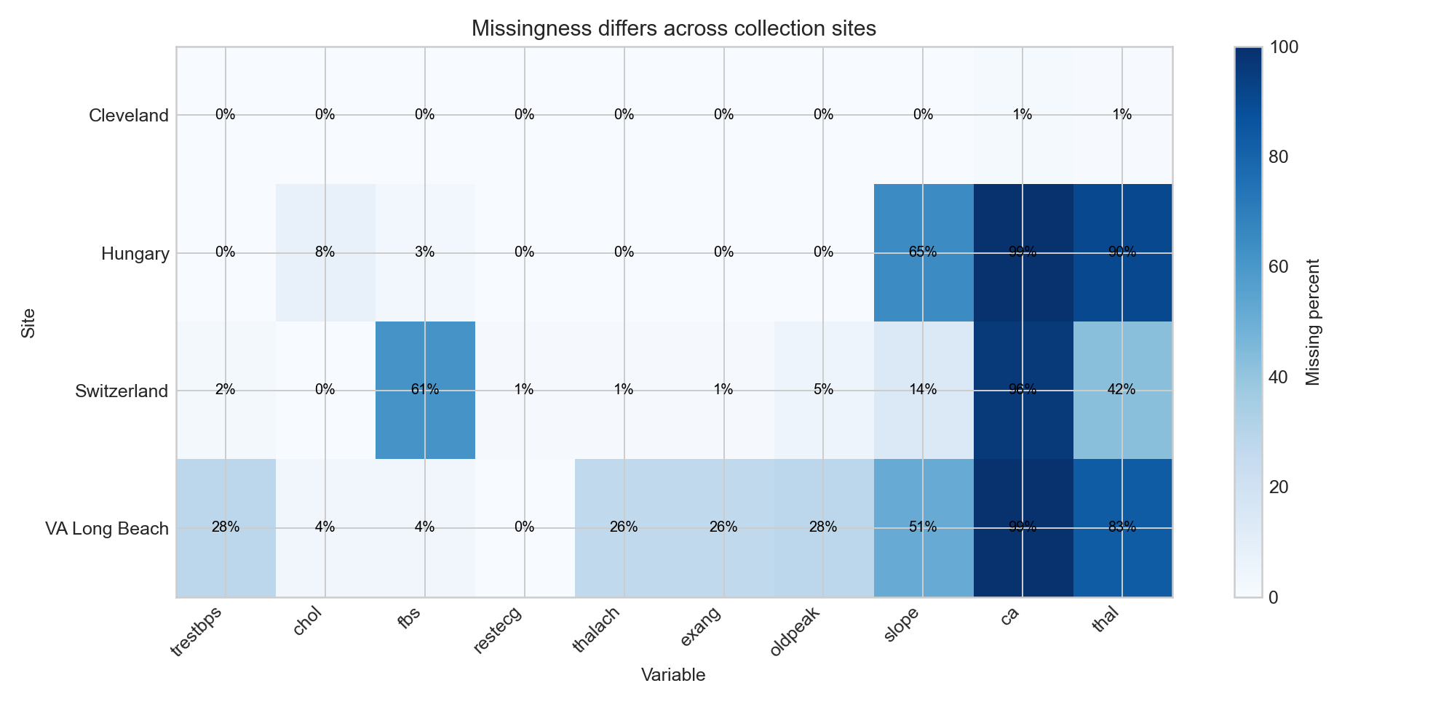
图 B1 站点间缺失比例 对应 Q4 LO4 LO6
site | num_0_pct | num_1_pct | num_2_pct | num_3_pct | num_4_pct | disease_binary_pct
Cleveland | 54.1 | 18.2 | 11.9 | 11.6 | 4.3 | 45.875
Hungary | 63.9 | 36.1 | 0 | 0 | 0 | 36.054
Switzerland | 6.5 | 39 | 26 | 24.4 | 4.1 | 93.496
VA Long Beach | 25.5 | 28 | 20.5 | 21 | 5 | 74.5

审查提示：哪些是直接观察到的事实？哪些只是关于仪器、临床流程或人群差异的假设？需要什么来源信息才能区分？

三、相似性 抽样 变换和降维
对应 Q3、Q5–Q9。每项结果都用于比较方案；数值变化本身不等于方案更好。

C1 尺度改变近邻
预处理和度量 | 名次 | 邻居 | 站点 | 距离
Euclidean raw | 1 | VA-Long-Beach-082 | VA Long Beach | 8.573
Euclidean raw | 2 | Cleveland-031 | Cleveland | 9.912
Euclidean raw | 3 | VA-Long-Beach-004 | VA Long Beach | 9.952
Euclidean raw | 4 | Cleveland-244 | Cleveland | 12.292
Euclidean raw | 5 | Cleveland-210 | Cleveland | 12.799
Euclidean raw | 6 | Cleveland-034 | Cleveland | 15.532
Euclidean standardized | 1 | Cleveland-098 | Cleveland | 0.621
Euclidean standardized | 2 | VA-Long-Beach-082 | VA Long Beach | 0.706
Euclidean standardized | 3 | VA-Long-Beach-147 | VA Long Beach | 0.708
Euclidean standardized | 4 | Cleveland-244 | Cleveland | 0.722
Euclidean standardized | 5 | Cleveland-271 | Cleveland | 0.739
Euclidean standardized | 6 | Cleveland-190 | Cleveland | 0.789
Manhattan standardized | 1 | VA-Long-Beach-082 | VA Long Beach | 1.081
Manhattan standardized | 2 | VA-Long-Beach-004 | VA Long Beach | 1.287
Manhattan standardized | 3 | Cleveland-175 | Cleveland | 1.299
Manhattan standardized | 4 | Cleveland-244 | Cleveland | 1.301
Manhattan standardized | 5 | Cleveland-098 | Cleveland | 1.381
Manhattan standardized | 6 | Cleveland-031 | Cleveland | 1.476

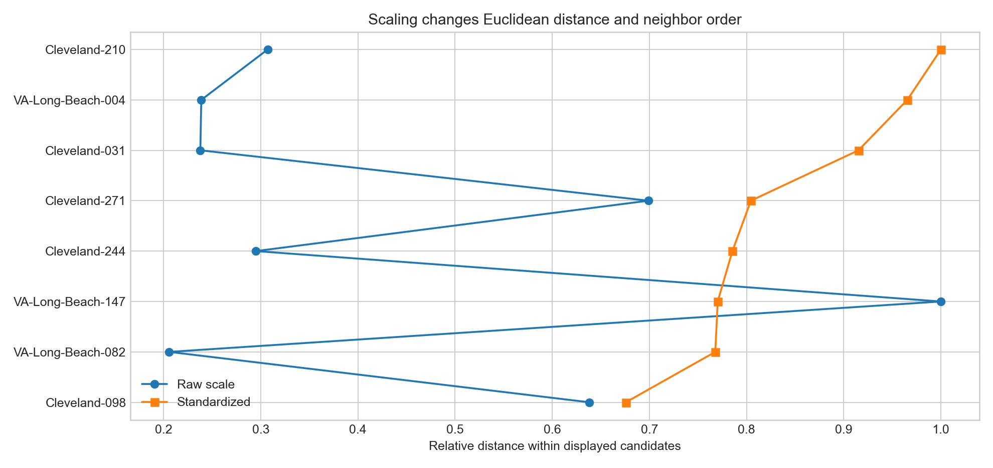
图 C1 缩放改变距离和近邻顺序 对应 Q5 LO7

C2 Minkowski Mahalanobis 向量和信息度量
候选 | Euclidean | Manhattan | Minkowski p3 | Mahalanobis | 检查
Cleveland-098 | 0.621 | 1.381 | 0.477 | 0.625 | rank may change; Mahalanobis also depends on covariance estimation
Cleveland-175 | 0.801 | 1.299 | 0.736 | 0.821 | rank may change; Mahalanobis also depends on covariance estimation
Cleveland-244 | 0.722 | 1.301 | 0.632 | 0.784 | rank may change; Mahalanobis also depends on covariance estimation
Cleveland-271 | 0.739 | 1.578 | 0.591 | 0.765 | rank may change; Mahalanobis also depends on covariance estimation
VA-Long-Beach-004 | 0.887 | 1.287 | 0.854 | 0.997 | rank may change; Mahalanobis also depends on covariance estimation
VA-Long-Beach-082 | 0.706 | 1.081 | 0.67 | 0.77 | rank may change; Mahalanobis also depends on covariance estimation
VA-Long-Beach-147 | 0.708 | 1.515 | 0.561 | 0.623 | rank may change; Mahalanobis also depends on covariance estimation
VA-Long-Beach-149 | 0.873 | 1.712 | 0.727 | 0.73 | rank may change; Mahalanobis also depends on covariance estimation

变换 | Euclidean | Manhattan | Cosine | Correlation | 解释
same | 0 | 0 | 1 | 1 | comparison
scaled_x2 | 5.603 | 16.772 | 1 | 1 | correlation ignores positive scaling and translation
shifted_plus2 | 6.325 | 20 | 0.902 | 1 | correlation ignores positive scaling and translation
reversed | 6.314 | 16.071 | 0.365 | -0.147 | comparison

信息量 | 值 | 工作含义
target_entropy_bits | 0.992 | uncertainty in the binary teaching outcome
mutual_information_age_bin | 0.046 | observed dependence; not causal importance
mutual_information_chol_bin | 0.061 | observed dependence; not causal importance
mutual_information_cp | 0.156 | observed dependence; not causal importance
mutual_information_exang | 0.109 | observed dependence; not causal importance

C3 二值和混合型相似性
记录A | 记录B | 共同0 | SMC | Jaccard
Cleveland-001 | Cleveland-002 | 0 | 0.333 | 0.333
Cleveland-001 | Cleveland-006 | 1 | 0.667 | 0.5
Cleveland-003 | Cleveland-013 | 0 | 0.667 | 0.667
Cleveland-011 | Cleveland-041 | 2 | 0.667 | 0

候选 | 站点 | 混合距离 | 使用维度 | 分项距离
Hungary-001 | Hungary | 0.447 | 5 | age:0.71; trestbps:0.07; sex:0.00; cp:1.00
Switzerland-001 | Switzerland | 0.377 | 6 | age:0.63; trestbps:0.25; sex:0.00; cp:0.00; slope:1.00
VA-Long-Beach-001 | VA Long Beach | 0.421 | 6 | age:0.00; trestbps:0.03; sex:0.00; cp:1.00; slope:0.50; exang:1.00
Cleveland-101 | Cleveland | 0.503 | 6 | age:0.37; trestbps:0.15; sex:0.00; cp:1.00; slope:1.00
Hungary-198 | Hungary | 0.516 | 6 | age:0.47; trestbps:0.12; sex:0.00; cp:1.00; slope:0.50; exang:1.00

C4 抽样和聚合
方法 | max_site_proportion_error_mean | max_site_proportion_error_std | max_site_proportion_error_max | disease_prevalence_abs_error_mean | disease_prevalence_abs_error_std | disease_prevalence_abs_error_max
simple_random | 0.0497 | 0.0226 | 0.1243 | 0.0356 | 0.0246 | 0.1051
site_stratified | 0.004 | 0.0 | 0.004 | 0.0302 | 0.0234 | 0.1134

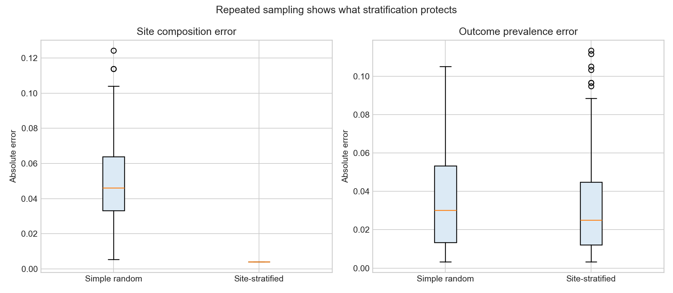
图 C2 分层抽样保护站点构成但不能保证所有统计量 对应 Q7 LO8
站点 | 人数 | 年龄均值 | 年龄SD | 患病比例 | 聚合后果
Cleveland | 303 | 54.439 | 9.039 | 0.459 | one site row hides patient variation and reduces 920 records to 4
Hungary | 294 | 47.827 | 7.812 | 0.361 | one site row hides patient variation and reduces 920 records to 4
Switzerland | 123 | 55.317 | 9.032 | 0.935 | one site row hides patient variation and reduces 920 records to 4
VA Long Beach | 200 | 59.35 | 7.812 | 0.745 | one site row hides patient variation and reduces 920 records to 4

C5 变换和标准化
注意：chol、trestbps或thalach中记录为0的值可能是异常值或缺失哨兵。必须先核对来源定义，不能用log变换把编码问题变成看似正常的数值。
变量或操作 | 样本 | 原始设置 | 原始偏度或计数 | 变换后偏度 | 解释
chol | 890 | 199.13 | -0.614 | -1.523 | log1p is a candidate, not an automatic requirement
oldpeak | 858 | 0.879 | 1.041 | 0.213 | log1p is a candidate, not an automatic requirement
trestbps | 861 | 132.132 | 0.213 | -13.488 | log1p is a candidate, not an automatic requirement
age equal-width bins | 920 | 5 bins | NA | NA | fixed widths can create uneven counts
age equal-frequency bins | 920 | 5 bins | NA | NA | quantile cut points must be fitted on training data

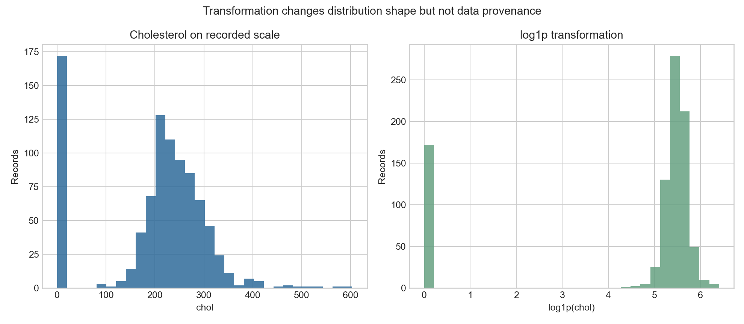
图 C3 变换改变分布形状但不会修复来源问题 对应 Q8 LO5 LO8

四、 综合工作流和边界
对应 Q8 和 Q10。Packet D不是答案键；你需要判断这些步骤是否足以解决本案例，并用前面证据说明理由。
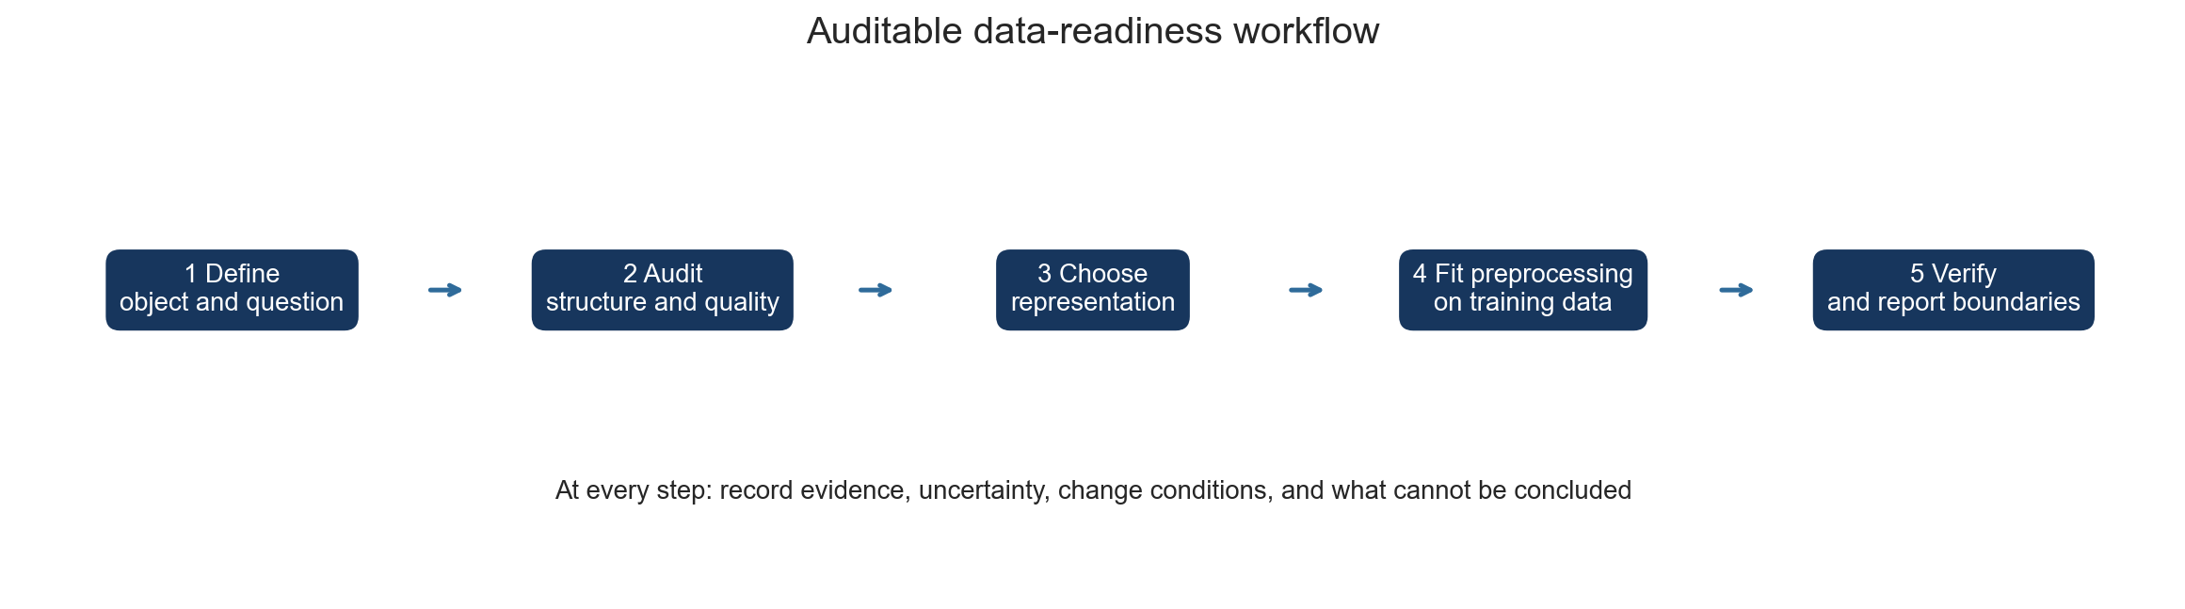
图 D1 可审计的数据准备路径 对应 Q10 LO3 LO5 LO6
步 | 行动 | 问题 | 证据 | 修改或停止条件
1 | define object question target and grouping | Q1 Q2 | data dictionary and structure audit | stop if observation unit or target cannot be defined
2 | audit provenance structure and quality | Q3 Q4 | characteristics missingness outliers duplicates site evidence | change design if missingness or site is entangled with outcome
3 | choose representation and similarity semantics | Q5 Q6 | metric sensitivity and mixed-type comparison | reject a metric dominated by scale or arbitrary codes
4 | set sampling aggregation and transformation | Q7 Q8 | sampling and transformation sensitivity | change if key subgroups disappear or information loss changes the question
5 | choose dimensionality strategy | Q9 | PCA loadings and feature option comparison | stop reduction if retained variance loses required interpretation
6 | split when generalization or fitted preprocessing is involved | Q8 Q10 | preprocessing audit | reject any parameter fitted with validation or test information
7 | document evidence uncertainty and boundary | Q10 | final readiness memo | do not claim clinical causal or deployment validity

预处理泄漏审查
流程 | 操作 | 使用的信息 | 诊断 | 决定
A | impute and scale on all 920 records, then split | uses future test distribution | leakage | reject
B | split first; fit imputation and scaling on training records; apply fixed parameters to test | test records do not set parameters | valid teaching workflow | retain
test standardized mean check | global-fit vs train-fit | global age mean -0.062; train-fit age mean -0.088 | a near-zero global test mean can be partly engineered by leakage | interpret with split provenance

结论边界
领域 | 证据可以支持 | 证据不能支持
descriptive | describe patterns in the supplied historical records | population prevalence or representativeness
association | identify observed relationships for teaching | causal effects of measurements or interventions
prediction | illustrate preparation effects | clinical utility safety calibration or external validity
missingness | locate missing values | identify mechanism without collection knowledge
site difference | show source distributions differ | attribute causes without source metadata
PCA | describe retained variance | preserve clinical meaning or predictive signal

