**Vaibhav Bhardwaj** — Data Analysist

Naghiar – Bilaspur, Himachal Pradesh 174030 – India  +91 8837761670 •  [instantquickquest@gmail.com](mailto:instantquickquest@gmail.com)

 [https://linkedin.com/in/vaibhav](https://linkedin.com/in/vaibhav-bhardwaj-work) •  https://github.com/vaibhav8400

# Objective

To obtain a Data Analyst position in a reputed organization where I can leverage my skills in data preprocessing, data visualization, and statistical analysis to derive meaningful insights and support data- driven decision-making. I aim to contribute to innovative projects by applying advanced analytical techniques and tools while continuously enhancing my expertise in business intelligence and predictive analytics.

# Education

**Lovely Professional University Jalandhar, Punjab**

*Bachelor of Technology in Computer Science and Engineering, CGPA: 8.01 2026*

Relevant Coursework: Data Structures and Algorithms, Operating Systems, Database Management Systems, Android App Development, Computer Networks, Software Engineering

**Pradesh Public International School of Sciences Hamirpur, H.P**

*Senior Secondary School Certificate (12th Grade), Percentage: 96% 2021*

Key Subjects: Physics, Chemistry, Mathematics, Computer Science

**Pradesh Public International School of Sciences Hamirpur, H.P**

*Secondary School Certificate (10th Grade), Percentage: 96% 2019*

Achievements: Good Rank in Mathematics and Science

# Technical Skills

**Programming Languages**: Java, C++, C **Tools/Technologies**: Git, Git Hub, Firebase, Android Studio **Operating Systems**: Linux, Windows

**Databases**: MySQL, MongoDB

**Frameworks**: Flutter, Google Colab

# Projects

**Project Title:** *Chat App Using Flutter*

**Description:** A chat app using Flutter as a framework.

**Technologies Used:** Flutter, Dart, Firebase

**Impact/Achievements:** Enables real-time messaging with instant updates.

**Demo/Code Link:** [GitHub Repository](https://github.com/johndoe/weather-app)

**Project Title:** *Mobile Phone Market Analysis*

**Description:** A Tableau-driven project analyzing trends and consumer preferences in the mobile phone industry for informed strategic decision-making.

**Technologies Used:** Tableau

**Impact/Achievements:** Created interactive dashboards revealing key market insights.

**Demo/Code Link:** [GitHub Repository](https://github.com/johndoe/task-manager)

# Certifications

**Flutter Development Track** : Certificate by Cipher Schools (Completed in 2024). **NPTEL Cloud Computing :** Certification by Swayam NPTEL (Completed in 2024). **Data Structures and Algorithms** : Online course by Coursera, completed in 2023.

# Achievements

**Online Gaming Community** : Created an online Gaming Community which organizes tournaments of different games.

# AI Recommendations for Improvement

**Recommendation 1**: Advanced Backend Skills and Framework **Recommendation 2**: Expand Your Project Portfolio with Problem-Solving Focus

**Recommendation 3**: Strengthen Algorithms and Data Structures Knowledge

# Self-Assigned Tasks (Till 10*th* week of this semester)

**Task 1**: [IBM Python for Data Science](https://www.coursera.org/learn/python-for-applied-data-science%02ai?specialization=ibm-data-science)

**Task 2** : [Introduction to HTML CSS](https://www.coursera.org/learn/introduction-html-css-javascript)

# Targets Allocated (Till 10*th* week of this semester)



* IBM Python for Data Science
* Introduction to HTML CSS and JavaScript

**Signatures**

**Vaibhav Bhardwaj Kamaljeet Kaur Dhillon**

*Student’s Full Name Instructor’s Full Name*

**Certificates of Allocated Tasks**

**Certificate Link** : https://coursera.org/verify/99YTPH59IELE

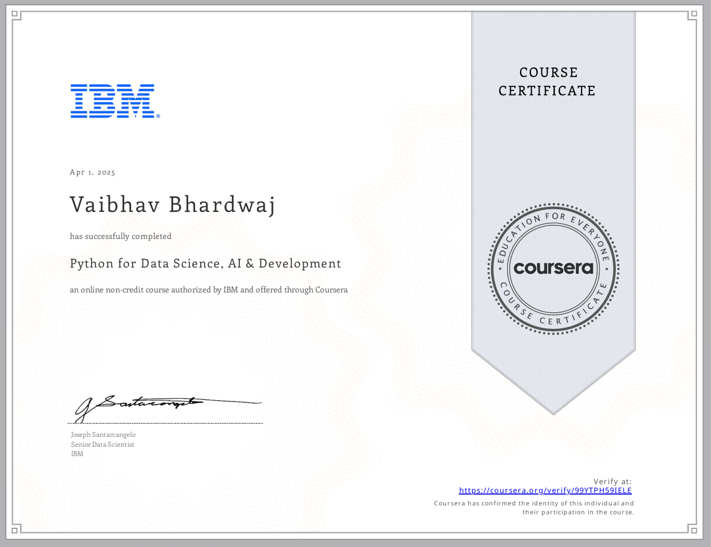

**Certificate Link** : https://coursera.org/verify/NLNKPOWCI8LK

