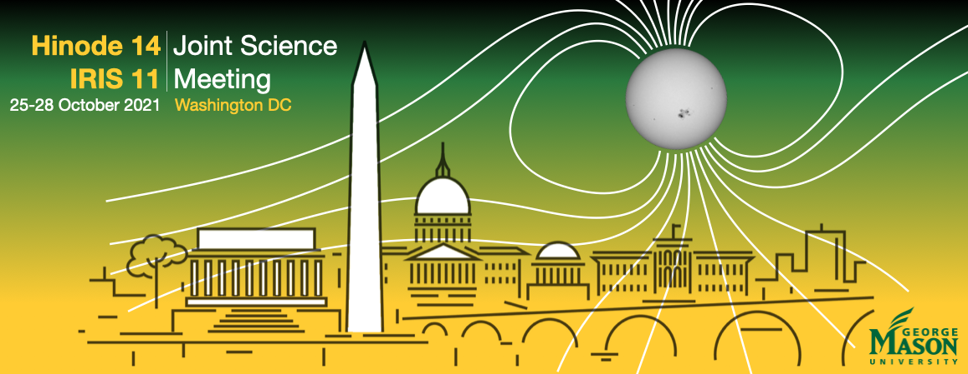

**TRAVEL SUPPORT APPLICATION FORM**

Please submit this form and your Curriculum Vitae

to  [hinode14meeting@gmail.com](mailto:hinode14meeting@gmail.com) before August 27, 2021

**Personal information**

Given Name:

Family name:

Date of PhD (or expected date):

Affiliation:

Position:

Email address:

**Motivation to attend Hinode-14 meeting**

(Applicants are strongly encouraged to submit an abstract)

**Abstract**

**Amount requested, itemized (maximum of $2000 per participant)**

(Grants might only provide partial support)