- 将vue-cli2中的webpack3升级为webpack4
对比

前提：2021年webpack已经升级到5了，要升级到webpack4要指定版本，否则会报错
1升级指定的版本
"webpack": "^4.26.0", //必须同步升级
"webpack-bundle-analyzer": "^3.6.0", //必须同步升级
"webpack-cli": "^3.3.10",//必须同步升级,webpack4将webpack和webpack-cli分开了
"webpack-dev-server": "^3.9.0", //必须同步升级
"mini-css-extract-plugin": "^0.9.0",//必须同步升级
"html-webpack-plugin": "^3.1.0", //必须同步升级
"webpack-merge": "^4.1.4" //必须同步升级
"file-loader": "^1.1.11",//建议升级最新版本
"url-loader": "^0.5.9", ,//建议升级最新版本
"vue-loader": "^15.9.6",//升级最新版本
"vue-style-loader": "^4.1.3",//升级最新版本
- webpack4 需要加入 模式配置
在webpack-base-config.js 输出对象中添加mode: process.env.NODE_ENV === 'production' ? 'production' : 'development',
- "vue-loader": "^15.9.6"
使用vue-loader15的需要在webpack-base-config.js中修改vue-loader使用方式
const VueLoaderPlugin = require('vue-loader/lib/plugin');
或者 const{ VueLoaderPlugin } = require('vue-loader')
plugins: [
new VueLoaderPlugin()
]
如果使用了scss 配置则将webpack.base.conf.js注释掉即可,vue-loader已经包含对css的编译,注释掉也不会影响系统.否则会css重复错误Invalid CSS after "...load the styles": expected 1 selector or at-rule, was "var content = requi"
需要加上-loader后缀
如下
module: {
rules: [
{
test: /\.vue$/,
loader: 'vue-loader',
// options: vueLoaderConfig
}
............
// {
// test: /\.scss$/,
// loaders: ['style-loader', 'css-loader', 'sass-loader']
// }
]
},

- webpack4 移除了 CommonsChunkPlugin,在 optimization属性中配置 压缩和模块分割
在webpack.prod.conf 文件中去除CommonsChunkPlugin相关，新增
optimization: {
runtimeChunk: {
name: 'manifest'
},
splitChunks: {
cacheGroups: {
vendor: {
test: /[\\/]node_modules[\\/]/,
name: 'vendor',
chunks: 'all'
},
'async-vendors': {
test: /[\\/]node_modules[\\/]/,
minChunks: 2,
chunks: 'async',
name: 'async-vendors'
}
}
}
}

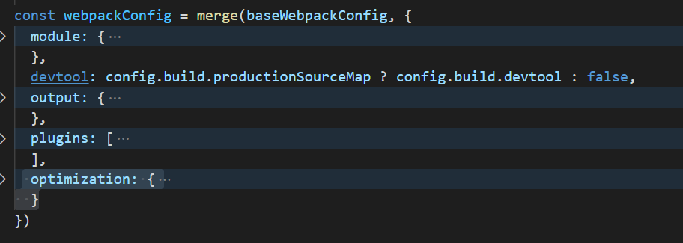
- webpack4 废弃extract-text-webpack-plugin 插件，替代方案为mini-css-extract-plugin插件
修改utils.js文件
const MiniCssExtractPlugin = require('mini-css-extract-plugin')

if (options.extract) {
// return ExtractTextPlugin.extract({
// publicPath: '../../',
// use: loaders,
// fallback: 'vue-style-loader',
// })
return [MiniCssExtractPlugin.loader].concat(loaders)
} else {
return ['vue-style-loader'].concat(loaders)
}

修改webpack.prod.conf.js文件
const MiniCssExtractPlugin = require('mini-css-extract-plugin')
new MiniCssExtractPlugin({
filename: utils.assetsPath('css/[chunkname].css'),

chunkFilename: utils.assetsPath('css/[name].[contenthash].css')
}),
// extract css into its own file
// new ExtractTextPlugin({
// filename: utils.assetsPath('css/[name].[contenthash].css'),
// // Setting the following option to `false` will not extract CSS from codesplit chunks.
// // Their CSS will instead be inserted dynamically with style-loader when the codesplit chunk has been loaded by webpack.
// // It's currently set to `true` because we are seeing that sourcemaps are included in the codesplit bundle as well when it's `false`,
// // increasing file size: https://github.com/vuejs-templates/webpack/issues/1110
// allChunks: false,
// }),

结束语:
其余的问题遇到再说
- 进一步优化webpack4最优配置
1.

