- (SJPO 2010, 1st round) The same constant force is used to accelerate two carts of the same mass on frictionless tracks. The force applied to cart A is twice as long in time as it is applied to cart B. the work the force does on A is W_{A}; the work on B is W_{B}. which statement is correct?
  - W_{A} = W_{B}
  - W_{A} = W_{B}
  - W_{A} = 2W_{B}
  - W_{A} = 4W_{B}
  - W_{B} = 2W_{A}

- (SJPO 2015, 1st round) An infinite conducting cylinder of radius R₂, has an infinite concentric cylindrical cavity of radius R₁. The cross section is as shown below. The cylinder has no charge but a thin wire carrying positive charge per unit length ρρ runs along the center of the cylindrical hollow, parallel to the cylinder. What is the charge per unit area on the inner surface of the cylinder?
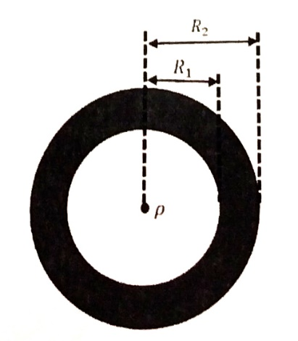

- (SJPO 2012, 1st round) For the system consisting of 2 blocks shown in the figure below, a horizontal force F is applied so that block B does not fall due to its weight. The masses of A and B are 12.0 kg and 2.0 kg respectively. The horizontal surface is frictionless and the co-efficient of static friction between the two blocks is 0.45. the minimum magnitude of F is
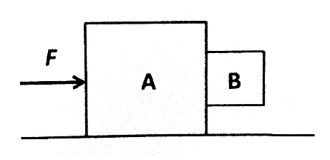
  - 63/10 g
  - 100/3 g
  - 280/9 g
  - 560/9 g
  - 70g

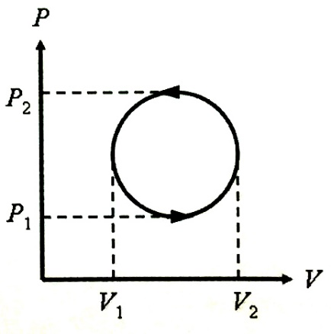
- (SJPO 2009, 1st round) A thermodynamic system undergoes a cyclic process as shown in the figure below. the heat energy absorbed by the system over one complete cycle is:

- (SJPO 2009, 1st round) Suppose the two plates of a balance scale are in equilibrium while the scale is kept underwater (see figure). On one side is a 1kg iron weight (Fe) and on the other side is an unknown amount of mercury (Hg). If the density of iron is 7870 kg/m³ and the density of mercury is 13550 kg/m³, when you lift it out of the water,
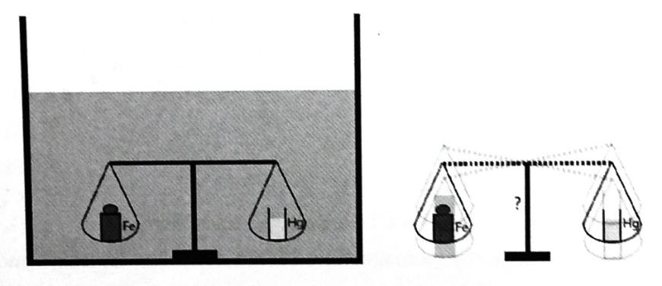
  - The scale is still balanced
  - You can balance it again by adding 180 g to the plate on the left
  - You can balance it again by adding 97 g to the plate on the right
  - You can balance it again by adding 58 g to the plate on the right
  - You can balance it again by adding 29 g to the plate on the left

- (SJPO 2011, 1st round) A 8.0 g bullet is shot into a 4.0 kg block, at rest on a frictionless horizontal surface. The bullet remains lodged in the block. The block moves toward a spring and compresses it by 9.4 cm. the force constant of the spring is 1000 N/m. the initial speed of the bullet is closest to
  - 710 m/s
  - 740 m/s
  - 770 m/s
  - 800 m/s
  - 830 m/s
- (SJPO 2012, 1st round) A beam of light strikes one mirror of a pair of right angle mirrors at an angle of incidence of 45º as shown in the diagram. If the right angle mirror assembly is rotated such that the angle of incidence is now 55º, what will happen to the angle of the beam that emerges from the right angle mirror assembly?
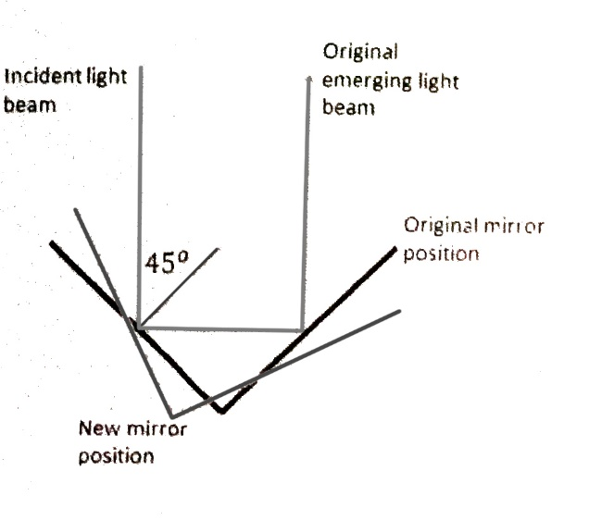
  - It will move through an angle of 15º with respect to the original emerging beam
  - It will move through an angle of 35º with respect to the original emerging beam
  - It will move through an angle of 45º with respect to the original emerging beam
  - It will move through an angle of 55º with respect to the original emerging beam
  - It will emerge parallel to the original emerging beam

- (SJPO 2012, 1st round) The total energy of a blackbody radiation source is collected for one minute and used to heat water. The temperature increases from 27.0ºC to 28.0ºC. If the absolute temperature of the blackbody source is doubled, what is the final temperature of the water?
  - 29.0ºC
  - 32.0ºC
  - 35.0ºC
  - 43.0ºC
  - 54.0ºC

- (SJPO 2013, 1st round) Two masses, m₁ and m₂, are joined by a massless spring of force constant k and placed on a horizontal frictionless surface. The system is released from rest when the separation between the masses is x. If the unstretched length of the spring is x₀, the speed of the mass m₁ when the two masses are at the distance x₀ apart is

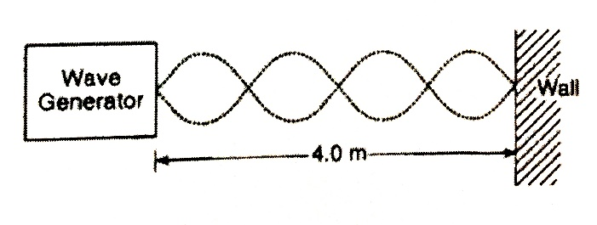
- (SJPO 2012, 1st round) A wave generator located 4.0 m from a reflecting wall produces a standing wave in the string, as shown in the diagram below. If the speed of the wave is 30 m/s, what is its frequency?
  - 1.2 Hz
  - 15 Hz
  - 30 Hz
  - 40 Hz
  - 36 Hz

- (SJPO 2011, 1st round) X-rays of wavelength 0.098 nm scattered from a newly discovered crystalline material are observed to have a first-order intensity maximum at an angle 20º measured from the incident direction as shown in the figure below. Assuming that the material is made of elemental atoms arranged in a cubic array, what is the number density of atoms in the material?
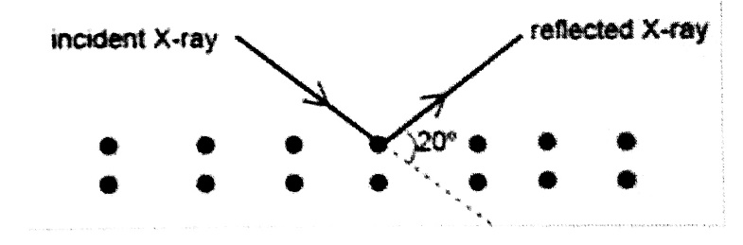
  - 4.4510²⁸ m⁻³
  - 8.0910²⁸ m⁻³
  - 2.2710²⁸ m⁻³
  - 4.3010¹⁹ m⁻³
  - 3.4010¹⁹ m⁻³

- (SJPO 2009, 1st round) Point changes q, located at x = 0, and 9q, located at x = L are a distance L apart. Where should a third charge, Q, be placed along the x axis so that the net force on ALL THREE charges vanishes? What is the required value of Q?
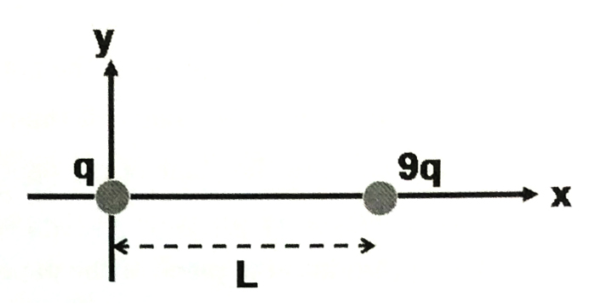
  - At x = L/9 and Q = -6q/16
  - At x = L/4 and Q = -6q/16
  - At x = L/4 and Q = -9q/16
  - At x = L/3 and Q = -6q/16
  - At x= L/3 and Q = -9q/16

- (SJPO 2013, 1st round) A particle exhibiting uniform circular motion with radius r has its speed increased 3 times and the centripetal force is hence increased by 64 N. the original centripetal force is
  - 16 N
  - 12 N
  - 8 N
  - 6 N
  - 18 N

- (SJPO 2008, 1st round) The percentage increase in the energy of a particle whose speed is changed from rest to 0.8c (where c is the speed of light) is closest to
  - 50%
  - 67%
  - 75%
  - 80%
  - 88%

- (SJPO 2008, 1st round) A particle moves at a constant speed in a circular path with a radius of 2.06 cm. If the particle makes four revolutions each second, what is the magnitude of its acceleration?
  - 20 m/s²
  - 18 m/s²
  - 13 m/s²
  - 15 m/s²
  - 24 m/s²

