- (SJPO 2014, 1st round) A body at rest explodes, breaking into three pieces which move off at different velocities, all in the same horizontal plane. The following figure shows the experimental results as drawn from a stroboscopic photograph of the event. The time interval between flashes was 0.10 s. The pieces X and Y travels at right angles to each other and are collected after the explosion and their masses are found to be 2.0 kg and 1.0 kg respectively. Piece Z was unfortunately lost after the explosion. What is the mass of piece Z?
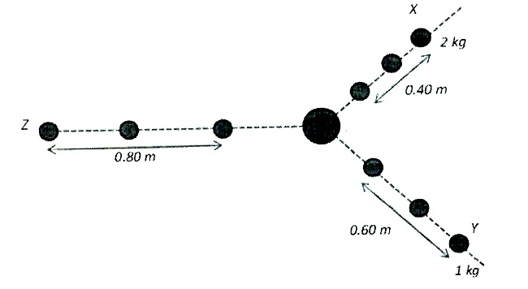
  - 1.25 kg
  - 1.50 kg
  - 2.00 kg
  - 0.85 kg
  - 3.00 kg

- (SJPO 2014, 1st round) As shown in the diagram below, a mass M with charge +q is sliding down the slope at constant velocity v. when the mass enters the region with the uniform electric field E,
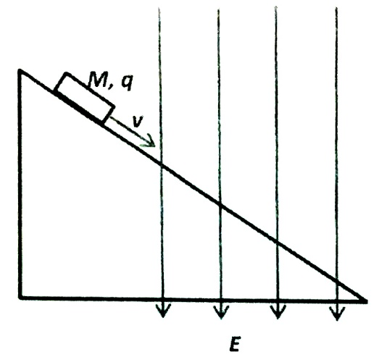
  - The mass will continue to slide down at constant velocity v.
  - The velocity of the mass will increases as it slides down the slope.
  - The velocity of the mass will decreases as it slides down the slope.
  - The mass will come to a stop immediately.
  - The mass will reverse direction and accelerate up the slope.

- (SJPO 2012, 1st round) For the system consisting of 2 blocks shown in the figure below, a horizontal force F is applied so that block B does not fall due to its weight. The masses of A and B are 12.0 kg and 2.0 kg respectively. The horizontal surface is frictionless and the co-efficient of static friction between the two blocks is 0.45. the minimum magnitude of F is
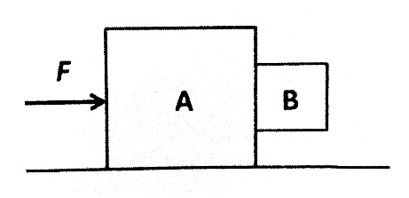
  - 63/10 g
  - 100/3 g
  - 280/9 g
  - 560/9 g
  - 70g

- (SJPO 2014, 1st round) Microwaves from an emitter are incident on a metal plate (XY). A probe is used to search for the reflected wave. Please see figure below. What is the distance l such that the probe will receive microwaves of maximum intensity?
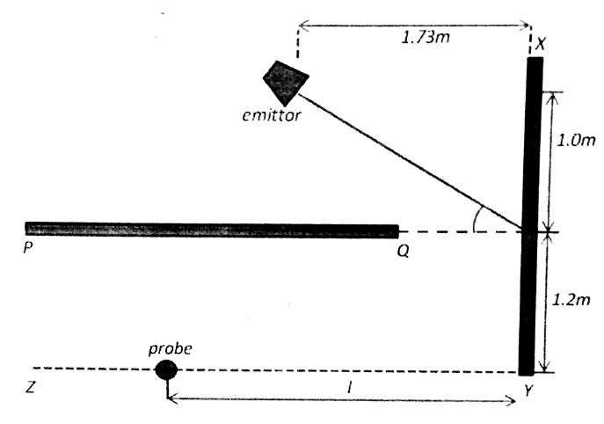
  - 1.38 m
  - 0.69 m
  - 2.40 m
  - 1.20 m
  - 2.08 m

- (SJPO 2009, 1st round) Identical springs with spring constant k are connected to identical masses of mass M in three different configurations as shown in figures 1, 2, and 3 below. The periods of oscillations in the configurations are T₁, T₂, and T₃, respectively. Which statement is correct?
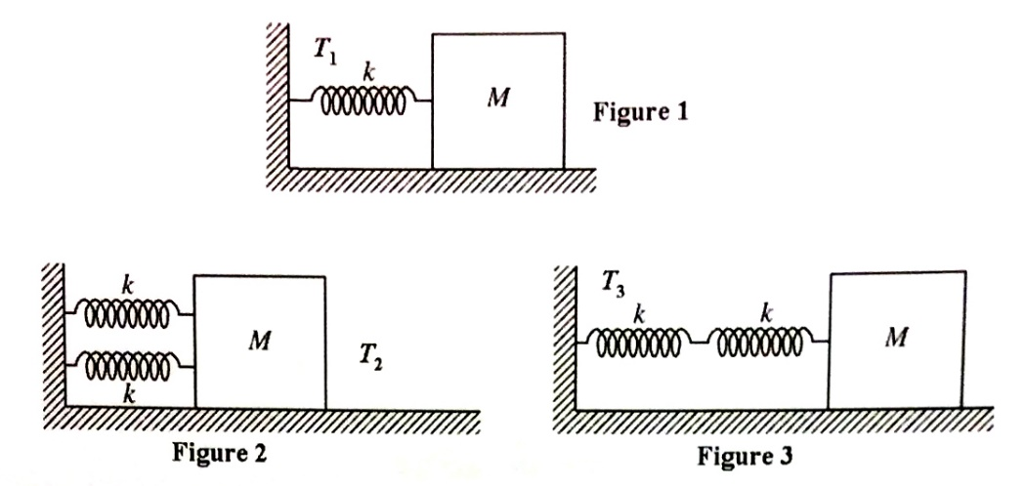

- (SJPO 2014, 1st round) A person stands at a distance 1.0 m from a mirror hung vertically on the wall. He can only see the upper half of his body. In order to see the entire length of his body, what should he do?
  - Place himself 2.0 m away from a mirror
  - Place himself 0.5 m away from the mirror
  - Place himself 4.0 m away from the mirror
  - Place himself 8.0 m away from the mirror
  - It would be a futile attempt to just move himself forward or backwards from the mirror.

- (SJPO 2013, 1st round) An ideal gas exerts a pressure of 60 Pa when its temperature is 400 K and the number density of molecules is n. Another sample of the same gas exerts a pressure of 30 Pa when its temperature is 300 K. How many molecules are present in unit volume of this second sample?
  - 4n/3
  - 3n/2
  - 3n/4
  - 2n/2
  - n/2

- (SJPO 2015, 1st round) At a point out of Earth and at a distance x from its center, the Earth’s gravitational field is -about 5 N kg⁻¹. At the Earth’s surface, the field is about 10 N kg⁻¹. Which of the following gives an approximate value of the radius of the Earth?

  - 2x

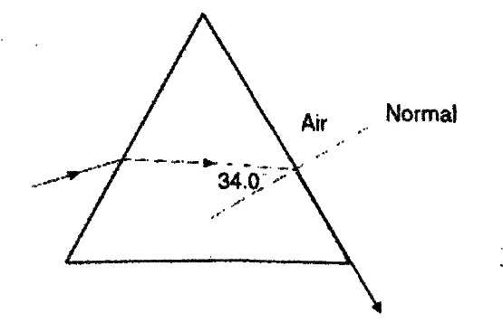
- (SJPO 2012, 1st round) The diagram below shows a ray of monochromatic light (5.0910¹⁴ Hz) passing through a glass prism. What is the speed of the light ray in the prism?

  - 1.6810⁸ m/s
  - 1.8110⁸ m/s
  - 3.0010⁸ m/s
  - 1.0310⁸ m/s
  - 2.6010⁸ m/s

- (SJPO 2012, 1st round) A diatomic molecule consists of two point masses, m₁ and m₂, separated by a distance r. if x is the distance from m₁ to the center of mass, what is the moment of inertia about an axis parallel to the molecular axis passing through the center of mass? Not that the molecular axis is the line joining the two atoms in the diatomic molecule.
  - 0

- (SJPO 2012, 1st round) Green light of wavelength 500 nm and of intensity 0.50 W/m² is shone on a solar cell of area 0.040 m². The solar cell generates sufficient power to drive a small microfluidic device that heats 0.050g of water from 300 K to 301 K in 1.0 minutes. The number of photons that reach the solar cell per second is
  - 5.010¹⁶
  - 5.010¹⁰
  - 6.010²⁸
  - 6.010²⁰
  - 5.010¹⁸

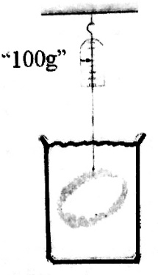
- (SJPO 2014, 1st round) A spring balance reads 100 g when an iron ring is weighted in water. What will the balance read if the ring is now weighted in oil? The densities of water, oil and iron are 100 kg/m³, 730 kg/m³ and 7874 kg/m³, respectively.

  - 96 g
  - 98 g
  - 100 g
  - 102 g
  - 104 g

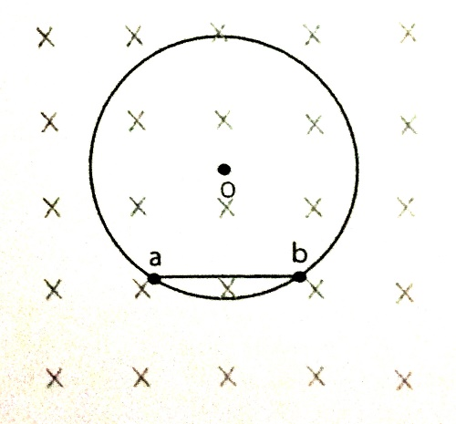
- (SJPO 2012, 1st round) A charged particle moves in a circular path in a magnetic field of B = 0.8 T. as shown in the diagram below, the particle takes 2.010⁻⁴ s to travel from a to b and then continues to take another 1.010⁻³ s to go from b to a. the distance between a and b is 0.30 m and the charge on the particle is 3.010⁻⁸C. The momentum of the particle is
  - 7.210⁻⁹ kg m/s
  - 3.610⁻⁹ kg m/s
  - 1.4410⁻⁸ kg m/s
  - 2.8810⁻⁸ kg m/s
  - 5.7610-8 kg m/s

- (SJPO 2011, 1st round) A drum has a radius of 0.40 m and a moment of inertia of 4.5 kg m². The frictional torque of the drum axle is 3.0 Nm. A 15m length of rope is would around the rim. The drum is initially at rest. A constant force is applied of the free end of the rope is completely unwound and slips off. At that instant, the angular velocity of the drum is 13 rad/s. the drum then decelerates and comes to a halt. The constant force applied to the rope is closest to
  - 7.5 N
  - 14 N
  - 18 N
  - 27 N
  - 33 N

- (SJPO 2015, 1st round) An alpha particle and a proton follows the same circular path in a uniform magnetic field. What is the ratio of the alpha’s particle’s velocity to the proton’s velocity? You can consider the case to be non-relativistic.
  - 1/4
  - 1/2
  - 1
  - 2
  - 4

