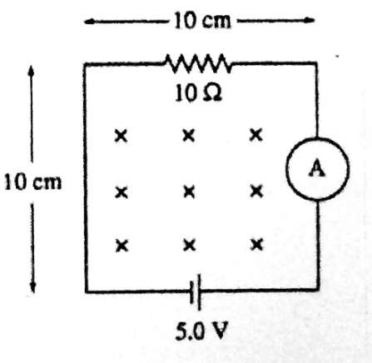
- (SJPO 2011, 1st round) The circuit shown below is in a uniform magnetic field that is into the page and is decreasing in magnitude at the rate of 150 T/s. the magnitude and direction of the current in the loop is given by

  - 0.35 A counter-clockwise
  - 0.35 A clockwise
  - 0.65 A counter-clockwise
  - 0.65 A clockwise
  - 0.85 A counter clock-wise

- (SJPO 2015, 1st round) At a point out of Earth and at a distance x from its center, the Earth’s gravitational field is -about 5 N kg⁻¹. At the Earth’s surface, the field is about 10 N kg⁻¹. Which of the following gives an approximate value of the radius of the Earth?

  - 2x

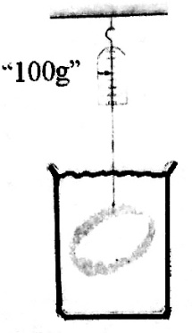
- (SJPO 2014, 1st round) A spring balance reads 100 g when an iron ring is weighted in water. What will the balance read if the ring is now weighted in oil? The densities of water, oil and iron are 100 kg/m³, 730 kg/m³ and 7874 kg/m³, respectively.

  - 96 g
  - 98 g
  - 100 g
  - 102 g
  - 104 g

- (SJPO 2008, 1st round) If we lived in a universe in which the value of Planck’s constant is larger, which of the following statements would not be true?
  - The de Broglie wavelength of an object would be longer
  - Photons with a fixed frequency would have more energy
  - The probability of tunnelling across a barrier would be smaller
  - The maximum kinetic energy of the photoelectron would be larger
  - The product of the uncertainties in measuring the position and momentum of an object would be larger

- (SJPO 2011, 1st round) As you walk away from a plane mirror on a wall, your image
  - Gets smaller
  - May or may not get smaller, depending on where the observer is positioned.
  - Is always a real image, no matter how far you are from the mirror.
  - Changes from being a virtual image to a real image as you pass the focal point.
  - Is always the same size.

- (SJPO 2008, 1st round) A puck moves with uniform acceleration on a straight air track (frictionless). It passes two points A and B with speed 2 m/s and 8 m/s respectively. If the puck passes through the two points within a time of 0.1 s, the distance between A and B is
  - 20 cm
  - 30 cm
  - 40 cm
  - 50 cm
  - 60 cm

- (SJPO 2012, 1st round) A diatomic molecule consists of two point masses, m₁ and m₂, separated by a distance r. if x is the distance from m₁ to the center of mass, what is the moment of inertia about an axis parallel to the molecular axis passing through the center of mass? Not that the molecular axis is the line joining the two atoms in the diatomic molecule.
  - 0

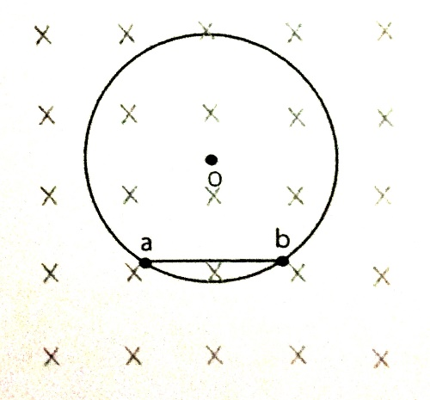
- (SJPO 2012, 1st round) A charged particle moves in a circular path in a magnetic field of B = 0.8 T. as shown in the diagram below, the particle takes 2.010⁻⁴ s to travel from a to b and then continues to take another 1.010⁻³ s to go from b to a. the distance between a and b is 0.30 m and the charge on the particle is 3.010⁻⁸C. The momentum of the particle is
  - 7.210⁻⁹ kg m/s
  - 3.610⁻⁹ kg m/s
  - 1.4410⁻⁸ kg m/s
  - 2.8810⁻⁸ kg m/s
  - 5.7610-8 kg m/s

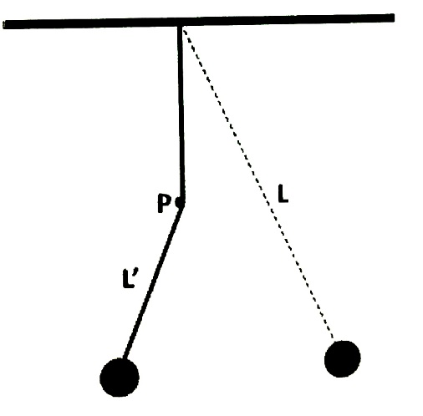
- (SJPO 2015, 1st round) As shown in the diagram, a pendulum of length L is hung from the ceiling and at a point P, a peg is placed. L’ denotes the shortened length of the pendulum during part of its oscillation. The period of the oscillation is now

- (SJPO 2009, 1st round) Point changes q, located at x = 0, and 9q, located at x = L are a distance L apart. Where should a third charge, Q, be placed along the x axis so that the net force on ALL THREE charges vanishes? What is the required value of Q?
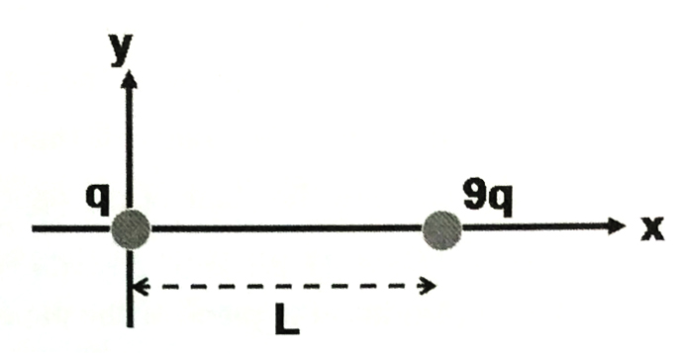
  - At x = L/9 and Q = -6q/16
  - At x = L/4 and Q = -6q/16
  - At x = L/4 and Q = -9q/16
  - At x = L/3 and Q = -6q/16
  - At x= L/3 and Q = -9q/16

- (SJPO 2009, 1st round) Identical springs with spring constant k are connected to identical masses of mass M in three different configurations as shown in figures 1, 2, and 3 below. The periods of oscillations in the configurations are T₁, T₂, and T₃, respectively. Which statement is correct?
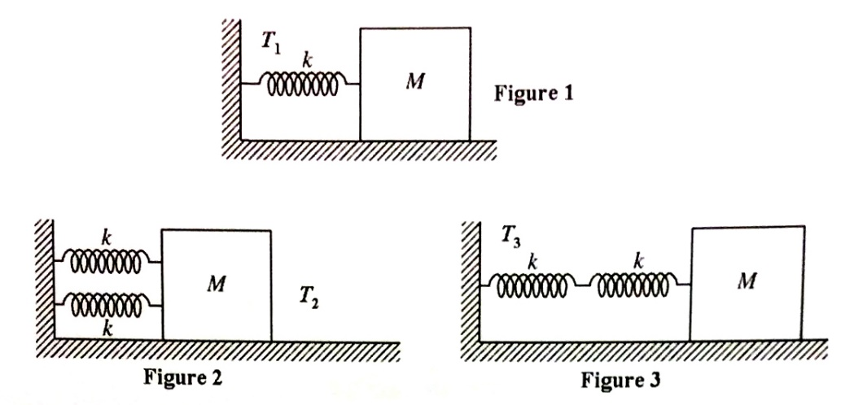

- (SJPO 2010, 1st round) The same constant force is used to accelerate two carts of the same mass on frictionless tracks. The force applied to cart A is twice as long in time as it is applied to cart B. the work the force does on A is W_{A}; the work on B is W_{B}. which statement is correct?
  - W_{A} = W_{B}
  - W_{A} = W_{B}
  - W_{A} = 2W_{B}
  - W_{A} = 4W_{B}
  - W_{B} = 2W_{A}

- (SJPO 2015, 1st round) Two identical masses, A and B, are tied to strings and placed on a horizontal frictionless disc as in the figure below. The two masses are then set to move about the center of the disc with the same angular velocity ω. Given that the tension of the string connecting mass A to the center of the disc is T, determine the tension of the string connecting mass B to mass A.
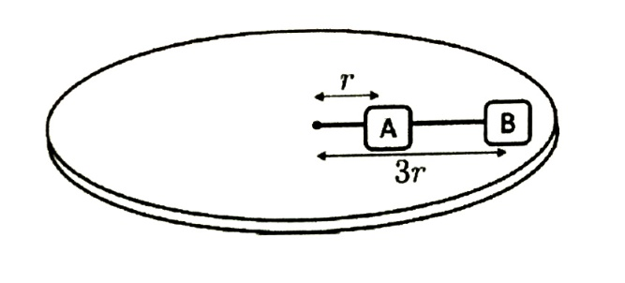
  - T/4
  - 3T/4
  - T
  - 3T
  - 4T

- (SJPO 2014, 1st round) Before a train enters a tunnel, it is important that it sounds its horn. The train velocity is 80 km/h and the speed of sound is taken to be 340 m/s. the echo of the horn signal is reflected off the surface of the cliff through which the tunnel runs. The echo is heard 2.0 s after the driver sounds the horn. The distance of the train from the cliff at the time when the echo is heard is
  - 318 m
  - 260 m
  - 362 m
  - 159 m
  - 636 m

- (SJPO 2010, 1st round) A baseball is thrown vertically upward and feels no air resistance. As it is rising,
  - Both its momentum and its mechanical energy are conserved.
  - Both its momentum and kinetic energy are conserved.
  - Its kinetic energy is conserved but its momentum is not.
  - The gravitational potential energy is not conserved but its momentum is.
  - Its momentum is not conserved but its mechanical energy is.

