- (SJPO 2015, 1st round) Two identical masses, A and B, are tied to strings and placed on a horizontal frictionless disc as in the figure below. The two masses are then set to move about the center of the disc with the same angular velocity ω. Given that the tension of the string connecting mass A to the center of the disc is T, determine the tension of the string connecting mass B to mass A.
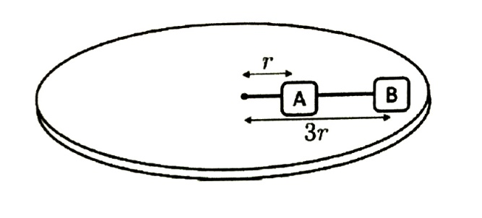
  - T/4
  - 3T/4
  - T
  - 3T
  - 4T

- (SJPO 2010, 1st round) A baseball is thrown vertically upward and feels no air resistance. As it is rising,
  - Both its momentum and its mechanical energy are conserved.
  - Both its momentum and kinetic energy are conserved.
  - Its kinetic energy is conserved but its momentum is not.
  - The gravitational potential energy is not conserved but its momentum is.
  - Its momentum is not conserved but its mechanical energy is.

- (SJPO 2013, 1st round) An ideal gas exerts a pressure of 60 Pa when its temperature is 400 K and the number density of molecules is n. Another sample of the same gas exerts a pressure of 30 Pa when its temperature is 300 K. How many molecules are present in unit volume of this second sample?
  - 4n/3
  - 3n/2
  - 3n/4
  - 2n/2
  - n/2

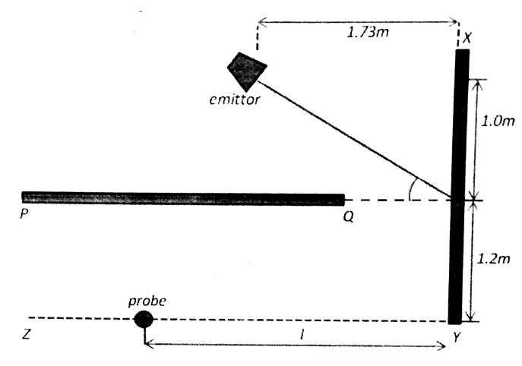
- (SJPO 2014, 1st round) Microwaves from an emitter are incident on a metal plate (XY). A probe is used to search for the reflected wave. Please see figure below. What is the distance l such that the probe will receive microwaves of maximum intensity?

  - 1.38 m
  - 0.69 m
  - 2.40 m
  - 1.20 m
  - 2.08 m

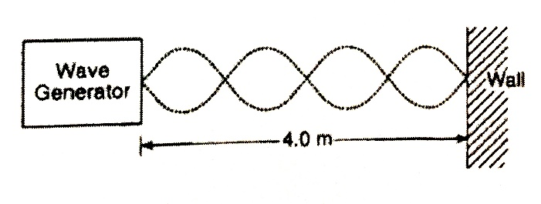
- (SJPO 2012, 1st round) A wave generator located 4.0 m from a reflecting wall produces a standing wave in the string, as shown in the diagram below. If the speed of the wave is 30 m/s, what is its frequency?
  - 1.2 Hz
  - 15 Hz
  - 30 Hz
  - 40 Hz
  - 36 Hz

- (SJPO 2012, 1st round) Green light of wavelength 500 nm and of intensity 0.50 W/m² is shone on a solar cell of area 0.040 m². The solar cell generates sufficient power to drive a small microfluidic device that heats 0.050g of water from 300 K to 301 K in 1.0 minutes. The number of photons that reach the solar cell per second is
  - 5.010¹⁶
  - 5.010¹⁰
  - 6.010²⁸
  - 6.010²⁰
  - 5.010¹⁸

- (SJPO 2014, 1st round) A body at rest explodes, breaking into three pieces which move off at different velocities, all in the same horizontal plane. The following figure shows the experimental results as drawn from a stroboscopic photograph of the event. The time interval between flashes was 0.10 s. The pieces X and Y travels at right angles to each other and are collected after the explosion and their masses are found to be 2.0 kg and 1.0 kg respectively. Piece Z was unfortunately lost after the explosion. What is the mass of piece Z?
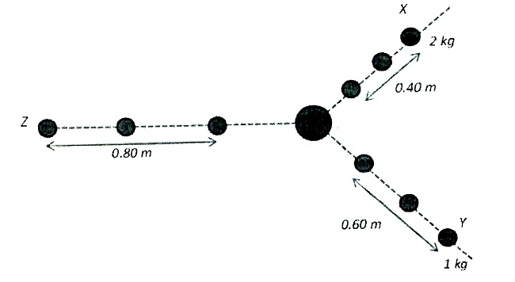
  - 1.25 kg
  - 1.50 kg
  - 2.00 kg
  - 0.85 kg
  - 3.00 kg

- (SJPO 2011, 1st round) A 8.0 g bullet is shot into a 4.0 kg block, at rest on a frictionless horizontal surface. The bullet remains lodged in the block. The block moves toward a spring and compresses it by 9.4 cm. the force constant of the spring is 1000 N/m. the initial speed of the bullet is closest to
  - 710 m/s
  - 740 m/s
  - 770 m/s
  - 800 m/s
  - 830 m/s

- (SJPO 2013, 1st round) A particle exhibiting uniform circular motion with radius r has its speed increased 3 times and the centripetal force is hence increased by 64 N. the original centripetal force is
  - 16 N
  - 12 N
  - 8 N
  - 6 N
  - 18 N

- (SJPO 2010, 1st round) Two very large parallel sheets carry equal but opposite uniform surface charge densities. A point charge that is placed near the middle of the sheets equidistant from both of them feels an electrical force F due to the sheets. If this charge is now moved to half its distance from the positive plate, the force it will feel is closest to
  - F/4
  - 2F
  - F
  - 4F
  - F/2

- (SJPO 2013, 1st round) Two masses, m₁ and m₂, are joined by a massless spring of force constant k and placed on a horizontal frictionless surface. The system is released from rest when the separation between the masses is x. If the unstretched length of the spring is x₀, the speed of the mass m₁ when the two masses are at the distance x₀ apart is

- (SJPO 2011, 1st round) X-rays of wavelength 0.098 nm scattered from a newly discovered crystalline material are observed to have a first-order intensity maximum at an angle 20º measured from the incident direction as shown in the figure below. Assuming that the material is made of elemental atoms arranged in a cubic array, what is the number density of atoms in the material?
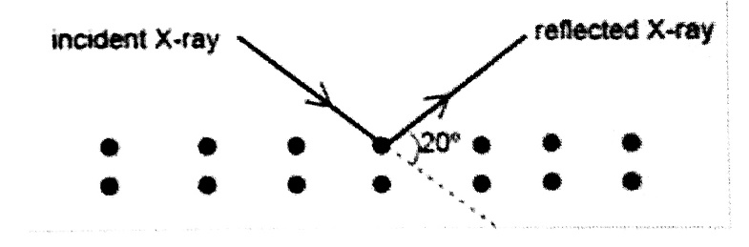
  - 4.4510²⁸ m⁻³
  - 8.0910²⁸ m⁻³
  - 2.2710²⁸ m⁻³
  - 4.3010¹⁹ m⁻³
  - 3.4010¹⁹ m⁻³

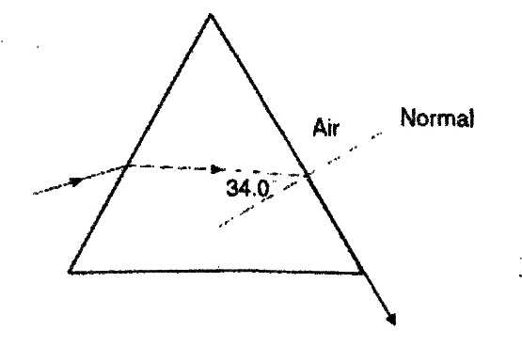
- (SJPO 2012, 1st round) The diagram below shows a ray of monochromatic light (5.0910¹⁴ Hz) passing through a glass prism. What is the speed of the light ray in the prism?

  - 1.6810⁸ m/s
  - 1.8110⁸ m/s
  - 3.0010⁸ m/s
  - 1.0310⁸ m/s
  - 2.6010⁸ m/s

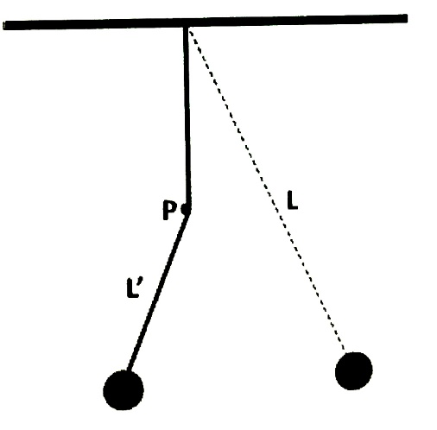
- (SJPO 2015, 1st round) As shown in the diagram, a pendulum of length L is hung from the ceiling and at a point P, a peg is placed. L’ denotes the shortened length of the pendulum during part of its oscillation. The period of the oscillation is now

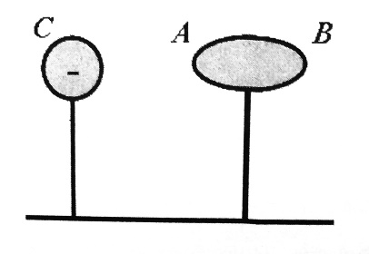
- (SJPO 2010, 1st round) As shown in the figure, a neutral conductor is mounted on an insulator and brought close to a negatively charged conductor C. When electrostatic equilibrium has been achieved, which of the following mathematical statements regarding the potential of the A and B ends of the conductor is true? Assume ground to be of zero potential.

