Dear Hui Qin and group members,

Thanks for submitting your GBA on time. I am pleased that you have put in reasonably good effort to meet the requirements of the GBA and submission on time. Your turnitin similiarity index of 19% is reasonable, therefore no cause for concern.

Overall, you did best for Q2a and Q2b. However, there is room for improvement for Q4a where you were did not manage to classify some level 3 activities under the correct Level 2 scope of activities.

You may refer to my other comments in the document.

Here is a detail breakdown of the individual components. For other details, please refer to my comments in the document:

|  |  |  |
| --- | --- | --- |
|  | **Maximum Marks** | **Awarded** |
| **Section 1: Understanding the Relationship between Organisation and Projects** | | |
| **Q1** | **12** | **9** |
| **Q2a** | **7** | **6** |
| **Q2b** | **5** | **4.5** |
| **Q2c** | **8** | **6** |
| **Section 2: Understanding Project Management Structures & Organisation Culture** | | |
| **Q3a** | **12** | **8.5** |
| **Q3b** | **12** | **7.5** |
| **Section 3: Defining Project and Estimating Project Times** | | |
| **Q4a** | **8** | **5** |
| **Q4b** | **6** | **4** |
| **Q4c** | **6** | **5** |
| **Section 4: Managing Project Risk** | | |
| **Q5a** | **12** | **9** |
| **Q5b** | **12** | **9.5** |
| **Total** | **100** | **74** |

Do continue to work hard and all the best in your ECA!

Cheers,

Shireen

http://www.unisim.edu.sg/about-unisim/Overview/PublishingImages/UniSIM_logo.gif

**BUS353e**

**Project Management**

**Assignment 2 – Group Based Assignment**

**January 2017 Presentation**

|  |  |
| --- | --- |
| **Name** | **Student ID** |
| Chin Wei Mun | Y1411180 |
| Low Hong Yen | H1510811 |
| Lim Hui Qin | Z1610579 |

Table of Contents

Question 1 3

Question 2 5

Part (a-i) 5

Part (a-ii) 6

Part (b) 6

Part (c-i) 8

Part (c-ii) 8

Question 3 9

Part (a) 9

Part (b) 10

Question 4 12

Part (a) 12

Part (b) 13

Part (c) 13

Question 5 14

Part (a) 14

Part (b) 15

Bibliography 16

# Question 1

According to Larson & Gray in their 2014 book, Project Management – The Managerial Process, projects can be classified into three categories, namely Compliance projects, Strategic projects and Operational projects. Such classification is essential for identifying the steps required for projects classified under the category.

Compliance Projects

Compliance projects, also called Emergency projects, are projects where organizations carry out to ensure that they comply with regulatory requirements such that they can avoid the penalties imposed. Such projects are necessary as they determine if organizations are allowed to operate in the region.

Project B is a compliance project because the crowd control system to be implemented is a requirement by Singapore Civil Defence Force (SCDF). According to the Evacuation Planning Guidelines 2013, the procedures for evacuation in the event of fire involve crowd management. For instance, the fire escape routes need to accessible by everyone at all times and everyone in the crowd has to be accounted for. Under Singapore Fire Safety Act Chapter 109A, anyone who is guilty of an offence under this act would be liable on conviction to a fine not exceeding $10,000 unless otherwise stated.

Strategic Projects

Strategic projects directly support the organization’s long-run mission, which can be directed toward increasing revenue or market share. This includes new products and research and development in the organization. Project C and Project F can be classified as strategic projects.

For Project C, by setting up its own fish farm, PMS will have a better control over the quality of the fresh produces they offer to customers. It reduces the likelihood of receiving unreliable or stale fish from vendors and suppliers. In addition, Project C helps to eliminate the middle-man in the supply chain, thereby cutting down on import costs. These envisaged deliverables are in line with PMS’ mission to “Enrich Customers’ Livings at Affordable Cost” where fresh produces are provided at lower cost.

For Project F, by offering membership and partnering with a bank, it incentivizes customers with SingaBank’s credit card to patron at PMS. Existing customers will also feel encouraged to sign up for the membership card where they can enjoy rebates or discounts when shopping at PMS, which they have already been doing. This helps in increasing customers’ loyalty with the supermarket and it is the first step for PMS to explore other great opportunities that can be leveraged on with SingaBank.

Operational Projects

Operational projects are projects designed to improve the efficiency of systems, reduce costs and improve performance to support current operations. Projects A, D and E can be classified as operational projects.

Project A is the implementation of customer self-checkout system at the supermarkets, which supports the current manual checkout process. It will potentially lower the supermarket’s operation cost as less manpower is required in the checkout process. Additionally, it increases the operations efficiency as manpower who was previously managing the checkout counters can be deployed to support other functions. Integrity of the checkout process is also maintained by leveraging on technology and customers will be performing their own checkouts.

Project D is the implementation of an online store where customers can make their purchases without having to be physically present in the store. It is an efficient and effective marketing strategy where customers can enjoy the convenience and flexibility of online shopping. Through this, PMS can also save on the operating costs by having less physical stores. The supermarket’s presence, however, will be heightened with the availability of online store. This allows PMS to reach out to a wider customer base and drive sales for their products.

Project E is to expand the warehouse at Tuas. It helps to improve the current logistic processes as a bigger warehouse means that PMS can afford to import and carry more products, be it in quantity or variety. It also allows PMS to enjoy economies of scale when they import in bulk from the suppliers. With a bigger storage area, products are less likely to be damaged as a result of space constraints and items in supermarkets will be stocked up in a timely manner. This will have a positive impact ton customers shopping experience.

# Question 2

## Part (a-i)

One of the criteria for selecting which project to implement is using financial criteria. For Projects A and B, one method of using financial criteria to evaluate project selection is using the Payback Period method. The Payback Period method measures the time it will take for PMS to recover the project investment; a shorter payback period is desirable. Such a method emphasizes on the cash flow of the organization, which is a key factor in business.

The formula for Payback Period is:

Payback Period (years) = Estimated Project Cost / Annual Savings

For Project A:

Payback Period (years) = $150,000 / $45,000

= 3.33 years

For Project B:

Payback Period (years) = $50,000 / $12,000

= 4.17 years

This means that PMS will take 3.33 years for Project A to recover the project investment made, whereas Project B will take up to 4.17 years to recover its investment.

Rate of Return is the annual income from an investment made, in this case, the percentage of income that will be received from implementing the projects.

The formula for Rate of Return is:

Rate of Return (%) = Annual Savings / Estimated Project Cost

For Project A:

Rate of Return (%) = $45,000 / $150,000

= 30%

For Project B:

Rate of Return (%) = $12,000 / $50,000

= 24%

This means that Project A will reap 30% income of the investment made while Project B will reap 24% of income of investment made.

Based on the above analysis of Payback Period and Rate of Return, Project A is the better project choice, as it will reap 30% income annually after the initial payback period of 3.33 years, rather than Project B reaping just 24% annual income after 4.17 years of payback period. There is a short payback period with high returns for Project A.

## Part (a-ii)

Apart from the Payback Period, PMS has to also take note of other selection criteria. One such selection criteria to consider would be the fact that Project B, being a regulation imposed by the Singapore Civil Defence Force, is a project mandatory to execute, and there will be penalties imposed if not adhered to.

Another consideration would be human safety. Project B is with regards to the crowd control system for efficient evacuation in the event of fire. Without the implementation of Project B, in event of fire, the lives of PMS stakeholders may be threatened. But with the implementation of Project B, it also gives external stakeholders confidence that PMS is concerned about the safety and wellbeing of its employees that a proper evacuation system is in place.

Hence, after consideration of the above two reasons, even though it takes a longer time for Project B to have a smaller rate of return, PMS should choose to implement Project B.

## Part (b)

Net Present Value (NPV) uses the management’s minimum desired rate-of-return to compute the value of all net cash inflows. If the NPV result meets the minimum desired rate-of-return, the project is eligible for consideration otherwise the project will be rejected.

Calculation of the Net flow according to the cash flow information provided is as below:

|  |  |  |  |  |  |  |  |
| --- | --- | --- | --- | --- | --- | --- | --- |
| **Project C** | | | | **Project D** | | | |
| Year | Inflow | Outflow | Net flow | Year | Inflow | Outflow | Net flow |
| Yr0 | 0 | 500,000 | -500,000 | Yr0 | 0 | 200,000 | -200,000 |
| Yr1 | 400,000 | 250,000 | 150,000 | Yr1 | 100,000 | 70,000 | 30,000 |
| Yr2 | 600,000 | 200,000 | 400,000 | Yr2 | 250,000 | 60,000 | 190,000 |
| Yr3 | 800,000 | 200,000 | 600,000 | Yr3 | 450,000 | 50,000 | 400,000 |

*Figure 1.1: Cash flow information (in S$) for Project C and D – with net flow*

With the number of years, outflow, net inflows, minimum desired rate of return and inflation, we can calculate the NPV for both projects. Required rate of return is calculated as the sum of minimum desired rate of return and inflation.

The following Excel shows the NPV computation for Projects C and D:

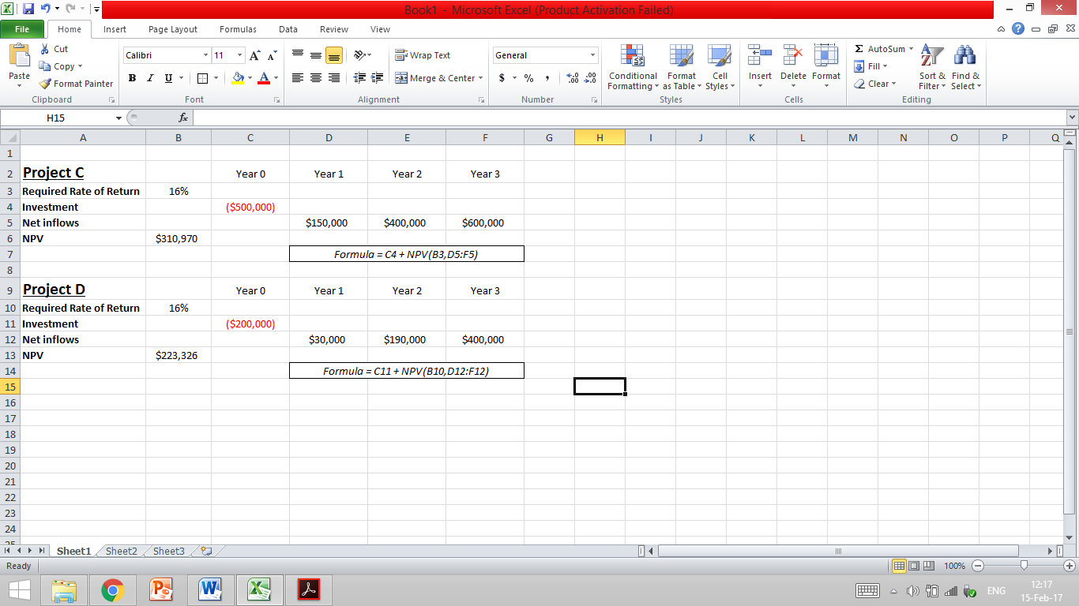

*Figure 1.2: Net Present Value (NPV) analysis for Project C and D*

According to the above computation, PMS can choose either Project C or Project D to implement, as both will generate positive NPV returns. Or, if there are other considerations such as resources allocation, PMS can choose to implement Project C rather than Project D, as Project C generates $310,970 NPV as compared to Project D’s $223,326.

## Part (c-i)

Apart from using financial criteria to evaluate the selection of projects, there are a few non-financial criteria PMS can take into account. Such non-financial criteria is of the realization that although profit-making is important for a business, long-term survival is dependent upon developing and maintaining core competencies of the business.

Firstly, the business needs to consider if the project to be implemented can capture a larger market share. PMS’ long-term goal is to be listed in the Singapore Stock Exchange by 2019. In order to receive this goal, most, if not all, of PMS’ activities should be directed to increasing revenue and market share among the customers.

Secondly, the business needs to consider if the project will develop core technology that can be used in its next-generation products. As technology is ever-changing, customer’s needs and habits are as well. It is important for PMS to catch up to the speed of changing technologies, so that they are not outdated and left behind other competitors, but rather, can adjust themselves to fit the needs and preferences of customers.

Thirdly, the business needs to consider if the project helps to reduce dependency on unreliable suppliers or inputs. For a business, reputation for being able to deliver goods and services of acceptable quality and timeline to customers is important. If PMS is encountering problems with its supplier on timely and acceptable quality goods, this will affect PMS’ relationship with its customers and affect sales in the long-run.

## Part (c-ii)

In our opinion, a project that impacts development of core technology that will be used in next-generation products should have the highest weightage.

As mentioned previously, technology is ever-changing and so are the tastes and needs of consumers. By focusing on projects that develop core technology that will be used in future, PMS can gain a competitive advantage and first-mover advantage over its competitors by forecasting what would be preferred by customers and attracting them first. In this way, market share and profits will be increased in the long-run as well.

# Question 3

## Part (a)

The first stakeholder identified is the Top Management of the organization. This includes the Chief Executive Officer, Chief Financial Officer, Chief Operations Officer and managers in the organization with influential powers. The dependency on top management is for them to approve the project funding and establish priorities amongst other projects or operations taking place concurrently. For instance, if the funding approved by the management is less than the project budget, the project team will need to redefine the project scope in order to ensure that the budgeted cost falls within the funds allocated. To cater to the dependency, project team can work closely with the stakeholder to ensure that the project receives adequate support and sufficient traction from the top management. Communicating project budget in advance and providing cost breakdown to top management is one method to facilitate the approval of funding required for the project.

The second stakeholder identified is the Contractors. This includes the software contractor who will be in-charge of the design, development and testing of PSC software. The dependency on contractors is the lack of control over quality of work and timeliness of task completion. They are external parties engaged for their domain expertise or availability of resources and they do not report to the project manager. For instance, if the contractors took a longer time than planned to develop the PSC software, it would result in schedule slippage where the overall project may get delayed. To cater to the dependency, project manager need to tactfully manage the relationship with the contractor in order to ensure that deliverable from contractor meets the project requirements. Scheduling weekly meetings with contractor is a controlling method that allows potential issues to be raised in a timely manner thereby reducing the impact on the project.

The third stakeholder identified is the Customers. They are the supermarket patrons, end-users of the self checkout counters. The dependency on customers is their purchasing requirements and satisfaction from the shopping experience which relates to the project scope and success. As they frequent the supermarket and make purchases, it is necessary that the self checkout counters designed meets their requirements. For instance, if the design of the checkout counters limits the number of items in each purchase, it would cause inconvenience to customers who often make bulk purchases. To cater to the dependency, the project team needs to first understand the customers purchase behaviors and identify their needs. This is helpful in defining the project scope and requirements. Incorporating a space for customers to place their items in the design of the checkout counters ensures that the project meets customers’ requirements when they perform checkout.

The fourth stakeholder identified is the Government Agency. In this case, it refers to the Monetary Authority of Singapore (MAS). The dependency on MAS is the constraints they place on the project as a result of their policies and guidelines on payment systems in Singapore. Being the local regulator, MAS oversees the payment system in Singapore to ensure its overall safety, efficiency and development. For instance, new changes to payment system introduced need to be pursued in coordination with monetary policy implementation process. To cater to the dependency, the project team needs to be aware of the existing policies and ascertain that the project scope and deliverable is compliant. When addressing the payment workflow design of the checkout counters, any ambiguity should be clarified with MAS and explicit clearance or approval should be obtained. This serves to defend the project integrity and safeguard the organization’s compliance to regulatory.

## Part (b)

Applying approach “separate the people from the problem” on stakeholder Top Management in negotiating conflict in priorities within organization.

In the situation where Mr Koh Hong Teck is tasked to work on the PSC project and another project relating to the relocation of supermarket warehouse, the top management would need to prioritize and agree upon which project take greater importance and require Mr Koh Hong Teck to render his immediate support. Project manager should refrain from being emotional about the prioritization and invoke feelings of biasness or anger to the situation. Instead of blaming Mr Koh Hong Teck for not committing to the PSC project, project manager should separate the person in question, Mr Koh Hong Teck, from the problem of resource allocation. Upon seeking management’s direction on priorities, project manager need to be objective when receiving the management decision. Project need to be planned in accordance to current resource availability and overcome the initial challenge.

Applying approach “when possible, use objective criteria” on stakeholder Contractors in negotiating quality of work done.

In the situation where the design of the PSC software done by contractor is deemed to be of inferior quality, both the project team and the contractor need to discuss and agree on what is perceived as “acceptable quality”. This can be achieved by using objective criteria for fairness from an independent source. The objective criteria serves as an unbiased benchmark that both parties can rely on to facilitate the discussion. The industry standard for self checkout software design or software designs from companies that have successfully implemented self checkout counters can be used as the objective reference. It provides both project team and contractor a guidance as to what is deemed as “acceptable quality”. Requests raised with reference to the objective criteria would therefore be more appealing and accepted by both project team and contractor.

Applying approach “invent options for mutual gain” on stakeholder Customers in negotiating expectations of self checkout counters.

In the situation where self checkout counters are only designed to accept either cash or electronic payments but the project scope includes customers’ flexibility in deciding the mode of payment to use when making purchases, be in cash payments or electronic payments. By proceeding with the current design where self checkout counters only accept electronic payment, customers’ flexibility would need to be compromised. To create a scenario where both the project team and customers can have their requirements met, project manager need to devise a new solution to solve the issue. As it is technically challenging to have one self checkout counter accept both cash and electronic payment methods, the project manager can propose having two self checkout counters accepting cash payment while the remaining three to accept electronic payment. The proposed solution provides both parties with mutual gain where customers retain their flexibility is choosing the payment method and project team is able to implement the solution without much difficulty.

Applying approach “focus on interests, not positions” on stakeholder Government Agency in negotiating non-compliance to regulatory requirements.

In the situation where Infocomm Media Development Authority (IMDA) rejects the application for installation of network cables due to policy requirements in “Guidelines on Use of Telecommunication Riser Ducts”, it is important for project manager to focus on the overall interest of the situation rather than being defensive. The overall Interest lies in the true intention behind the application rejection, without thorough consideration, project team may take unnecessary extreme measures to defend the application for installation. Rejection could be due to overloading of riser ducts which is unknown prior to the examination by IMDA. The solution would be for project team to work with IMDA to resolve the riser ducts capacity constraints, after which the project team would be able to continue with the installation of network cables for self checkout counters.

# Question 4

## Part (a)

Work Breakdown Structure for PSC Project.

1. PMS Self Checkout Counter (PSC) Project
   1. Coordinate & Purchasing *(In Charge: Project Manager)*
      1. Assemble project team and contractors
      2. Study customers & staff requirements
      3. Conduct site survey for contractors
      4. Purchase Point of Sales terminals
      5. Purchase banking equipment
   2. System Design & Testing *(In Charge: Retail System Manager, Ms Helina)*
      1. Design PSC System
      2. Hack concrete floor
      3. Layout electrical cable
      4. Layout network cable
      5. Test connectivity with banks
      6. Test overall system
   3. Facilities & Installation *(In Charge: Facilities and Hardware Manager, Mr Koh)*
      1. Install checkout stations
      2. Publicize PSC System
      3. Put on signature and fixtures
      4. Train store staff
      5. Launch PSC System

## Part (b)

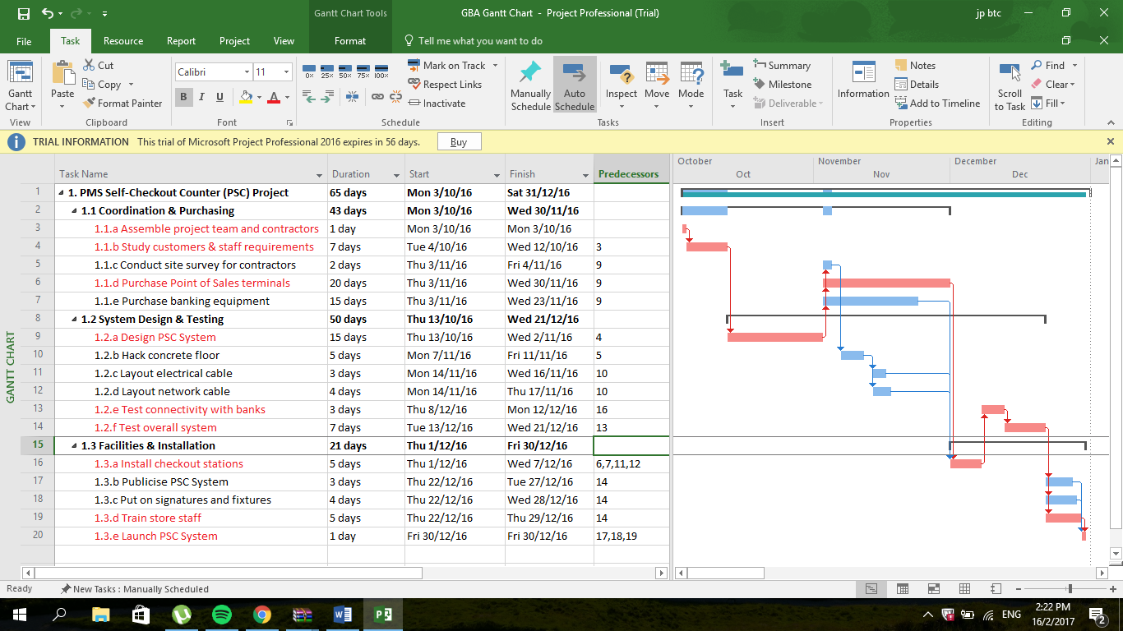

*Figure 4.1: Gantt Chart for PSC Project*

## Part (c)

Base on the Gantt Chart, the project will be completed on 30 December 2016. The project follows the following critical path:

*(1) PMS Self-Checkout Counter (PSC) Project 🡪 (2) Assemble project team and contractors 🡪 (3) Study customers and staff requirements 🡪 (4) Design PSC System 🡪 (6) Purchase Point of Sales terminals 🡪 (11) Install checkout stations 🡪 (12) Test connectivity with banks 🡪 (13) Test overall system 🡪 (16) Train more staff 🡪 (17) Launch PSC System*

The PMS Self-Checkout Counter (PSC) Project will be completed a day ahead of schedule. There is no clash of activities and the schedule is planned with some slack in between. The table below shows the activities that have free slack. Free slack refers to the amount of time an activity can be delayed without delaying the early start of any successor activity.

|  |  |
| --- | --- |
| Activity | Free slack |
| Purchase banking equipment | 5 |
| Layout electrical cable | 10 |
| Layout network cable | 9 |
| Publicize PSC System | 2 |
| Put on signatures and fixtures | 1 |

# Question 5

## Part (a)

|  |  |  |  |
| --- | --- | --- | --- |
| **Item** | **Category** | **Description of Risk** | **Consequence** |
| Risk 1 | Technical | Issues related to the performance and reliability of the Point of Sales terminals may arise. The terminals may be dysfunctional or turns faulty shortly after purchasing. For instance, the terminals may experience frequent breakdown or have some functions that are not working properly such as the touchscreen being insensitive. | New terminals must be purchased to replace the dysfunctional ones or hire technicians to conduct maintenance of the machines that are faulty. This would add on to the cost of implementing the project and pose financial-related issues. For instance, the project manager might have to cut down on the cost of other activities to ensure the project does not exceed its budget. |
| Risk 2 | External | Goods and services may be delayed and not delivered on time by suppliers and contractors. For instance, the delivery of the Point of Sales terminals or banking equipment may be delayed due to unforeseen circumstances such as bad weather or political unrest. The contractor’s firm may quit halfway through the project as well. | A delay in delivery of the Point of Sales terminals and banking equipment would affect the start date of other activities such as the installation of checkout stations. Similarly, the project would be delayed if the contractors were to quit halfway. Moreover, this would incur extra cost for the project as the project manager has to source and hire new contractors. |
| Risk 3 | Organizational | The PSC project requires managers and employees from various department to work together to ensure the schedule of the project can flow smoothly. For instance, the facilities and hardware manager has to inform the retail system manager when the installation of the checkout stations are completed so that the latter can test the overall system. Hence, a working environment that does not encourage cooperation and collaboration across different departments is a risk. Managers rarely communicate with one another and only focus on completing tasks and meeting goals related to their own department. | Without proper communication and a supportive working environment, misunderstandings and workplace conflict can arise easily thus causing disruptions to the project. For instance, the retail system manager would not know when the system is ready for testing and might push the blame on the hardware and facilities if it results in a delay of the schedule. |
| Risk 4 | Project Management | The project manager may underestimate the duration of the project. Some of the activities may take a longer time to complete as compared to what was initially planned. For instance, it might take more than 2 days to conduct site survey. | The project will not go according to schedule if the project manager underestimates the duration as certain activities cannot be carried out if their predecessors are incomplete. This would result in the project not meeting its stipulated deadline and hence, the system would be unable to launch by 31 December 2016. |

## Part (b)

Technical Risk

The technical risk can be responded by transferring it. Transferring risk does not change the risk but pass the responsibility to another party. This can be achieved by ensuring the goods purchased come with warranty. With warranty, the suppliers would be bounded to offer free of charge maintenance or one-to-one exchange of the Point of Sales terminals or banking equipment should any of the items become faulty or malfunction while under the warranty period. In so doing, the concern of incurring extra cost as a result of technical risk would reduce, the budget of the project would not be affected as well.

External Risk

The external risk can be responded by avoiding it. Risk avoidance is changing the project plan to eliminate the risk or condition. To avoid late delivery of the goods, materials can be purchased from countries that are politically stable. For instance, purchasing from an Australian supplier would reduce the chance of any disruptions in the supply of the materials due to political unrest as compared to purchasing from an Indonesian supplier. Moreover, research can be done beforehand to avoid these external risks such checking if the country is going through any major events that could hinder the supply process or choose to work with contractors who are more reputable in the industry and/or have good reviews.

Organizational Risk

The organizational risk can be responded by mitigating it. This means to either reduce the likelihood of the event occurring and or the impact that the adverse event would have on the project. As a project manager, the chances of miscommunication and work-related conflicts can be reduced by creating a conducive and positive work environment that supports collaboration and communication. For instance, communication can be improved by having frequent meetings so that managers from different departments can update each other on the progress of the project, thus providing transparency and ensuring the project flows smoothly.

Project Management Risk

The project management risk can be responded by retaining it. This refers to a conscious decision to accept the risk of an event occurring. For instance, if a flood were to occur and cause disruptions to the installations work, the project manager can only react to it and re-work the project schedule. As it is a result of natural causes, project manager need to keep in mind the possibility of uncontrolled event occurring and acknowledge the risk. This risk is being retained by the project team as there is minimal external dependency and it would need to be resolved internally as a team or by the project manager.

# Bibliography

*Emergency Response Plan.* (2013). Retrieved 2017, from Singapore Civil Defence Force: https://www.scdf.gov.sg/content/scdf_internet/en/building-professionals/fire-safety-permit-and-certification/emergency-response-plan1/_jcr_content/par/download_3/file.res/ERP%20-%20Evacuation%20Planning%20Guidelines%20v2.pdf

*Fire Safety Act (Chapter 109A).* (n.d.). Retrieved from Singapore Statutes Online: http://statutes.agc.gov.sg/aol/search/display/view.w3p;ident=cfa49bc1-1542-4d1f-bf7a-826564ff1721;page=0;query=DocId%3A%22b66f6cff-ff65-4bd3-8d25-6f2d3ed97176%22%20Status%3Ainforce%20Depth%3A0%20ValidTime%3A20170219000000%20TransactionTime%3A2017021900000

Larson, E. W. & Gray, C. F. (2014), *Project Management – The Managerial Process 6th Edition*,

McGraw-Hill Education