http://www.unisim.edu.sg/about-unisim/Overview/PublishingImages/UniSIM_logo.gif

**ANL201**

**Data Visualization for Business**

**Assignment 2 – Group Based Assignment**

**January 2017 Presentation**

|  |  |
| --- | --- |
| **Name** | **Student ID** |
| Hafizah Binte Md Azhar | Y1073356 |
|  |  |
| Lim Hui Qin | Z1610579 |

Contents

Question 1 4

1 Part (a) 4

1 Part (b) 4

1 Part (c) 5

1 Part (d) 6

Question 2 8

2 Part (a) 8

2 Part (b) 8

2 Part (c) 9

2 Part (d) 10

2 Part (e) 11

Question 3 12

3 Part (a) 12

3 Part (b) 13

References 14

# Question 1

## 1 Part (a)

RCA is a well known brand in the consumer electronic industry. It started out focusing on the broadcasting industry by selling GE and Westinghouse’s radio equipment before venturing into selling consumer electronics products. It then diversified into other non related industry and successfully became a conglomerate. The existing General Manager, David Sarnoff, stepped down and handed the company over to his son Robert Saarnoff in 1970. When David Sarnoff died a year later, it was said that “much of RCA’s success died with him” (History of the manufacturer RCA (RCA Victor Co. Inc.); New York (NY)). This might be because he did not properly groom his son to be his successor. Due to Robert Sarnoff’s inexperienced, RCA’s research and development on its existing product lines stagnate (Davis, 1987). In 1971, RCA stopped manufacturing computers despite being one of the eight major computer companies in the 1960s. Internal conflicts among the management weakened the company further. RCA lost money when it introduced new consumer electronic products such as the ‘SelectaVision videodisc system’ as it was technologically obsolete (History of the manufacturer RCA (RCA Victor Co. Inc.); New York (NY)). This eventually led to the downfall of RCA.

## 1 Part (b)

The Balanced Scorecard (BSC) was designed in the early 1990s by David Norton and Robert Kaplan (Tay, 2017). In using the BSC, the organization is viewed from four perspectives – Learning and Growth, Internal Processes, Customer and Financial – to determine its overall performance. This enables the organization to get a more accurate feedback than if only the financial perspective is used.

The Learning and Growth perspective is also sometimes referred to as the Innovation and Development perspective. This perspective looks at the organization’s ability to introduce new products and services as well as its ability to improve productivity by working on its key processes. One example of key processes would be the training or help and tools made available to the employees to help them in carrying out their work. After World War II, RCA introduced many innovative consumer electronic products into the market successfully. When David Sarnoff failed to groom his successor, the lack of training and learning led to RCA’s progress being stagnant. In the 1970s, introduction of new consumer electronic products was unsuccessful. The technology used was outdated. RCA should have spent more time in doing research to develop a more advanced technology.

Under Internal Process perspective, key business processes for success must be identified after which measures are to be introduced to monitor the performance of the said processes. This perspective may not have been well looked into when RCA decided to abandon the computer business. If RCA continued on its research and development as well as improved its processes in manufacturing computers, it might not have lost $250 million in writeoff (Davis, 1987).

Customer’s satisfaction in any business is crucial. With many organization offering similar products, customers are able to pick and choose who they do business with. As such, it is important for an organization to devise measures from the customers’ perspective to increase performance. Under Customer perspective in the BSC, the organization needs to identify customers’ requirement for the products and services provided to them. RCA’s business strategy may have failed because it did not ask its customers what they want.

The last perspective, Financial, is the traditional measure used by all organizations to monitor their success. Here, profitability is one measure to determine the success of the organization. RCA lost $250 million in write-off when it was manufacturing computers. This could be due to the measures in the other three perspectives discussed earlier not selected appropriately, thus affecting the overall profitability of the company.

## 1 Part (c)

A good Business Performance Measure enables the organization to track or gauge its progress. Performance measures can be grouped into three categories – input, output, and outcome. As the name suggests, input measures are typically used to track the inputs by the organization. This helps the organization in decision making and analysis of actual results, although limited. To be able to determine if the results are achieved, output measures are used. These are results generated from the inputs. Outcome measures give information on how a certain activity benefits the shareholder.

One measure RCA should have used to measure its performance would be tracking the top 6 most popular items sold. From here, it would be able to see if any of the new products introduced is popular. If many of the new products are reflected in the list, RCA would be able to conclude that the introduction of the said products is well received by its customers. With the introduction of the ‘SelectaVision’ videodisc system, RCA should have tracked how well was its sales.

Another measure RCA could use would be the profit made selling these new products as compared to the old products. If the new products were very popular and especially if they bring in more profits, RCA should continue producing them.

## 1 Part (d)

**Business Performance Measure: Top 6 Most Popular Item**

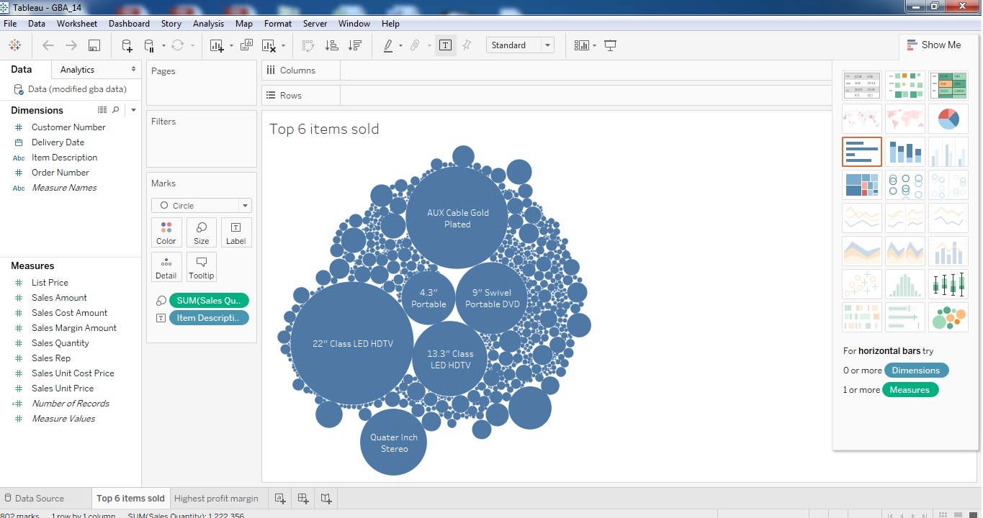

Based on the bubble chart, the top 6 most popular items in terms of quantity sold are:

* 22” Class LED HDTV
* AUX Cable Gold Plated
* 13.3” Class LED HDTV
* 9” Swivel Portable DVD
* Quarter Inch Stereo Interconnect Cable
* 4.3” Portable Pocket Digital ATSC LED TV

**Business Performance Measure: Highest Profit Margin**

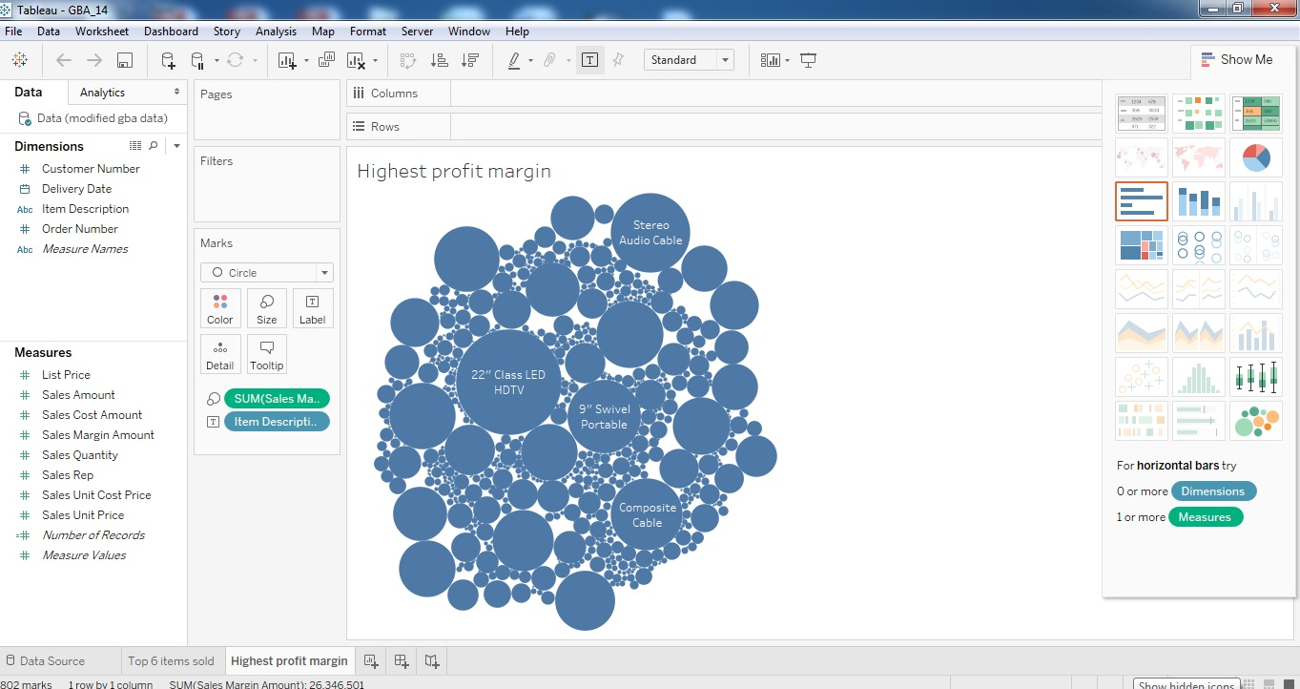

Based on the bubble chart above, the products with the highest profit margin are:

* 22” Class LED HDTV
* 9” Swivel Portable DVD
* Stereo Audio Cable
* Composite Cable

# Question 2

## 2 Part (a)

Yes, Nintendo is a strategy focused organization. Its goal is to “maximize long term corporate value while trying to benefit everyone and everything impacted by their company”. This goal is supported by its organization structure where development heads roll up to general managers who report to President Chief Production Office. This allows new ideas or proposed changes to be highlighted in a systematic manner for implementation.

Another strategic direction by Nintendo is its plan on expansion and early venture. Though it stared out in the playing cards industry, the company perceived a lack of further development and sought opportunities in other industries. It took bold decisions to venture into love hotels, taxi services, toy market and video games. Although some ventures had failed, Nintendo managed to make its mark in the video gaming industry.

## 2 Part (b)

The first business performance measure is the profitability of research and development. It measures the net profit from the revenue generated by products and the cost spent on research and development. It belongs to the financial perspective of the Balanced Scorecard.

The financial perspective often revolves around growth, profitability and increase in shareholder value. For all profit oriented organization, financial perspective is an important measure to determine the company’s performance. However, it should not be over emphasized in case it results in an unbalanced view. For instance, the profitability of research and development may not necessary mean that the organization has improved overall. There could be a setback in terms of innovation but it went unnoticed because the focus was on profitability. Financial perspective is also crucial in shaping the organization’s strategic objective. As the end state for most organizations is to witness financial growth, it is natural for organizations to factor in financial gains in objective setting.

Line chart can be used to represent this measure. Line chart is useful in representing time series data and spotting trend line. Since profitability is measured at interim time period, such as every quarter or annually, the horizontal axis on the line chart can be used to show the timeline. The vertical axis would therefore represent the profitability in dollars. When plotted, any gains or loss can be easily identified visually. It also serves to show progression or pattern over time.

The first business performance measure is the percentage of passes in quality checks. It measures the percentage passes based on the number of products that clear the quality checks and the number of products sampled. It belongs to the internal business process perspective of the Balanced Scorecard.

The internal business process perspective allows managers to understand the business performance and if customers are satisfied with the products and services. It is important to identify the key business processes that have direct impact to the organization’s operations and determine how best to monitor. For instance, although product development is essential to Nintendo, the percentage of passes in quality checks show the products’ quality and standard. While mass quantity of the products can be produced and sold, it does not mean that the products meet customers’ expectations. Hence the need for quality checks to be conducted serves as a form of control. Product quality is an aspect within internal business processes that should not be neglected.

Bar chart can be used to represent this measure. The horizontal axis of the bar can be used to represent the various products produced or the different batches in the production line. As percentage of passes in quality checks is not time sensitive and each round of quality checks conducted are independent, each bar would show a category. The vertical axis itself would represent the percentage pass calculated from each cycle of quality checks.

## 2 Part (c)

A possible target value for the percentage of passes in quality checks would be for every team to achieve at least 85% pass in quality checks for their products. Below are some considerations when setting up this target value.

**Easily understood and communicated**

The target value is straightforward and can be easily disseminated to the team. To ensure that everyone is aware,, the managers can include this as an agenda item in team meetings.

**Clear in established expectations**

The target value set is clear in terms of what is to be expected. Example, for every 100 products being sampled for quality checks, there should be less than 15 products that are defects from the sample.

**Encouragements given to stretch performance**

The target value is standardized across the function used to measure performance. To encourage employees, managers can reward the team that exceeds targets such that they feel motivated.

## 2 Part (d)

The following are considerations when designing the two business performance measures.

**Impact to organization’s strategic objective**

Both measures have a direct impact to Nintendo’s objective of “producing and marketing the best products and support services available”. Research and development is an indication of the products’ customer value while the quality checks ensure that products meet the standards.

**Measurability of the business performance measures**

Both measures are quantitative in nature hence measureable. Profitability of research and development can be measured by calculating the net profit from revenue generated from the products and amount send on research and development. Percentage passes in quality checks can be measured by taking the ratio of passes to the total sample.

**Availability and accessibility of data required to derive the measure**

Data required to measure profitability of research and development can be extracted from the Nintendo’s accounting system or from the annual cash flow statement. Data required to measure percentage passes in quality checks can be extracted from the Operations information system where the data on production workflow is available. In terms of accessibility, it is dependent on the role and job scope of the analyst as some data may be classified as restricted.

**Frequency of measurement**

Frequency of measuring the profitability of research and development can be done quarterly or yearly, depending on business needs. This allows the management to review the budget and cost effectiveness. Frequency of measuring percentage passes in quality checks can be done more regularly, for instance monthly or in sync with production cycle. As quality checks are conducted periodically, it is necessary to ensure that percentage passes are being tracked.

## 2 Part (e)

Profitability of research and development is a lagging measure. It can only be measured at the end of a time period, for instance after the first quarter of the year. As it is historical in nature, the data is often easy to identify and extract. However it lacks predictive power. The measurement may not stand true or give a reflection of future occurrence.

Percentage passes in quality checks is a leading measure. It can be used to drive other measures such as customer satisfaction or regulatory compliance. By measuring the intermediate process in product development by checking the quality, it provides a guide as to the number of complaints expected to receive as a result of defects. This allows Nintendo to make interim changes to the current process.

# Question 3

## 3 Part (a)

Edward Trufte mentions that chart junks are charts whereby comparisons between the time dimension axis and widget dimension axis is impossible. This is evident in the bar graph shown in (o) due to several reasons.

**Selective and incoherent data representation**

Firstly, the quantitative measurements of both the dimension and time axis are inconsistent. For example, in the time axis, the quarters are selectively displayed as QI 2014, Q2 2014, Q3 2014, Q2 2015 and Q3 2015. Without any apparent reason, the quarters Q4 2014 and Q1 2015 have been left out. This causes the bar chart to be incomplete, biased and selective in its viewing.

Furthermore, the widget axis firstly does not only begin with 0 but it has inconsistent in its readings. The bar Q1 2014 is seen to be 3 times more than Q2 2014 when in fact the bar Q2 2014 is actually almost 60% in value of Q1 2014. The bar has visually handicapped this interpretation as it fails to start its widget axis with 0 values. Moreover, the widget axis is inconsistent in its interval whereby some intervals are 3 and other are 5. According to Nathan Yau, “allowing across points is the main purpose of visualization (Yau 2013). As such, the incoherent intervals has failed in allowing us to interpret is data.

**Readability**

The 4 horizontal gridlines across the bars causes comparison to be almost impossible due to it’s fain colours. With reference to the colour scale charts (Yau 2013), the comparative grid lines fall under the narrow colour scales which causes readers to squint and misinterpret the data. Hence the visualization is a failure.

**Visual hierarchy**

As mentioned by Nathan Yau, “When you look at visualization, you tend to spot thing that stand out.” (Yau 2013)When looking at the bar chart, noticeably the Bars of Q1 2014 and Q3 2014 are of a bigger width than the rest. As such, readers would focus more on these bars and its data. Also, Q3 2015 bar seems to be spaced further away from the other bars causing reader to pay lesser attention to this data. Hence the visualization is a failure.

In conclusion, the bar data is bias and incoherent as it is selective in highlighting certain data such as Q1 2014 and outstands selective data making this a bias visualization. Furthermore its use of colours and inconsistency causes difficulty in visualizing and hence making it a junk chart.

## 3 Part (b)

Data visualisation is effective through a well-represented chart. A visually appealing chart should consist of visual hierarchy, readability, comparisons, contacts and negative space. This allows the user to interpret the chart intuitively.

Firstly, the bar chart can be improved by having a consistent widget and time dimension axis. The widget axis should start from 0 with regular intervals at 10 or 25 increments. The time axis should be consistent and show all four quarters from 2014 to 2015.

Secondly, the width of the bars should be standardized and there should have equal negative space in between each bar. For ease of comparison, the comparative grid lines should be of a broader colour scale whereby the gridlines are darker and more visible.

Thirdly, the chart labels should be consistent and adopt the same format. It should also be in a progressive order form left to right. It would also be helpful to include the scale of measurement used in the data labels and chart title should be concise. This would enhance the overall look and feel of the chart, making it appear more professional and enhance the clarity of the information presented.

Lastly, since the bar chart represents a quarterly data, it should ideally only span across one year to avoid any misconception or misinterpretation of the chart. It is recommended to show data for 2014 and 2015 separately on two charts.

An example of the improved chart is included below for reference with the use of dummy data.

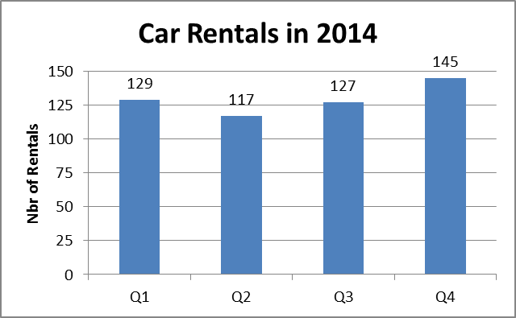 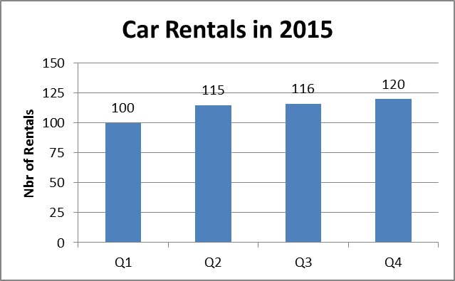

# References

Davis, L. (1987, September 20). *Did RCA Have To Be Sold?* Retrieved February 12, 2017, from The New York Times: http://www.nytimes.com/1987/09/20/magazine/did-rca-have-to-be-sold.html?pagewanted=all

*History of the manufacturer RCA (RCA Victor Co. Inc.); New York (NY)*. (n.d.). Retrieved February 27, 2017, from Radio Museum: http://www.radiomuseum.org/dsp_hersteller_detail.cfm?Company_id=743

Tay, E. (2017). *ANL 201 Data Visualisation for Business Study Guide.* Singapore: SIM University.

Yau, N. (2013). *Data points: Visualization that means something*. United States: John Wiley & Sons.