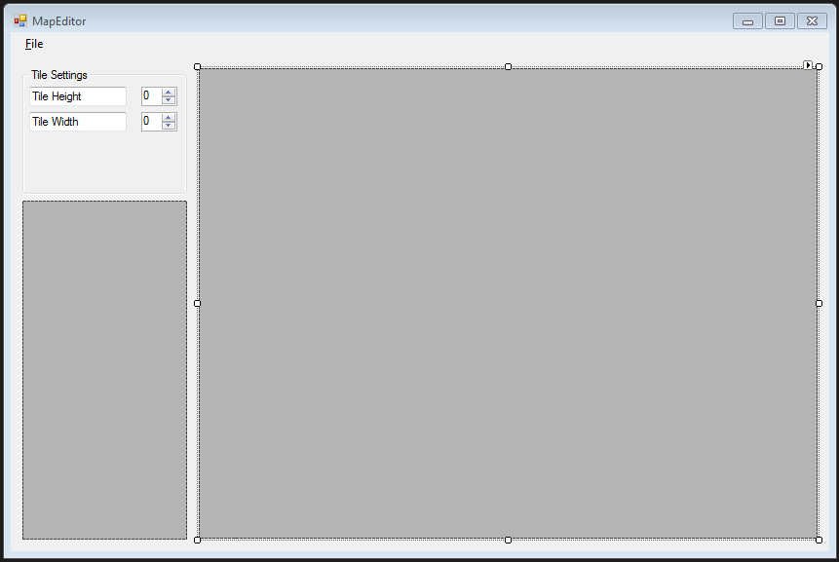

Simple map editor which will take in tile map and allow user to individually select tiles and arrange them in a grid to create a map.

Box to the left will give preview of tiles and larger box to the right will contain the grid where the tiles can be placed.