KMS STARFARM
Knowledge Management System

User Guide & Project Overview
With screenshots · Step-by-step instructions · KPI framework

Version: 1.0 — August 28, 2026
System: KMS Starfarm v1.0.0
Purpose: Response to CTU deliverables request — project showcase & user manual
Status: Live system · All screenshots taken from the running application

KMS Starfarm — Knowledge Management System

User Guide & Project Overview
**Document** | KMS Starfarm User Guide
**Version** | 2.0
**Date** | August 28, 2026
**System** | KMS Starfarm v1.0.0
**Purpose** | Project deliverable & end-user guide (CTU request response)

Table of Contents
- Introduction
- System Architecture
- Use Cases by User Role
- Getting Started
- KPI Analysis Dashboard
- Document Management
- AI Chat Assistant (RAG)
- Knowledge Pipeline Configuration
- KPI Extraction & Review Workflow
- Settings & Administration
- End-to-End Scenario Walkthroughs
- Appendix

1. Introduction

1.1 What is KMS Starfarm?
KMS Starfarm is a full-stack Knowledge Management System (KMS) with integrated Retrieval-Augmented Generation (RAG) capabilities. It was designed to help agricultural programme teams store, search, analyse, and extract insights from their project documentation in one centralised platform.
Key capabilities:
- Document repository — Upload, parse, organise, and preview project documents (PDF, Word, text, etc.).
- AI-powered search & chat — Ask natural-language questions and receive answers grounded in your own documents, with source citations.
- KPI extraction & dashboard — Automatically extract performance indicators from uploaded reports and visualise them across agricultural value chains.
- Multi-tenant & role-based — Support for organisations, teams, roles, and API keys.

1.2 Purpose of This Document
This guide serves a dual purpose, in response to the CTU deliverables request:
- Showcasing project progress — Demonstrating the current state of the KMS, its features, and the extent of implementation to date (including KPIs, indicators, and document management).
- Teaching end users how to operate the system — Step-by-step instructions for every major feature, illustrated with screenshots from the live application.

1.3 Intended Audience
- Programme managers and reviewers who need to understand what the KMS delivers and how it works.
- End users (project staff, analysts, field coordinators) who will use the system day-to-day.
- System administrators who will configure and maintain the platform.

2. System Architecture

2.1 High-Level Platform Overview
The platform is a monolithic web application comprising a React frontend, a FastAPI backend, an LLM inference server, a vector search engine, and a task queue — all running locally without Docker.
┌─────────────────────────────────────────────────────────────────────┐
│ KMS STARFARM PLATFORM │
├─────────────────────────────────────────────────────────────────────┤
│ │
│ ┌─────────────┐ │
│ │ React SPA │ Dashboard · Chat · Documents · KPI Review │
│ │ (port 5173)│ Settings · Knowledge Config · Auth │
│ └──────┬──────┘ │
│ │ HTTP / REST API calls │
│ ▼ │
│ ┌──────────────────────────────────────────────────┐ │
│ │ FastAPI Backend (port 8081) │ │
│ │ │ │
│ │ /chat · /ingestion · /config · /dashboard│ │
│ │ /auth · /embed · /database · /api-keys │ │
│ └────┬──────────────┬──────────────┬───────────────┘ │
│ │ │ │ │
│ ┌────┴────┐ ┌──────┴──────┐ ┌───┴──────────┐ │
│ │ LLM │ │ FAISS │ │ Celery + │ │
│ │ Server │ │ Vector │ │ Redis │ │
│ │ (8000) │ │ Store │ │ (6379) │ │
│ │ │ │ (local) │ │ async tasks │ │
│ └─────────┘ └─────────────┘ └──────────────┘ │
│ │
│ ┌──────────────────────────────────────────────────────────┐ │
│ │ Data Stores │ │
│ │ ┌────────────┐ ┌──────────┐ ┌──────────┐ ┌───────────┐ │ │
│ │ │ SQLite / │ │ FAISS │ │ Local │ │ JSON │ │ │
│ │ │ LiteDB │ │ index │ │ uploads │ │ (KPI │ │ │
│ │ │ (meta) │ │ (vectors│ │ (files) │ │ cache) │ │ │
│ │ └────────────┘ └──────────┘ └──────────┘ └───────────┘ │ │
│ └──────────────────────────────────────────────────────────┘ │
└─────────────────────────────────────────────────────────────────────┘

2.2 Technology Stack
Layer | Technology | Role
**Frontend** | React 18 + TypeScript + Vite 6 | SPA user interface
**UI Components** | shadcn/ui (Radix UI) + Tailwind CSS 3.4 | Component library + styling
**Routing** | React Router DOM v7 | Client-side routing
**Charts** | Chart.js + react-chartjs-2 | KPI dashboard visualisations
**PDFs** | react-pdf + pdfjs-dist | In-app document preview
**Backend** | FastAPI (Python 3.11–3.12) | REST API + business logic
**Task Queue** | Celery 5.4 + Redis 7 | Async parsing, summarisation, embedding
**LLM** | vLLM-MLX / Ollama (Llama 3.2 3B) | Chat generation, KPI extraction
**RAG Framework** | LangGraph + LangChain | Chatbot orchestration graph
**Embeddings** | HuggingFace `all-MiniLM-L6-v2` | 384-dimensional vector representations
**Vector Store** | FAISS | Approximate nearest-neighbor search
**Database** | LiteDB / SQLite (local) / PostgreSQL (prod) | Document metadata, users, roles
**Storage** | Local filesystem / MinIO | Uploaded file storage
**Auth** | Supabase Auth (mock mode for local) | JWT-based authentication

2.3 Component Responsibilities
Component | Path | Responsibility
Chat Routes | `kms/api/chat_routes.py` | `POST /chat/` — streams RAG answers via LangGraph
Dashboard Routes | `kms/api/dashboard_routes.py` | `GET/POST /dashboard/kpi*` — KPI CRUD, extraction, review
Ingestion Routes | `kms/api/ingestion_routes.py` | `POST /ingestion/` — file upload, document CRUD
Embed Routes | `kms/api/embed_routes.py` | `POST /embed/documents` — vectorise enabled documents
Config Routes | `kms/api/config_routes.py` | `GET/PUT /config` — pipeline settings
Auth Routes | `kms/api/auth_routes.py` | `POST /auth/signin, signup, signout`
Retriever | `kms/retrieval/` | 6 strategies: default, semantic, keyword, hybrid, ensemble, reranked
Splitter | `kms/splitting/splitter.py` | 5 strategies: recursive, semantic, markdown_header, hierarchical, context_aware
Vector Store | `kms/vector_store/` | FAISS operations: add, search, delete, rerank, context compression
LangGraph Chatbot | `kms/chatbot/demo/graph.py` | 8-node state graph with checkpointer
Database | `kms/database/` | LiteDB/PostgreSQL document metadata storage
Embeddings | `kms/embeddings/embedding_service.py` | HuggingFace sentence-transformers embeddings

2.4 LangGraph RAG Pipeline — Chat Flow
Every question submitted via the Chat page passes through an 8-node LangGraph state machine before returning an answer. This is not a simple prompt → response — the system retrieves, reranks, generates, and self-checks before answering.
User Question
│
▼
┌────────────────┐
│ ROUTING │ Decides: "fallback" or "transform_query"
│ NODE │ (Currently forced to transform_query)
└───┬────────┬───┘
│ │
(fallback) (transform_query)
│ │
▼ ▼
┌────┐ ┌────────────────────┐
│END │ │ TRANSFORM QUERY │ LLM rephrases the question
└────┘ │ (rewrite) │ using chat history for context
└────────┬───────────┘
│
▼
┌────────────────────┐
│ CoT (Chain-of- │ Checks document summaries
│ Thought) │ from DB; decides if summaries
│ │ alone are enough or retrieval needed
└────────┬───────────┘
│
▼
┌────────────────────┐
│ RETRIEVE │ FAISS cosine similarity search
│ │ Returns top-K relevant chunks
└────────┬───────────┘
│
▼
┌────────────────────┐
│ RERANK │ Cross-encoder re-scores all
│ │ retrieved chunks, keeps top-20
└────────┬───────────┘
│
▼
┌────────────────────┐
│ GENERATE │ LLM generates streaming answer
│ (RAG chain) │ using chunks + chat history
└────────┬───────────┘
│
▼
┌────────────────────┐
│ HALLUCINATION │ Two-step grading:
│ CHECK │ 1) Is answer grounded in docs?
│ │ 2) Does answer address the Q?
└───┬────────────┬───┘
│ │
(not supported) (useful → END → returned to user)
│
▼
┌────────┐
│ END │ Fallback message returned
└────────┘
Node detail:
Node | What it does | LLM calls
**Routing** | Classifies the question type; currently forces all questions to `transform_query` | None (hardcoded)
**Transform Query** | Rewrites the question using chat history, decomposes into sub-queries | 1 (rewrite chain)
**CoT (Chain-of-Thought)** | Reads all document summaries from DB; decides if summaries alone answer the question | 1 (CoT chain)
**Retrieve** | FAISS similarity search using the transformed query; returns top-K chunks | None (vector search)
**Rerank** | Cross-encoder model rescores retrieved documents by relevance; keeps top-20 | None (cross-encoder)
**Generate** | LLM generates answer from retrieved chunks + summaries + chat history | 1 (generate chain)
**Hallucination Check** | Two-step: grades if answer is grounded in docs, then grades if answer addresses question | 2 (hallucination + correctness chains)
**Fallback** | Returns: *"I'm sorry, I don't know how to answer that..."* | None

State persisted across turns via a file-based checkpointer (kms_memory.pkl), enabling multi-turn conversations with memory.

2.5 Document Lifecycle
Every document goes through a defined pipeline from upload to queryability:
UPLOAD PARSE CHUNK EMBED INDEX
┌──────────┐ ┌──────────┐ ┌──────────┐ ┌──────────┐ ┌──────────┐
│ File │ │ Text │ │ Split │ │ Vector │ │ FAISS │
│ saved │──▶│ extraced│──▶│ into │──▶│ embed │──▶│ added │
│ locally │ │ from │ │ overlap-│ │ 384-dim │ │ to │
│ │ │ PDF/ │ │ ping │ │ vectors │ │ index │
│ LiteDB: │ │ DOCX │ │ chunks │ │ │ │ │
│ status= │ │ LiteDB: │ │ LiteDB: │ │ LiteDB: │ │ Search │
│ unparsed│ │ status= │ │ chunks │ │ status= │ │ ready │
│ │ │ parsed │ │ stored │ │ enabled │ │ │
└──────────┘ └──────────┘ └──────────┘ └──────────┘ └──────────┘
│ │
Only if ENABLED When ENABLED
(user toggle) (user toggle)
Key rules:
- Upload saves file to uploads/, creates metadata in LiteDB with parsing_status = "Unparsed".
- Parse extracts text (via docling, mistral_ocr, or text_loader), splits into chunks (default 1500 chars / 400 overlap), sets parsing_status = "SUCCESS".
- Enable toggle ON: chunks are embedded and added to FAISS → the document becomes searchable via Chat and usable for KPI extraction.
- Disable toggle OFF: chunks removed from FAISS → document no longer searchable. Metadata preserved.
- Delete removes file from disk, metadata from LiteDB, and vectors from FAISS (if enabled).

2.6 Data Store Topology
Store | Technology | What it stores | Location
Metadata DB | LiteDB (SQLite) | Document metadata, chunk info, user/role data, org data | `kms/documents.litedb`
Vector Index | FAISS | 384-dim embeddings + document chunk text | `vector_stores/faiss_index/`
File Storage | Local filesystem | Original uploaded files (PDF, DOCX, etc.) | `uploads/`
KPI Cache | JSON file | LLM-extracted KPI values (approved) | `dashboard_kpis.json`
KPI Pending | JSON file | Unapproved KPI extraction results | `dashboard_kpi_pending.json`
KPI Baseline | JSON file | Original Excel baseline values | `frontend/public/kpi_data.json`
Chat Memory | Pickle file | LangGraph conversation checkpoint | `kms_memory.pkl`
Config | YAML | Pipeline settings (LLM, embedding, chunking, retrieval) | `config.yaml`
Env Vars | dotenv | Secrets, API keys, env overrides | `.env`

2.7 Retrieval Strategies
Strategy | How it works | When to use
**Default** | FAISS cosine similarity search, returns top-K results | General-purpose, fast
**Semantic** | Pure embedding similarity with configurable score threshold | When you want to filter low-relevance results
**Keyword** | BM25 lexical matching on raw text | Exact term matching, technical jargon
**Hybrid** | Combines semantic + keyword with configurable priority weighting | Best of both worlds
**Ensemble** | Weighted blend of multiple retrievers' scores | Maximum coverage, highest quality
**Reranked** | Semantic search + cross-encoder reranking (top-20) | When precision matters most

2.8 Retrieval Strategies — Comparison
Precision Recall Speed
──────── ────── ─────
Default ████░░░░░ ███░░░░░░ ██████████ (fastest)
Semantic █████░░░░ ███░░░░░░ ████████░░
Keyword ██░░░░░░░ █████░░░░ █████████░
Hybrid █████░░░░ █████░░░░ ███████░░░
Ensemble ██████░░░ ██████░░░ █████░░░░░
Reranked ███████░░ ████░░░░░ ███░░░░░░░ (slowest, best quality)

2.9 Deployment Modes
Mode | Command | Services | Best for
**Local (no Docker)** | `bash start.sh` | Redis + vLLM-MLX + FastAPI + Celery + Vite | Development, demos, local analysis
**Docker** | `make build && make up` | All in containers (Ollama optional) | Production, servers, shared access
**API-only** | `poetry run kms server --port 8081` | Backend only | SDK integration, headless use

2.10 API Endpoints Summary
Endpoint | Method | Purpose | Auth
`/auth/signup` | POST | Register new user | No
`/auth/signin` | POST | Log in, receive JWT | No
`/auth/signout` | POST | Log out, invalidate session | Yes
`/auth/me` | GET | Current user info | Yes
`/chat/` | POST | Stream RAG answer (SSE) | Yes
`/ingestion/` | POST | Upload document | Yes
`/ingestion/documents` | GET | List documents | Yes
`/ingestion/documents/{id}` | DELETE | Delete document | Yes
`/embed/documents` | POST | Embed all enabled documents | Yes
`/embed/document` | POST | Embed single document | Yes
`/dashboard/kpi` | GET | Get KPI data (baseline + LLM) | Yes
`/dashboard/kpi/recalculate` | POST | Re-run LLM extraction on all enabled docs | Yes
`/dashboard/kpi/extract` | POST | Extract KPIs for human review | Yes
`/dashboard/kpi/apply` | POST | Apply approved KPI changes | Yes
`/config` | GET | Read pipeline config | Yes
`/config` | PUT | Update pipeline config | Yes
`/database/info` | GET | Database statistics | Yes
`/roles` | CRUD | Role-based access control | Yes
`/organizations` | CRUD | Multi-tenant org management | Yes
`/api/api-keys` | CRUD | API key management | Yes

The complete API surface is browsable interactively in the Swagger documentation served by the backend at http://localhost:8081/docs. Each endpoint can be tested directly from the browser — useful for troubleshooting and for casual integration work.
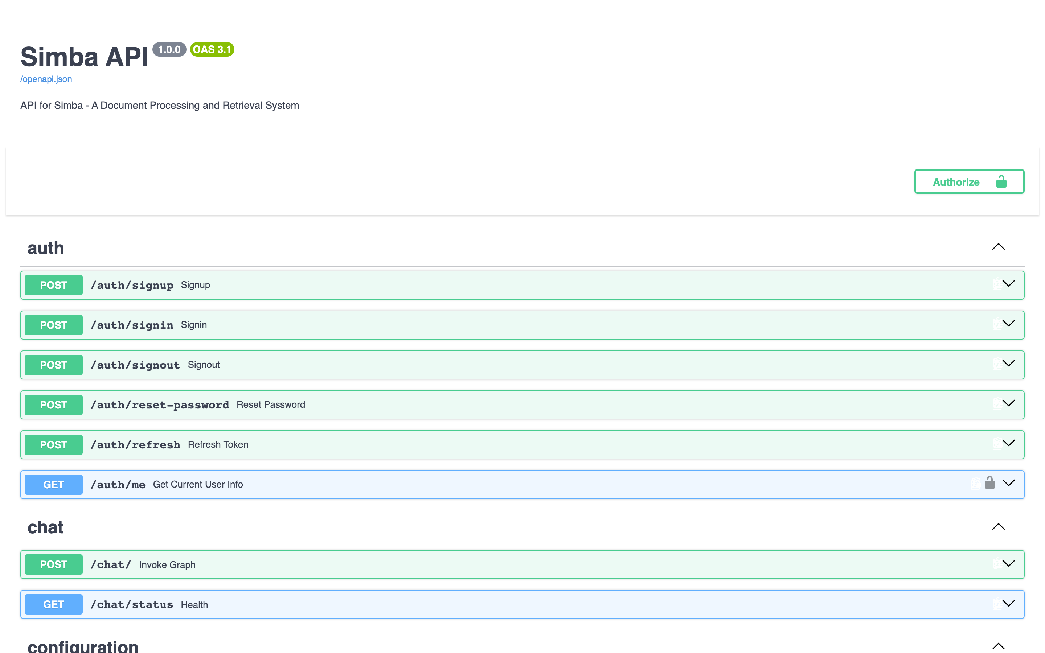
API Documentation — Swagger UI

3. Use Cases by User Role

3.1 Programme Manager
# | Use case | Steps | System effect
1 | **Upload baseline survey report** | Documents → Upload → select PDF → Parse → Enable | Document parsed, chunks indexed in FAISS, dashboard staleness flag set
2 | **Ask "What is the cooperative profit gap in Mango?"** | Chat → type question → send | LangGraph retrieves relevant chunks → LLM answers with citation to source document
3 | **Review & approve LLM-extracted KPIs** | Dashboard → Review & Extract → toggle ON/OFF rows → Apply Selected | `dashboard_kpis.json` updated, dashboard cards refresh with new values
4 | **Compare chains in cross-chain view** | Dashboard → Cross-Chain tab → scan table | Identifies which chain or group outperforms others for a given indicator
5 | **Generate AI summary for team sharing** | Documents → click sparkles icon on a row | Celery task generates summary via LLM, stored in document metadata

The views this role uses most are the Dashboard (below), the Chat assistant, and the KPI Review page — all covered step-by-step in Chapters 5, 7, and 9.
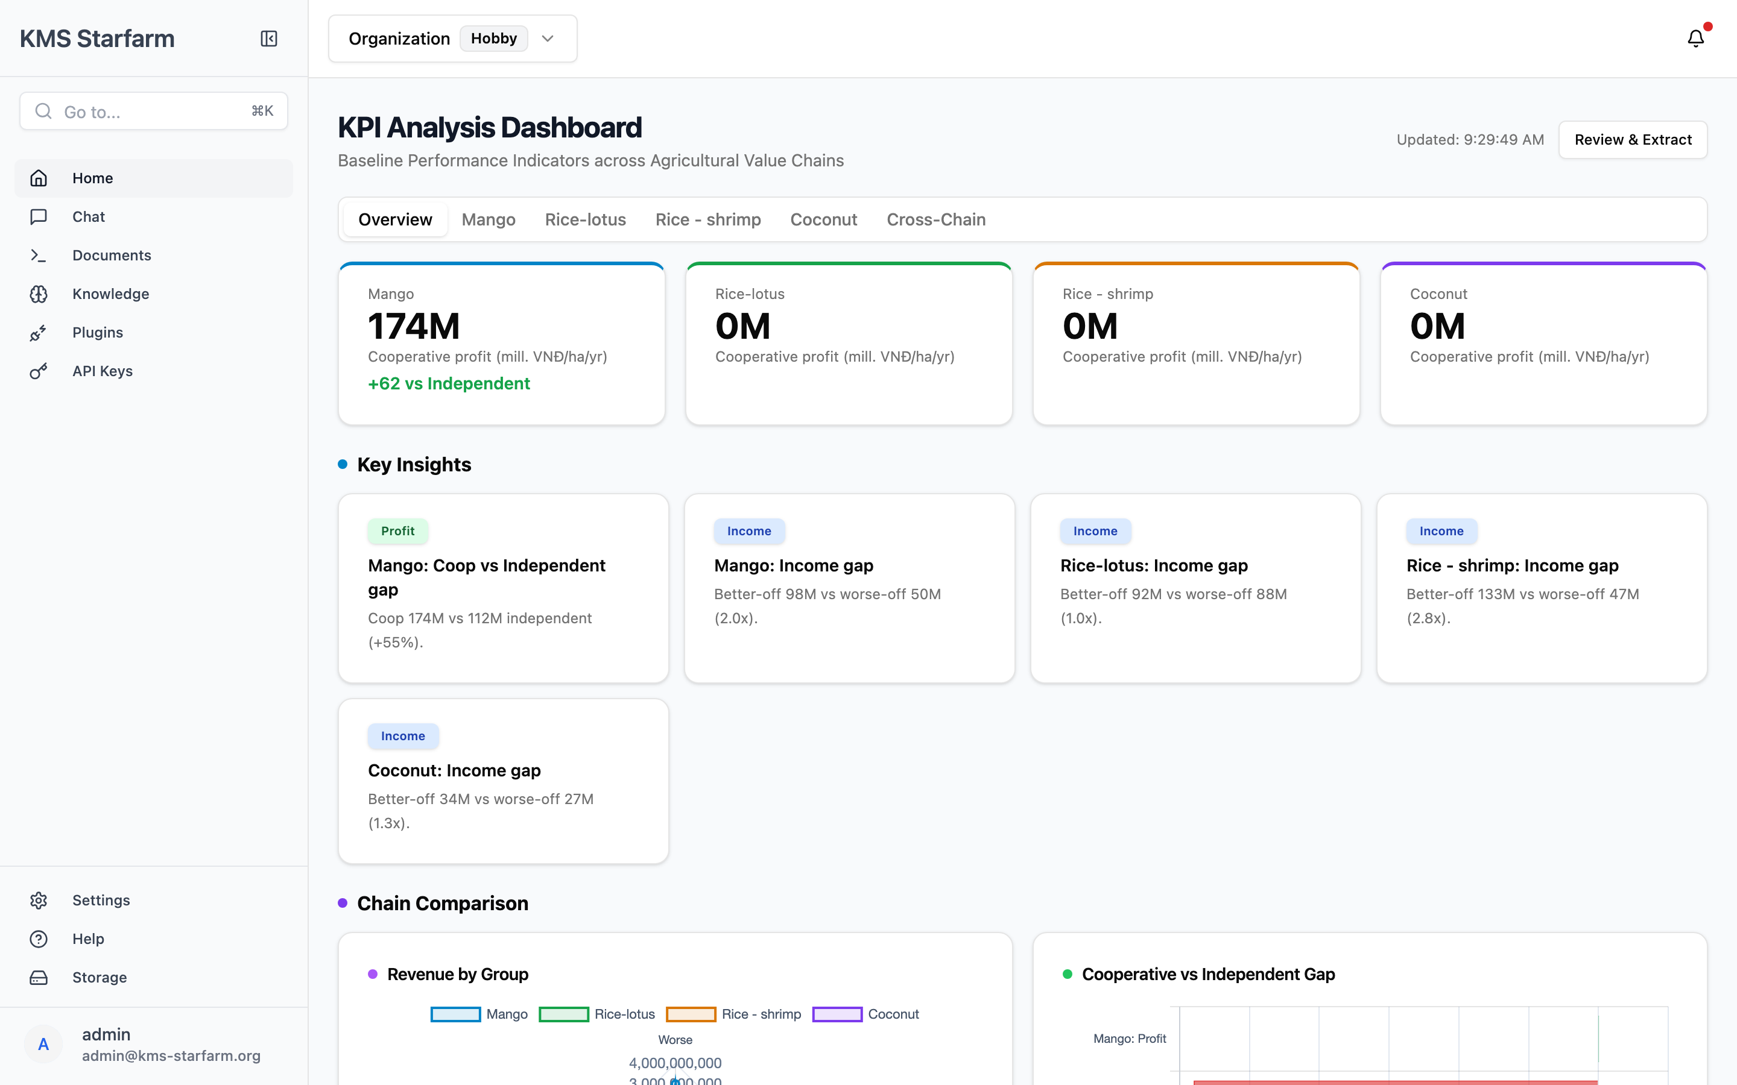
Example — Dashboard used by Programme Manager

3.2 Data Analyst
# | Use case | Steps | System effect
1 | **Bulk upload and selective enable** | Documents → Upload (Folder tab) → select folder → Parse Selected → selectively Enable | All files parsed, only enabled ones embedded in FAISS
2 | **Cross-document analytical queries** | Chat → ask complex question spanning multiple reports | Hybrid retrieval searches across all enabled docs, reranks, generates comparative answer
3 | **Audit KPI extraction accuracy** | KPI Review → filter by chain → inspect proposed vs baseline values | Can toggle off incorrect LLM extractions before applying
4 | **Export answers with citations** | Chat → click Sources(N) → review excerpt → Copy answer | Sources panel shows page number + chunk excerpt for each citation

The Folder Upload tab (below) supports the analyst's bulk-ingestion workflows; the Source Panel provides the citations needed for analytical write-ups.
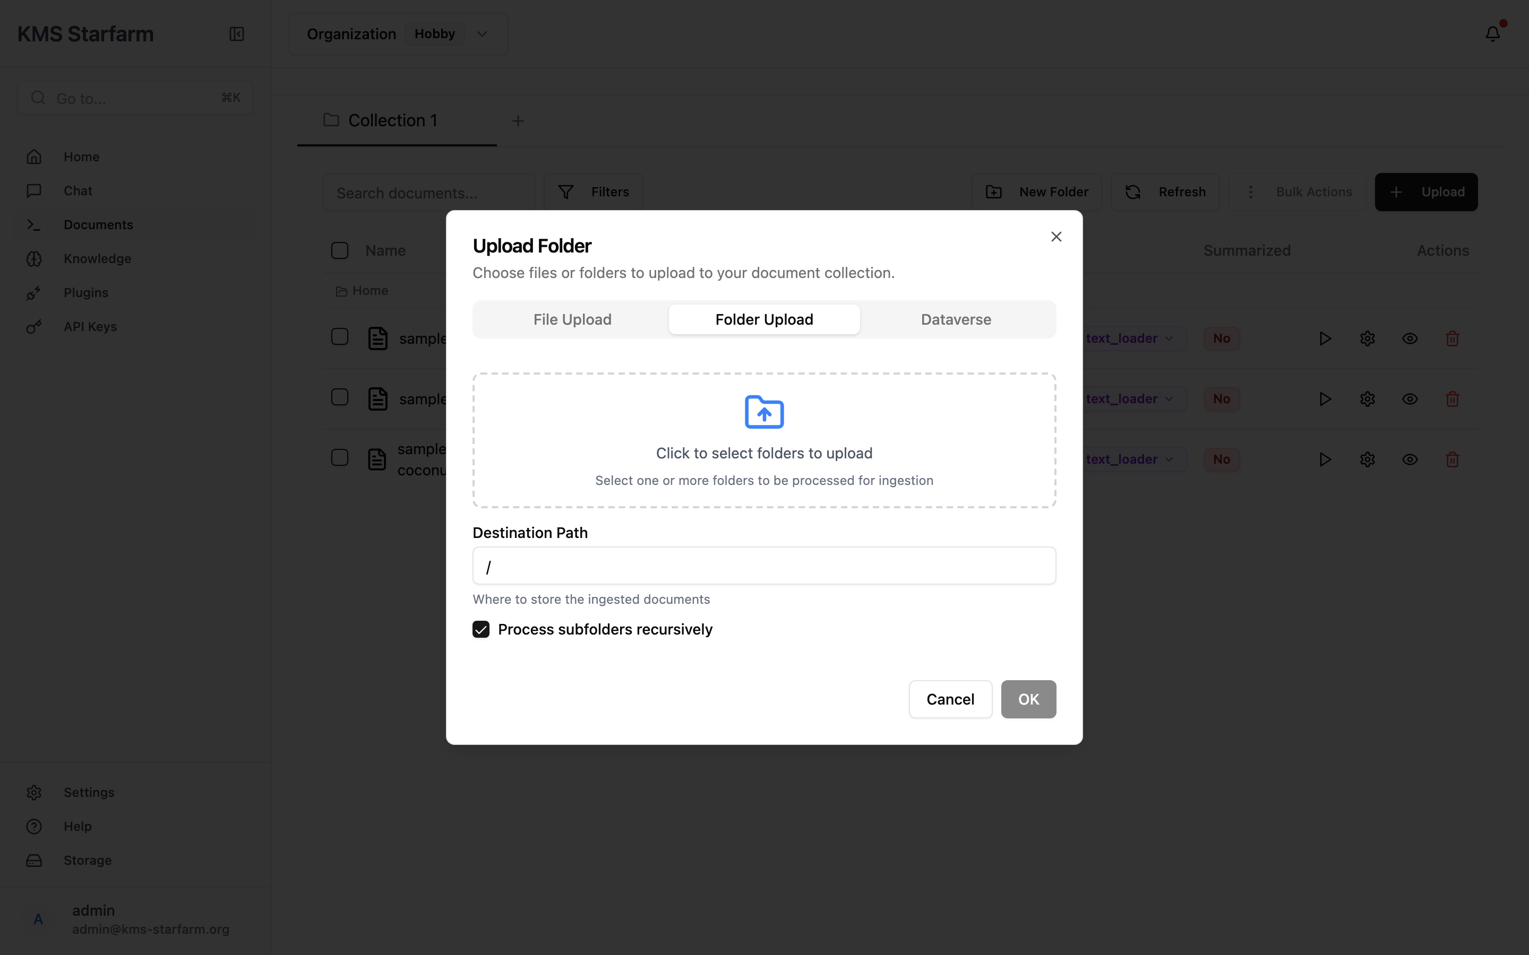
Example — Folder Upload used by Data Analyst

3.3 System Administrator
# | Use case | Steps | System effect
1 | **Change LLM provider/model** | Knowledge → verify current config; edit `config.yaml` → restart | LLM calls route to new provider
2 | **Manage users and API keys** | Settings → Members / API Keys | Users granted/revoked access; API keys created for SDK integration
3 | **Clear and rebuild vector index** | `DELETE /database/clear_database` → re-enable all documents | FAISS index cleared, chunks re-embedded from scratch
4 | **Verify production readiness** | Knowledge → review all config sections | Confirms correct LLM, embedding, chunking, retrieval, storage settings

The Settings area (below) is the administrator's main console for users, roles, and API keys.
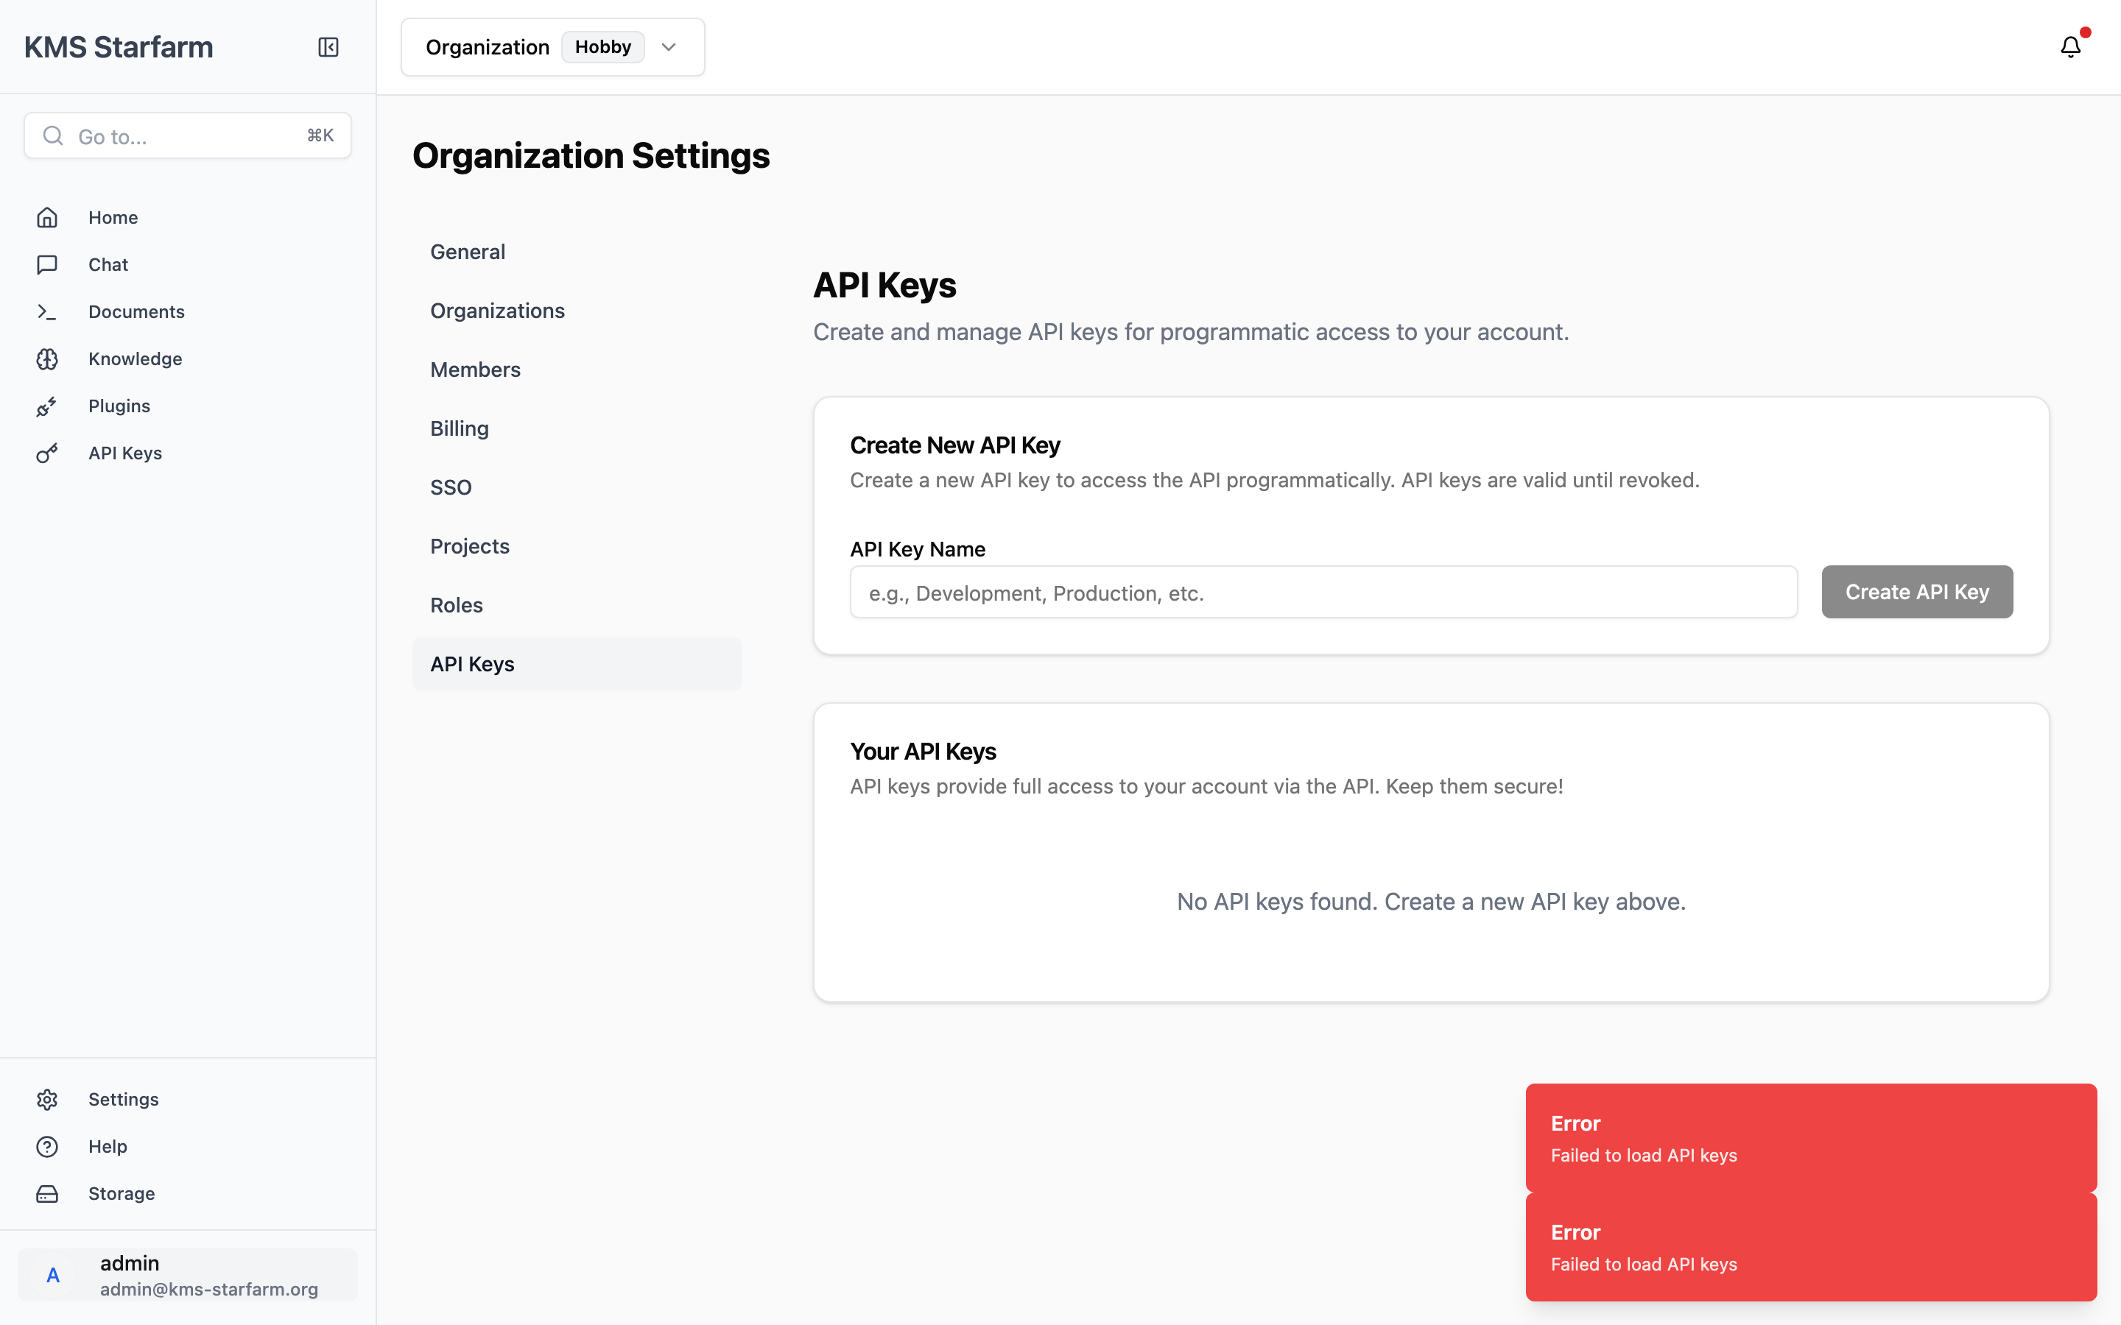
Example — API Keys used by System Administrator

4. Getting Started

4.1 Prerequisites
- Python 3.11 or 3.12 (Poetry package manager)
- Node.js 20+
- Redis 7.0+
- Git

4.2 Installation & Startup
# 1. Clone the repository
git clone <repository-url>
cd kms
# 2. Install backend dependencies (Poetry)
poetry install
# 3. Install frontend dependencies
cd frontend && npm install && cd ..
# 4. Start all services
bash start.sh
After startup the following endpoints are available:
Service | URL
Frontend | `http://localhost:5173`
Backend API | `http://localhost:8081`
LLM (vLLM-MLX) | `http://localhost:8000`
Redis | `localhost:6379`

4.3 Logging In
Navigate to http://localhost:5173. If not authenticated, you are redirected to the Sign In page.
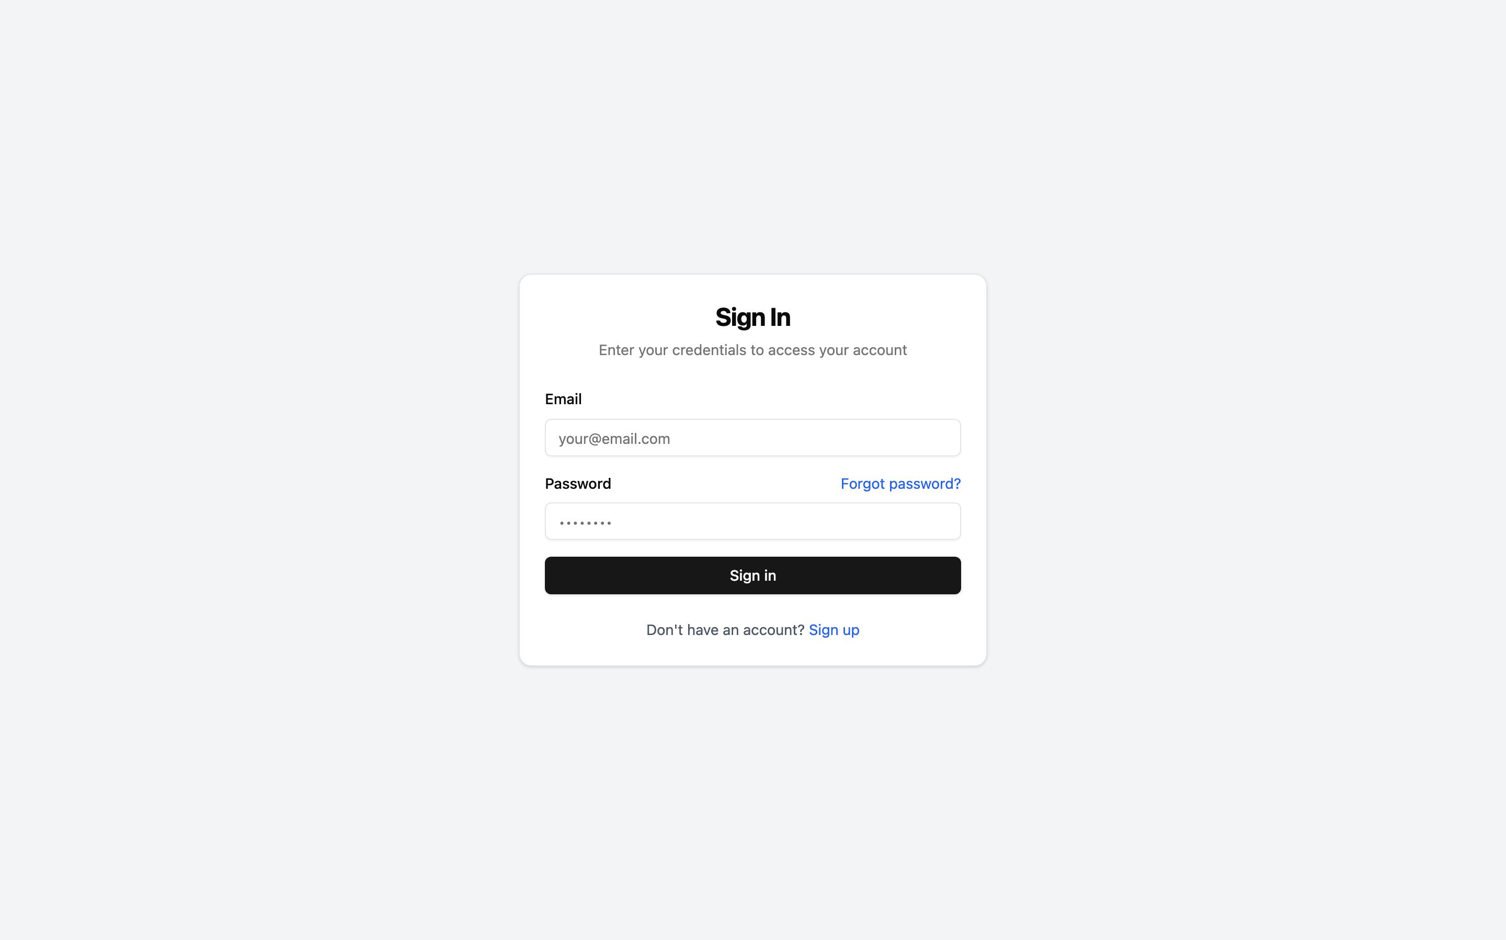
Login — Sign In page
- Enter your Email and Password.
- Click Sign in.
- On first use (mock/local mode), any email and password will work — the system provisions a default admin account.
- To create a new account, click Sign up and follow the registration flow.
- If you forgot your password, click Forgot password? to receive reset instructions.
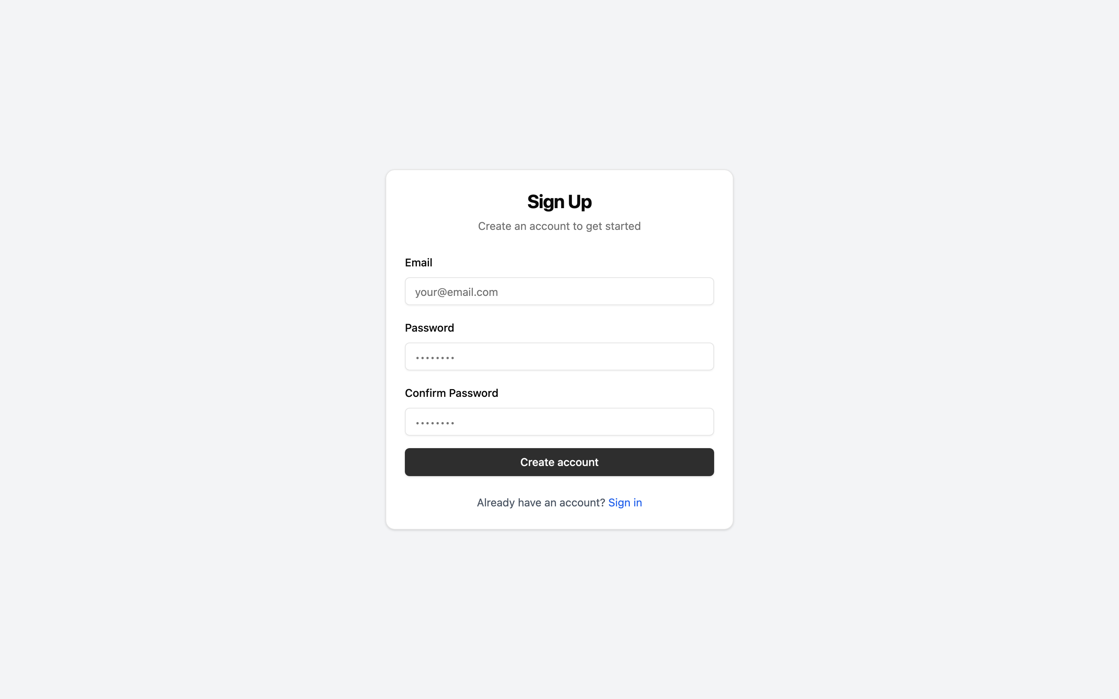
Sign Up — Registration page
After successful login, the sidebar shows your user identity at the bottom (e.g., admin / admin@kms-starfarm.org).

5. KPI Analysis Dashboard
The KPI Analysis Dashboard is the central view for monitoring performance indicators across the agricultural value chains covered by the project.

5.1 Overview
Navigate to Home in the sidebar (or directly to /). The dashboard loads at the Overview tab by default.

Dashboard Overview
What you see:
Element | Description
**Hero cards** (4) | One per value chain — shows **Cooperative profit** in million VNĐ/ha/year and the delta vs Independent (e.g., *Mango: 174M, +62 vs Independent*). The card's coloured top border matches the chain.
**Key Insights** (5 cards) | Auto-computed highlights, e.g., "Mango: Coop vs Independent gap — Coop 174M vs 112M (+55%)" and Income gaps across chains (Better-off vs Worse-off).
**Chain Comparison charts** | *Revenue by Group* (radar/polar chart) and *Cooperative vs Independent Gap* (horizontal bar).
**Tab bar** | Overview
**Review & Extract** button | Top-right — launches the KPI extraction & review flow (see Chapter 9).
**Updated timestamp** | Top-right — shows when KPI data was last refreshed.

5.2 Dashboard Data Flow
┌──────────────────┐
│ kpi_data.json │ ← Baseline (Excel import)
│ (always loaded) │
└────────┬─────────┘
│
▼
┌──────────────────┐
│ dashboard_ │ ← LLM-extracted values
│ kpis.json │ (approved from review)
└────────┬─────────┘
│
┌────────────┴────────────┐
│ Merge: baseline as │
│ foundation, LLM values │
│ overwrite where present │
└────────────┬────────────┘
│
▼
┌──────────────────┐
│ Dashboard API │ GET /dashboard/kpi
│ response: │
│ chains → KPIs │
│ per group │
└────────┬─────────┘
│
▼
┌──────────────────┐
│ React Dashboard │
│ renders hero │
│ cards, charts, │
│ indicator cards │
└──────────────────┘

5.3 What Happens When Documents Change
Action | Dashboard effect
Document **enabled** | `is_stale = true` set; amber "New data available" banner appears; auto-recalculate triggered
Document **disabled** | Same staleness detection; previous LLM-extracted values cleared if docs changed
Document **deleted** | Staleness detected; next dashboard load triggers recalculation
**No enabled docs** | Dashboard shows only baseline values from `kpi_data.json` (no LLM enrichment)
**Recalculate** button clicked | Full LLM extraction re-run on all enabled docs; `dashboard_kpis.json` overwritten

5.4 Chain Detail Tab
Click any chain tab (e.g., Mango) to see indicator-level detail.
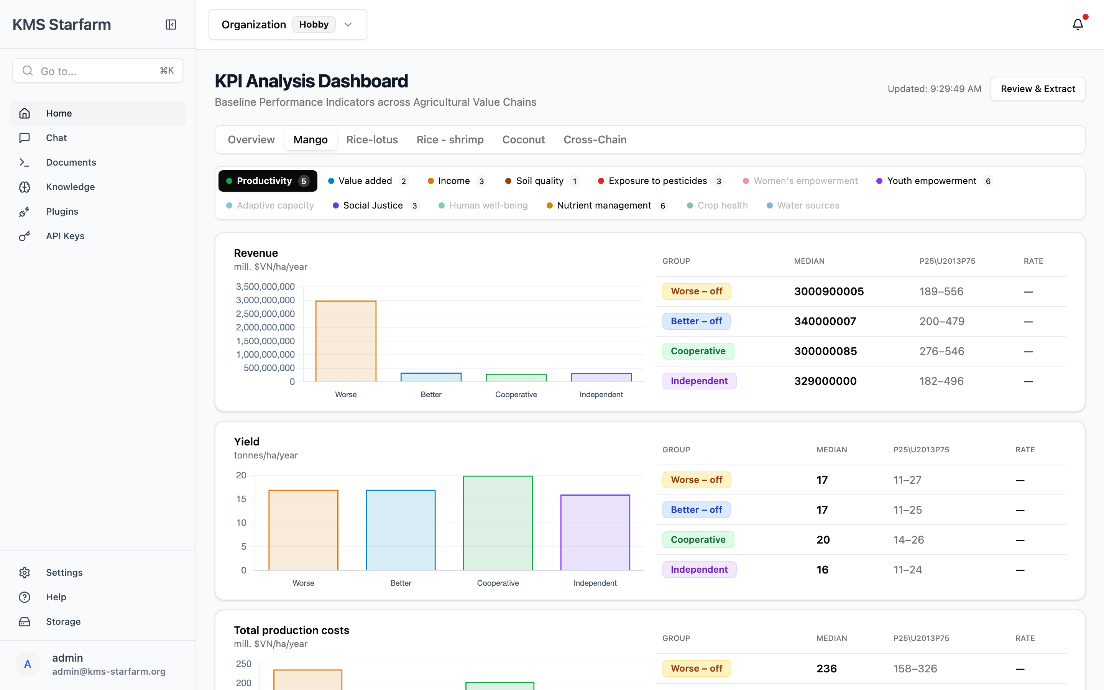
Mango Chain — KPI Detail
Filter bar (top): 13 KPI category pills, each with a count badge:
Productivity (5) · Value added (2) · Income (3) · Soil quality (1) · Exposure to pesticides (3) · Women's empowerment · Youth empowerment (6) · Adaptive capacity · Social Justice (3) · Human well-being · Nutrient management (6) · Crop health · Water sources
Click a pill to filter. Active category is highlighted in dark.
Indicator cards: Each indicator (e.g., Revenue, Yield, Total production costs) is rendered as a card with:
- A bar chart comparing median values across the four groups: Worse-off, Better-off, Cooperative, Independent.
- A detail table on the right with columns: Group, Median, P25–P75 range, Rate.
For example, Yield in Mango shows Cooperative farms achieving 20 tonnes/ha/year — higher than all other groups.

5.5 Cross-Chain Comparison
Click the Cross-Chain tab to compare the same indicator across all value chains side by side.
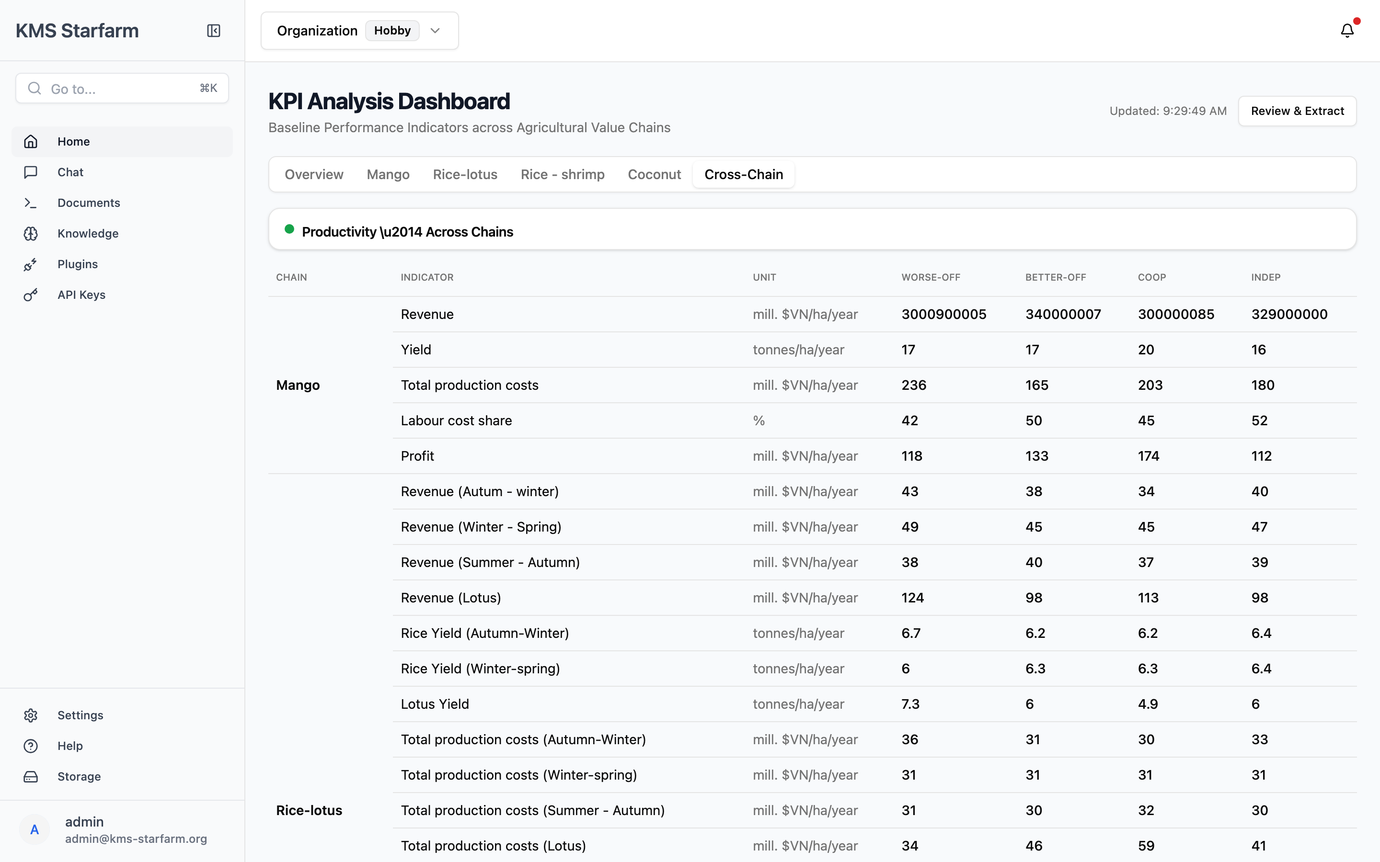
Cross-Chain Comparison
This tab renders a table per KPI category. Each row shows one indicator with its median values in all four chains, broken down by group (Worse-off, Better-off, Cooperative, Independent). Use it to quickly spot which chain or group outperforms others for a given indicator.
For example, the Productivity section shows Mango Revenue and Yield alongside Rice-lotus and other chain values in the same view.

6. Document Management
The Documents page is the knowledge base for all project files. It handles upload, parsing, embedding, and preview.
Navigate via Documents in the sidebar.
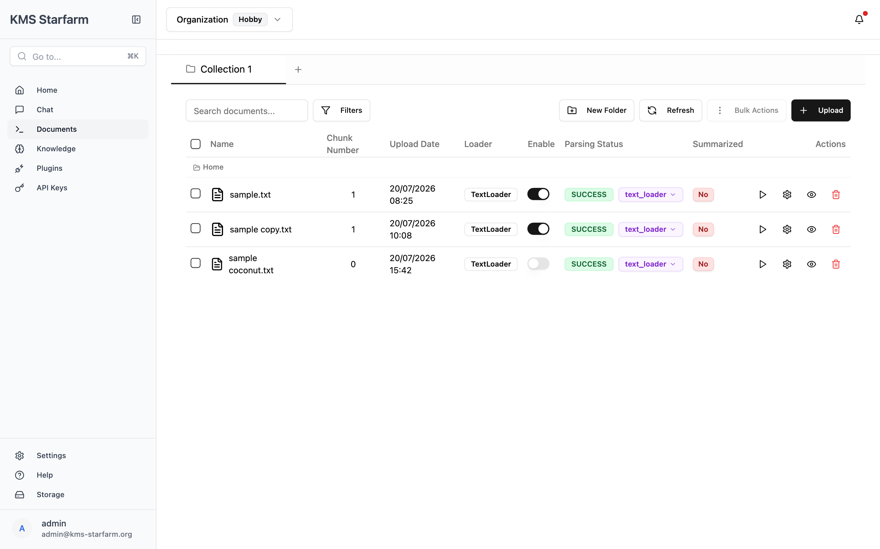
Document Management

6.1 Layout
Element | Description
**Collection tabs** | Top bar — organises documents into collections (e.g., *Collection 1*). Click **+** to add a new collection.
**Search bar** | Filter documents by name.
**Filters** button | Show/hide columns and filter by Parsing Status or Summarised flag.
**New Folder** | Create a folder inside the current collection.
**Refresh** | Reload the document list from the server.
**Bulk Actions** | Appears when one or more rows are selected — e.g., *Parse Selected*, *Summarise Selected*.
**Upload** (black button) | Open the file upload dialog.

6.2 Document Table Columns
Column | Description
**Checkbox** | Select documents (Shift+click for range).
**Name** | File name with type icon. Hover to inline-rename.
**Chunk Number** | Number of text chunks produced after parsing.
**Upload Date** | When the file was uploaded.
**Loader** | Parser/engine used (e.g., `TextLoader`).
**Enable** (toggle) | Switch ON to embed the document and make it queryable via Chat and KPI extraction. OFF documents are stored but not indexed.
**Parsing Status** | `SUCCESS` (green), `FAILED` (red), `PENDING` (orange), or `Unparsed` (grey). A parser dropdown (e.g., `text_loader`) lets you switch parser before re-parsing.
**Summarised** | Whether an AI summary has been generated (`Yes`/`No`). Hover the sparkles icon to generate.
**Actions** | Per-row: **Parse** (▶), **Configure parser** (⚙), **Preview** (👁), **Delete** (🗑).

6.3 Uploading Documents
- Click Upload → a dialog with three tabs opens:
- File Upload — Drag & drop or click to select files (.pdf, .doc, .docx, .txt, .md). Shows Uploading to: {folder} when inside a folder.
- Folder Upload — Import an entire local folder (with Process subfolders recursively option).
- Dataverse — Import by dataset persistent ID (e.g., doi:10.7910/...).
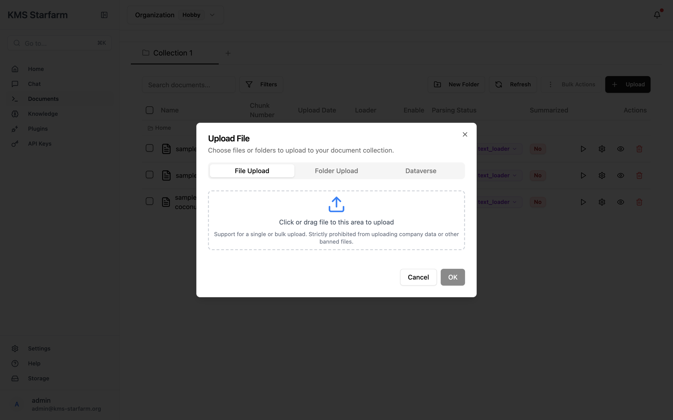
Upload dialog — File Upload tab

Upload dialog — Folder Upload tab
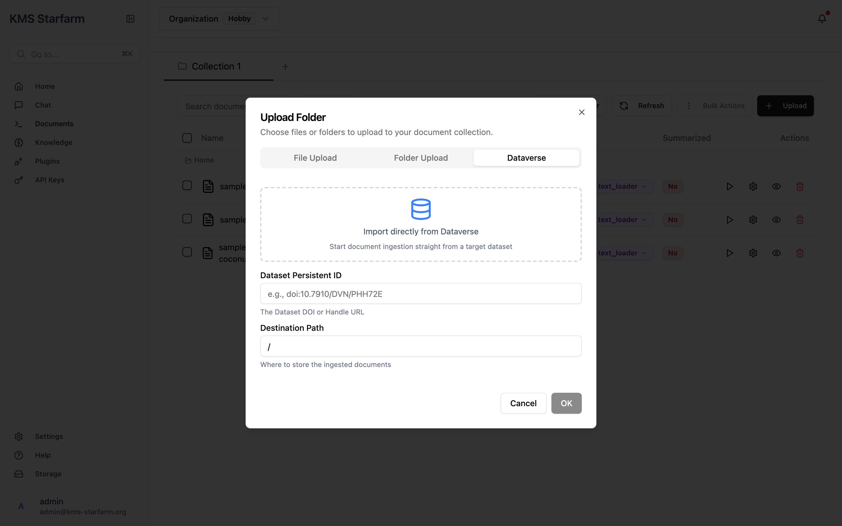
Upload dialog — Dataverse tab
- While uploading, a progress bar overlay appears: Preparing files → Uploading → Processing.
- After upload, documents appear in the table with Parsing Status Unparsed — click Parse (▶) or Bulk Actions → Parse Selected to parse them.

6.4 Enabling Documents for Search
Toggling Enable ON embeds the document's chunks into FAISS. Only enabled documents are:
- Searched when you ask questions in Chat.
- Used as source material for KPI extraction.
Tip: Enable only the documents that contain reliable data. The system currently shows sample.txt, sample copy.txt, and sample coconut.txt as examples — enable the two with the toggle in the ON position.

6.5 Previewing a Document
Click the eye (👁) icon on any row to open PreviewModal:
- Left panel — Original Document — Rendered file (PDF/image/text) with Download and Open in Tab buttons.
- Right panel — Document Chunks — The parsed text chunks (e.g., Chunk 1) rendered as Markdown. Each chunk has action icons: AI summary, Edit, Delete.
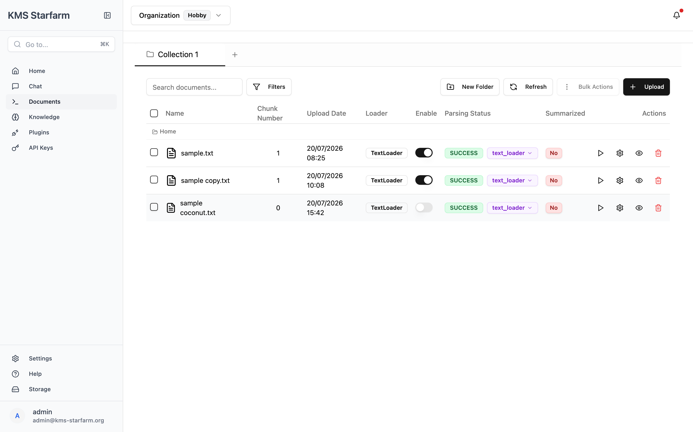
Document Preview modal — original + chunks

6.6 File Organisation
- New Folder button opens the folder-creation dialog (below); the new folder appears in the breadcrumb path.
- Drag & drop a row onto a folder to move the document.
- Breadcrumb (Home / folder) shows the current location.
- Floating bulk bar appears when items are selected, with Parse Selected, Enable/Disable, and Delete actions.
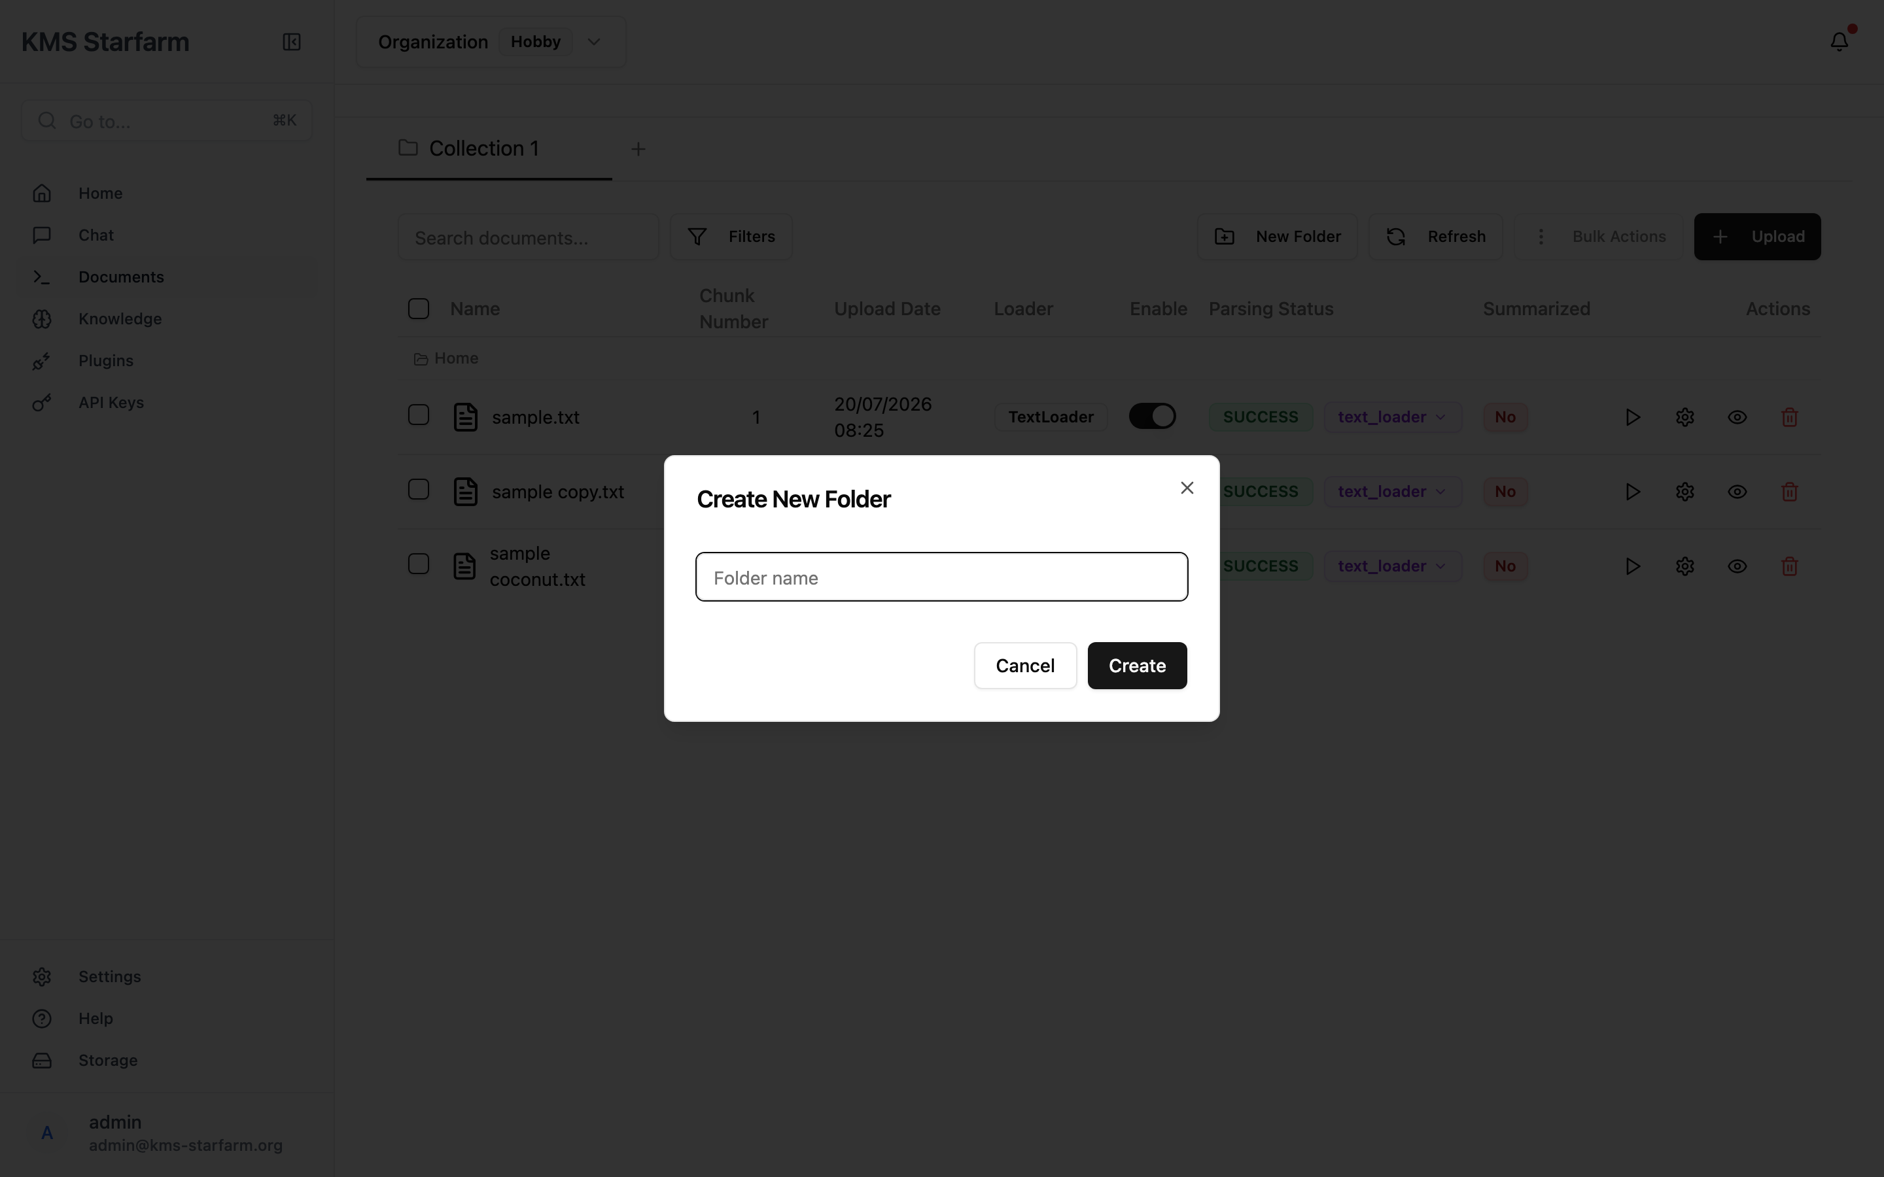
Create New Folder dialog

7. AI Chat Assistant (RAG)
The Chat page provides a conversational AI that answers questions grounded in your uploaded documents — it does not hallucinate from general knowledge.
Navigate via Chat in the sidebar.
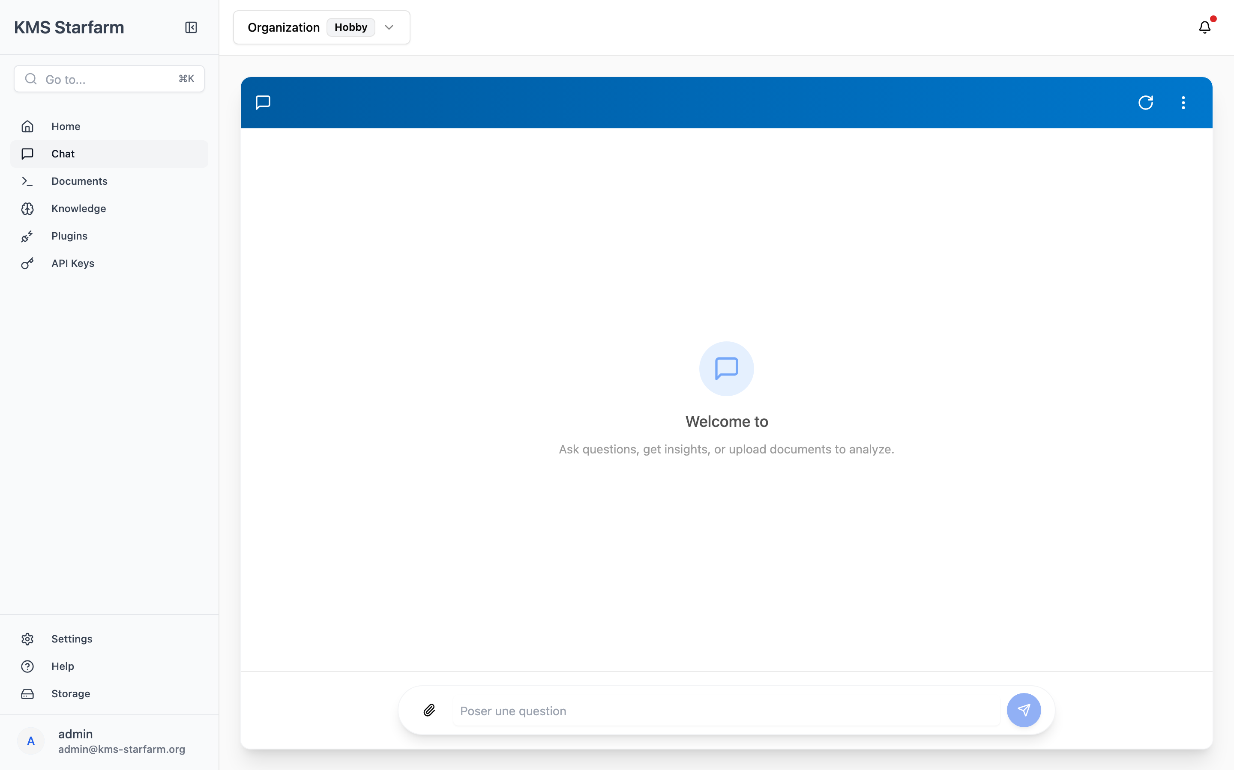
Chat Interface

7.1 Interface Overview
Element | Description
**Blue header bar** | Chat title with a **refresh** (↻) button and a **⋯ menu** (*Nouvelle discussion* / *Terminer la discussion*).
**Empty state** | Centred card — *"Welcome to … Ask questions, get insights, or upload documents to analyze."*
**Input bar** (bottom) | Paperclip (📎) to upload files inline, text field placeholder *"Poser une question"* (Ask a question), and a blue circular **send** button (✈).

7.2 What Happens When You Ask a Question
Here is the exact sequence of events inside the system:
User types: "What is the revenue for cooperative mango farmers?"
│
▼
┌─────────────────────────────────────────────────────────┐
│ 1. TRANSFORM QUERY │
│ LLM rewrites question using chat history │
│ → Sub-queries generated for better retrieval │
└────────────────────────┬────────────────────────────────┘
│
▼
┌─────────────────────────────────────────────────────────┐
│ 2. COT (CHAIN-OF-THOUGHT) │
│ Reads summaries of all documents in database │
│ Decides: summaries enough? → Yes: answer from summary│
│ No: → full retrieval │
└────────────────────────┬────────────────────────────────┘
│
▼
┌─────────────────────────────────────────────────────────┐
│ 3. RETRIEVE (FAISS) │
│ Cosine similarity search on 384-dim embeddings │
│ Returns top-K most similar chunks │
│ Only searches ENABLED documents │
└────────────────────────┬────────────────────────────────┘
│
▼
┌─────────────────────────────────────────────────────────┐
│ 4. RERANK (Cross-encoder) │
│ Re-scores all retrieved chunks for relevance │
│ Keeps top-20 most relevant passages │
└────────────────────────┬────────────────────────────────┘
│
▼
┌─────────────────────────────────────────────────────────┐
│ 5. GENERATE (LLM) │
│ Input: chunks + summaries + chat history + question │
│ Output: streaming answer (token-by-token) │
│ Rendered with Markdown (tables, code, bold, etc.) │
└────────────────────────┬────────────────────────────────┘
│
▼
┌─────────────────────────────────────────────────────────┐
│ 6. HALLUCINATION CHECK │
│ Step A: Is the answer grounded in the documents? │
│ Yes → Step B No → reject, retry │
│ Step B: Does the answer address the question? │
│ Yes → return to user │
│ No → return fallback message │
└─────────────────────────────────────────────────────────┘
While the graph runs, the user first sees the animated Thinking indicator in the message thread:
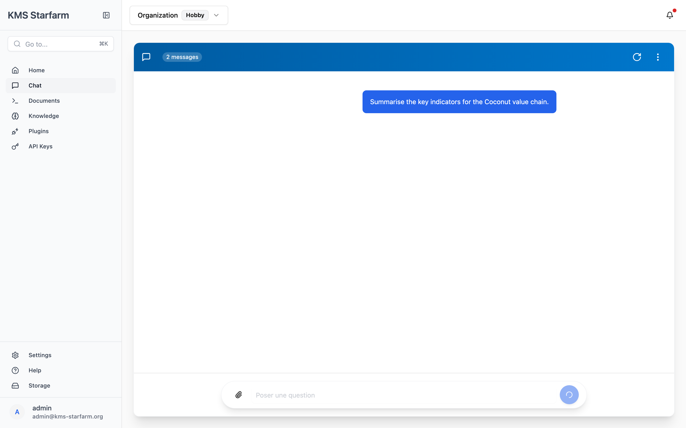
Chat — Thinking indicator while the pipeline runs
The final reply is streamed token-by-token and rendered as Markdown, together with the Sources (N) citation button:
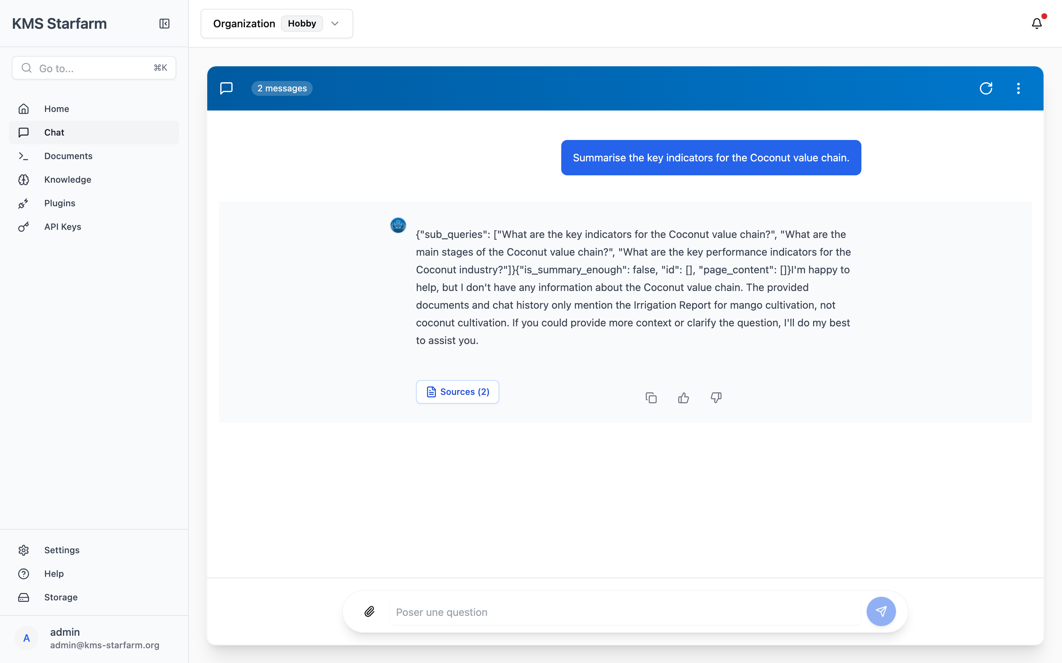
Chat — grounded answer with sources button

7.3 Sources & Citations
Each assistant reply includes:
- A Sources (N) button — Click to open the Source Panel (slide-in drawer). Sources are grouped by file name, sorted by relevance, showing the file icon, extension badge (PDF/XLSX), and "Cited N times". Selecting a source shows the page number, an Open document link, and the excerpt preview that was used.
- Follow-up question suggestions — Chips labelled "Suggestions:" below the answer. Click one to submit it as the next question.
- Feedback row — Copy (with "Copied!" confirmation), Thumbs Up 👍, Thumbs Down 👎 to rate the answer.
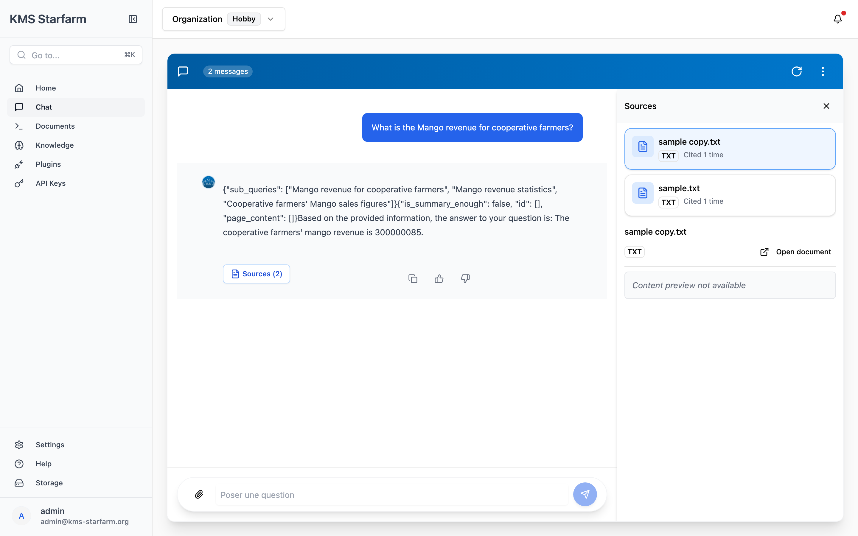
Source Panel — cited files and excerpts

7.4 Managing Conversations
- New discussion — From the ⋯ menu, select Nouvelle discussion to clear the chat and start fresh. Alternatively, click the ↻ reset icon in the header.
- End discussion — Select Terminer la discussion to close the session (also notifies the parent window if embedded).
- History — Messages persist in localStorage across page reloads; a sessionId is maintained per conversation. The LangGraph checkpointer (kms_memory.pkl) preserves multi-turn context.

7.5 What Affects Chat Answers
Action | Effect on Chat
**Enable** a document | Chunks added to FAISS → future queries can retrieve them
**Disable** a document | Chunks removed from FAISS → no longer retrieved
**Delete** a document | Chunks and metadata removed → no longer available
**Re-parse** a document | New chunks created, but user must re-Enable to re-embed
**Upload new document** | Must Parse + Enable before it appears in chat
**Change retrieval method** | Different chunks retrieved (semantic vs keyword vs hybrid)
**Change chunk_size** | Affects granularity of future parses (not retroactive)
**Change LLM model** | Different answer quality/style; same retrieval results
**Clear database** (`DELETE /database/clear_database`) | All vectors erased → chat will return no results until docs re-enabled

8. Knowledge Pipeline Configuration
The Knowledge page exposes the current backend pipeline settings in a read-only view. It is useful for administrators and reviewers to verify how documents are processed.
Navigate via Knowledge in the sidebar.
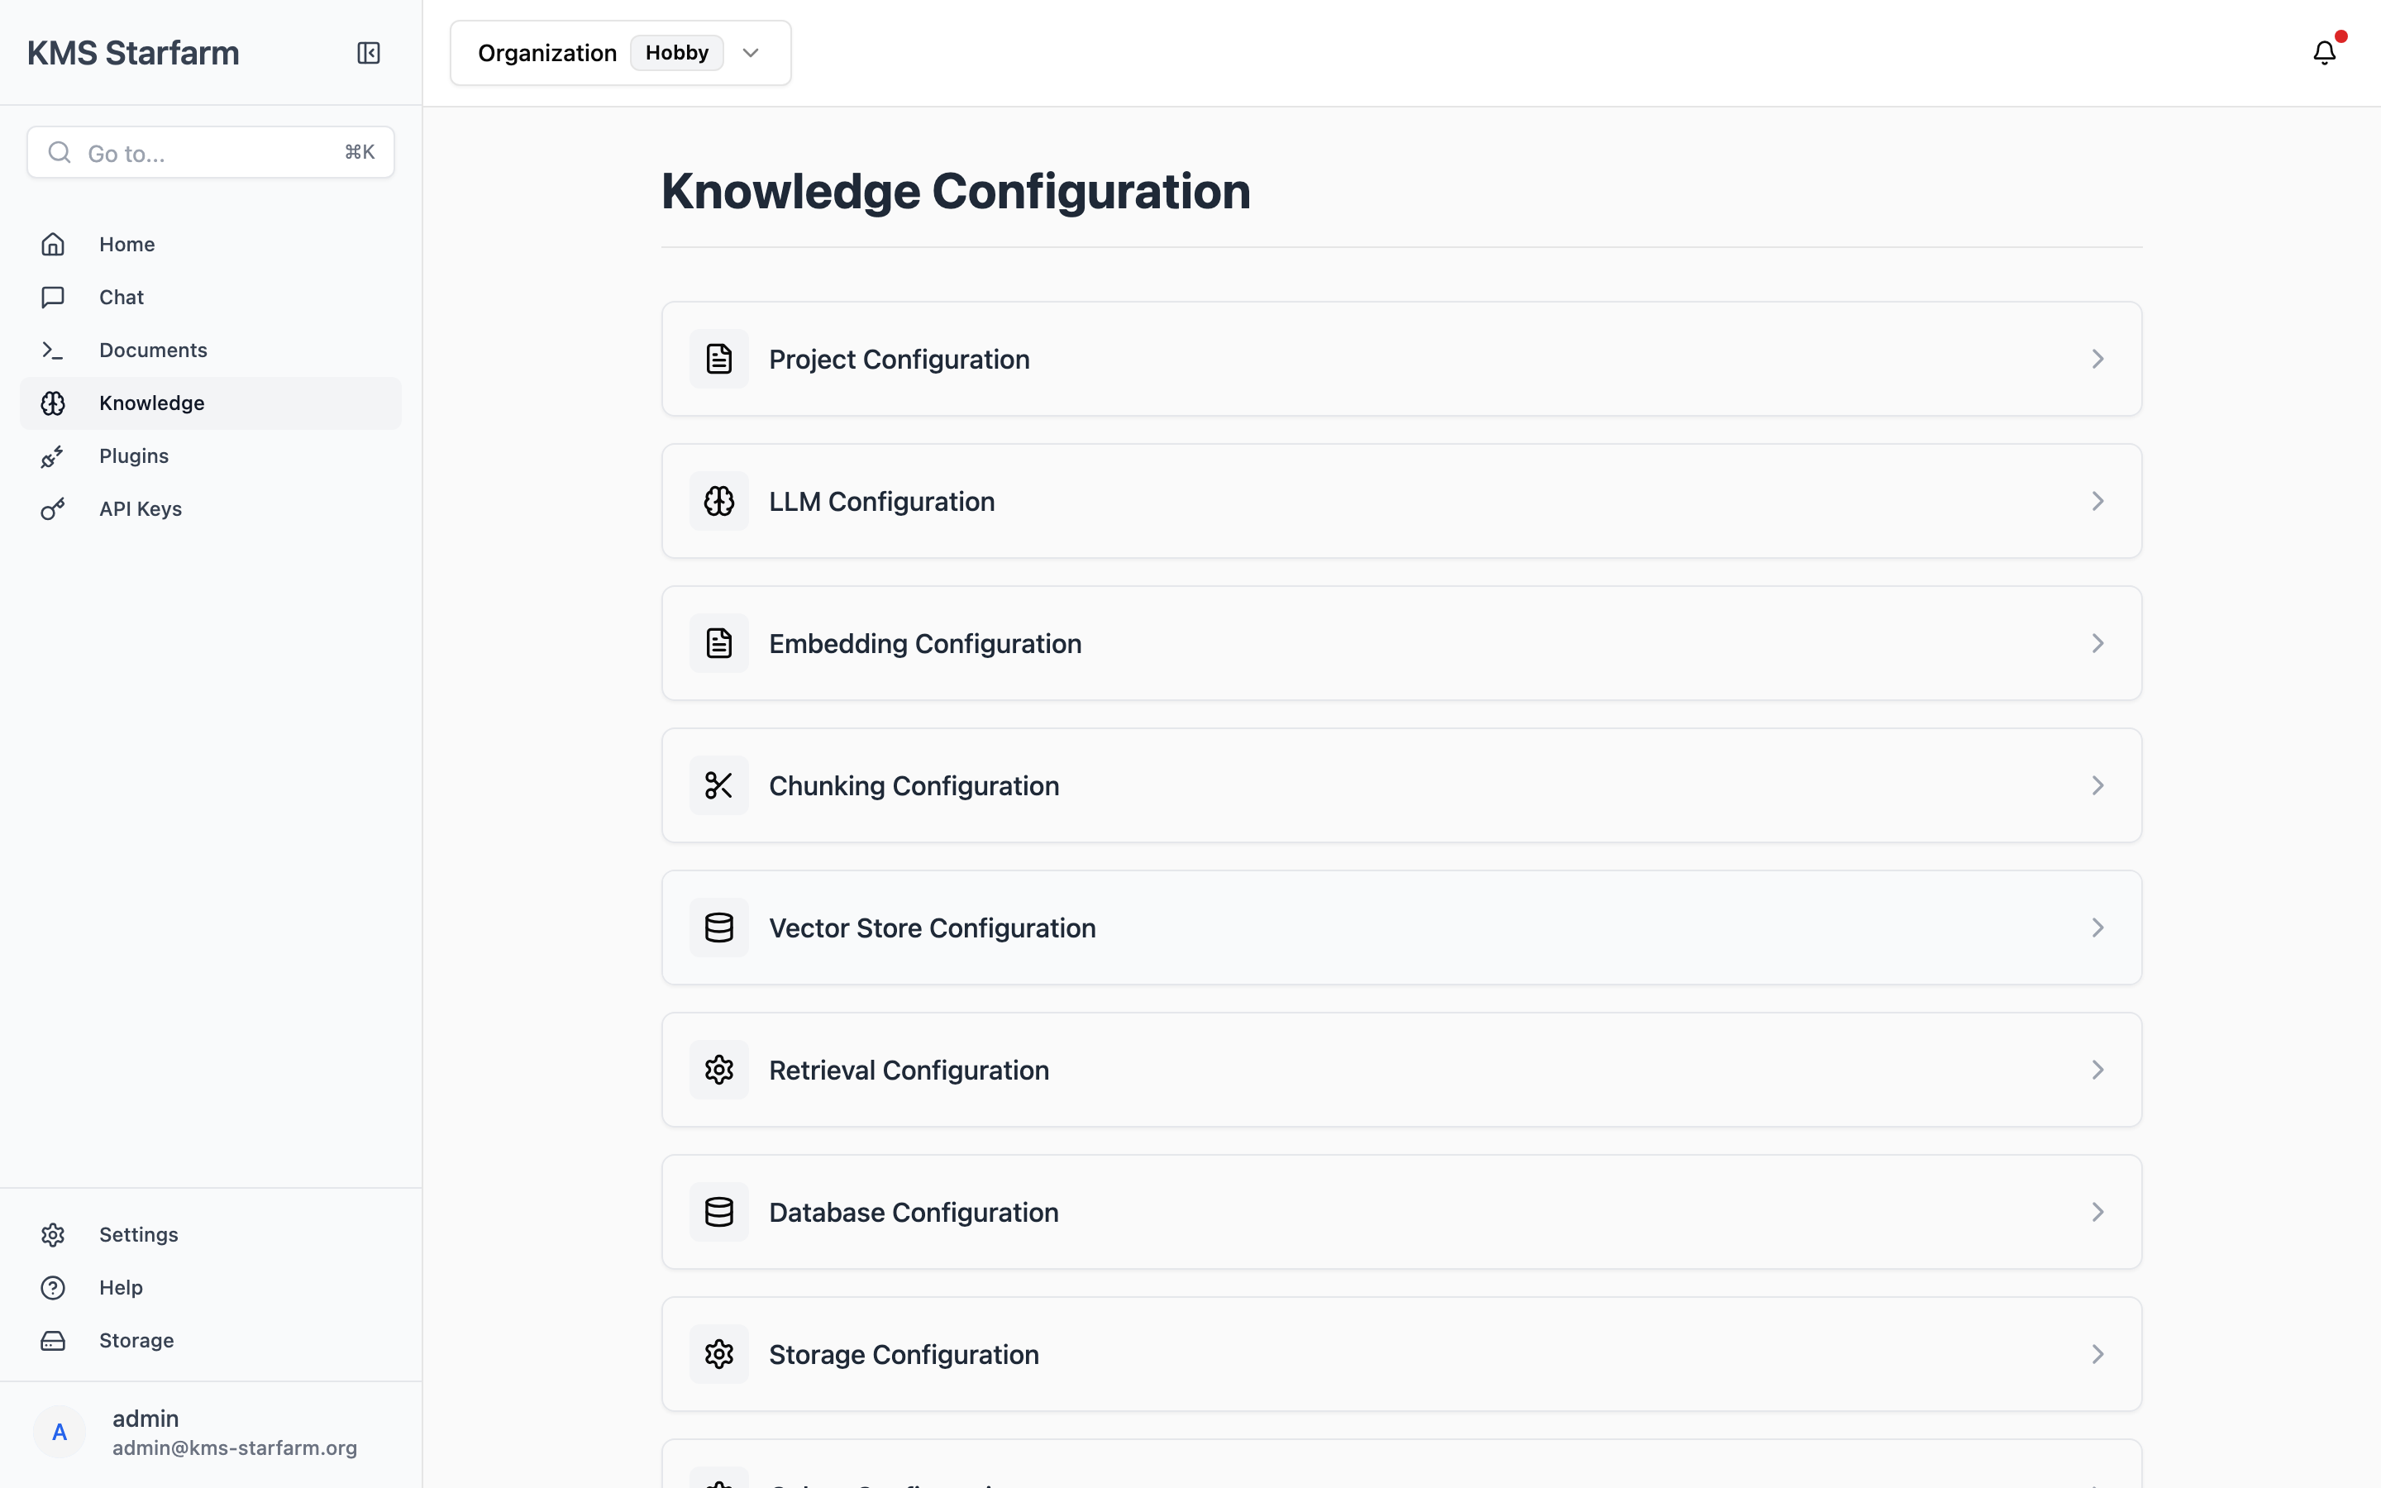
Knowledge Configuration
Clicking the › chevron on any card expands the section to show its live values:
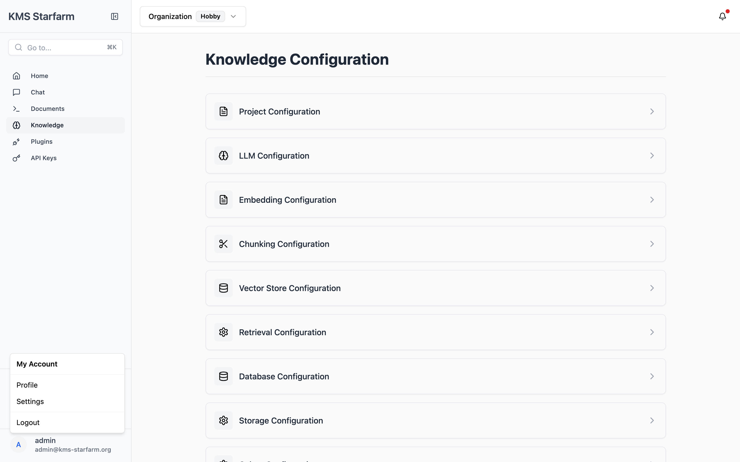
Knowledge Configuration — sections expanded

Knowledge Configuration — Retrieval section detail

8.1 Configuration Sections
The page shows collapsible cards (click the › chevron to expand):
Card | What it shows
**Project Configuration** | Project name, version, api_version
**LLM Configuration** | Provider (`vllm` / `ollama`), model name (`Llama-3.2-3B`), base URL, temperature, max tokens, streaming, additional params
**Embedding Configuration** | Provider (`huggingface`), model (`all-MiniLM-L6-v2`), device (`mps`/`cuda`/`cpu`)
**Chunking Configuration** | `chunk_size` (e.g., 1500) and `chunk_overlap` (e.g., 400)
**Vector Store Configuration** | Provider (`faiss`), collection name (`chunk_embeddings`)
**Retrieval Configuration** | Method (`default` / `semantic` / `hybrid` / `ensemble` / `reranked`), top-K, score threshold, reranker model & threshold, semantic weights
**Database Configuration** | Provider (`litedb` / `postgres`), connection details
**Storage Configuration** | Provider (`local` / `minio`), bucket/endpoint (hidden when `local`)
**Celery Configuration** | Broker URL and result backend (Redis)

8.2 Reading the Values
- Masked secrets — Any field containing api_key, secret_key, password, or token is shown as •••••••••••••••••••••• for security.
- Strikethrough fields — Settings not applicable to the current provider (e.g., base_url when using a local model) appear crossed out with a tooltip explaining why.
- JSON objects — Complex values (arrays, nested objects) render as scrollable <pre> blocks.
This page is read-only — configuration is edited via `config.yaml` and `.env` on the server.

9. KPI Extraction & Review Workflow
This is the bridge between the document repository and the dashboard: the system uses the LLM to extract KPI values from your enabled documents, then lets you review and approve the proposed changes before they appear on the dashboard.

9.1 Triggering Extraction
From the dashboard, click Review & Extract (top-right). This navigates to /kpi-review.

9.2 KPI Extraction — Behind the Scenes
┌──────────────────────────────────────────────────────┐
│ Step 1: Find all ENABLED documents │
│ (metadata.enabled = True in LiteDB) │
└───────────────────┬──────────────────────────────────┘
│
▼
┌──────────────────────────────────────────────────────┐
│ Step 2: Build context text │
│ Up to 5 most recent docs × 1500 chars each │
│ (sorted by upload date, most recent first) │
└───────────────────┬──────────────────────────────────┘
│
▼
┌──────────────────────────────────────────────────────┐
│ Step 3: LLM extraction prompt │
│ Sends context + extraction instructions │
│ LLM returns JSON array of KPI entries │
│ Each: {chain, kpi, indicator, unit, group, │
│ median, p25, p75, rate} │
└───────────────────┬──────────────────────────────────┘
│
▼
┌──────────────────────────────────────────────────────┐
│ Step 4: Match against baseline │
│ Fuzzy match by kpi + indicator + group │
│ New indicators: marked is_new=true │
│ Changed values: show baseline → proposed │
└───────────────────┬──────────────────────────────────┘
│
▼
┌──────────────────────────────────────────────────────┐
│ Step 5: Human review (KPI Review page) │
│ User approves/rejects per row/chain/KPI │
└───────────────────┬──────────────────────────────────┘
│
▼
┌──────────────────────────────────────────────────────┐
│ Step 6: Apply approved entries │
│ Merged into dashboard_kpis.json │
│ Dashboard refreshes with new values │
└──────────────────────────────────────────────────────┘

9.3 Review Page
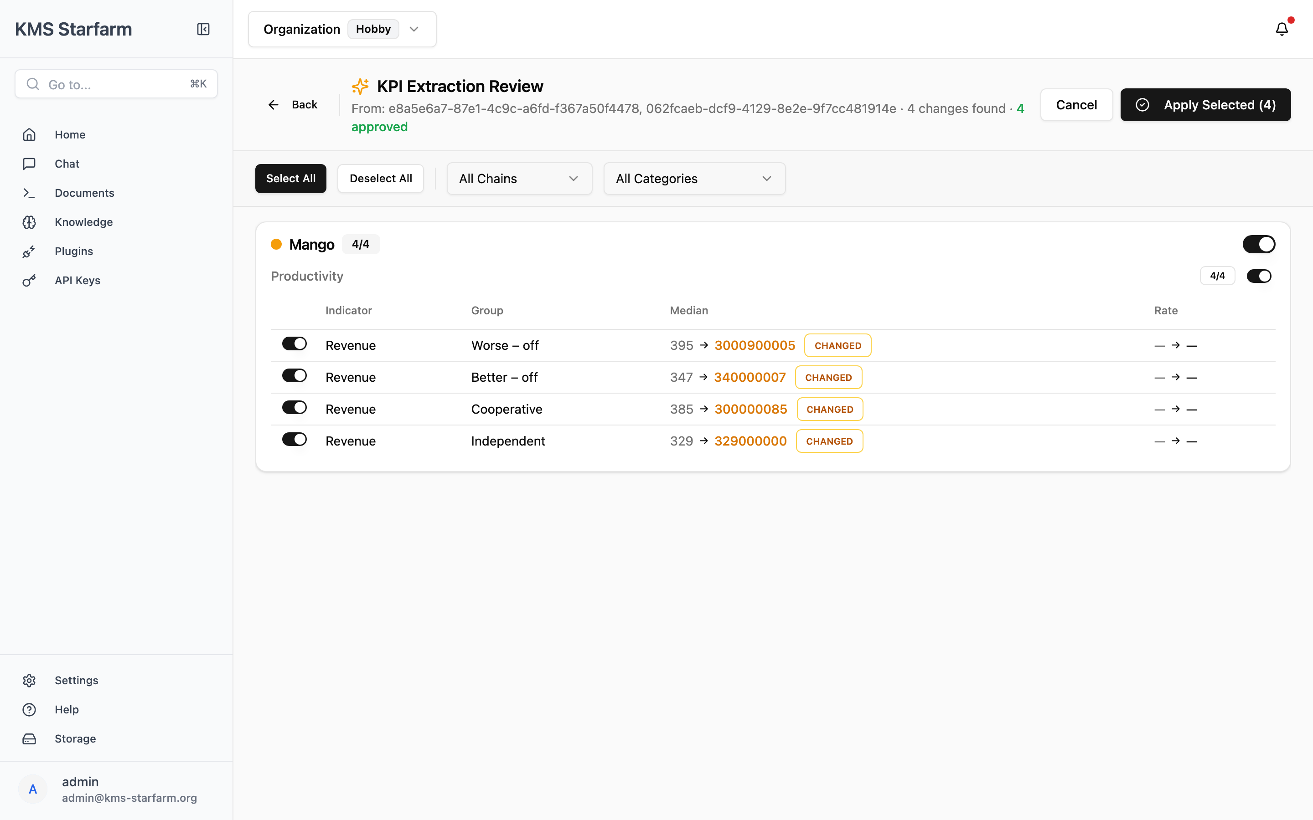
KPI Extraction Review
Header bar:
- Back — Return to dashboard without applying.
- Title — KPI Extraction Review with a sparkles (✨) icon.
- Summary line — "From: {source doc IDs} · N changes found · X approved" (e.g., 4 changes found · 4 approved).
- Cancel / Apply Selected (N) buttons — Apply is disabled until at least one indicator is approved; shows a spinner while applying.
Toolbar:
- Select All / Deselect All buttons.
- All Chains dropdown — Filter to a single chain (Mango, Rice-lotus, Rice-shrimp, Coconut).
- All Categories dropdown — Filter to a KPI category (Productivity, Income, Soil quality, …).
Review list (grouped Chain → KPI → Indicator):
- Per-chain card (e.g., Mango 4/4) with a colour-coded dot and a master toggle switch to approve/reject the whole chain at once.
- Per-KPI section (e.g., Productivity 4/4) with its own toggle.
- Indicator rows with:
- Approval toggle (individual).
- Indicator name — shows a green NEW badge for brand-new indicators.
- Group (Worse-off / Better-off / Cooperative / Independent).
- Median cell: baseline → proposed (e.g., 395 → 3000900005) with a CHANGED (amber) or NEW (green) badge when the value differs from baseline.
- Rate cell (often — → — when only median data exists).
- Unapproved rows render at 40% opacity.
Note: Rows are clickable — clicking anywhere on a row toggles its approval. Use the per-chain or per-KPI switch to batch-approve.

9.4 Applying Changes
- Review each proposed change. Toggle OFF any values you do not want to apply.
- Click Apply Selected (N).
- The system merges approved values into dashboard_kpis.json and redirects you back to the dashboard where the updated values are visible immediately.

10. Settings & Administration
The Settings area covers organisation, team, and access management.
Navigate via Settings in the sidebar (or /settings).

10.1 Organisation Settings
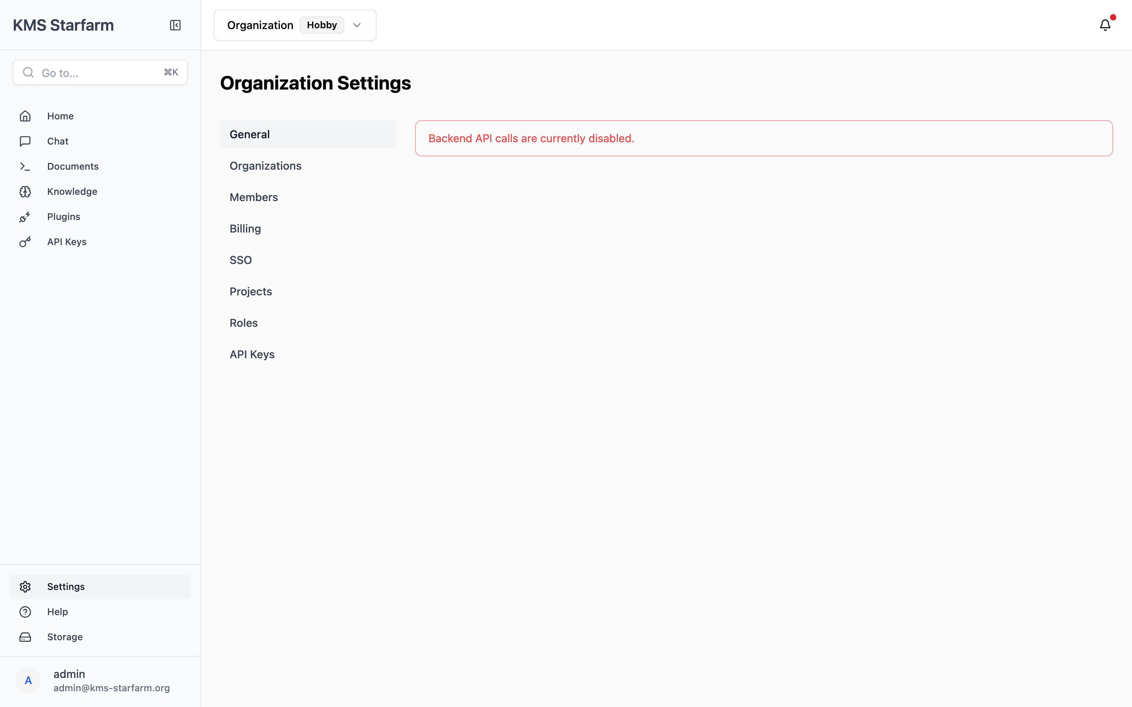
Organisation Settings
The organisation settings page has a left navigation menu:
Menu item | Description
**General** | Organisation name, basic info, and a *Danger Zone* to delete the organisation
**Organizations** | Manage organisations (create, rename, delete)
**Members** | Team member management — invite, change roles, paginate
**Billing** | Usage & plan info (currently *Hobby* plan — upgrade prompts shown). *(Coming soon)*
**SSO** | Single sign-on configuration. *(Coming soon)*
**Projects** | Project-level settings. *(Coming soon)*
**Roles** | Role-based access control (RBAC) — system roles, all permissions, my permissions
**API Keys** | Generate and manage API keys for programmatic access

The top bar shows the current organisation selector: Organization · Hobby ▾ (click to switch or manage organisations).

10.2 Roles Page
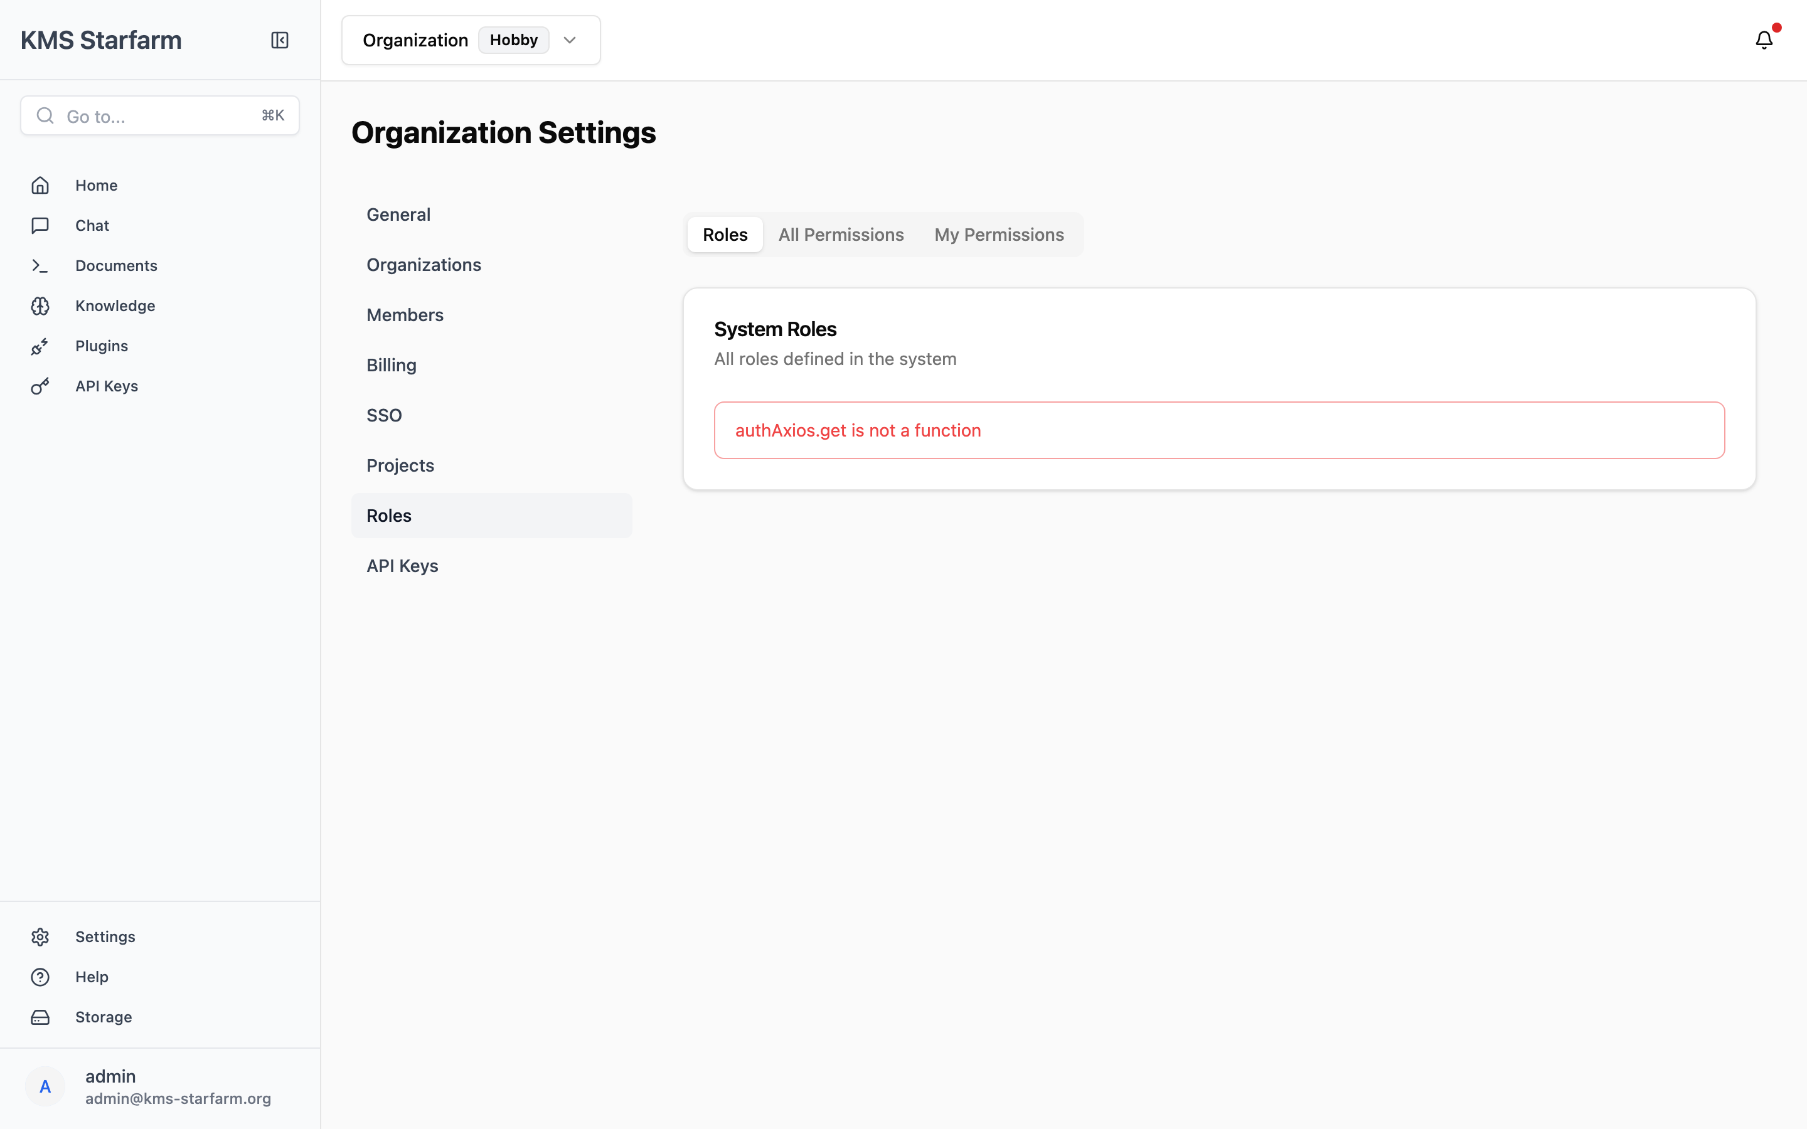
Roles
Tabs: System Roles, All Permissions, My Permissions. Roles define what actions a user can perform (read, write, admin, etc.).

10.3 API Keys Page
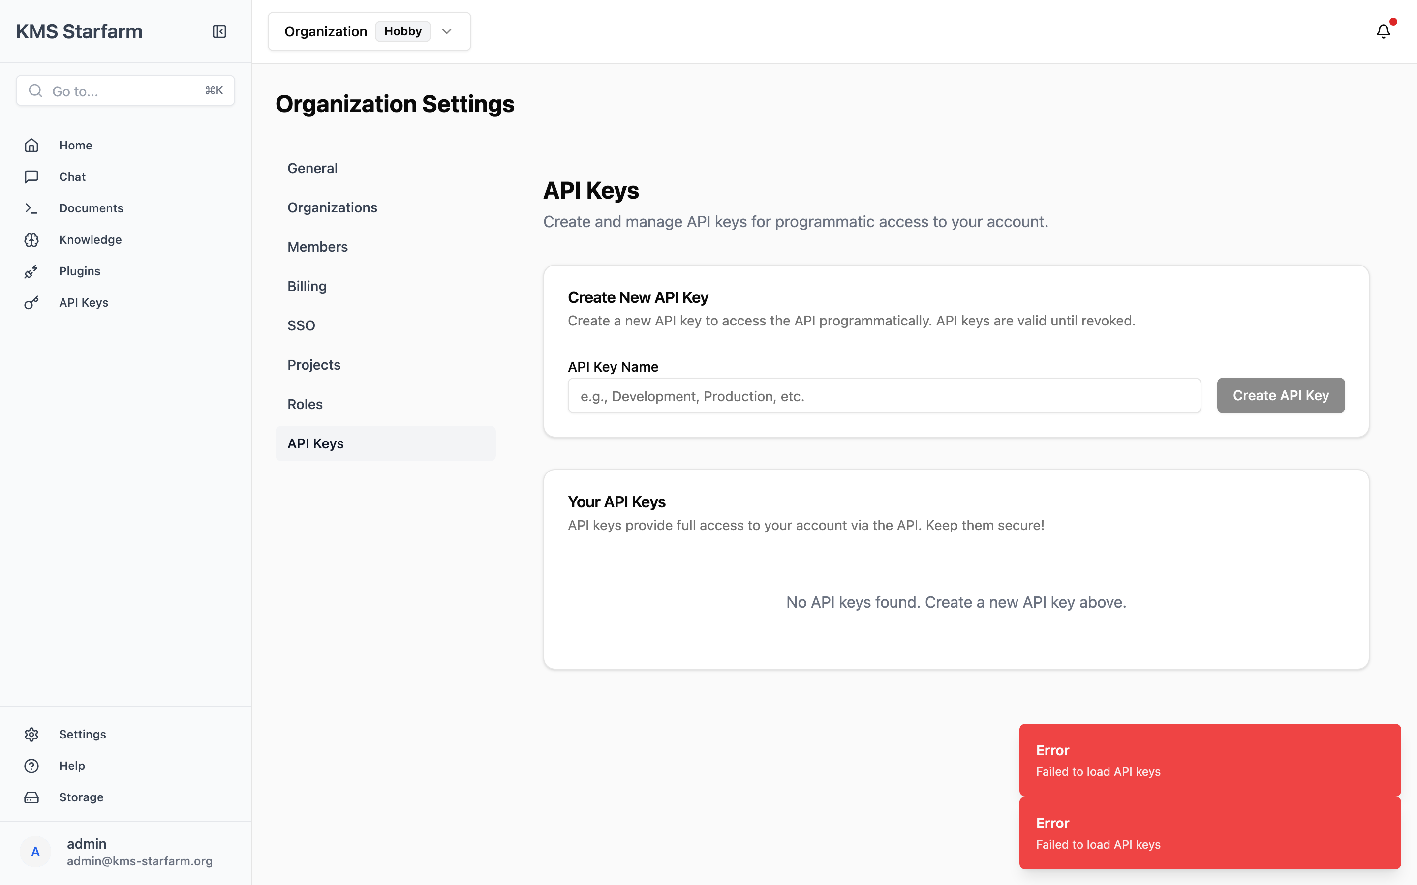
API Keys
- Create New API Key form at the top.
- On creation, a green success card shows the key value once only with a copy button — an amber warning notes it will not be shown again.
- Table columns: Name, masked prefix, Created, Last Used, Active/Inactive badge, Delete action (with confirmation dialog).

10.4 Members
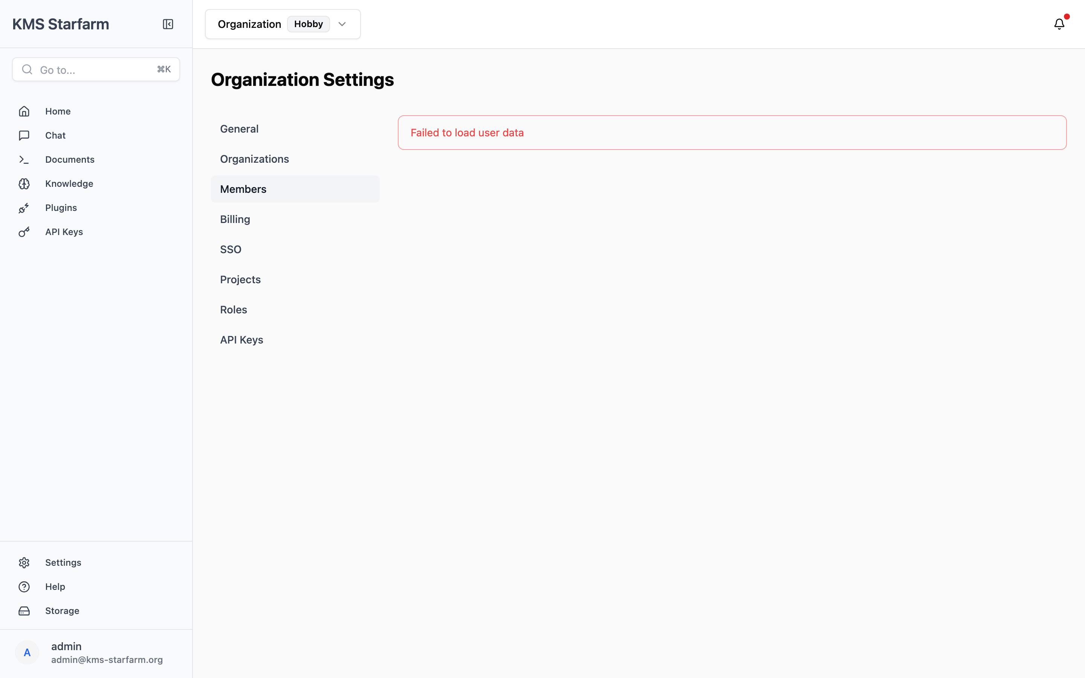
Members
Table with avatar, name, email, Organisation Role and Project Role dropdowns, pagination controls (rows per page, page input, first/prev/next/last buttons).

10.5 Organisations
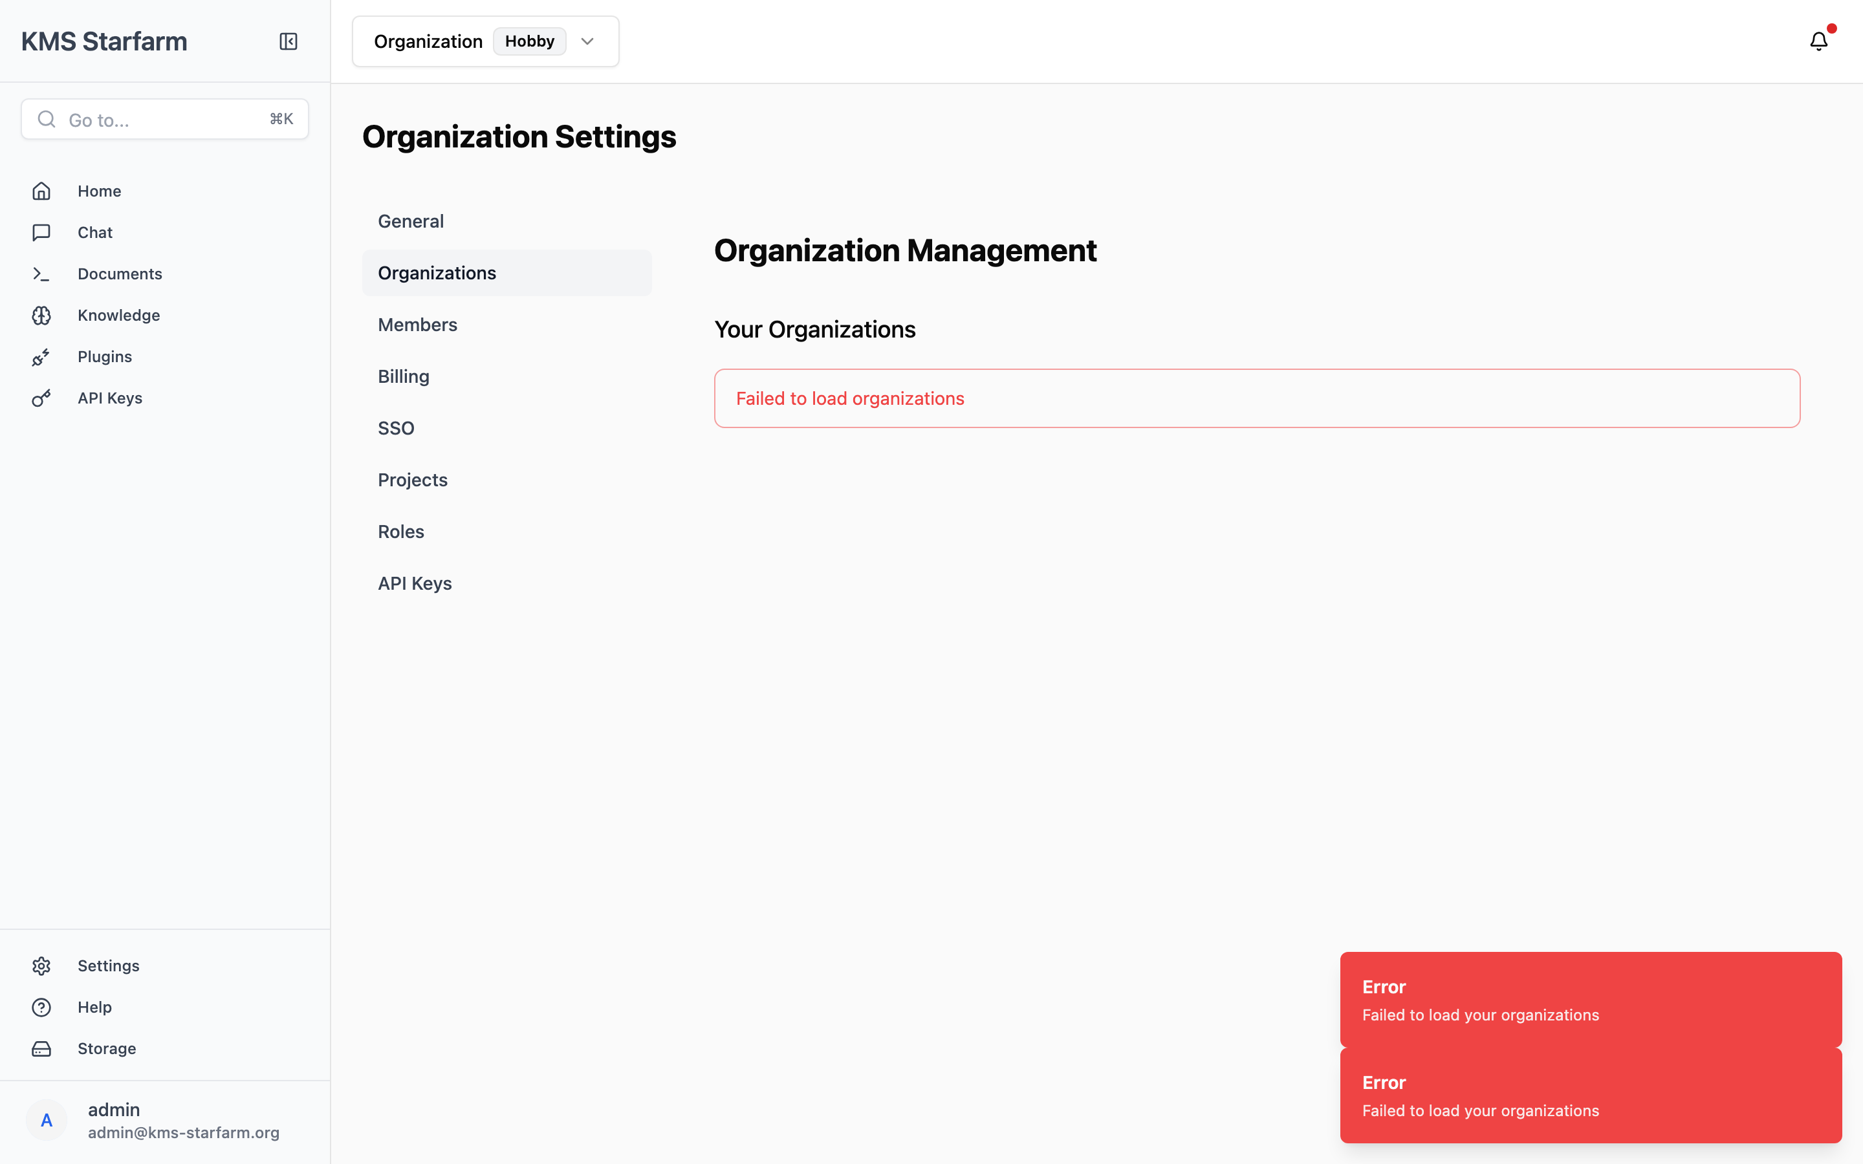
Organisations
Tabbed management (General, Members, Billing, SSO, Projects) — create organisation, view details, invite members with roles (admin/member/viewer/owner), usage/billing progress bars.

11. End-to-End Scenario Walkthroughs
These scenarios trace the full system state through realistic user actions, showing exactly what happens at each step.

Scenario 1: Document Upload → Parse → Enable → Dashboard Updates
User goal: Upload a baseline survey report and see its KPI values appear on the dashboard.
STEP 1: UPLOAD
─────────────────────────────────────────────────
User action: Documents → Upload → "Mango_Baseline_2026.pdf"
System does:
• File saved to: uploads/Mango_Baseline_2026.pdf
• Metadata created in LiteDB:
filename: "Mango_Baseline_2026.pdf"
parsing_status: "Unparsed"
enabled: False
chunk_number: 0
• Dashboard: nothing changes yet (doc not enabled)
STEP 2: PARSE
─────────────────────────────────────────────────
User action: Click Parse (▶) on the document row
System does:
• Celery task dispatched to worker
• File loaded via PyPDFLoader (or docling)
• Text split into chunks: RecursiveCharacterTextSplitter
(chunk_size=1500, chunk_overlap=400)
• Each chunk assigned UUID
• Metadata updated:
parsing_status: "SUCCESS"
chunk_number: N (e.g., 42 chunks)
loader: "PyPDFLoader"
• Chat: still cannot retrieve this doc (not enabled)
• Dashboard: no change
STEP 3: ENABLE
─────────────────────────────────────────────────
User action: Toggle Enable ON
System does:
• Each chunk embedded via all-MiniLM-L6-v2 → 384-dim vector
• Vectors added to FAISS index (vector_stores/faiss_index/)
• Metadata: enabled = True
• Staleness check triggered:
enabled_doc_ids changed → is_stale = true
• Frontend auto-triggers recalculate (POST /dashboard/kpi/recalculate)
STEP 4: KPI EXTRACTION (automatic or manual)
─────────────────────────────────────────────────
System does (on recalculate):
• Loads baseline from kpi_data.json
• Builds context: up to 5 enabled docs × 1500 chars
• LLM call: extraction prompt → JSON array of KPI entries
• Entries matched against baseline (fuzzy by kpi+indicator+group)
• Results saved to dashboard_kpis.json
• Dashboard refreshes: hero cards, charts, indicator cards update
State after Step 4:
- Dashboard shows KPI values enriched by LLM extraction from the new document
- Chat can now retrieve chunks from this document
- KPI Review page shows the extracted changes for approval
On-screen at each step:

Step 1 — Upload dialog
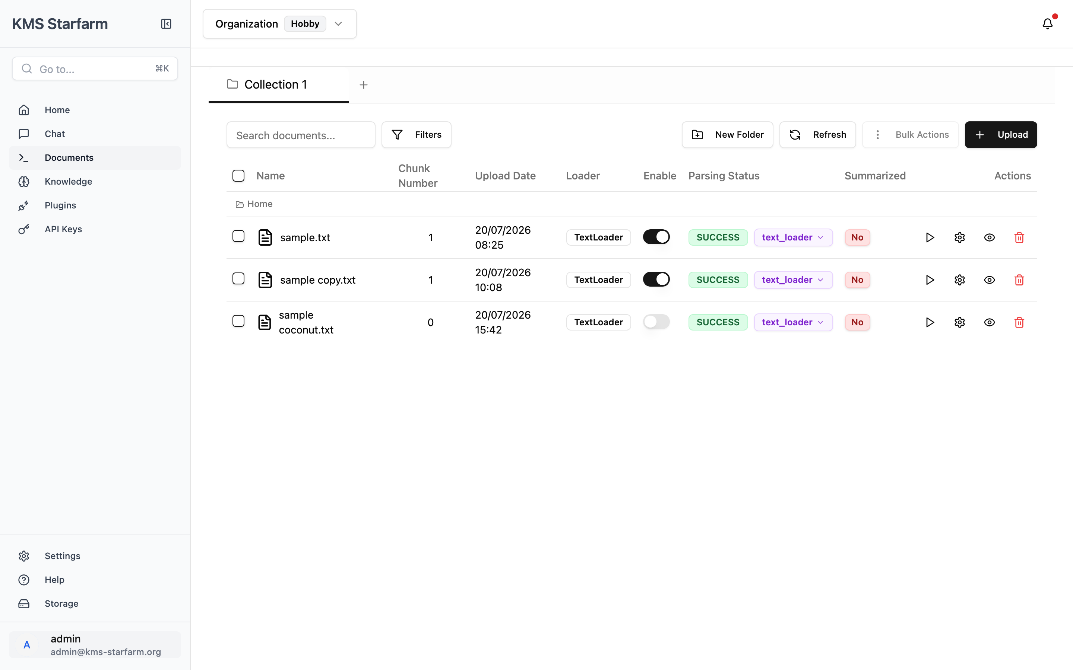
Steps 2–4 — Document table after upload, parse and enable

Scenario 2: Chat RAG — Question → Retrieval → Grounded Answer
User goal: Ask "What is the revenue for cooperative mango farmers?" and get a sourced answer.
STEP 1: QUESTION ENTERS GRAPH
─────────────────────────────────────────────────
User types: "What is the revenue for cooperative mango farmers?"
System does:
• POST /chat/ with {message: "...", thread_id: "session-uuid"}
• HumanMessage created, LangGraph invoked with state
STEP 2: TRANSFORM QUERY
─────────────────────────────────────────────────
Node: transform_query
System does:
• LLM rewrites question using chat history
• Generates sub-queries for better retrieval
• Output: ["revenue cooperative mango farmers"]
• State: sub_queries updated
STEP 3: CHAIN-OF-THOUGHT
─────────────────────────────────────────────────
Node: cot
System does:
• Fetches all document summaries from LiteDB
• LLM evaluates: do summaries alone answer the question?
• Decision: summaries not specific enough → full retrieval needed
• State: is_summary_enough = false
STEP 4: RETRIEVE
─────────────────────────────────────────────────
Node: retrieve
System does:
• FAISS cosine similarity search on transformed query
• Only searches ENABLED documents
• Returns top-K chunks (default K=5)
• Each chunk: page_content + metadata (source file, page)
• State: documents = [chunk1, chunk2, ...]
STEP 5: RERANK
─────────────────────────────────────────────────
Node: rerank
System does:
• Cross-encoder model rescores each chunk
• Ranks by relevance to original question
• Keeps top-20 most relevant
• State: reranked_documents updated
STEP 6: GENERATE
─────────────────────────────────────────────────
Node: generate
System does:
• Concatenates chunk text into context string
• Builds chat history from previous messages
• LLM call: generate_chain
Input: context + question + chat_history + summaries
Output: streaming text (token-by-token)
• Response streamed to frontend via SSE
STEP 7: HALLUCINATION CHECK (implicit)
─────────────────────────────────────────────────
System does:
• Grades: is generation grounded in documents? → "yes"
• Grades: does generation answer the question? → "yes"
• Returns "useful" → answer sent to user
RESULT: User sees streaming answer with Markdown formatting
"Sources (3)" button shows cited file names and excerpts
Follow-up suggestions appear below
On-screen: the question is submitted (left), the answer streams back grounded in the retrieved chunks (right panel), and the Sources panel opens to reveal the cited excerpts:

Chat — question and grounded answer

Chat — Sources panel with cited excerpts

Scenario 3: KPI Review and Approval
User goal: Review LLM-extracted KPIs and approve only the accurate ones.
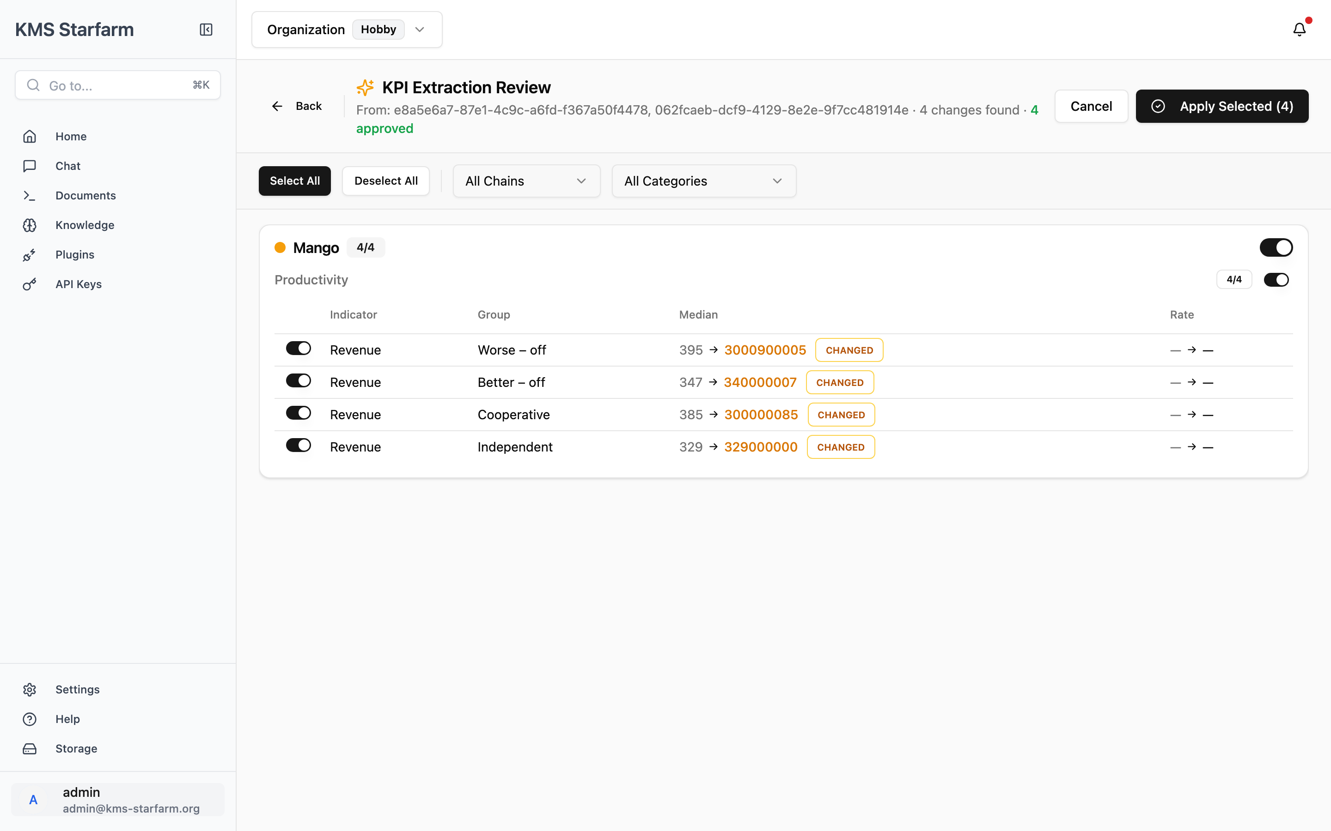
KPI Review — approval workflow
STEP 1: TRIGGER EXTRACTION
─────────────────────────────────────────────────
User clicks "Review & Extract" on dashboard
System does:
• POST /dashboard/kpi/extract
• Finds all enabled documents
• Runs LLM extraction on their content
• Creates pending entries with baseline comparison
• Returns: pending_id + list of KPIPendingEntry objects
STEP 2: REVIEW PAGE LOADS
─────────────────────────────────────────────────
User sees:
┌──────────────────────────────────────────┐
│ KPI Extraction Review │
│ From: abc123 · 4 changes found · 4/4 │
│ [Cancel] [Apply Selected (4)] │
├──────────────────────────────────────────┤
│ ○ Mango (4/4) [toggle ON] │
│ Productivity (4/4) [toggle ON] │
│ Revenue │
│ Cooperative median: 395 → 500 CHANGED│
│ Independent median: 320 → 380 CHANGED│
│ Worse-off median: 200 → 250 CHANGED│
│ Better-off median: 280 → 330 CHANGED│
└──────────────────────────────────────────┘
STEP 3: USER REVIEWS
─────────────────────────────────────────────────
User action: Toggles OFF the "Worse-off" row
System does:
• Row opacity drops to 40%
• Summary: "3 approved"
• Apply button: "Apply Selected (3)"
STEP 4: APPLY
─────────────────────────────────────────────────
User clicks "Apply Selected (3)"
System does:
• POST /dashboard/kpi/apply with {pending_id, approved_ids}
• Only approved entries merged into dashboard_kpis.json
• Pending file deleted
• Redirects to dashboard
STEP 5: DASHBOARD REFRESHES
─────────────────────────────────────────────────
User sees:
• Mango hero card: cooperative profit updated
• Revenue chart: bars reflect new values
• "Updated: a few seconds ago" timestamp
• Worse-off value remains at baseline (was rejected)

Scenario 4: Document Disable/Re-enable Effects
User goal: Understand what happens when document state changes.

Document table — Enable toggles
ACTION: DISABLE a document
─────────────────────────────────────────────────
User toggles Enable OFF on "Mango_Baseline_2026.pdf"
System does:
1. Removes all chunks from FAISS index
2. Metadata: enabled = False
3. Staleness check: enabled_doc_ids changed → is_stale = true
4. Dashboard: "New data available" banner appears
Effects:
• Chat: questions can no longer retrieve chunks from this doc
• KPI extraction: this doc excluded from context
• Dashboard: shows stale data until recalculate is triggered
ACTION: RE-PARSE a document
─────────────────────────────────────────────────
User clicks Parse (▶) on an already-parsed document
System does:
1. Old chunks deleted from LiteDB
2. New text extracted from original file
3. New chunks created (may differ in number)
4. Metadata: chunk_number updated, parsing_status = "SUCCESS"
IMPORTANT:
• Document remains ENABLED (toggle doesn't change)
• But old vectors are stale in FAISS
• User should: Disable → re-Enable to refresh embeddings
ACTION: DELETE a document
─────────────────────────────────────────────────
User clicks Delete (🗑) → confirms
System does:
1. File removed from uploads/ directory
2. Metadata removed from LiteDB
3. If enabled: chunks removed from FAISS
4. Staleness check triggered
Effects:
• Chat: no longer retrieves from this doc
• KPI extraction: excluded from future runs
• Dashboard: recalculates without this doc's data
ACTION: CLEAR DATABASE (admin)
─────────────────────────────────────────────────
Admin: DELETE /database/clear_database
System does:
1. All FAISS vectors erased
2. All document metadata cleared
3. All files remain on disk (orphaned)
Effects:
• Chat: returns no results (empty index)
• Dashboard: shows only baseline values
• Recovery: re-upload and re-enable documents

Scenario 5: New User Onboarding Flow
User goal: First-time user explores the system from login to asking their first question.
STEP 1: OPEN APPLICATION
─────────────────────────────────────────────────
User navigates to http://localhost:5173
→ Redirected to /auth/login
STEP 2: LOGIN
─────────────────────────────────────────────────
User enters: admin@kms-starfarm.org / password123
System does:
• POST /auth/signin → mock auth returns JWT tokens
• Tokens stored in localStorage
• Redirected to / (Dashboard)
STEP 3: DASHBOARD (first view)
─────────────────────────────────────────────────
User sees:
• 4 hero cards (Mango, Rice-lotus, Rice-shrimp, Coconut)
• Baseline values from kpi_data.json
• Key Insights cards with auto-computed highlights
• "Updated: ..." timestamp
• Sidebar: Home, Chat, Documents, Knowledge, Settings
STEP 4: EXPLORE DOCUMENTS
─────────────────────────────────────────────────
User navigates to Documents
Sees: existing sample documents (sample.txt, sample coconut.txt)
Some enabled, some not
User uploads "My_First_Report.pdf" → Parse → Enable
Document appears in table with status SUCCESS, enabled ON
STEP 5: KPI EXTRACTION
─────────────────────────────────────────────────
User returns to Dashboard
Sees: "New data available" banner
Auto-recalculate triggered
After extraction: hero card values updated
User clicks "Review & Extract" → reviews proposed changes → Applies
STEP 6: FIRST CHAT QUESTION
─────────────────────────────────────────────────
User navigates to Chat
Types: "What are the main findings in the report I just uploaded?"
System:
• Transforms query
• Retrieves chunks from "My_First_Report.pdf"
• Generates answer with citations
User sees: streaming answer with "Sources (2)" button
Clicks Sources → sees excerpts from their uploaded file
Clicks a follow-up suggestion → continues conversation
On-screen at each step:

Step 2 — Sign-in page

Step 3 — Dashboard, first view

12. Appendix

12.1 KPI Framework

Value Chains (4)
Chain | Description
Mango | Mango production
Rice-lotus | Rice–lotus rotation system
Rice-shrimp | Rice–shrimp integrated farming
Coconut | Coconut production

Farmer / Organisation Groups (4)
Group | Meaning
Worse-off | Resource-poor / lower-income households
Better-off | Better-resourced households
Cooperative | Members of farmer cooperatives
Independent | Independent (non-coop) farmers

KPI Categories & Example Indicators
# | Category | Example Indicators | Unit
1 | Productivity | Revenue, Yield, Total production costs, Labour cost share, Profit | mill. VNĐ/ha/yr; tonnes/ha/yr; %
2 | Value added | Value added per ha, per labour day | mill. VNĐ/ha/yr
3 | Income | Household income, Farm income | mill. VNĐ/yr
4 | Soil quality | Soil organic matter, pH, erosion | Score / tonnes/ha
5 | Exposure to pesticides | Pesticide use frequency, toxicity index | Applications/yr; score
6 | Women's empowerment | Decision-making, income share, workload | Score / %
7 | Youth empowerment | Youth participation, employment | Score / %
8 | Adaptive capacity | Diversification, climate adaptation practices | Score
9 | Social Justice | Equity, benefit sharing | Score
10 | Human well-being | Food security, health, satisfaction | Score
11 | Nutrient management | Fertiliser use efficiency | kg/ha; score
12 | Crop health | Pest/disease incidence | % / score
13 | Water sources | Water access, irrigation efficiency | Score / m³/ha

12.2 File & Format Support
Format | Parser | Notes
PDF | `docling` / `mistral_ocr` | Recommended for scanned PDFs: `mistral_ocr` (requires `MISTRAL_API_KEY`)
Word (.doc/.docx) | `docling`
Plain text (.txt) | `text_loader`
Markdown (.md) | `text_loader`
Images (jpg/png) | `mistral_ocr` | OCR extraction
Excel (.xlsx/.xls) | `UnstructuredExcelLoader`
PowerPoint (.pptx/.ppt) | `UnstructuredPowerPointLoader`
CSV | `CSVLoader`
RTF / ODT / ODS / ODP | Various `Unstructured*` loaders

12.3 Chunking Strategies
Strategy | How it works | Best for
**Recursive Character** (default) | Splits at character count boundaries (1500 chars / 400 overlap) | General-purpose, any document
**Semantic Chunking** | Splits at semantic topic shifts using embedding similarity | Documents with clear topic boundaries
**Markdown Header** | Splits by markdown headers, preserving structure | Markdown files, structured docs
**Hierarchical** | Respects document hierarchy (sections, subsections) | Technical reports, manuals
**Context-Aware** | Recursive with larger overlap to preserve context | Long documents, narrative text

12.4 System Requirements
Requirement | Minimum
Python | 3.11 or 3.12
Node.js | 20+
Redis | 7.0+
RAM | 8 GB (16 GB recommended when running LLM locally)
Disk | 10 GB for models + uploads
OS | macOS (Apple Silicon) / Linux

12.5 Troubleshooting
Symptom | Likely cause | Fix
Dashboard shows "Backend API calls are currently disabled" | Backend not running or wrong `VITE_API_URL` | Check `frontend/.env` → `VITE_API_URL=http://localhost:8081`; restart with `bash start.sh`
Document stays "Unparsed" | Parser failed or Celery not running | Check `/tmp/kms.log`; restart Celery: `poetry run kms parsers`
Chat returns no answer / hallucination | No documents are **Enabled** | Go to Documents → toggle **Enable** ON for at least one parsed document
KPI extraction returns no changes | No enabled documents or LLM not reachable | Verify `http://localhost:8000/v1/models` responds; check `/tmp/vllm.log`
Vectors not updating after re-parse | FAISS index stale | Disable → re-Enable the document to refresh embeddings
Dashboard shows stale data | Enabled docs changed since last extraction | Click "Review & Extract" or wait for auto-recalculate
Login fails | Supabase not configured | In local/mock mode any email/password works. Check `/tmp/kms.log` for auth errors
Chat returns "I'm sorry, I don't know..." | Hallucination check failed or no relevant docs | Enable more documents; try rephrasing the question
Slow chat responses | LLM inference slow or retrieval large | Check LLM server logs; consider reducing top-K in config

12.6 Glossary
Term | Definition
**KMS** | Knowledge Management System — central repository for project knowledge.
**RAG** | Retrieval-Augmented Generation — LLM answers grounded in retrieved document chunks.
**FAISS** | Facebook AI Similarity Search — vector index for fast semantic retrieval.
**Chunk** | A small text segment (e.g., 1500 chars) produced by splitting a document.
**Embedding** | Vector representation (384 dimensions) of a text chunk, used for similarity search.
**LLM** | Large Language Model (here: Llama 3.2 via vLLM-MLX).
**LangGraph** | Framework for building stateful, multi-step LLM workflows as graphs.
**CTU** | Country Technical Unit — country-level technical team (project context).
**KPI** | Key Performance Indicator — a measurable value tracking programme performance.
**Baseline** | Original Excel-imported KPI values used as foundation for all comparisons.
**Staleness** | Flag set when enabled documents change, triggering dashboard recalculation.
**Cross-encoder** | Neural model that scores query-document relevance for reranking.
**VNĐ** | Vietnamese đồng — currency used for financial KPIs (mill. = million).

12.7 References
- Project repository: local path /Users/hqnghi/git/kms
- Startup: bash start.sh (local) or make build && make up (Docker)
- Configuration: config.yaml + .env / frontend/.env
- API docs (when backend running): http://localhost:8081/docs (Swagger UI)

End of document — KMS Starfarm User Guide v2.0

