A new LASSO-BiLSTM-based ensemble learning approach for exchange rate forecasting
Siyuan Liu ª, Qiqian Huang ª, Mingchen Li ^{b,c}, Yunjie Wei ^{b,d}
ª Beijing 101 High School
^{b} Academy of Mathematics and Systems Science, Chinese Academy of Sciences, Beijing, 100190, China
^{c} School of Mathematical Sciences, University of Chinese Academy of Sciences, Beijing 100190
^{d} Center for Forecasting Science, Chinese Academy of Sciences, Beijing 100190, China

Abstract: Foreign exchange rate affects many countries’ economic status and development. Therefore, it is essential to find the factors affecting the exchange rate price and make reasonable predictions. This paper proposes the novel LASSO-BiLSTM-based ensemble learning method by integrating LASSO and BiLSTM to predict the USD/CNY exchange rate. First, 29 variables are selected to reflect economic activites on market and macroeconomic levels. Then, LASSO-BiLSTM-based ensemble learning approach is adopted with two steps: 1) LASSO is used to select six variables that are highly correlated with the exchange rate to reduce noises. 2) BiLSTM is employed to forecast exchange rate with the six chosen variables. Last, to test the effectiveness of BiLSTM, comparisons with four deep learning algorithms, which are extreme learning machine (ELM), kernel extreme learning machine (KELM), long short-term memory (LSTM), and support vector regression (SVR), are conducted. The result shows that LASSO-BiLSTM outperforms the other models in 1-step forecast (MAE: 0.051, RMSE: 0.072, MDA:0.777). Same conclusion applies to 3-steps and 6-
steps forecast. Overall, the proposed LASSO-BiLSTM-based ensemble learning method demonstrates high potential in time series forecasting.
Keywords: Exchange rate forecasting, Macroeconomic factors, Market-based variables, Time series forecasting
- Introduction
Foreign exchange rates are always characterized by high volatility and uncertainty since it is influenced by numerous unstable factors, such as economic factors and geopolitical events and environmental factors (Njindan Iyke, 2020). However, forecasting the foreign exchange rates is essential for the government as it relates to the country’s financial security and may be used to have foresight on policymaking (Sun et al., 2020). Moreover, for enterprises and individuals, accurate foreign exchange rates may help them to hedge risks and gain considerable investment income. Thus, different models are adopted to precisely capture the complexity and nonlinearity of the foreign exchange rates (Rossi, 2013). However, decades of research are still plagued by low prediction accuracy, and the prediction of exchange rate series has become particularly important in recent years as the data magnitude and data modality have been updated (search index, sentiment, etc.). This research aims to predict the exchange rate of USD/CNY by employing new combinations of variables and using different neural network models, improving the original methodology.
Models applied to exchange rate forecasting can be divided into three categories: 1) econometric and statistic methods, including ARIMA, GARCH, VAR, etc. Econometric and statistical methods always have the stationarity assumption and perform better with stationary data. However, the predictions would be far less than ideal with the nonstationary data. 2) artificial intelligence model, including ANN, SVR, NN, etc. Other artificial intelligence models such as multi-functional recurrent fuzzy neural network and new gate control unit network are developed recently (Wang et al, 2022; Nasiri & Ebadzadeh, 2022). Artificial intelligence models overcome the shortages of econometric and statistical methods but also have parameters optimal and overfitting problems. 3) Hybrid approach, which can combine parametric and nonparametric techniques. Ince & Trafalis divided the prediction process into two stages, using ARIMA to determine the correct input in the first stage, and combining ANN and SVR to forecast the exchange rate in the second stage (Ince & Trafailis, 2006). Henríquez & Kristjanpoller (2019) first used ICA to extract the noise of time series and then used NN in forecasting. Other hybrid models such as the VMD-CNN-GRU-based model (Zhao et al., 2023), CNN-BiLSTM(Méndez et al., 2023), ANN-GJR (Baffour et al., 2019), and GRU-LSTM (Islam & Hossain, 2020) were used in recent years. Whereas existing literature mainly adopted a data-driven framework. The long-term result may not be captured accurately without comprehensively considering the influence of correlated variables.
Traditionally, macroeconomic and market-level variables are used to forecast the exchange rate. Since macroeconomic variables and the exchange rate are strongly and directly correlated, the predictions were made in various countries. Nor & Masron (2020) analyzed the situation in Somalia and illustrated that shocks and macroeconomic factors lead the high volatility. Kim & Park concluded that specific macroeconomic variables affect short-term and long-term fluctuations of the exchange rate in the US, respectively. Moreover, the relationships between macroeconomic variables and the exchange rate vary in different countries.
Market-level variables may be divided into different categories. For instance, for the commodity market, the cross-correlations between the exchange rate and commodity prices were analyzed (Cashin et al., 2004; Lu et al., 2017). Some pieces of literature may focus on specific commodities and take the financial market into account, studying correlations across energy, gold, the stock market, and the exchange rate (Sujit & Kumar, 2011; Jain & Biswal, 2016; Singhal et al., 2019). Others may use google trends to predict the exchange rates since it represents public opinions to a certain degree and may be more accurate in predicting the actual directions of change in the nominal exchange rate (Bulut, 2018).
However, existing literature uses only macroeconomics variables or market-level variables to predict the exchange rate, and a few uses both. Moreover, among these variables, some may have the highest relevance to the exchange rate (Wei et al., 2018). Thus, selecting the most necessary variables and excluding variables with low relevance may reduce noise, providing a more accurate result.
Therefore, a novel LASSO-BiLSTM-based ensemble learning approach for exchange rate forecasting is proposed. First, this study collect the exchange rate historical data with related variables, whose external variables contain 29 variables in 4 areas; second, this study adopt the LASSO method to screen many variables in order to reduce the amount of subsequent calculations and to improve the accuracy; third, this study adopt the neural network model of Bi-LSTM to forecast the exchange rate series; finally, this study adopt a variety of prediction evaluation indexes to assess the prediction results in order to illustrate the superiority of the model proposed in this study.
The major contributions in this paper are as follows. First, compared with the previous study, it is the first time that the market-based variables and macroeconomic variables have been selected to predict the exchange rate of USD/CNY and this new method may take market sentiment, uncertainty, public opinions, and other explicit relationships between macroeconomic variables and exchange rate into account. Second, the collected features are filtered using LASSO, an efficient tool, to improve the prediction efficiency and accuracy. Third, the prediction is performed using an efficient Bi-LSTM model, which, to the best of our knowledge, is the first time it has been applied to exchange rate prediction.
The rest of this study is organized as follows. Section 2 shows the literature review related to this study. Section 3 introduces the related models, including LASSO, SVR, ELM, LSTM, BiLSTM, and KELM. Section 4 proposes 29 initially chosen variables in four different categories, six selected variables with the most significant relevance, and the adopted evaluation criteria. Finally, the performances of five neural network models and the other five LASSO-combining models are compared horizontally in Section 5. In Section 6, we discuss the results of the study, including a description of the contributions of this study, shortcomings and perspectives for the future. Figure 1 below demonstrates the overall process of this study.
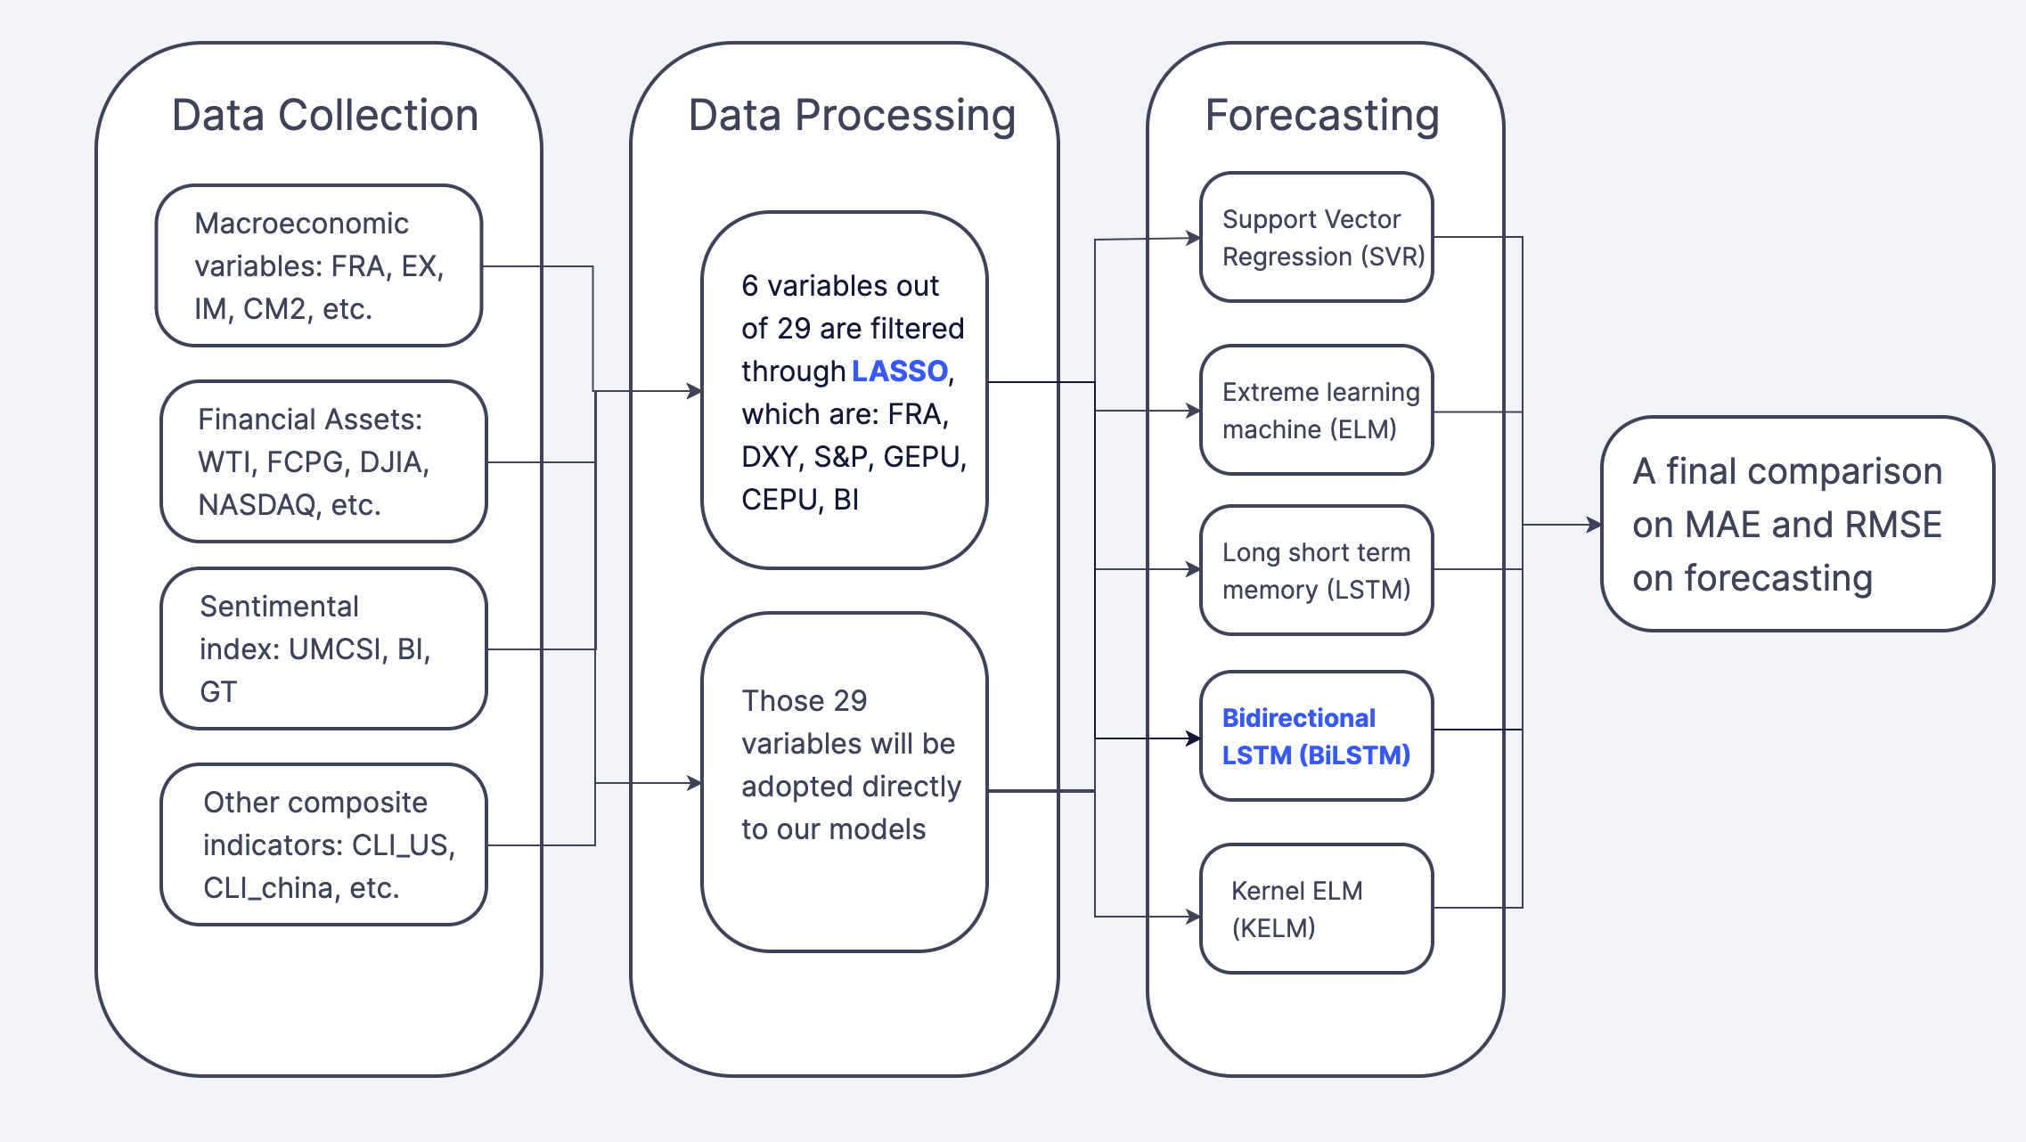
Figure 1. A LASSO-BiLSTM-based ensemble learning approach
- Literature Review
This section reviews relevant literature about exchange rate forecasting with forecasting model and variable selection.

2.1 Forecasting model
Traditionally, econometrics and statistic methods are univariate or multivariate analyses of time series. For example, by adopting ARIMA, Reddy SK (2015) investigates the behavior of daily exchange rates of the Indian Rupee (INR) against four other currencies. To improve, ensemble approaches based on econometrics and statistic models are used, such as ARIMA-based time series methods, GARCH-based and VAR-based learning (Pilbeam & Langeland, 2014; Khashei et al., 2015; Brownlees & Gallo, 2009; Epaphra, 2017; Parot et al., 2019).
However, univariate or multivariate analysis has limited capacity to analyze nonlinear data and requires linearity assumption. Machine learning can overcome these barriers effectively. For instance, Panda and Narasimhan (2007) found that neural network ANN outperforms linear autoregressive (LAR) and random walk (RW) models. Evolutionary support vector machine (SVR) and other ensemble learning approaches all demonstrate adaptive properties such as non-parametric, noise-tolerant, allowing machine learning models to map non-linear functions effectively (Fu et al., 2019; Sun & Yu, 2019; Amelot et al., 2020; Kaushik & Giri, 2020).
The remaining shortages of machine learning, such as overfitting, and backpropagated error decay, are then improved by deep learning method. Kaushik and Giri (2020) proposed the LSTM-RNN model that achieves higher prediction accuracy. Sun et al. (2020) proposed a new ensemble deep learning approach LSTM-B to improve forecasting accuracy and potential trading profitability. Dautel et al. (2020) examines the effectiveness of GRU and indicate its suitability in exchange rate forecasting. Other deep learning models, such as MLP, CNN, NGCU and MFRFNN, are also implemented in time series prediction (Wang et al., 2021; Wang et al., 2022; Nasiri & Ebadzadeh, 2022; Singh et al., 2022; Liu et al., 2023). However, to best of our knowledge, the deep learning model BiLSTM hasn’t been adopted in Forex Prediction. According to existing literature, it is mainly adopted to analyze sentimental texts, financial market, and tourism demand (Chen et al., 2017; Zhang et al., 2018; Rhanoui et al., 2019; Xu et al., 2019; Mustaqeem et al., 2020; Kulshrestha et al., 2020; Lu et al., 2020; Yang & Wang, 2022). Since BiLSTM has a strong capacity to capture future information and analyze sentiments effectively, adopting BiLSTM in the Forex market can better adapt to the instability of exchange rates and economic uncertainty.

2.2 Variable selection
Multiple domains of variables are adopted to forecast exchange rates. The most commonly used are macroeconomics variables and research shows that the movement of the exchange rate is tightly related to the performance of macroeconomic fundamentals (Huang et al., 2004; Rime et al., 2010; Molodtsova & Papell, 2012; Chaudhuri & Ghosh, 2016; Beckmann & Schüssler, 2016; Ca’ Zorzi et al., 2017; Beckmann & Czudaj, 2017). Financial variables, such as Dow Jones and stock market indices are also frequently adopted to capture the volatility of exchange rates (Huang et al., 2007; Yuan, 2013; Xiao, 2013; Raheem, 2020). Other variables that reflect market sentiment also show predictive power (Heiden et al., 2013; Bulut, 2017; Lin et al., 2022). However, only a few research adopt variables from different domains at the same time (Morales-Arias & Moura, 2013). To improve, this study selects macroeconomic variables, indicators in the financial market, sentimental index, and composite indicators to reflect economic activities comprehensively. Table 1 below provides a summary of current exchange rate forecasting literatures.
Table 1: Summary of current exchange rate forecasting references
References | Data set | Methods | Wide range of data | deep learning model | Feature selection
Reddy SK (2015) | Exchange rate  (INR/USD, INR/GBP, INR/EUR & INR/JPY) | ARIMA, Neural Network & Fuzzy models | × | × | ×
Epaphra, M. (2017) | Exchange rate (TZS/USD) | GARCH&EGARCH | × | × | ×
Kaushik & Giri (2020) | Macroeconomic variables | VAR, SVM,LSTM | × | √ | ×
Dautel et al. (2020) | Exchange rate (EUR/USD, GBP/USD, JPY/USD, CHF/USE) | LSTM, GRU | × | √ | ×
Wang et al. (2021) | Exchange rate(USD/CNY) | CNN-TLSTM | × | √ | √(only target to exchange rate)
Lin et al., (2022) | Baidu index, exchange rate (USD/CNY) | WOA-STL-BI-LSTM | × | √ | ×
Bulut (2017) | Google Trends, exchange rate of 11 OCED countries | PPP model, interest parity model, monetary model | × | × | ×
Morales-Arias & Moura (2013) | macroeconomic variables, returns/volatility of asset markets & cyclical and confidence indices | long-horizon regression approach | √ | × | ×
Parot et al., (2019) | Exchange rate (EUR/USD, GBP/USD, JPY/USD) | ANN, VAR, VECM | √ | × | ×
Pilbeam & Langeland (2014) | Exchange rate (USD/JPY, USD/CHF, USD/GBP, USD/EUR) | GARCH models | √ | × | ×
Salisu et al., (2019) | Commodity price indices, exchange rate(AUD/USD, CAD/USD, GBP/USD, EUR/USD) | a bivariate single predictive model | × | × | ×
Altan & Karasu (2019) | CCI, exchange rate (USD/TRY, EUR/TRY) | SVM | × | × | ×
Yasir et al., (2019) | Sentimental texts (5.9 million tweets), Exchange rate(PKR/USD, GBP/USD, HKD/USD) | CNN-based, linear regression, SVR | × | √ | ×
- Methodology
Several machine learning approaches were used in the method. The least absolute shrinkage and selection operator (LASSO) method is used to select several optimal variables out of 29. Bidirectional long short-term memory (BiLSTM) model, extreme learning machine (ELM), kernel extreme learning machine (KELM), long short-term memory (LSTM), and support vector regression (SVR) models will be used in forecasting USD/CNY, and its accuracy will be compared amongst these models.

3.1 Least absolute shrinkage and selection operator
The LASSO is a powerful method for variable selection and constructing regression. This method was proposed by Tibshirani (1996), which is used to enhance the testing accuracy of machine learning models. LASSO adds a penalty to the model’s residual sum of squares (RSS) (Tibshirani, 1996). The variable will be penalized more if the RSS exceeds the penalty term; therefore, a regularization process will be applied to shrink some of its coefficients to zero so the penalty will not be too high (Tibshirani, 1997). Thus, only features with non-zero coefficient are left, feature selection is achieved.
The LASSO method can bring several advantages. First, the LASSO can increase the interpretability of the regression model due to the shrinkage of several redundant or least correlated variables. Researchers can then interpret the most significant explanatory variable, eliminating irrelevant variables that are not correlated. Second, this process reduces overfitting. Overfitting usually occurs when the training model has too many explanatory variables. Although the model will fit well in training, it does not accurately predict the testing data. Last, a trade-off between bias and variance will be found. This is because when the penalty term increases, bias increases and variance decreases, thus making the model less complex and reaching a balance between bias and variance.
In a linear model, the formula is assumed to be
$Y=Xβ+ε$ (1)
with response variable Y and explanatory variable X. X can also be defined as an X_{n×k} matrix and Y can be defined as a Y_{n×1} matrix in vector form.
The LASSO minimizes the RSS with an upper bound to the sum of the absolute values of the model parameters. The upper bound is denoted as t. The LASSO formula is now shown in equation 2.
$minimize\sum_{i=1}^{n}{{\left(y_{i}−\sum_{j}{x_{ij}β_{j}}\right)}^{2} subject to \sum_{j=1}^{k}{\left|β_{j}\right|<t}}$ (2)
Which also means in vector form, the optimization will be
$minimize \left(\frac{{\left|Y−Xβ\right|}_{2}^{2}}{n}\right) subject to \sum_{j=1}^{k}{\left|β_{j}\right|<t}$ (3)
A penalty term λ is added before the sum of model parameter’s absolute value. The larger the penalty term, the more shrinkage the model will be. Therefore, the parameter estimation will be
$\hat{β}\left(λ\right)=\underset{β}{argmin}\left(\frac{{\left|Y−Xβ\right|}_{2}^{2}}{n}+λ \sum_{j=1}^{k}{\left|β_{j}\right|}\right)$ (4)
After the shrinkage, this study assumes the jth coefficient β_{j}(λ) = 0. In this circumstance, these features with coefficient = 0 will be excluded from the model. Researchers can alter the penalty values to change the number of features selected. Therefore, the LASSO method of feature selection is a useful method for feature selection in machine learning.

3.2 Long short-term memory and bidirectional long short-term memory
The long short-term memory (LSTM) and bidirectional long short-term memory (BiLSTM) are deep learning models to predict the response variable based on existing variables. BiLSTM is a bidirectional LSTM approach that can detect both positive and negative cues. Both methods are instrumental, where many explanatory variables need to be explained.
Hochreiter and Schmidhuber (1997) invented the LSTM approach. The key idea behind the LSTM approach is to regulate the cell states by using three gates, the input, forget, and output gates. The forget gate determines whether the information should be kept or forgotten. The input gate determines how much information appears in the input values. The output gate controls information output from the cell state to the hidden state (Hochreiter & Schmidhuber, 1997). Figure 2 demonstrates the architecture of LSTM.

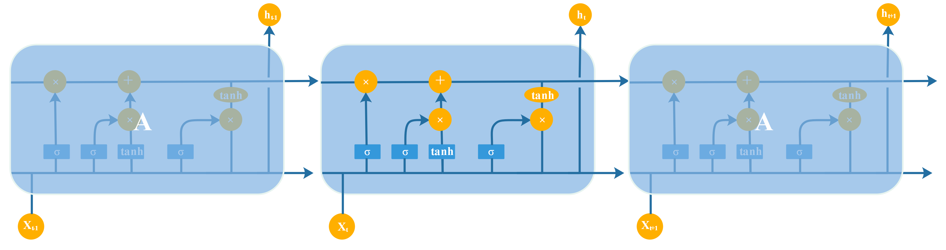
Figure 2. Graphical representation of LSTM

LSTM replaces the nodes of the recurring neural network (RNN) model with special cells, which solves RNN’s vanishing gradient problem (Aslan et al., 2021). The LSTM calculated the hidden state h_{t}, for gates, transformation, and state update, at time t (Sherstinsky, 2020). The initial data sequence inputted into the LSTM is represented as x₁, x₂, …, x_{n}. The LSTM model can be described as follows:
Gates:
$f_{t}=\text{sigmoid}\left(W_{f}∙\left[h_{t−1},x_{t}\right]+b_{f}\right)$ (5)
$i_{t}=\text{sigmoid}\left(W_{i}∙\left[h_{t−1},x_{t}\right]+b_{i}\right)$ (6)
$o_{t}=\text{sigmoid}\left(W_{o}∙\left[h_{t−1},x_{t}\right]+b_{o}\right)$ (7)
Transformation:
${\tilde{C}}_{t}=tanh⁡(W_{c}∙\left[h_{t−1},x_{t}\right]+b_{c})$ (8)
State update:
$C_{t}=f_{t}∗C_{t−1}+i_{t}∗{\tilde{C}}_{t}$ (9)
$h_{t}=o_{t}∗tanh⁡(C_{t})$ (10)
where f_{t}, i_{t}, and o_{t} are three gates, C_{t} represents the cell state, and h_{t} represents the hidden state (Zhang et al., 2020). W and b are cell parameters. These structures work together to form a network. Inputs pass through these functions and output from the hidden state.
On the other hand, BiLSTM is a bidirectional LSTM approach. BiLSTM contains five layers, input layer, embedding layer, BiLSTM layer, concatenation layer, and output layer (Zhang et al., 2020). Figure 3 demonstrates the architecture of the BiLSTM model.
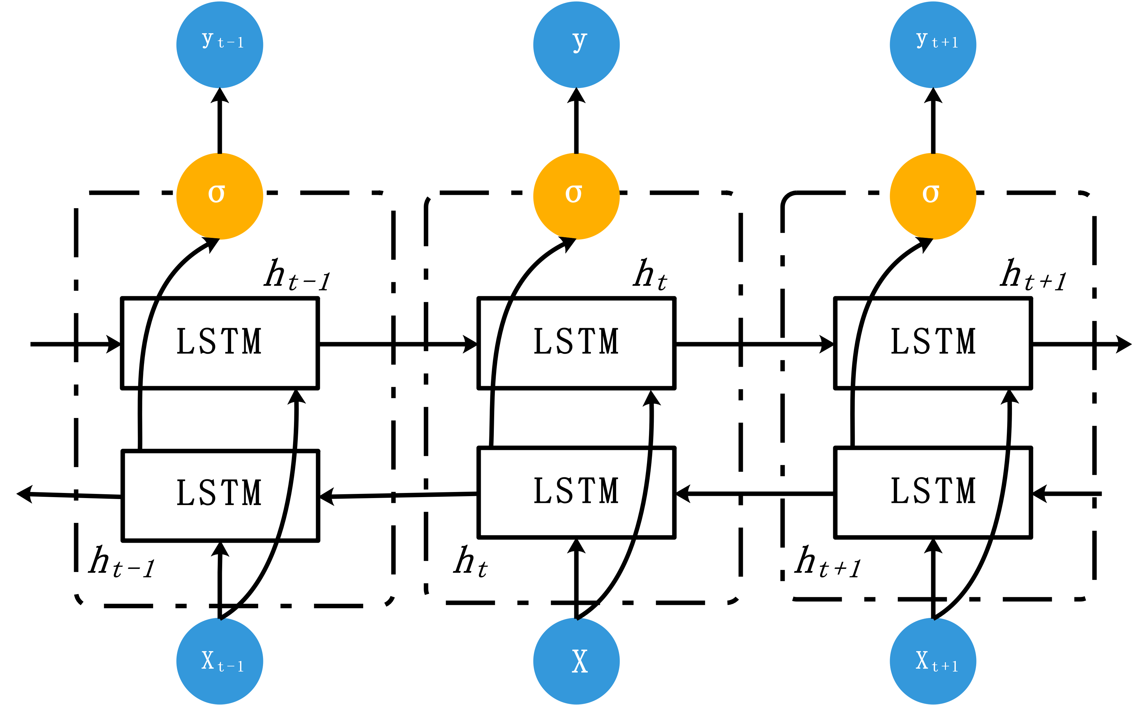
Figure 3. Graphical representation of BiLSTM
In the first layer, the input layer, let D = d₁, d₂, d₃, …, d_{v} be the total number of dimensions the data input. Then, i₁, i₂, i₃, …, i_{n} be the total unique indices in each dimension. The data is now carried as a sequence of unique indices that allows the embedding layer and BiLSTM layer to compute (Hameed & Garcia-Zapirain, 2020). The input layer processes data into the machine and organizes it, preparing for later data processing and model running.
The embedding layer transformed the input into an embedding matrix with dimension n*d, where n depicts the number of indices in dimension d (Hameed & Garcia-Zapirain, 2020). The resulting embedding matrix X looks approximately like the following.
$X= \left[\begin{matrix}\begin{matrix}\begin{matrix}x_{1,1} \\ x_{2,1} \\ x_{3,1}\end{matrix} & \begin{matrix}x_{1,2} \\ x_{2,2} \\ x_{3,2}\end{matrix}\end{matrix} & \begin{matrix}⋯ \\ ⋯ \\ ⋯\end{matrix} & \begin{matrix}x_{1,d} \\ x_{2,d} \\ x_{3,d}\end{matrix} \\ \begin{matrix}⋮ & ⋮\end{matrix} & ⋱ & ⋮ \\ \begin{matrix}\begin{matrix}x_{n−1, 1} \\ x_{n, 1}\end{matrix} & \begin{matrix}x_{n−1,2} \\ x_{n,2}\end{matrix}\end{matrix} & \begin{matrix}⋯ \\ ⋯\end{matrix} & \begin{matrix}x_{n−1,d} \\ x_{n,d}\end{matrix}\end{matrix}\right]$ (11)
The BiLSTM layer processes the pre-embedded data into the BiLSTM model. The BiLSTM layer contains two LSTM models to predict the hidden state $H = (h_{1}, h_{2}, …, h_{n})$. The hidden state in this paper will be the dollar against the CNY exchange rate. At time t, for the input x_{t}, the hidden unit vector function $\vec{h}$ is calculated based on the previous hidden state ${\vec{h}}_{t−1}$. At the same time, a backward hidden function $\overset{⃖}{h}$ is calculated based on the future hidden state ${\overset{⃖}{h}}_{t+1}$.
In the concatenation layer, the hidden states at both directions $\vec{h}$ and $\overset{⃖}{h}$, are concatenated into a long vector (Chen et al., 2017). Mathematically, the hidden vector h is represented as follows:
$h_{t}={{\vec{h}}_{t} ⨁ \overset{⃖}{h}}_{t} , h_{t}∈R^{2L}$ (12)
Where $⨁$ represents the concatenation method and L means the size of each direction of LSTM. The output of BiLSTM can be summarized as a single strand $h_{t}=[{{\vec{h}}_{t}, \overset{⃖}{h}}_{t}]$.
Lastly, the final value after the concatenation layer is shown in the output layer.

3.3 Support vector regression
Support vector regression (SVR) is a machine learning model adopted from the basis of support vectors. In a nutshell, SVR divides the dataset into different classes, and the response variable’s prediction will be classified into one of those classes.
Considering a set of training dataset $\{\left(x_{1},y_{1}\right), …,(x_{l},y_{l})\}$ $⊂Χ×ℝ$, where $Χ$ is a matrix for the input patterns. An ε-SV regression is defined as a function that each predicted point has at most ε deviation to the actual point (Cortes & Vapnik, 1995). This means this regression will not accept any deviations larger than ε.
Therefore, for the linear function $f$:
$f\left(x\right)=\left\langle ω\right.,\left.x\right\rangle +b, ω∈Χ, b∈ℝ$ (13)
With $ω$ is a vector in $Χ. \left\langle ω\right.,\left.x\right\rangle$ represents the dot product of the above two vectors. To keep the regression flat, we need a smaller $ω$ is needed. Therefore, the equation $\left\langle ω\right.,\left.ω\right\rangle = \frac{1}{2}{\left\|ω\right\|}^{2}$ is minimized in the optimization problem below:
$\text{minimize} \frac{1}{2}{\left\|ω\right\|}^{2}$ (14)
$$\text{S.T.} \left\{\begin{aligned}y_{i}−\left\langle ω\right.,\left.x_{i}\right\rangle −b≤ε \\ \left\langle ω\right.,\left.x_{i}\right\rangle +b−y_{i}≤ε\end{aligned}\right.$$
This optimization problem will only work if all of the points can lie between +ε and -ε. However, some datasets have data outside of the above boundary. Slack variables are implemented as $ξ_{i}\text{, }ξ_{i}^{∗}$ to represent the distance of datapoint to the nearest boundary (Wu et al., 2004).
Therefore, the new optimization minimizes the $\left\langle ω\right.,\left.ω\right\rangle$ as well as $ξ_{i}\text{, }ξ_{i}^{∗}$. The new equation will be:
$\text{minimize} \frac{1}{2}{\left\|ω\right\|}^{2}+C \sum_{ i=1}^{l}{{(ξ}_{i}\text{+}ξ_{i}^{∗})}$ (15)
$$\text{S.T.} \left\{\begin{aligned}y_{i}−\left\langle ω\right.,\left.x_{i}\right\rangle −b≤ε+ξ_{i} \\ \left\langle ω\right.,\left.x_{i}\right\rangle +b−y_{i}≤ε+ξ_{i}^{∗} \\ ξ_{i}\text{, }ξ_{i}^{∗}≥0\end{aligned}\right.$$
where C is a constant controlling the deviation allowed for slack variables (Smola & Schölkopf, 2004). This equation is the final model proposed, effectively making valid predictions.

3.4 Extreme learning machine and Kernel extreme learning machine
Extreme learning machine (ELM) is another deep learning model to compare with LASSO-BiLSTM. This model was first introduced in 2006, aiming to improve the efficiency of the single-hidden-layer feedforward network (SLFNs) (Huang et al., 2006).
Overall, there are numerous benefits of ELM. First, the speed of ELM is extremely fast. It takes only seconds or faster than seconds to finish the model’s learning phase (Huang et al., 2006). For complicated models, the ELM learning machine only spends 1.6 minutes on running, but similar algorithms, such as SVR, takes 12 hours (Huang et al., 2006). Thus, ELM runs more efficiently. Second, the ELM model’s simplicity reduces multiple problems in other traditional gradient-based learning methods, such as overfitting and improper learning rate (Huang et al., 2006). The simple and straightforward ELM algorithm minimized these problems overall.
For N arbitrary distinct training samples of inputs (x_{i}, t_{i}), which x_{i} represents ${[x_{i1}, x_{i2}, …,x_{in}]}^{T} ∈ R^{n}$ and t_{i} represents ${[t_{i1}, t_{i2}, …,t_{im}]}^{T}∈R^{m}$. Therefore, the training sample $\left(x_{i},t_{i}\right)∈R^{n}×R^{m}, (i=1, 2, 3,…,N)$, the output of SLFN for $\tilde{N}$ hidden nodes can be represented as:
$o_{j}=\sum_{i=1}^{\tilde{N}}{β_{i}f_{i}(x_{j})}=\sum_{i=1}^{\tilde{N}}{β_{i}f(a_{i}∙x_{j}+b_{i})}, j=1, 2,…,N$ (16)
Where $o_{j}$ is the output in SLFN, for input $x_{i}, i=1, 2,…,N$. $a_{i}$ and $b_{i}$ are the learning parameters for j^{th} hidden node, and there are $N$ hidden nodes in total. $β_{i}={[β_{i1},β_{i2},…,β_{im}]}^{T}$ is a linking parameter connecting between the j^{th} hidden node to the output $o_{j}$ (Ding et al., 2014). $f(a_{i}∙x_{j}+b_{i})$ is the activation function for the SLFN (Ding et al., 2014).
The equation above can be represented concisely as:
$Hβ=O$ (17)
And H is the output matrix for the hidden layer, β is the linking matrix between hidden layer and outputs, and O is the output matrix for the SLFN (Ding et al., 2015). They can be represented mathematically as:
$H={\left[\begin{matrix}f(a_{1}∙x_{1}+b_{1}) & ⋯ & f(a_{i}∙x_{j}+b_{i}) \\ ⋮ & ⋱ & ⋮ \\ f(a_{1}∙x_{N}+b_{1}) & ⋯ & f(a_{i}∙x_{j}+b_{i})\end{matrix}\right]}_{N×\tilde{N}},$ (18)
$$β={\left[\begin{matrix}β_{1}^{T} \\ ⋮ \\ β_{\tilde{N}}^{T}\end{matrix}\right]}_{\tilde{N}×m}, O={\left[\begin{matrix}O_{1}^{T} \\ ⋮ \\ O_{N}^{T}\end{matrix}\right]}_{N×m}$$
For minimizing $\left\|O−T\right\|$ in ELM model, $a_{i}$ and $b_{i}$ are needed to be assigned randomly without considering the input data. Therefore, this model now became a linear one, using the Moore-Penrose (MP) generalization of H, denoted as $H^{†}$ (Chen et al., 2016).
Therefore, the output weight $β$ will be produced by the algorithm below after transformation, which finishes the ELM model:
$β=H^{†}Τ$ (19)
Kernel extreme learning machine (KELM) is a Kernel approach to ELM. Multiple variations of KELM are used in previous research, such as multiple KELM (Liu et al., 2015), hybrid KELM (Lv et al., 2020). Variations of kernels are also used, such as the radial basis function (RBF) kernel (Iosifidis et al., 2015), exponential radial basis function (ERBF) kernel (Madheswaran & Dhas, 2015). In this research, the RBF kernel is used. This kernel is added to the ELM model making it more accurate in testing data. It is a popular kernel used in multiple areas. The RBF kernel can be defined as:
$K_{RBF}\left(\text{x}, \text{x}\text{’}\right)=exp⁡[−γ{\left\|\text{x-x}\text{’}\right\|}^{2}]$ (20)
where $γ$ is the parameter that sets the spread of the kernel (Ding et al., 2021). By using such method, a more accurate prediction might be achieved.

3.5 Model Parameters
The parameters are specified and determined in this paper’s model. Table 2 shows all of the model parameters’ values and its determination method.
Table 2: Model Parameters Values and Determination Approach
Model | Parameters | Determination Approach | Values
LASSO selection | Model Alpha | Grid Search | Between [0, 10]
SVR | Input Dimension | Preset | --
 | Kernel | Default | RBF Kernel
 | Constant C | Default | 1.0
 | Gamma (γ) | Default | 1/number of features
ELM | Input Dimension | Preset | --
 | Model structure selection | According to (Akusok, 2015) | LOO (Leave-One-Out)
LSTM | Input Dimension | Preset | --
 | Optimizer | Standard optimizer | Adam
 | Size of hidden layer | Trial and error approach | 12
 | Maximum of epoch | Preset | 100
BiLSTM | Input Dimension | Preset | --
 | Size of hidden layer | Trial and error approach | 16
 | Maximum of epoch | Consistent with previous models | 100+100
KELM | Kernel | Consistent with previous models | RBF Kernel
 | Gamma (γ) | Default | 1/number of features
 | Adjusting parameter C | Trial and error approach | 2
 | Error Tolerance in Kernel Matrix factorization | Default | 1e-5
- Empirical study

4.1 Data collection
29 variables ranging from various fields are selected, including: (1)Macroeconomic variables: Federal exchange reserve asset (FER), export value (EX), import value (IM), China money supply (CM2), China consumer price index (CCPI), industrial value added (IVA), Producer Price Index (PPI), purchasing managers’ index (PMI), America consumer price index(ACPI), dollar index (DXY), America money supply (AM2), Global economic policy uncertainty (GEPU), China economic policy uncertainty (CEPU), America economic policy uncertainty (AEPU), America Economic Policy Uncertainty: News Index (AEPU-NI). (2) Financial assets: West Texas Intermediate (WTI), future closing price of gold (FCPG), Dow Jones industrial average (DJIA), NASDAQ Composite Index (NASDAQ), The S&P 500 index (S&P), S&P 500 Volatility Index (VIX), Shenzhen composite index (SZCOMP), Shanghai composite index (SHCOMP). (3) Sentimental index: University of Michigan consumer sentiment index (MCSI), average searching number in Google Trends (GT), average searching number in Baidu index (BI). (4) Other composite indicators: China composite leading indicator (CLI_China), global composite leading indicator (CLI_Global), America composite leading indicator (CLI_US). Table 3 provides a list of 4 categories and 29 detailed variables.
Table 3: Selected variables within four categories
Category | Detailed variables
Macroeconomic variables | FER, EX, IM, CM2, CCPI, IVA, PPI, PMI, ACPI, DXY, AM2, GEPU, CEPU, AEPU, AEPU-NI (15)
Financial assets | WTI, FCPG, DJIA, NASDAQ, S&P, VIX, SZCOMP, SHCOMP (8)
Sentimental index | MCSI, GT, BI(3)
Other Composite indicators | CLI_China, CLI_Global, CLI_US(3)
In total, fifteen macroeconomic variables, eight financial asset variables, three sentimental variables, and three other composite indicators are chosen. The monthly data of GT and BI are obtained from google trends (https://trends.google.com/trends/) and the Baidu index (https://index.baidu.com/v2/index.html), respectively. MCSI is obtained from Fred economic data (https://fred.stlouisfed.org/series/UMCSENT), CLI_China, CLI_Global, and CLI_US are obtained from OEDC (https://data.oecd.org/leadind/composite-leading-indicator-cli.htm), other variables are obtained from the Wind Database (http://www.wind.com.cn/).
The data were selected from January 2011 to June 2022, separated into an in-sample subset and an out-of-sample subset. The in-sample subset contains the former 80% of the data, while the out-of-sample subset contains the rest of the 20%. Thus, 1) the in-sample subset is used for model training with the data from January 2011 to February 2020. 2) the out-sample subset is used for testing the data from March 2020 to June 2022.
Five seed words are selected for GT and BI, which are: RMB to US dollar exchange rate, RMB exchange rate, RMB to US dollar, Dollar RMB exchange rate, and Dollar renminbi exchange. In this cast, GT is used to represent public opinions in the US, while BI is used to represent public opinions in China. Moreover, the average monthly searching volume is used to represent the overall public opinions toward the exchange rate in different periods.
A logarithmic transformation is applied to the variables that contain data greater than 100, which are: FER, EX, CM2, AM2, FCPG, DJIA, NASDAQ, S&P, SZCOMP, SHCOMP, BI. All data undergo a standard scaling process after the log transformation.
The statistical properties of the exchange rate and selected variables are represented in Table 4. The data distributions of CLI_China and PPI are relatively asymmetric since the absolute skew are the greatest, while M2 and WTI tend to be symmetric distributions. For kurtosis, since the value of CEPU is greater than 3, the data distribution is mesokurtic, while the other variables are platykurtic distributed.
Table 4. Statistical properties of variables
Variables | mean | Standard deviation | skewness | kurtosis | Jarque-bera | P-value | Observation
FER | 10.41 | 0.09 | 0.28 | 2.59 | 2.22 | 0.00 | 109
EX | 7.52 | 0.16 | 0.26 | 1.84 | 7.38 | 0.03 | 109
IM | 7.34 | 0.13 | 0.31 | 1.79 | 8.45 | 0.14 | 109
M2 | 14.07 | 0.29 | 0.02 | 1.91 | 5.36 | 0.00 | 109
CPI | 2.55 | 1.29 | 0.46 | 1.86 | 9.82 | 0.32 | 109
CPI_US | 1.80 | 0.89 | 0.48 | 1.88 | 9.94 | 0.00 | 109
IVA | 7.93 | 3.61 | 0.17 | 1.84 | 6.62 | 0.00 | 109
PPI | 0.39 | 4.02 | 0.76 | 2.58 | 11.29 | 0.00 | 109
PMI | 50.67 | 0.93 | 0.42 | 1.90 | 8.68 | 0.82 | 109
DXY | 89.17 | 8.42 | -0.27 | 2.55 | 2.25 | 0.00 | 109
WTI | 71.55 | 22.82 | 0.01 | 2.46 | 1.28 | 0.00 | 109
COMEX | 7.21 | 0.13 | 0.40 | 2.02 | 7.21 | 0.46 | 109
DJIA | 9.78 | 0.27 | -0.16 | 1.80 | 6.94 | 0.00 | 109
NASDAQ | 8.46 | 0.37 | -0.19 | 1.83 | 6.82 | 0.00 | 109
AM2 | 9.39 | 0.15 | 0.04 | 2.00 | 4.61 | 0.00 | 109
S&P | 7.59 | 0.28 | -0.20 | 1.78 | 7.43 | 0.00 | 109
VIX | 16.20 | 4.82 | 0.35 | 1.97 | 7.04 | 0.21 | 109
MCSI | 87.13 | 10.83 | -0.03 | 2.00 | 4.56 | 0.00 | 109
SZCOMP | 9.19 | 0.17 | 0.47 | 1.98 | 8.77 | 0.53 | 109
SHCOMP | 7.91 | 0.19 | 0.12 | 2.74 | 0.57 | 0.00 | 109
GEPU | 5.03 | 0.31 | 0.33 | 2.30 | 4.31 | 0.00 | 109
CEPU | 5.47 | 0.78 | 0.63 | 3.62 | 9.20 | 0.00 | 109
AEPU | 4.81 | 0.26 | 0.49 | 1.81 | 10.70 | 0.04 | 109
AEPU-NI | 4.92 | 0.31 | 0.29 | 1.91 | 6.98 | 0.00 | 109
CLI_China | 99.92 | 0.95 | 0.80 | 2.84 | 11.87 | 0.00 | 109
CLI_US | 100.00 | 0.61 | 0.53 | 2.00 | 9.69 | 0.00 | 109
CLI_Global | 100.07 | 0.58 | 0.37 | 1.60 | 11.43 | 0.00 | 109
BI | 8.33 | 0.64 | 0.21 | 2.23 | 3.45 | 0.00 | 109
GT | 42.07 | 11.10 | 0.44 | 2.32 | 5.67 | 0.00 | 109

LASSO is used to select variables. Former 80% of data (from January 2011 to February 2020) are used to select variables. As a penalty is added to the residual sum of square, some variables’ coefficients shrink to zero, which can be illustrated in Figure 4. Eventually, six variables are selected: FER, DXY, S&P, GEPU, CEPU, and BI.
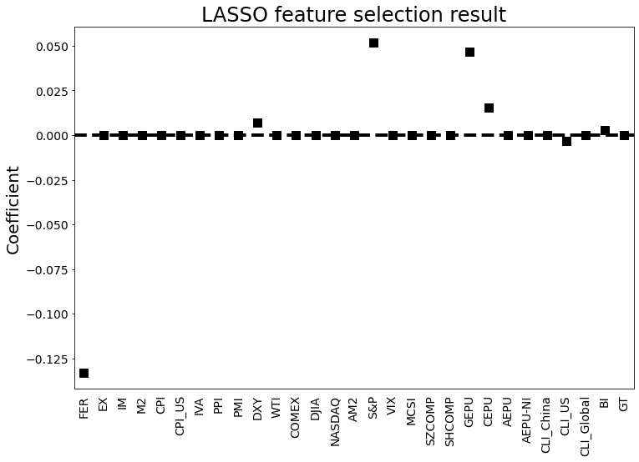
Figure 4. The coefficients of different variables for LASSO

4.2 Evaluation Criteria
Five machine learning approaches are used to make comparisons, including SVR, ELM, LSTM, BiLSTM, and KELM to find a model with strong predictive power.
Meanwhile, three methods are used to evaluate the level of forecasting accuracy, including MAE, RMSE, and MDA. Here are the following formulas:
MAE=$\frac{\sum_{t=1}^{n}{\left|\hat{Y_{t}}−Y_{t}\right|}}{n}$ (21)
RMSE=$\sqrt{\frac{1}{n}\sum_{t=1}^{n}{{(Y_{t}−\hat{Y_{t}})}^{2}}}$ (22)
$MDA=\frac{1}{n}\sum_{t}{1_{sign\left(Y_{t}−Y_{t−1}\right)==sign(\hat{Y_{t}}−\hat{Y_{t−1}})}}$ (23)
where $Y_{t}$ and $\hat{Y_{t}}$ stand for the actual value and forecast value at time t respectively, while n represents the number of observations. Smaller MAE and RMSE values means less deviation between the actual value and the forecast value. Greater MDA means higher consistency between forecast and actual directions of the exchange rate.
- Performance comparison

5.1 Forecasting Performance
This section discusses the forecasting accuracy of five machine learning approaches and LASSO-combining approaches. 1 step forecasting, 3 step forecasting, and 6 step forecasting are performed on every model. Performances are evaluated as below. The runtime and memory usage for the 1-step forecasting are shown in appendix 1 and appendix 2.
Table 5 illustrates the forecasting error on 1-step forecasting. Based on the table, LASSO enhances the forecasting accuracy effectively since models with LASSO demonstrate significantly lower MAE and RMSE. For instance, LSTM has 0.337 MAE and 0.388 RMSE, while after applying LASSO, MAE and RMSE decrease 0.23 and 0.237 respectively. Moreover, BiLSTM-based model outperforms the other models. Without adopting LASSO, BiLSTM obtains the smallest MAE and RMSE (MAE:0.102, RMSE:0.132). It outperforms other models without feature selection, such as SVR (MAE:0.264, RMSE:0.322). After adopting LASSO, the result illustrates that LASSO-BiLSTM has the smallest error compared with 9 other models (MAE: 0.051,RMSE: 0.072). Additionally, the MDA for LASSO-BiLSTM is also the highest to 0.777. This demonstrates that 77.7% of the predictions’ direction is same as the actual direction. Overall, LASSO-BiLSTM forecasts with the greatest accuracy.
Table 5: Evaluated performance of 1-step forecasting
 | MAE | RMSE | MDA
SVR | 0.264 | 0.322 | 0.407
ELM | 0.180 | 0.233 | 0.444
LSTM | 0.337 | 0.388 | 0.407
BiLSTM | 0.102 | 0.132 | 0.630
KELM | 0.252 | 0.277 | 0.630
LASSO-SVR | 0.190 | 0.227 | 0.667
LASSO-ELM | 0.164 | 0.208 | 0.519
LASSO-LSTM | 0.107 | 0.151 | 0.630
LASSO-BiLSTM | 0.051 | 0.072 | 0.777
LASSO-KELM | 0.095 | 0.125 | 0.741
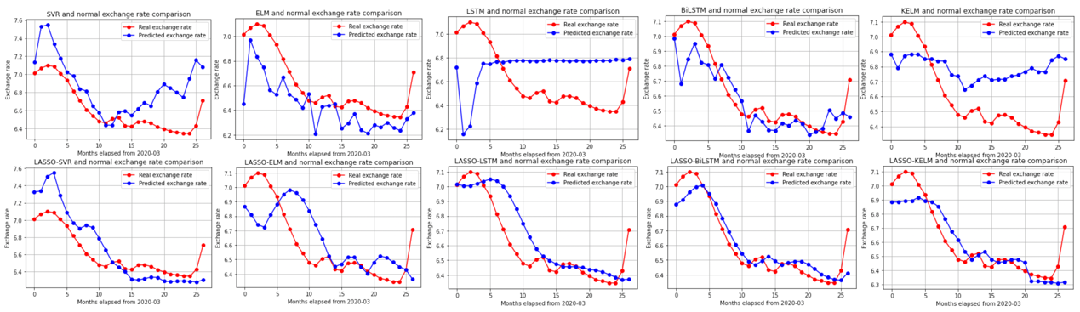
Figure 5 (high-resolution version is attached in Appendix 3) demonstrates the real exchange rate (red line) and the predicted exchange rate (blue line) in 1-step forecasting for all models. Graphically seen, LASSO-BiLSTM has the most accurate prediction.
Figure 5. Visualization of forecasting results
Models’ performances in 3-steps forecast and 6-steps forecast are analyzed as follow. Table 6 demonstrates the model performance errors in 3-steps forecasting, and table 7 shows the errors for 6-steps forecasting.
As shown in table 6 and 7, models with LASSO demonstrate significantly lower MAE and RMSE compared to models without. For instance, after adopting LASSO, MAE of LSTM decreases from 0.334 to 0.147 in 3-steps forecast and decreases from 0.325 to 0.237 in 6-steps forecast. Therefore, LASSO selection is also effective in multi-step exchange rate forecast. Moreover, LASSO-BiLSTM also achieved the best result in 3-steps forecasting and 6-steps forecasting (MAE: 0.127, RMSE: 0.147). More specifically, the proposed model outperforms other models by more than 0.019 MAE and 0.022 RMSE. When the predicting horizon increased from 3 steps to 6 steps, LASSO-BiLSTM outperforms other models by more than 0.022 MAE and 0.032 RMSE. Therefore, LASSO-BiLSTM has the lowest error in both 3-steps and 6-steps forecasting.
Table 6: Evaluated performance of 3-steps forecast
 | MAE | RMSE | MDA
SVR | 0.278 | 0.418 | 0.346
ELM | 0.265 | 0.321 | 0.462
LSTM | 0.334 | 0.401 | 0.577
BiLSTM | 0.186 | 0.245 | 0.423
KELM | 0.240 | 0.260 | 0.462
LASSO-SVR | 0.221 | 0.284 | 0.481
LASSO-ELM | 0.183 | 0.218 | 0.481
LASSO-LSTM | 0.147 | 0.195 | 0.556
LASSO-BiLSTM | 0.127 | 0.147 | 0.592
LASSO-KELM | 0.146 | 0.169 | 0.481
Table 7: Evaluated performance of 6-steps forecast
 | MAE | RMSE | MDA
SVR | 0.465 | 0.671 | 0.346
ELM | 0.252 | 0.283 | 0.307
LSTM | 0.325 | 0.356 | 0.462
BiLSTM | 0.333 | 0.363 | 0.385
KELM | 0.275 | 0.297 | 0.462
LASSO-SVR | 0.211 | 0.293 | 0.444
LASSO-ELM | 0.212 | 0.248 | 0.444
LASSO-LSTM | 0.237 | 0.287 | 0.519
LASSO-BiLSTM | 0.189 | 0.204 | 0.519
LASSO-KELM | 0.226 | 0.236 | 0.481
In conclusion, LASSO and BiLSTM-based models can effectively increase forecasting accuracy. LASSO plays an essential role in enhancing accuracy since it selects the most correlated variables and thus artificial intelligence models can emphasize on them. Whereas non-LASSO models emphasize 29 variables equally, which means less correlated variables may not contribute to forecasting accuracy but instead create noises. Moreover, LASSO-BiLSTM outperforms the other models since it has strong capacity to train numerical time series data twice and learn from the future as well as past (Siami-Namini et al. 2019). With 29 variables that reflect economic status, LASSO-BiLSTM selects data that contribute to forecasting accuracy and thus respond to high volatility effectively.
Furthermore, the 29 variables have been selected from various dimensions to predict the exchange rate of USD/CNY, our result gives new implications of what variables are significantly related to the exchange rate forecast. More specifically, 6 variables have the highest relevance with the forecast, which are: FER, DXY, S&P, GEPU, CEPU, and BI.
Foreign exchange reserves (FER) are foreign assets held by the central bank, which may be in the form of foreign currency, bonds, treasury bills, and other government securities. The explicit relationship between the exchange rate and foreign exchange reserves is that as CNY depreciated, a trade surplus would occur and thus the foreign exchange reserve would be accumulated. However, in the long run, the correlation between China’s foreign exchange reserves and the exchange rate has been found positive (Narayan & Smyth, 2006).
The U.S. Dollar Index (DXY) is used to evaluate the value of the dollar against a basket of six foreign currencies, which are the Euro, Swiss Franc, Japanese Yen, Canadian Dollar, British Pound, and Swedish Krona. An increase in DXY means that the Dollar is gaining strength compared to the currencies of other countries, and thus the market sentiment would be influenced. Then, the transaction in the international market would further affect the exchange rate of the dollar against the CNY. Even though the interactions between DXY and the exchange rate are relatively intermediate, DXY still has a relatively significant effect on the response variable as this research shows. We induce that DXY incorporates the international market’s situations and sentiments greatly, and thus enhances forecasting accuracy.
S&P 500 is a stock market index that reflects the stock performance of 500 leading companies in the U.S. The overall trend of the S&P 500 reflects investors’ sentiments toward the U.S. stock market and affects investors’ decisions on fund purchases since the index can be used as a benchmark. Moreover, Lilley and Rinaldi (2018) have first illustrated that S&P 500 and exchange rate began to move synchronously since the financial crisis, which is tightly related to proxies’ risk preference. Based on this research, Lilley et al. (2020) have further discovered that the U.S. dollar is likely to depreciate when risk appetite is high. Since BiLSTM is highly sensitive to market sentiment, the forecasting accuracy would be relatively ideal as S&P 500 is adopted.
The measurement of economic policy uncertainties (EPU) incorporates three components: quantification of policy-related economic uncertainty as shown by the newspaper, index reported by the Congressional Budget Office (CBO), and the uncertainty index drawn from Federal Reserve Bank of Philadelphia’s Survey of Professional Forecasters (Economic Policy Uncertainty Index, 2012). Since the newspaper-based measurement is adopted, the capture of uncertainty would incorporate textual sentiment. This shows a high consistency with BiLSTM’s characteristic, which adopts a bidirectional prediction of texts and shows high sensitivity to emotion. Other sentiment analyses have also been done based on BiLSTM (Xu et al., 2019). Moreover, since the sample data of exchange rates are selected from a long-term scale, they would be more volatile. Liming et al. (2019) illustrate that as the volatility of exchange rates increases, the positive shock of EPU would also increase. This positive feedback loop illustrates the tight positive relationship between EPU and the exchange rate under uncertainty. Thus, if two indexes show consistency, the forecasting result brought by BiLSTM would also be more accurate.
Baidu Index (BI) illustrates the search volume of 5 keywords, which are: RMB to US dollar exchange rate, RMB exchange rate, RMB to US dollar, Dollar RMB exchange rate, and Dollar renminbi exchange. High search volume may reveal the public’s attention to the exchange rate and foreign exchange market over a period of time, and thus reflect the fluctuation of market sentiments. Lin et al. (2022) have found that BI is effective for the exchange rate forecast by using the BiLSTM model, which is consistent with this research’s result.

5.2 Diebold-Mariano Test
Diebold-Mariano (DM) test is utilized to test the statistical superiority of LASSO-BiLSTM. The DM test is performed by checking the loss differential expectation score. Null hypothesis ($H_{0}$) is two forecasts have equal predicting accuracy. To reject H₀, the significance level should lower than 10%. The loss differential is calculated according to the root mean squared error (RMSE).
Table 8: Diebold-Mariano test on results performance
 | SVR | ELM | LSTM | BiLSTM | KELM | LASSO-SVR | LASSO-ELM | LASSO-LSTM | LASSO-KELM
LASSO-BiLSTM | -3.921*** | -3.490*** | -3.807*** | -2.108** | -5.394*** | -4.291*** | -4.120*** | -2.949*** | -3.019***
SVR |  | -0.732 | -1.264 | 3.479*** | 1.590 | 1.795* | 2.122** | 2.905*** | 3.474***
ELM |  |  | -0.306 | 3.226*** | 1.322 | 2.444** | 2.432** | 2.746** | 3.154***
LSTM |  |  |  | 3.997*** | 1.559 | 2.723** | 2.919*** | 3.152*** | 3.600***
BiLSTM |  |  |  |  | -4.059* | -3.185*** | -2.776*** | -0.618 | 0.288
KELM |  |  |  |  |  | 1.231 | 1.815** | 3.248*** | 4.044***
LASSO-SVR |  |  |  |  |  |  | 1.402 | 2.755** | 4.067***
LASSO-ELM |  |  |  |  |  |  |  | 2.931*** | 3.454***
LASSO-LSTM |  |  |  |  |  |  |  |  | 1.117
*** 1% Significance Level
** 5% Significance Level
* 10% Significance Level
As shown in table 8, all of the DM statistics for LASSO-BiLSTM are negative and p values are smaller than 5%. Therefore, the null hypothesis is rejected. It is revealed that the LASSO-BiLSTM approach is far superior to the other benchmarks under 95% confidence level.

5.3 Further Verification
The LASSO-BiLSTM method is also tested on datasets other than USD-CNY, in order to demonstrate its effectiveness. After deleting the variables that related to China’s economic status, the rest of the variables are used to test Dollar (USD) to Pound (GBP). The result from this additional test also indicates that LASSO-BiLSTM is the best method for exchange rate forecasting.
Table 9: USD-GBP forecasting performance
 | MAE | RMSE
SVR | 0.135 | 0.151
ELM | 0.078 | 0.100
LSTM | 0.145 | 0.155
BiLSTM | 0.041 | 0.043
KELM | 0.064 | 0.076
LASSO-SVR | 0.034 | 0.038
LASSO-ELM | 0.063 | 0.078
LASSO-LSTM | 0.035 | 0.043
LASSO-BiLSTM | 0.025 | 0.030
LASSO-KELM | 0.044 | 0.050
As shown in table 9, for a completely different dataset, the MAE and RMSE for LASSO-BiLSTM are still the smallest among all of the models. This further demonstrates that for exchange rate forecasting, LASSO-BiLSTM currently provides the best result and the smallest error possible.
To further verify the effectiveness of LASSO-BiLSTM model comparing to more up to date models, Gated Recurrent Unit (GRU) and Temporal Convolutional Network (TCN) and its LASSO selection version are performed. The dataset used is still USD-CNY dataset. The parameters are the same as above parameters. To make the result consistent, parameters in all following models are kept consistent with the BiLSTM parameters in table 2. The result is shown in the following table.
Table 10: New models comparison
 | MAE | RMSE
LASSO-BiLSTM | 0.051 | 0.072
GRU | 0.346 | 0.374
TCN | 0.347 | 0.482
LASSO-GRU | 0.067 | 0.091
LASSO-TCN | 0.073 | 0.094
Even comparing with more state-of-the-art models, as illustrated in table 10, LASSO-BiLSTM still yields the lowest error, the highest forecasting accuracy. Therefore, this paper concludes that LASSO-BiLSTM is shown to be the most effective model in exchange rate forecasting.
- Conclusion and Discussions
The main purpose of this study is to improve the accuracy of exchange rate forecast. To achieve, the novel LASSO-BiLSTM-based ensemble learning method is proposed to predict the USD/CNY exchange rate. The framework of the proposed approach includes three steps. Firstly, 29 related variables from four different categories are selected. Secondly, LASSO feature selecting approach is used to choose six variables with the greatest relevance. Lastly, five deep learning methods (SVR, ELM, LSTM, KELM, BiLSTM) that employ 29 related variables and LASSO-combining models (LASSO-SVR, LASSO-ELM, LASSO-LSTM, LASSO-KELM) are adopted to forecast the exchange rate of USD/CNY. Overall, LASSO plays a significant role in forecast accuracy and LASSO-BiLSTM has the best performance in 1 step forecasting, 3 steps forecasting and 6 steps forecasting. To verify the robustness of LASSO-BiLSTM, same test has applied to the forecast of USD/GBP and LASSO-BiLSTM still outperformed the other models.
This study has four major implications: (1)LASSO-BiLSTM has outstanding potential to forecast exchange rate (2) Adopting LASSO as feature selection can reduce overfitting effectively and thus improve the result (3) BiLSTM-based model can effectively process information from both direction and thus outperforms other models (4) Considering different types of variables before forecast can better understand economic situation. These conclusions can apply to further study and help improve forecasting performance.
Since exchange rate is tightly related countries economic status, financial transaction and enterprise decisions, exchange rate forecasting would be highly essential. Therefore, the newly raised methodology will provide two management implications. First, the proposed model can help policy makers make decisions and thus ensure countries’ economic development and security. Second, individual transactors can learn from the signals and thus manage their assets effectively.
Although the proposed framework has obtained an outstanding forecasting performance, it still has certain limitations. Firstly, LASSO-BiLSTM has only applied to Forex market but not applied to other markets. Since variables in other financial markets also have high volatility, LASSO-BiLSTM may also have strong potential to forecast those variables. Secondly, this study mainly focuses on short-run forecast. To apply the model in more situations, LASSO-BiLSTM can also be tested in long-run forecast in future study. Lastly, to capture data characteristic more comprehensively, further study can extract features of other models and adopt BiLSTM-based ensemble learning approach to forecast.

Reference
Akusok, A., Bjork, K.-M., Miche, Y., & Lendasse, A. (2015). High-Performance Extreme Learning Machines: A Complete Toolbox for Big Data Applications. IEEE Access, 3, 1011–1025. https://doi.org/10.1109/access.2015.2450498
Altan, A., & Karasu, S. (2019). The Effect of Kernel Values in Support Vector Machine to Forecasting Performance of Financial Time Series. The Journal of Cognitive Systems, 4(1), 17–21. https://dergipark.org.tr/en/pub/jcs/issue/44276/570863
Amelot, L. M. M., Subadar Agathee, U., & Sunecher, Y. (2020). Time series modelling, NARX neural network and hybrid KPCA–SVR approach to forecast the foreign exchange market in Mauritius. African Journal of Economic and Management Studies, 12(1), 18–54. https://doi.org/10.1108/ajems-04-2019-0161
Aslan, M. F., Unlersen, M. F., Sabanci, K., & Durdu, A. (2021). CNN-based transfer learning–BiLSTM network: A novel approach for COVID-19 infection detection. Applied Soft Computing, 98, 106912.
Baffour, A. A., Feng, J., & Taylor, E. K. (2019). A hybrid artificial neural network-GJR modeling approach to forecasting currency exchange rate volatility. Neurocomputing, 365, 285-301.
Beckmann, J., & Czudaj, R. (2017). Exchange rate expectations and economic policy uncertainty. European Journal of Political Economy, 47, 148–162. https://doi.org/10.1016/j.ejpoleco.2016.06.003
Beckmann, J., & Schüssler, R. (2016). Forecasting exchange rates under parameter and model uncertainty. Journal of International Money and Finance, 60, 267–288. https://doi.org/10.1016/j.jimonfin.2015.07.001
Brownlees, C. T., & Gallo, G. M. (2009). Comparison of Volatility Measures: a Risk Management Perspective. Journal of Financial Econometrics, 8(1), 29–56. https://doi.org/10.1093/jjfinec/nbp009
Bulut, L. (2017). Google Trends and the forecasting performance of exchange rate models. Journal of Forecasting, 37(3), 303–315. https://doi.org/10.1002/for.2500
Bulut, L. (2018). Google Trends and the forecasting performance of exchange rate models. Journal of Forecasting, 37(3), 303-315.
Ca’ Zorzi, M., Kolasa, M., & Rubaszek, M. (2017). Exchange rate forecasting with DSGE models. Journal of International Economics, 107, 127–146. https://doi.org/10.1016/j.jinteco.2017.03.011
Cashin, P., Céspedes, L. F., & Sahay, R. (2004). Commodity currencies and the real exchange rate. Journal of Development Economics, 75(1), 239-268.
Chaudhuri, T. D., & Ghosh, I. (2016, July 3). Artificial Neural Network and Time Series Modeling Based Approach to Forecasting the Exchange Rate in a Multivariate Framework. ArXiv.org. https://doi.org/10.48550/arXiv.1607.02093
Chen, H. L., Wang, G., Ma, C., Cai, Z. N., Liu, W. B., & Wang, S. J. (2016). An efficient hybrid kernel extreme learning machine approach for early diagnosis of Parkinson׳ s disease. Neurocomputing, 184, 131-144.
Chen, L., Du, Z., & Hu, Z. (2019). Impact of economic policy uncertainty on exchange rate volatility of China. Finance Research Letters. https://doi.org/10.1016/j.frl.2019.08.014
Chen, T., Xu, R., He, Y., & Wang, X. (2017). Improving sentiment analysis via sentence type classification using BiLSTM-CRF and CNN. Expert Systems with Applications, 72, 221–230. https://doi.org/10.1016/j.eswa.2016.10.065
Chen, T., Xu, R., He, Y., & Wang, X. (2017). Improving sentiment analysis via sentence type classification using BiLSTM-CRF and CNN. Expert Systems with Applications, 72, 221-230.
Cortes, C., & Vapnik, V. (1995). Support-vector networks. Machine learning, 20(3), 273-297.
Datta, R. K., Sajid, S. W., Moon, M. H., & Abedin, M. Z. (2021). Foreign Currency Exchange Rate Prediction Using Bidirectional Long Short Term Memory. Studies in Computational Intelligence, 213–227. https://doi.org/10.1007/978-3-030-73057-4_17
Dautel, A. J., Härdle, W. K., Lessmann, S., & Seow, H.-V. (2020). Forex exchange rate forecasting using deep recurrent neural networks. Digital Finance. https://doi.org/10.1007/s42521-020-00019-x
Ding, S., Xu, X., & Nie, R. (2014). Extreme learning machine and its applications. Neural Computing and Applications, 25(3), 549-556.
Ding, S., Zhao, H., Zhang, Y., Xu, X., & Nie, R. (2015). Extreme learning machine: algorithm, theory and applications. Artificial Intelligence Review, 44(1), 103-115.
Ding, X., Liu, J., Yang, F., & Cao, J. (2021). Random radial basis function kernel-based support vector machine. Journal of the Franklin Institute, 358(18), 10121-10140.
Economic Policy Uncertainty Index. (2012). Policyuncertainty.com. https://www.policyuncertainty.com/
Epaphra, M. (2017). Modeling Exchange Rate Volatility: Application of the GARCH and EGARCH Models. Journal of Mathematical Finance, 07(01), 121–143. https://doi.org/10.4236/jmf.2017.71007
Fu, S., Li, Y., Sun, S., & Li, H. (2019). Evolutionary support vector machine for RMB exchange rate forecasting. Physica A: Statistical Mechanics and Its Applications, 521, 692–704. https://doi.org/10.1016/j.physa.2019.01.026
Hameed, Z., & Garcia-Zapirain, B. (2020). Sentiment classification using a single-layered BiLSTM model. IEEE Access, 8, 73992-74001.
Heiden, S., Klein, C., & Zwergel, B. (2013). Beyond Fundamentals: Investor Sentiment and Exchange Rate Forecasting. European Financial Management, 19(3), 558–578. https://doi.org/10.1111/j.1468-036x.2010.00593.x
Henríquez, J., & Kristjanpoller, W. (2019). A combined Independent Component Analysis–Neural Network model for forecasting exchange rate variation. Applied Soft Computing, 83, 105654.
Hochreiter, S., & Schmidhuber, J. (1997). Long short-term memory. Neural computation, 9(8), 1735-1780.
Huang, G. B., Zhu, Q. Y., & Siew, C. K. (2006). Extreme learning machine: theory and applications. Neurocomputing, 70(1-3), 489-501.
Huang, W., Lai, K. K., Nakamori, Y., & WANG, S. (2004). Forecasting Foreign Exchange Rates with Artificial Neural Networks: A Review. International Journal of Information Technology & Decision Making, 03(01), 145–165. https://doi.org/10.1142/s0219622004000969
Huang, W., Lai, K. keung, Nakamori, Y., Wang, S., & Yu, L. (2007). Neural Networks in Finance and Economics Forecasting. International Journal of Information Technology & Decision Making, 06(01), 113–140. https://doi.org/10.1142/s021962200700237x
Iosifidis, A., Tefas, A., & Pitas, I. (2015). On the kernel extreme learning machine classifier. Pattern Recognition Letters, 54, 11-17.
Islam, M. S., & Hossain, E. (2020). Foreign exchange currency rate prediction using a GRU-LSTM hybrid network. Soft Computing Letters, 100009.
Jain, A., & Biswal, P. C. (2016). Dynamic linkages among oil price, gold price, exchange rate, and the stock market in India. Resources Policy, 49, 179-185.
Kaushik, M., & Giri, A. K. (2020, February 19). Forecasting Foreign Exchange Rate: A Multivariate Comparative Analysis between Traditional Econometric, Contemporary Machine Learning & Deep Learning Techniques. ArXiv.org. https://doi.org/10.48550/arXiv.2002.10247
Khashei, M., Ali Montazeri, M., & Bijari, M. (2015). Comparison of Four Interval ARIMA-base Time Series Methods for Exchange Rate Forecasting. International Journal of Mathematical Sciences and Computing, 1(1), 21–34. https://doi.org/10.5815/ijmsc.2015.01.03
Kim, Y., & Park, C. (2020). Are exchange rates disconnected from macroeconomic variables? Evidence from the factor approach. Empirical Economics, 58(4), 1713-1747.
Kulshrestha, A., Krishnaswamy, V., & Sharma, M. (2020). Bayesian BILSTM approach for tourism demand forecasting. Annals of Tourism Research, 83, 102925. https://doi.org/10.1016/j.annals.2020.102925
Lilley, A., & Rinaldi, G. (2018, October 8). Currency Betas and Interest Rate Spreads. Papers.ssrn.com. https://ssrn.com/abstract=3262313
Lilley, A., Maggiori, M., Neiman, B., & Schreger, J. (2020). Exchange Rate Reconnect. The Review of Economics and Statistics, 1–28. https://doi.org/10.1162/rest_a_00978
Lin, Y., Wang, R., Gong, X., & Jia, G. (2022). Cross-correlation and forecast impact of public attention on USD/CNY exchange rate: Evidence from Baidu Index. Physica A: Statistical Mechanics and Its Applications, 127686. https://doi.org/10.1016/j.physa.2022.127686
Lin, Y., Wang, R., Gong, X., & Jia, G. (2022). Cross-correlation and forecast impact of public attention on USD/CNY exchange rate: Evidence from Baidu Index. Physica A: Statistical Mechanics and Its Applications, 127686. https://doi.org/10.1016/j.physa.2022.127686
Liu, P., Wang, Z., Liu, D., Wang, J., & Wang, T. (2023). A CNN-STLSTM-AM model for forecasting USD/RMB exchange rate. Journal of Engineering Research, 100079–100079. https://doi.org/10.1016/j.jer.2023.100079
Liu, X., Wang, L., Huang, G. B., Zhang, J., & Yin, J. (2015). Multiple kernel extreme learning machine. Neurocomputing, 149, 253-264.
Lu, W., Li, J., Wang, J., & Qin, L. (2020). A CNN-BiLSTM-AM method for stock price prediction. Neural Computing and Applications, 33(10), 4741–4753. https://doi.org/10.1007/s00521-020-05532-z
Lu, X., Li, J., Zhou, Y., & Qian, Y. (2017). Cross-correlations between RMB exchange rate and international commodity markets. Physica A: Statistical Mechanics and its Applications, 486, 168-182.
Lv, L., Wang, W., Zhang, Z., & Liu, X. (2020). A novel intrusion detection system based on an optimal hybrid kernel extreme learning machine. Knowledge-based systems, 195, 105648.
Madheswaran, M., & Dhas, D. A. S. (2015). Classification of brain MRI images using support vector machine with various Kernels. Biomedical Research, 26(3), 505-513.
Méndez, M., Merayo, M. G., & Núñez, M. (2023). Long-term traffic flow forecasting using a hybrid CNN-BiLSTM model. Engineering Applications of Artificial Intelligence, 121, 106041.
Molodtsova, T., & Papell, D. H. (2012). Taylor Rule Exchange Rate Forecasting during the Financial Crisis. NBER International Seminar on Macroeconomics, 9(1), 55–97. https://doi.org/10.1086/669584
Mong, T., & Ngan, U. (2016). Forecasting Foreign Exchange Rate by using ARIMA Model: A Case of VND/USD Exchange Rate. Research Journal of Finance and Accounting Www.iiste.org ISSN, 7(12), 2222–2847. https://core.ac.uk/download/pdf/234631456.pdf
Morales-Arias, L., & Moura, G. V. (2013). Adaptive forecasting of exchange rates with panel data. International Journal of Forecasting, 29(3), 493–509. https://doi.org/10.1016/j.ijforecast.2012.10.007
Mustaqeem, Sajjad, M., & Kwon, S. (2020). Clustering-Based Speech Emotion Recognition by Incorporating Learned Features and Deep BiLSTM. IEEE Access, 8, 79861–79875. https://doi.org/10.1109/access.2020.2990405
Narayan, P. K., & Smyth, R. (2006). The dynamic relationship between real exchange rates, real interest rates and foreign exchange reserves: empirical evidence from China. Applied Financial Economics, 16(9), 639–651. https://doi.org/10.1080/09603100500401278
Nasiri, H., & Ebadzadeh, M. M. (2022). MFRFNN: Multi-Functional Recurrent Fuzzy Neural Network for Chaotic Time Series Prediction. Neurocomputing. https://doi.org/10.1016/j.neucom.2022.08.032
Njindan Iyke, B. (2020). The Disease Outbreak Channel of Exchange Rate Return Predictability: Evidence from COVID-19. Emerging Markets Finance and Trade, 56(10), 2277–2297. https://doi.org/10.1080/1540496x.2020.1784718
Panda, C., & Narasimhan, V. (2007). Forecasting exchange rate better with artificial neural network. Journal of Policy Modeling, 29(2), 227–236. https://doi.org/10.1016/j.jpolmod.2006.01.005
Parot, A., Michell, K., & Kristjanpoller, W. D. (2019). Using Artificial Neural Networks to forecast Exchange Rate, including VAR‐VECM residual analysis and prediction linear combination. Intelligent Systems in Accounting, Finance and Management, 26(1), 3–15. https://doi.org/10.1002/isaf.1440
Pilbeam, K., & Langeland, K. N. (2014). Forecasting exchange rate volatility: GARCH models versus implied volatility forecasts. International Economics and Economic Policy, 12(1), 127–142. https://doi.org/10.1007/s10368-014-0289-4
Raheem, I. D. (2020). Global financial cycles and exchange rate forecast: A factor analysis. Borsa Istanbul Review. https://doi.org/10.1016/j.bir.2020.06.002
Reddy SK, B. A. (2015). Exchange Rate Forecasting using ARIMA, Neural Network and Fuzzy Neuron. Journal of Stock & Forex Trading, 04(03). https://doi.org/10.4172/2168-9458.1000155
Rhanoui, M., Mikram, M., Yousfi, S., & Barzali, S. (2019). A CNN-BiLSTM Model for Document-Level Sentiment Analysis. Machine Learning and Knowledge Extraction, 1(3), 832–847. https://doi.org/10.3390/make1030048
Rime, D., Sarno, L., & Sojli, E. (2010). Exchange rate forecasting, order flow and macroeconomic information. Journal of International Economics, 80(1), 72–88. https://doi.org/10.1016/j.jinteco.2009.03.005
Rossi, B. (2013). Exchange Rate Predictability. Journal of Economic Literature, 51(4), 1063–1119. https://doi.org/10.1257/jel.51.4.1063
Salisu, A. A., Adekunle, W., Alimi, W. A., & Emmanuel, Z. (2019). Predicting exchange rate with commodity prices: New evidence from Westerlund and Narayan (2015) estimator with structural breaks and asymmetries. Resources Policy, 62, 33–56. https://doi.org/10.1016/j.resourpol.2019.03.006
Sherstinsky, A. (2020). Fundamentals of recurrent neural network (RNN) and long short-term memory (LSTM) network. Physica D: Nonlinear Phenomena, 404, 132306.
Singh, G., Pradeepta Kumar Sarangi, Rani, L., Sharma, K., Sinha, S., Ashok Kumar Sahoo, & Bishnu Prasad Rath. (2022). CNN-RNN based Hybrid Machine Learning Model to Predict the Currency Exchange Rate: USD to INR. 2022 2nd International Conference on Advance Computing and Innovative Technologies in Engineering (ICACITE). https://doi.org/10.1109/icacite53722.2022.9823844
Singhal, S., Choudhary, S., & Biswal, P. C. (2019). Return and volatility linkages among International crude oil price, gold price, exchange rate and stock markets: Evidence from Mexico. Resources Policy, 60, 255-261.
Smola, A. J., & Schölkopf, B. (2004). A tutorial on support vector regression. Statistics and computing, 14(3), 199-222.
Sujit, K. S., & Kumar, B. R. (2011). Study on the dynamic relationship among gold price, oil price, exchange rate and stock market returns. International journal of applied business and economic research, 9(2), 145-165.
Sun, H., & Yu, B. (2019). Forecasting Financial Returns Volatility: A GARCH-SVR Model. Computational Economics. https://doi.org/10.1007/s10614-019-09896-w
Sun, S., Wang, S., & Wei, Y. (2020). A new ensemble deep learning approach for exchange rates forecasting and trading. Advanced Engineering Informatics, 46, 101160. https://doi.org/10.1016/j.aei.2020.101160
Tibshirani, R. (1996). Regression shrinkage and selection via the lasso. Journal of the Royal Statistical Society: Series B (Methodological), 58(1), 267-288.
Tibshirani, R. (1997). The lasso method for variable selection in the Cox model. Statistics in medicine, 16(4), 385-395.
Wang, J., Wang, X., Li, J., & Wang, H. (2021). A Prediction Model of CNN-TLSTM for USD/CNY Exchange Rate Prediction. IEEE Access, 9, 73346–73354. https://doi.org/10.1109/access.2021.3080459
Wang, J., Li, X., Li, J., Sun, Q., & Wang, H. (2022). NGCU: A New RNN Model for Time-Series Data Prediction. Big Data Research, 27, 100296. https://doi.org/10.1016/j.bdr.2021.100296
Wei, Y., Sun, S., Lai, K. K., & Abbas, G. (2018). A KELM-Based Ensemble Learning Approach for Exchange Rate Forecasting. Journal of Systems Science and Information, 6(4), 289-301.
Wu, C. H., Ho, J. M., & Lee, D. T. (2004). Travel-time prediction with support vector regression. IEEE transactions on intelligent transportation systems, 5(4), 276-281.
Xiao, L. (2013). Realized volatility forecasting: empirical evidence from stock market indices and exchange rates. Applied Financial Economics, 23(1), 57–69. https://doi.org/10.1080/09603107.2012.707769
Xu, G., Meng, Y., Qiu, X., Yu, Z., & Wu, X. (2019). Sentiment Analysis of Comment Texts Based on BiLSTM. IEEE Access, 7, 51522–51532. https://doi.org/10.1109/access.2019.2909919
Xu, G., Meng, Y., Qiu, X., Yu, Z., & Wu, X. (2019). Sentiment Analysis of Comment Texts Based on BiLSTM. IEEE Access, 7, 51522–51532. https://doi.org/10.1109/access.2019.2909919
Yang, M., & Wang, J. (2022). Adaptability of Financial Time Series Prediction Based on BiLSTM. Procedia Computer Science, 199, 18–25. https://doi.org/10.1016/j.procs.2022.01.003
Yasir, M., Durrani, M. Y., Afzal, S., Maqsood, M., Aadil, F., Mehmood, I., & Rho, S. (2019). An Intelligent Event-Sentiment-Based Daily Foreign Exchange Rate Forecasting System. Applied Sciences, 9(15), 2980. https://doi.org/10.3390/app9152980
Yuan, Y. (2013). Forecasting the movement direction of exchange rate with polynomial smooth support vector machine. Mathematical and Computer Modelling, 57(3-4), 932–944. https://doi.org/10.1016/j.mcm.2012.10.004
Zhang, Y., Wang, J., & Zhang, X. (2018, June 1). YNU-HPCC at SemEval-2018 Task 1: BiLSTM with Attention based Sentiment Analysis for Affect in Tweets. Aclanthology.org. https://doi.org/10.18653/v1/S18-1040
Zhang, Y., Wang, J., & Zhang, X. (2018, June). Ynu-hpcc at semeval-2018 task 1: Bilstm with attention based sentiment analysis for affect in tweets. In Proceedings of The 12th International Workshop on Semantic Evaluation (pp. 273-278).
Zhao, Z., Yun, S., Jia, L., Guo, J., Meng, Y., He, N., ... & Yang, L. (2023). Hybrid VMD-CNN-GRU-based model for short-term forecasting of wind power considering spatio-temporal features. Engineering Applications of Artificial Intelligence, 121, 182.

Appendix

Appendix 1: Runtime
Model | Runtime (Second)
SVR | 0.0026s
ELM | 0.0040s
LSTM | 4.9227s
BiLSTM | 14.0618s
KELM | 0.01135
LASSO-SVR | 7.9575s
LASSO-ELM | 7.9578s
LASSO-LSTM | 10.4951s
LASSO-BiLSTM | 19.5828s
LASSO-KELM | 7.9655s

Appendix 2: Memory
Model | Memory (Megabyte)
SVR | 0.0117
ELM | 0.015625
LSTM | 2.7695
BiLSTM | 6.0195
KELM | 4.7929
LASSO-SVR | 448.9921
LASSO-ELM | 449.0781
LASSO-LSTM | 453.1211
LASSO-BiLSTM | 484.3476
LASSO-KELM | 453.0586

Appendix 3: High Resolution Prediction Picture
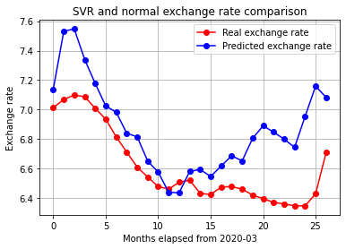
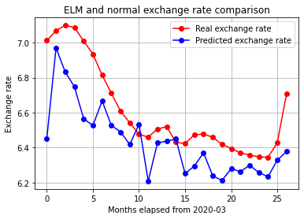
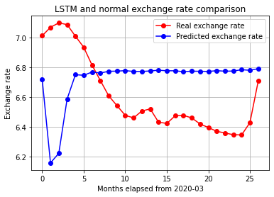
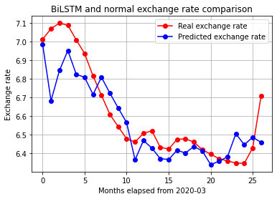
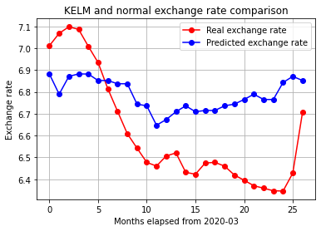
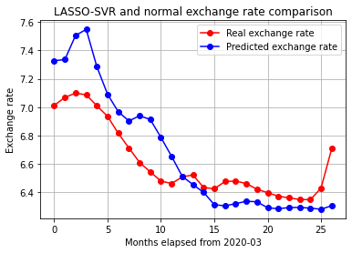
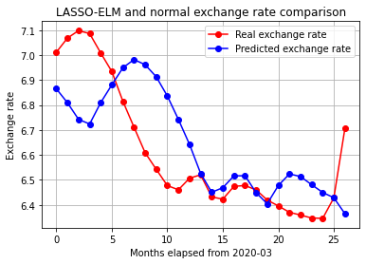
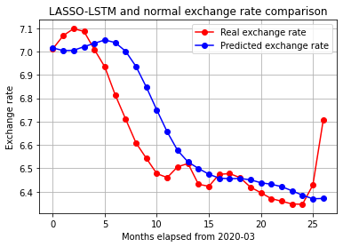
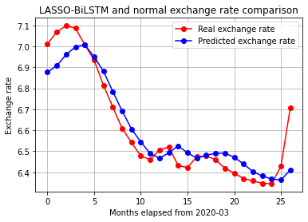
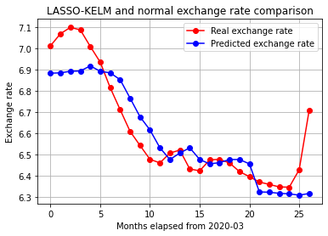

Corresponding author’s email: weiyunjie@amss.ac.cn (Yunjie Wei), Postal Address: Academy of Mathematics and Systems Science, Chinese Academy of Sciences, Zhongguancun East Road, # 55, Haidian District, Beijing, PR China, Tel: +86 10 82541655 Acknowledgements: This research work was partly supported by the National Natural Science Foundation of China under Grants No. 72171223, No. 71801213 and No. 71988101

