# How notification works

## System notifications

* User receive a message from another user.
* User receive a medal.
* User gain permission due to reputation increments (also new title).
* User is subscribed by someone. *(group notifications if too much entry)*

## User subscription:

When user A subscribe user B, according to user A’s settings, user A will receive a notification when:

* User B post new Problem.
* User B post new Blog.
* User B start new Discussion.
* User B share a MainPost.

## Topic subscription:

* An author post a blog to the Topic

## Self-posts subscription

* Someone post a Reply in user posted Problem
* Someone post a Reply in user posted Blog
* Someone post a Reply in user posted Discussion
* Someone post a Comment in user posted Reply
* Someone vote up/down a Post *(group notifications if too much entry)*

## Following MainPost notification

* Someone post a Reply in user following MainPost

## Problem Inviting

* When user is invited to solve a problem by someone.

# Diagrams

## Class Diagram

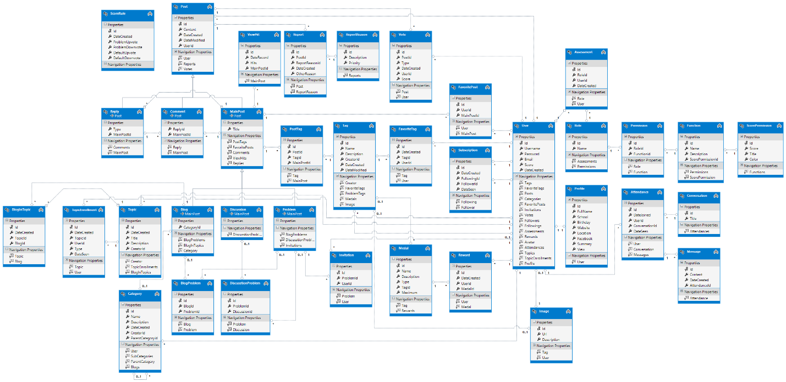

# Definitions, Acronyms and Abbreviations

## Post

## MainPost

## Problem

## Blog

## Discussion

## Topic

## Reply

## Comment