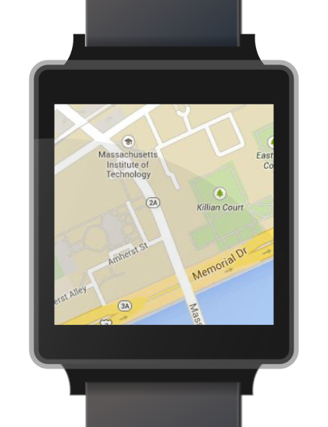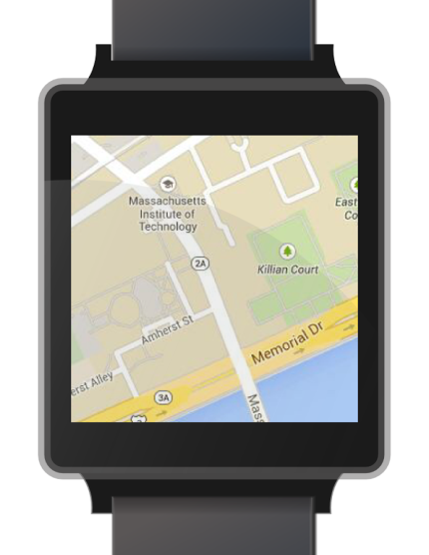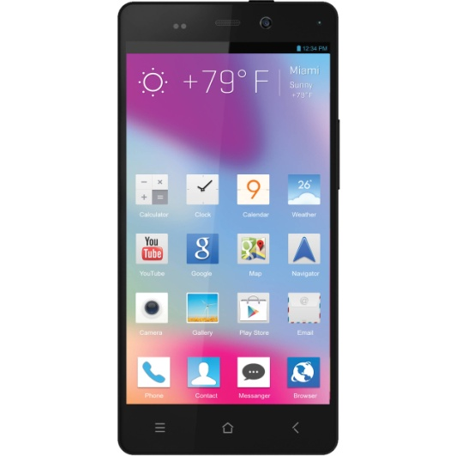

Current place

Current place

Current place

Information of point B

System auto transfer when user drives to new point

**A**

Information of point A

current place button will appear when user choose another place.

**B**

**B**

**C**

Information of point B

Information of point C

Tap to Point C

Double tap in information box

Point B

Point C

Point A

Tap to point B

Show first point and it’s information

Get information

Information of point A

**A**

sync