### List of Use Case

#### Web Application

##### <Guest> Overview Use Case

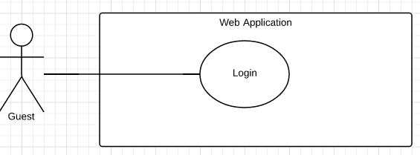

Figure 5 <Guest> Overview Use Case

###### <Guest> Login

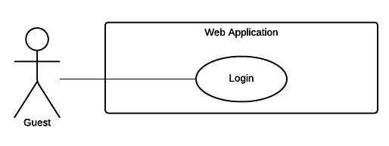

Figure 6 <Guest> Login

|  |  |  |  |
| --- | --- | --- | --- |
| USE CASE – WG01 | | | |
| Use Case No. | WG01 | **Use Case Version** | 2.0 |
| Use Case Name | Login | | |
| Author | DatNT | | |
| Date | 23/09/2015 | **Priority** | Normal |
| Actor:   * Guest   Summary:   * This use case allows guest to log in the system.   Goal:   * Guest can log in the system.   Triggers:   * Guest sends the login command.   Preconditions:   * N/A   Post Conditions:   * Success: Guest login the system. * Fail: Show error message.   Main Success Scenario:   |  |  |  | | --- | --- | --- | | Step | Actor Action | System Response | | 1 | Guest goes to login view. | System requires identity information from Guest:   * Email or customer code: free text input, required, length 3 – 250 * Password: free text input, required, length 6 – 32 | | 2 | Guest inputs information. |  | | 3 | Guest sends command to login to system | Guest will login system with their specific role  [Alternative 1]  [Exception 1] |   Alternative Scenario:   |  |  |  | | --- | --- | --- | | Step | Actor Action | System Response | | 1 | Guest enter wrong identity information. | Wrong identity information, System shows error message. |   Exceptions:   |  |  |  | | --- | --- | --- | | Step | Actor Action | System Response | | 1 | Missing of required fields | System notify guest to enter their identity information |   Relationships: N/A  Business Rules:   * Password are encrypted before being sent to server. * After login to system, guest will be redirected to specific view based on their role on the system: staff or customer. * If role is “Customer”, the system will display to Customer view. * If role is “Staff”, the system will display to Staff Dashboard view. | | | |

Table 10 Use case WG01 - <Guest> Login

##### <Staff> Overview Use Case

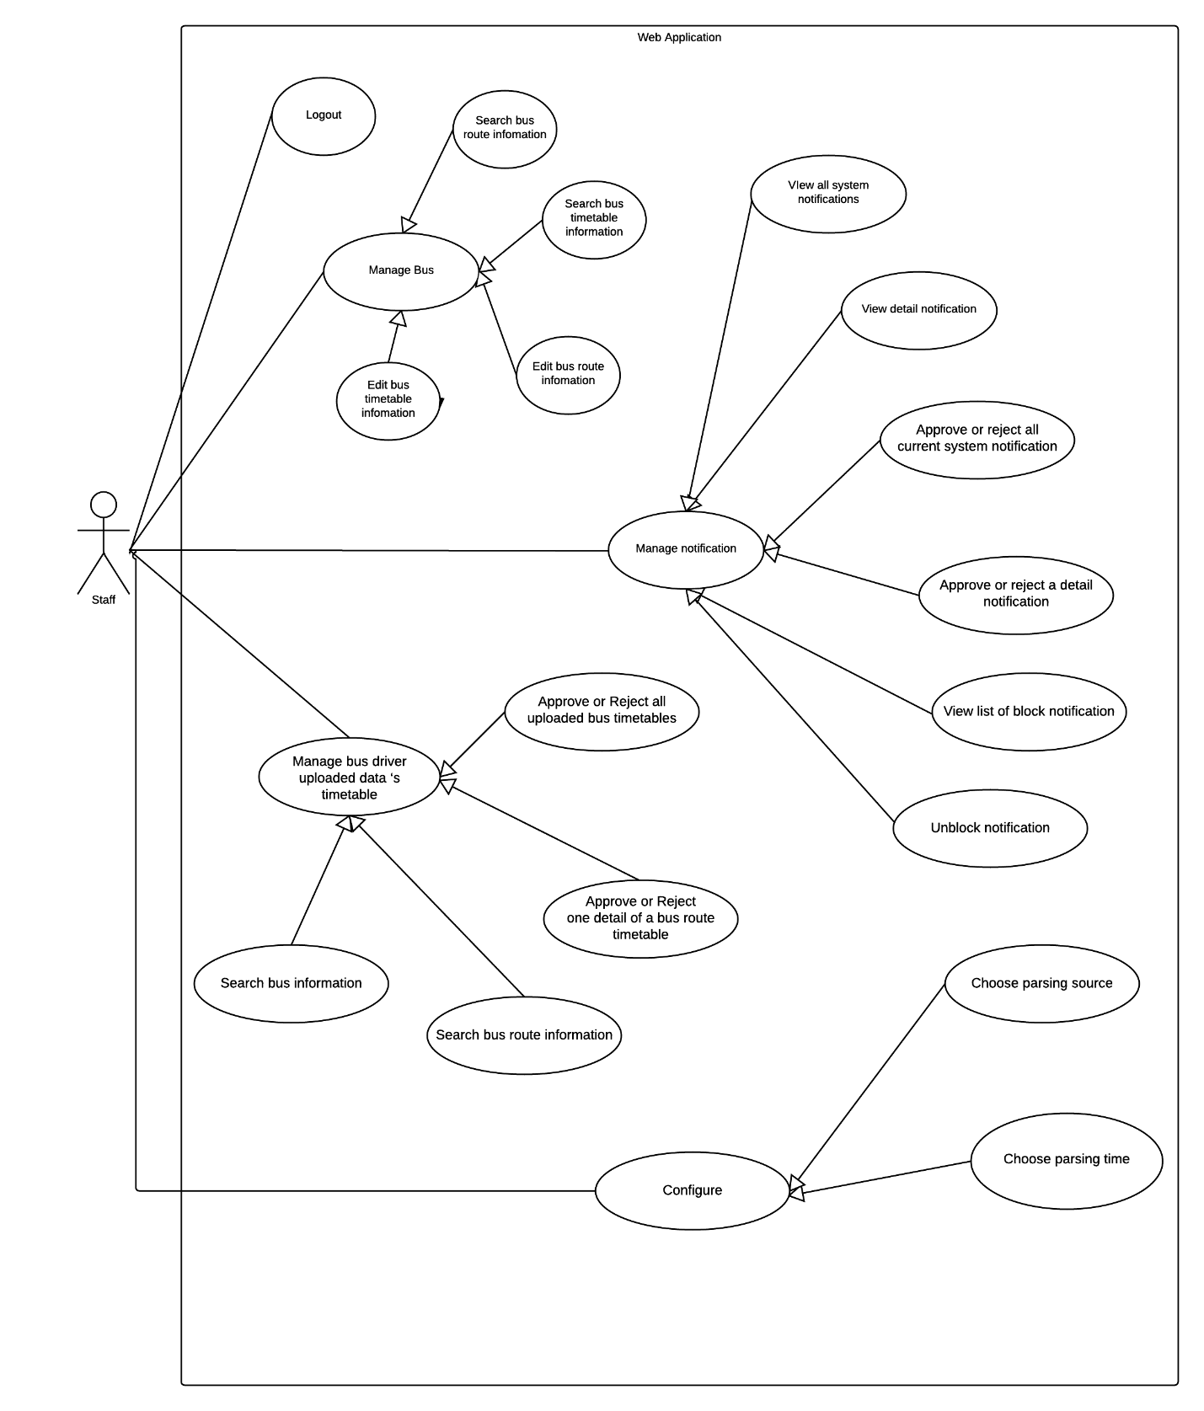

Figure 20 <Staff> Overview Use Case

###### <Staff> Logout

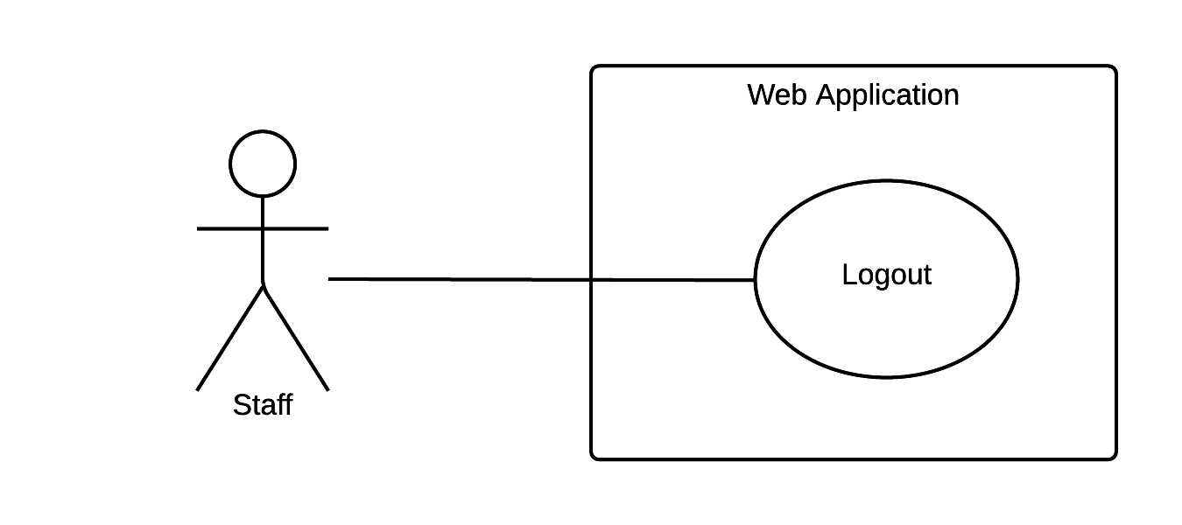

Figure 21 <Staff> View profile

|  |  |  |  |
| --- | --- | --- | --- |
| USE CASE – WS01 | | | |
| Use Case No. | WS01 | **Use Case Version** | 2.0 |
| Use Case Name | Logout | | |
| Author | DatNT | | |
| Date | 23/09/2015 | **Priority** | Normal |
| Actor:   * Staff   Summary:   * This use case allows staff logout the system.   Goal:   * Staff can logout the system.   Triggers:   * Staff sends logout command.   Preconditions:   * Staff must login into the system.   Post Conditions:   * Success: Staff logs out the system. * Fail: Show error message.   Main Success Scenario:   |  |  |  | | --- | --- | --- | | Step | Actor Action | System Response | | 1 | Staff sends logout command | User exists from system. |   Alternative Scenario: N/A  Exceptions: N/A  Relationships: N/A  Business Rules:   * If user is inactive in 60 minutes, system will automatically log user out. | | | |

Table 24 Use case WS01 - <Staff> View profile

###### <Staff> Search bus route notification

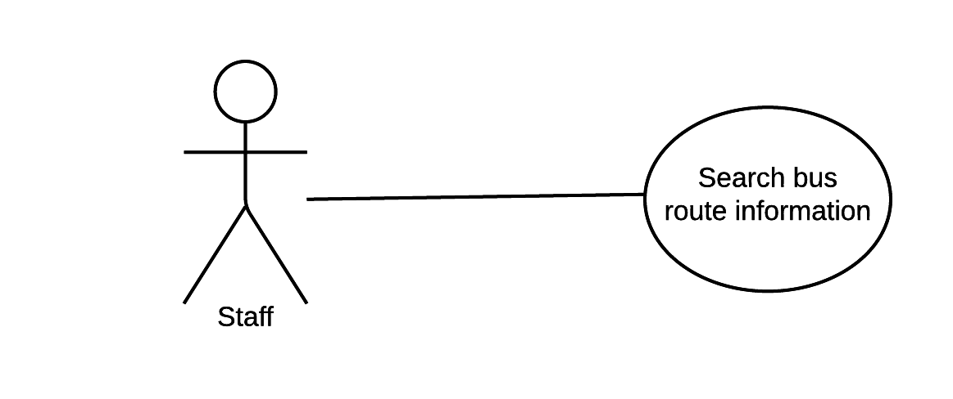

Figure 22 <Staff> Change password

|  |  |  |  |
| --- | --- | --- | --- |
| USE CASE – WS02 | | | |
| Use Case No. | WS02 | **Use Case Version** | 2.0 |
| Use Case Name | Search bus route notification | | |
| Author | DatNT | | |
| Date | 23/09/2015 | **Priority** | Normal |
| Actor:   * Staff   Summary:   * This use case allows staff search bus route information.   Goal:   * Staff can search information of bus route.   Triggers:   * Staff sends search command within text.   Preconditions:   * Staff must login into the system with roles Staff.   Post Conditions:   * Success: Information of bus route, which staff requested show on screen. * Fail: Show error message.   Main Success Scenario:   |  |  |  | | --- | --- | --- | | Step | Actor Action | System Response | | 1 | Staff goes to search view. | Search bus route information view will show all information of bus route on table:   * Input search field: on top-right of table and free input text. | | 2 | Staff sends search command | Show list information of bus route, which requested. |   Alternative Scenario: N/A  Exceptions: N/A  Relationships: N/A  Business Rules:   * List of bus route information is always update daily at 0:00 AM. * Page navigation must be display if list of bus route information have over ten item, which match text search. * Table will be empty if system does not find out bus route associated. | | | |

Table 25 Use case WS02 - <Staff> Change password

###### <Staff> Search bus timetable information

Figure 23 <Staff> Resolve new card request

|  |  |  |  |
| --- | --- | --- | --- |
| USE CASE – WS03 | | | |
| Use Case No. | WS03 | **Use Case Version** | 2.0 |
| Use Case Name | Search bus timetable information | | |
| Author | DatNT | | |
| Date | 23/09/2015 | **Priority** | Medium |
| Actor:   * Staff.   Summary:   * This use case allow staff search bus timetable information.   Goal:   * Staff can find out bus timetable information, which they required.   Triggers:   * Staff sends search command within text search.   Preconditions:   * Staff must login into the system with role Staff.   Post Conditions:   * Success: Information of bus’s timetable, which staff requested show on screen. * Fail: Show error message.   Main Success Scenario:   |  |  |  | | --- | --- | --- | | Step | Actor Action | System Response | | 1 | Staff goes to search bus timetable view. | New card request view will show all information of bus timetable on table:   * Input search field: on top-right of table and free input text. | | 2 | Staff sends search command | Show list information of bus timetable, which requested. |   Alternative Scenario: N/A  Exceptions: N/A  Relationships: N/A  Business Rules:   * List of bus route information is always update daily at 0:00 AM. * Page navigation must be display if list of bus route information have over ten item, which match text search. * Table will be empty if system does not find out bus route associated. | | | |

Table 26 Use case WS03 - <Staff> Resolve new card request

###### <Staff> View all system notification

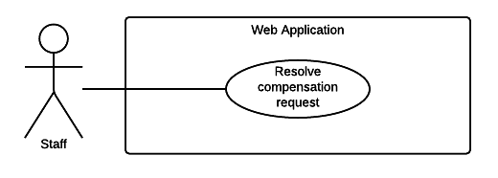

Figure 24 <Staff> Resolve compensation request

|  |  |  |  |
| --- | --- | --- | --- |
| USE CASE – WS04 | | | |
| Use Case No. | WS04 | **Use Case Version** | 2.0 |
| Use Case Name | View all system notification | | |
| Author | DatNT | | |
| Date | 23/09/2015 | **Priority** | High |
| Actor:   * Staff.   Summary:   * This use case allows staff view all system notification.   Goal:   * Staff can view all system notifications.   Triggers:   * Staff sends view command.   Preconditions:   * User must login into the system with role Staff.   Post Conditions:   * Success: A list of all system notifications, which staff requested show on screen. * Fail: Show error message.   Main Success Scenario:   |  |  |  | | --- | --- | --- | | Step | Actor Action | System Response | | 1 | Send view all command. | List of system notification which request will be show. |   Alternative Scenario: N/A  Exceptions: N/A  Relationships: N/A  Business Rules: | | | |

Table 27 Use case WS04 - <Staff> Resolve compensation request