1. Mobile Application

1.1. <Customer> Overview Use Case

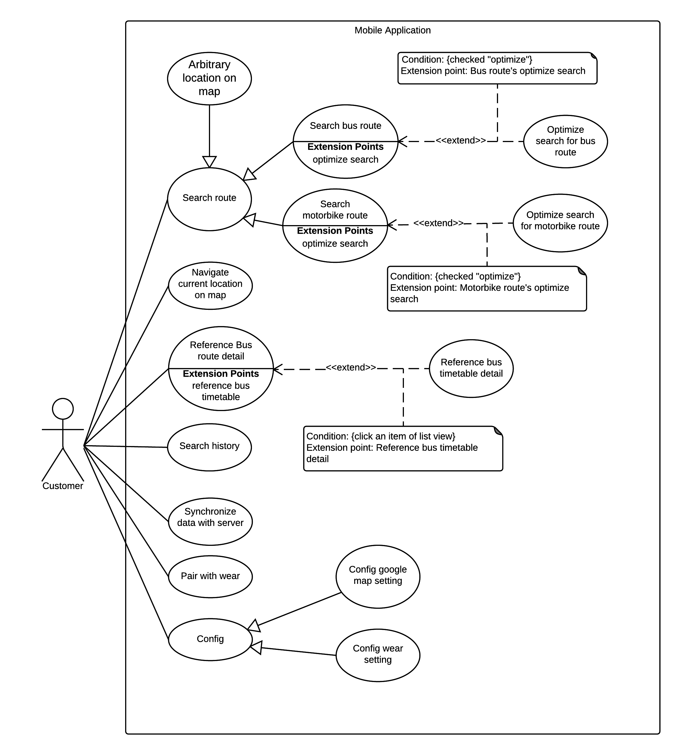

Figure 1 <Guest> Search Location

1. <Customer> Search Arbitrary location on map

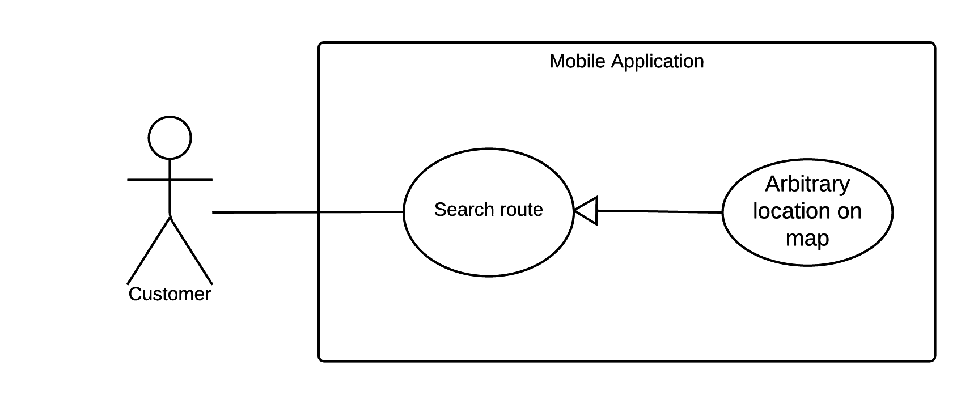

Figure 1 <Customer> Search Arbitrary Location on map

|  |  |  |  |
| --- | --- | --- | --- |
| USE CASE – UC01 | | | |
| Use Case No. | UC01 | **Use Case Version** | 2.0 |
| Use Case Name | Search Arbitrary location on map | | |
| Author | NgoanTT | | |
| Date | 23/09/2015 | **Priority** | Normal |
| Actor:   * Customer   Summary:   * This use case allows customer search arbitrary a the location on map.   Goal:   * The system show location on map and give detail information about location. Customer can save or share this location.   Triggers:   * Customer sends information of location command.   Preconditions:   * Mobile connect Wi-Fi   Post Conditions:   * Success: Show location on map and detail information about it. * Fail: Show alert with content “System not find location on map. Please try with other location!”   Main Success Scenario:   |  |  |  | | --- | --- | --- | | Step | Actor Action | System Response | | 1 | Customer click field “Tìm kiếm vị trí” on main screen. | - System display screen with field in other to Customer enter location want to find.  - System also view list history of Customer. | | 2 | Customer enter arbitrary location. | - System suggestion location for Customer. | | 3 | Customer click “Search” button. | - System show location on map  [Alternative 1] | | 4 | Customer choice location from history | - System show location on map  [Alternative 1] |   Alternative Scenario:   |  |  |  | | --- | --- | --- | | Step | Actor Action | System Response | | 1 | Customer enter location which System not find. | System show alert with content “System not find location on map. Please try with other location!” |   Exceptions:   |  |  |  | | --- | --- | --- | | Step | Actor Action | System Response | |  |  |  |   Relationships: N/A  Business Rules: N/A | | | |

Table 1 Use case UC01 - <Customer> Search Arbitrary Location on map

2.<Customer> Search Bus Route

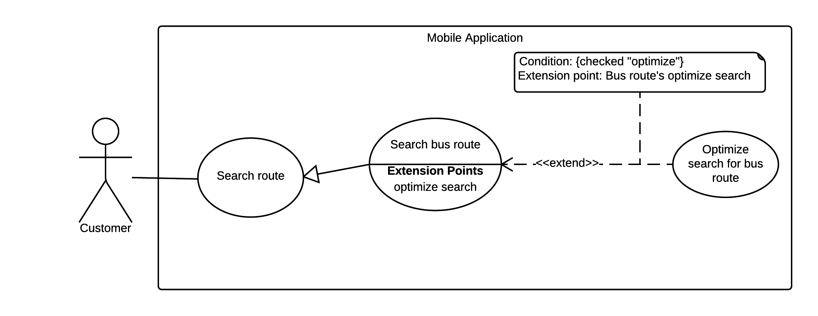

Figure 2 <Customer> Search Bus Route

|  |  |  |  |
| --- | --- | --- | --- |
| USE CASE – UC02 | | | |
| Use Case No. | UC02 | **Use Case Version** | 2.0 |
| Use Case Name | Search Bus Route | | |
| Author | NgoanTT | | |
| Date | 23/09/2015 | **Priority** | Normal |
| Actor:   * Customer   Summary:   * This use case allows customer search bus route thought some locations (from two to four).   Goal:   * The system will suggest some optimal paths for customer.   Triggers:   * Customer sends start location and end location command. * Customer can sends some option command.   Preconditions:   * Mobile must connect to Wi-Fi. * Customer click icon on main screen.   Post Conditions:   * Success: System draw route from start location to end location and show on map. * Fail: Show alert “System not find route”.   Main Success Scenario:   |  |  |  | | --- | --- | --- | | Step | Actor Action | System Response | | 1 | Customer click field “chọn điểm khởi hành”. | - System display screen allow Customer:   * Enter name of location Customer want to find (System will suggest some location corresponds with word Customer enter in field.) * Find location by click “vị trí của bạn” button. * Choice location from history | | 2 | Customer click “Search” button | - System will input location into field “chọn điểm khởi hành” | | 3 | Customer click field “chọn điểm đến” | - System display screen allow Customer:   * Enter name of location Customer want to find (System will suggest some location corresponds with word Customer enter in field.) * Find location by click “vị trí của bạn” button. * Choice location from history | | 4 |  | - System will input location into field “chọn điểm đến” | | 5 |  | - System show list with some optimal paths. [Alternative 1] | | 6 | Customer click choice one path. | - System will drag path on map and show detail about it. | | 7 | Customer can click choice “khởi hành lúc” | - System show dialog with hours and minute. | | 8 | Customer click “Xong” button. [Alternative 2] | - System show list with some optimal paths. [Alternative 1] | | 9 | Customer can click choice “tùy chọn” | - System show dialog include:   * “điểm trung gian 1”:text * “điểm trung gian 2”: text * “tối ưu”:checkbox * Tuyến ngắn nhất :radio * Số lần chuyển tuyến tối đa: radio * Số m đi bộ tối đa giữa hai trạm: radio | | 10 | Customer click “Xong” button. [Alternative 2] | - System show list with some optimal paths. [Alternative 1] |   Alternative Scenario:   |  |  |  | | --- | --- | --- | | Step | Actor Action | System Response | | 1 | Customer enter location incorrect which System not find. | System show alert “System not find route” | | 2 | Customer click “Hủy” button. | System do nothing |   Exceptions:   |  |  |  | | --- | --- | --- | | Step | Actor Action | System Response | |  |  |  |   Relationships: N/A  Business Rules: | | | |

Table 2 Use case UC02 - <Customer> Search Bus Route

3.<Customer> Navigate Current Location On Map

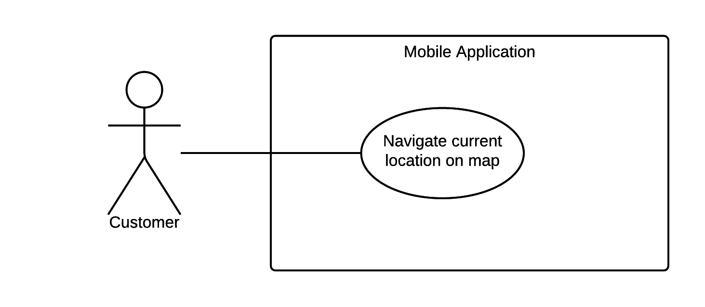

Figure 3 <Customer> Navigate Current Location On Map

|  |  |  |  |
| --- | --- | --- | --- |
| USE CASE – UC03 | | | |
| Use Case No. | UC03 | **Use Case Version** | 2.0 |
| Use Case Name | Navigate Current Location On Map | | |
| Author | NgoanTT | | |
| Date | 23/09/2015 | **Priority** | Normal |
| Actor:   * Customer   Summary:   * This use case allows customer search current location on map with GPS.   Goal:   * The system show current location on map and give detail information about location. Customer can save or share this location.   Triggers:   * Customer choice icon  on main screen.   Preconditions:   * Open GPS and Wi-Fi   Post Conditions:   * Success: Show location on map and detail information about it. * Fail:   Main Success Scenario:   |  |  |  | | --- | --- | --- | | Step | Actor Action | System Response | | 1 | Customer click choice icon  on main screen. | - System display dialog request Customer open GPS and Wi-Fi if want to use GPS find location. | | 2 | Customer click “OK” button | - System show current location of Customer on map. [Alternative 1] |   Alternative Scenario:   |  |  |  | | --- | --- | --- | | Step | Actor Action | System Response | | 1 | Customer click “Cancel” button | System turn of dialog and do nothing. |   Exceptions:   |  |  |  | | --- | --- | --- | | Step | Actor Action | System Response | |  |  |  |   Relationships: N/A  Business Rules: N/A | | | |

Table 3 Use case UC03 - <Customer> Navigate Current Location On Map

4.<Customer> Search Motorbike Route

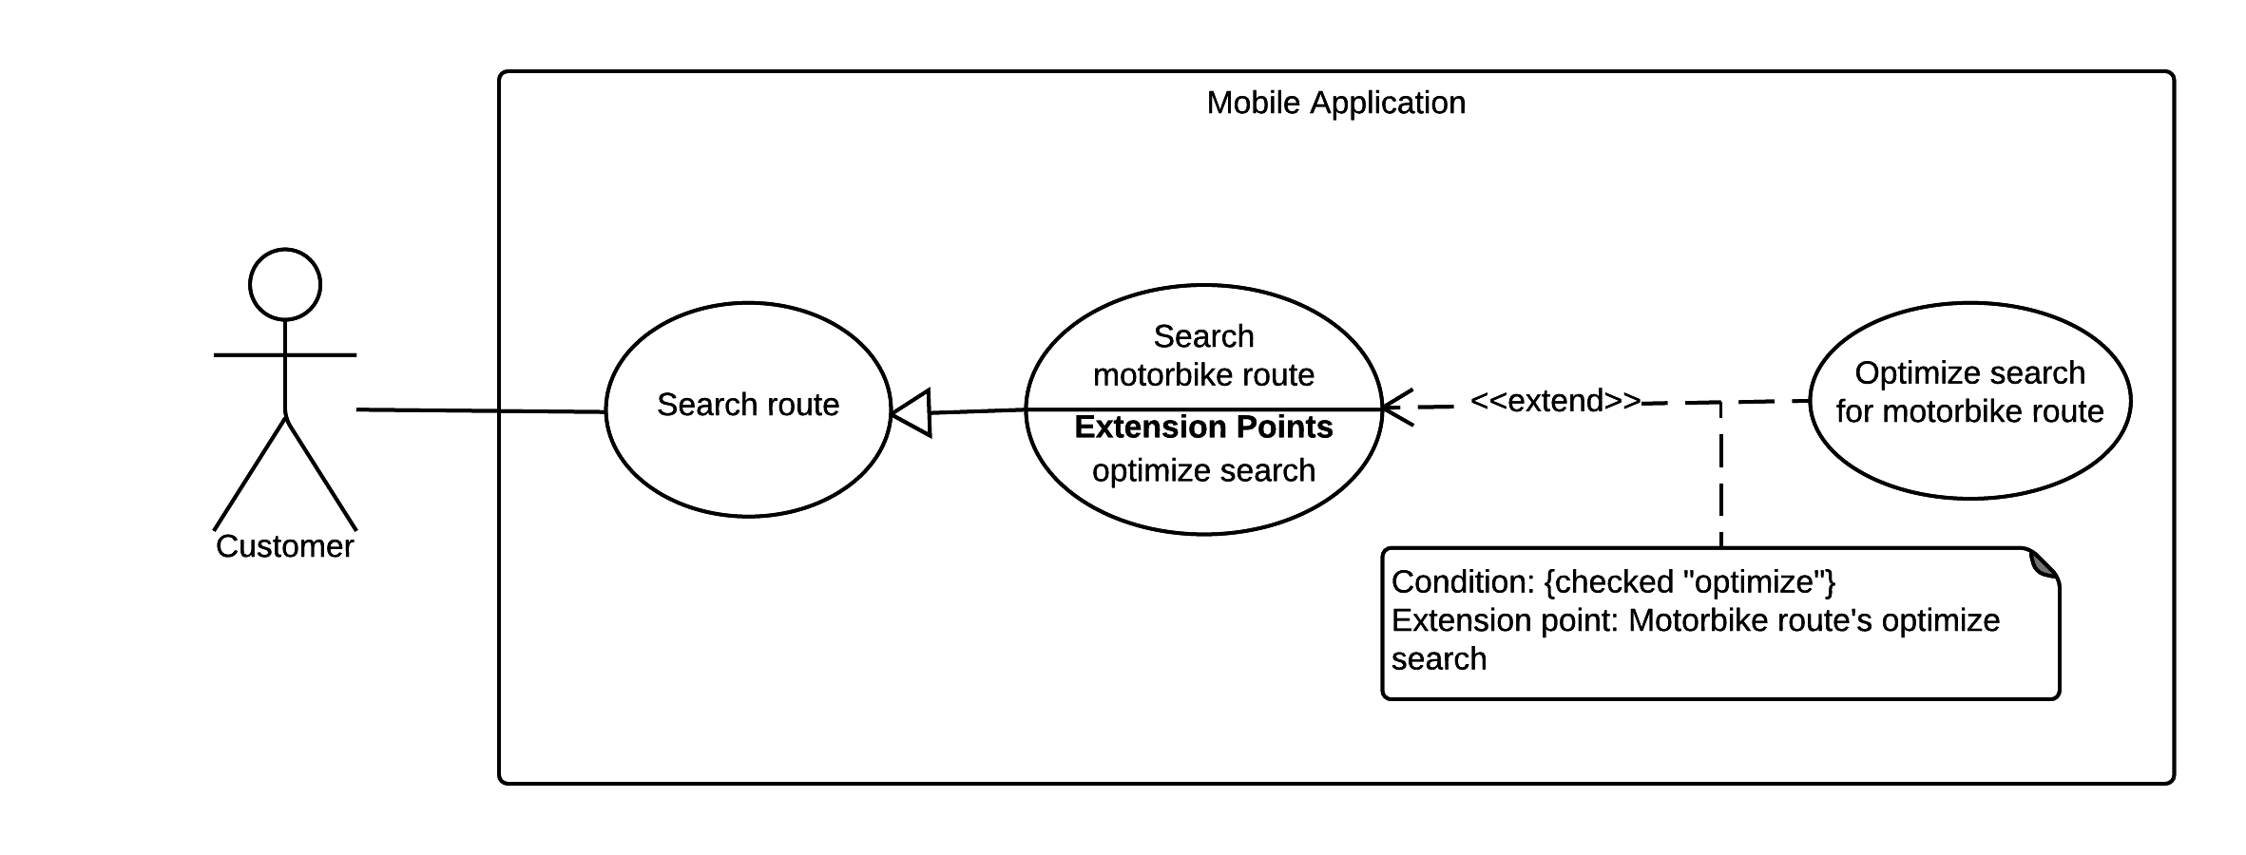

Figure 4 <Customer> Search Motorbike Route

|  |  |  |  |
| --- | --- | --- | --- |
| USE CASE – UC04 | | | |
| Use Case No. | UC04 | **Use Case Version** | 2.0 |
| Use Case Name | Search Motorbike Route | | |
| Author | NgoanTT | | |
| Date | 23/09/2015 | **Priority** | Normal |
| Actor:   * Customer   Summary:   * This use case allows customer search motorbike route thought some locations (from two to four).   Goal:   * The system will suggest some optimal paths for customer.   Triggers:   * Customer sends start location and end location command. * Customer can sends some option command.   Preconditions:   * Mobile must connect to Wi-Fi. * Customer click icon on main screen.   Post Conditions:   * Success: System draw route from start location to end location and show on map. * Fail: Show alert “System not find route”   Main Success Scenario:   |  |  |  | | --- | --- | --- | | Step | Actor Action | System Response | | 1 | Customer click field “chọn điểm khởi hành”. | - System display screen allow Customer:   * Enter name of location Customer want to find (System will suggest some location corresponds with word Customer enter in field.) * Find location by click “vị trí của bạn” button. * Choice location from history | | 2 | Customer click “Search” button | - System will input location into field “chọn điểm khởi hành” | | 3 | Customer click field “chọn điểm đến” | - System display screen allow Customer:   * Enter name of location Customer want to find (System will suggest some location corresponds with word Customer enter in field.) * Find location by click “vị trí của bạn” button. * Choice location from history | | 4 |  | - System will input location into field “chọn điểm đến” | | 5 |  | - System show some optimize paths. [Alternative 1] | | 6 | Customer can click choice “tùy chọn” | - System show dialog include:   * “điểm trung gian 1”:text * “điểm trung gian 2”: text * “tối ưu”:checkbox * Tuyến ngắn nhất :radio * Số lần chuyển tuyến tối đa: radio * Số m đi bộ tối đa giữa hai trạm: radio | | 10 | Customer click “Xong” button. [Alternative 2] | System show some optimaize paths. [Alternative 1] |   Alternative Scenario:   |  |  |  | | --- | --- | --- | | Step | Actor Action | System Response | | 1 | Customer enter location incorrect which System not find. | System show alert “System not find route” | | 2 | Customer click “Hủy” button. | System do nothing |   Exceptions:   |  |  |  | | --- | --- | --- | | Step | Actor Action | System Response | |  |  |  |   Relationships: N/A  Business Rules:   * When Customer choice vehicle is motorbike. System will disable option “khởi hành lúc”. | | | |

Table 4 Use case UC04 - <Customer> Search Motorbike Route

5.<Customer> Reference Bus Route Detail

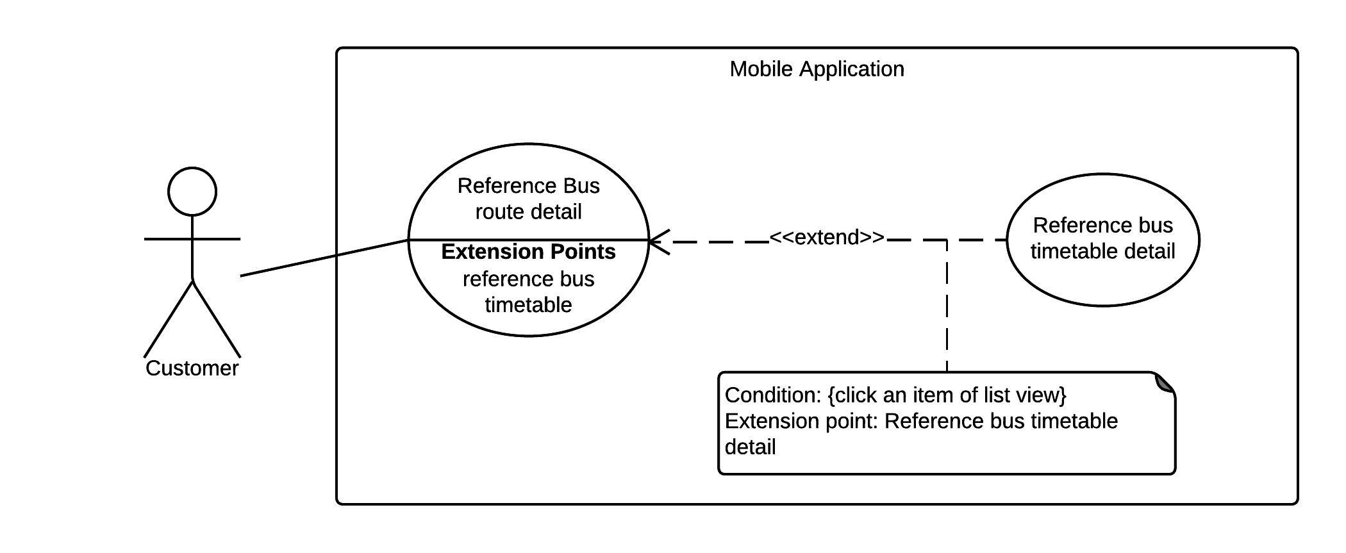

Figure 5 <Customer> Reference Bus Route Detail

|  |  |  |  |
| --- | --- | --- | --- |
| USE CASE – UC05 | | | |
| Use Case No. | UC05 | **Use Case Version** | 2.0 |
| Use Case Name | Reference Bus Route Detail | | |
| Author | NgoanTT | | |
| Date | 23/09/2015 | **Priority** | Normal |
| Actor:   * Customer   Summary:   * This use case allows customer show detail all bus route.   Goal:   * The system will display list bus route detail.   Triggers:   * Customer sends reference bus route detail command.   Preconditions:   * Mobile must connect to Wi-Fi.   Post Conditions:   * Success: System display list bus route detail on screen. * Fail: return list empty   Main Success Scenario:   |  |  |  | | --- | --- | --- | | Step | Actor Action | System Response | | 1 | Customer click field “reference bus route”. | - System will display list bus route include:   * Route number * Route name |   Alternative Scenario:   |  |  |  | | --- | --- | --- | | Step | Actor Action | System Response | |  |  |  |   Exceptions:   |  |  |  | | --- | --- | --- | | Step | Actor Action | System Response | |  |  |  |   Relationships: Reference Bus Timetable Detail  Business Rules: N/A | | | |

Table 5 Use case UC05 - <Customer> Reference Bus Route Detail

6.<Customer> Reference Bus Timetable Detail



Figure 6 <Customer> Reference Bus Timetable Detail

|  |  |  |  |
| --- | --- | --- | --- |
| USE CASE – UC06 | | | |
| Use Case No. | UC06 | **Use Case Version** | 2.0 |
| Use Case Name | Reference Bus Timetable Detail | | |
| Author | NgoanTT | | |
| Date | 23/09/2015 | **Priority** | Normal |
| Actor:   * Customer   Summary:   * This use case allows Customer can show detail about timetable of bus route   Goal:   * The system will display timetable of bus route   Triggers:   * Customer click an item of list view.   Preconditions:   * System have list of bus route detail.   Post Conditions:   * Success: System display detail timetable of bus route. * Fail: System will alert content “Bus route have not timetable”.   Main Success Scenario:   |  |  |  | | --- | --- | --- | | Step | Actor Action | System Response | | 1 | Customer will click an item of list view in reference bus route detail. | - System will display detail timetable of bus route.  [Alternative 1] |   Alternative Scenario:   |  |  |  | | --- | --- | --- | | Step | Actor Action | System Response | | 1 | Customer will click an item of list view in reference bus route detail | System will alert content “Bus route have not timetable” |   Exceptions:   |  |  |  | | --- | --- | --- | | Step | Actor Action | System Response | |  |  |  |   Relationships: N/A  Business Rules: N/A | | | |

Table 6 Use case UC06 - <Customer> Reference Bus Timetable Detail