1. Mobile Application

1.1. <Customer> Overview Use Case

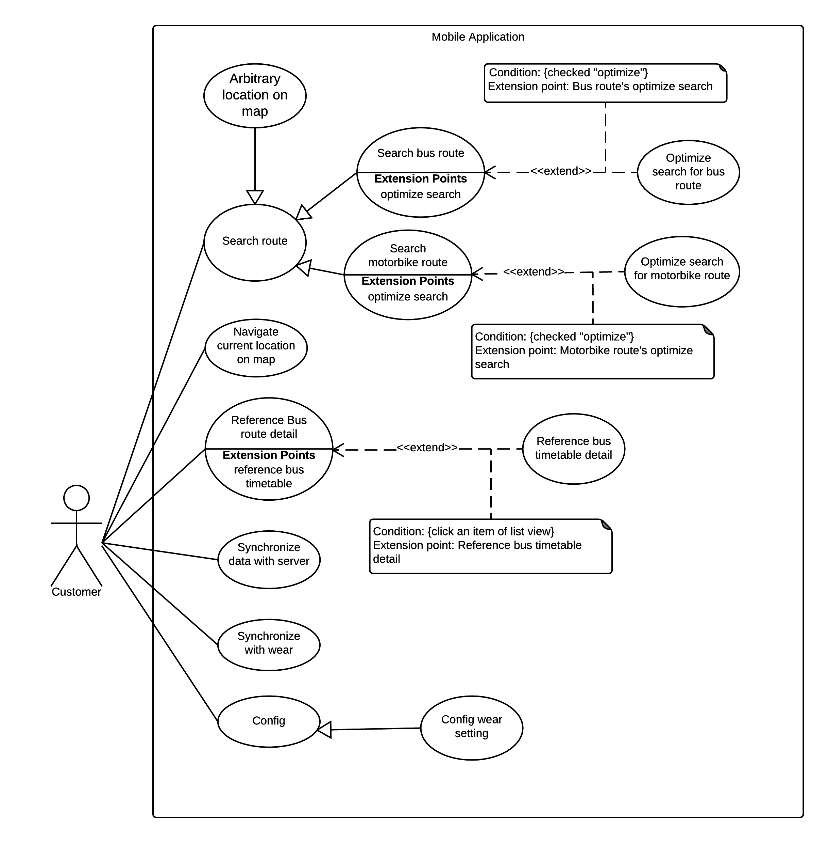

Figure 1 <Guest> Search Location

1. <Customer> Search Arbitrary location on map

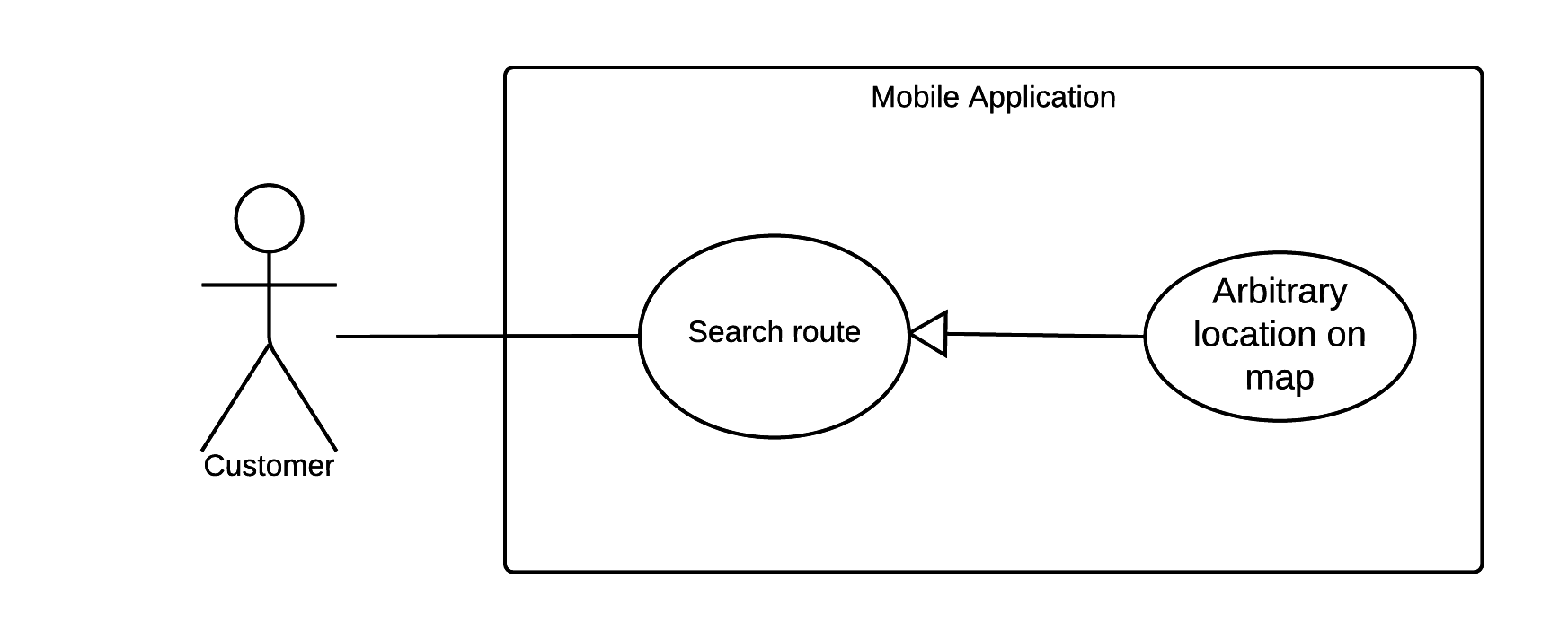

Figure 1 <Customer> Search Arbitrary Location on map

|  |  |  |  |
| --- | --- | --- | --- |
| USE CASE – UC01 | | | |
| Use Case No. | UC01 | **Use Case Version** | 2.0 |
| Use Case Name | Search Arbitrary location on map | | |
| Author | NgoanTT | | |
| Date | 23/09/2015 | **Priority** | Normal |
| Actor:   * Customer   Summary:   * This use case allows customer search arbitrary a location on map.   Goal:   * The system show location on map and give detail information about location.   Triggers:   * Customer sends location command.   Preconditions:   * Mobile must be connected to internet.   Post Conditions:   * Success: Show location on map and detail information about it. * Fail: Show error message.   Main Success Scenario:   |  |  |  | | --- | --- | --- | | Step | Actor Action | System Response | | 1 | Customer goes to search view. | System display search view include:   * Location search: text input * Show list history | | 2 | Customer input arbitrary location.  [Alternative 1] | System suggestion location while typing. | | 3 | Customer sends command search | - System process and show location on map.  [Alternative 2] |   Alternative Scenario:   |  |  |  | | --- | --- | --- | | Step | Actor Action | System Response | | 1 | Customer sends location from history. | System process and show location on map. | | 2 | Cannot find location on map. | Show message notify to customer that location not found on map. |   Exceptions:   |  |  |  | | --- | --- | --- | | Step | Actor Action | System Response | | 1 | Mobile doesn’t have internet | Show error message that this device haven’t connected to internet yet. |   Relationships: N/A  Business Rules:   * The information is loaded from Google map. | | | |

Table 1 Use case UC01 - <Customer> Search Arbitrary Location on map

2.<Customer> Search Bus Route

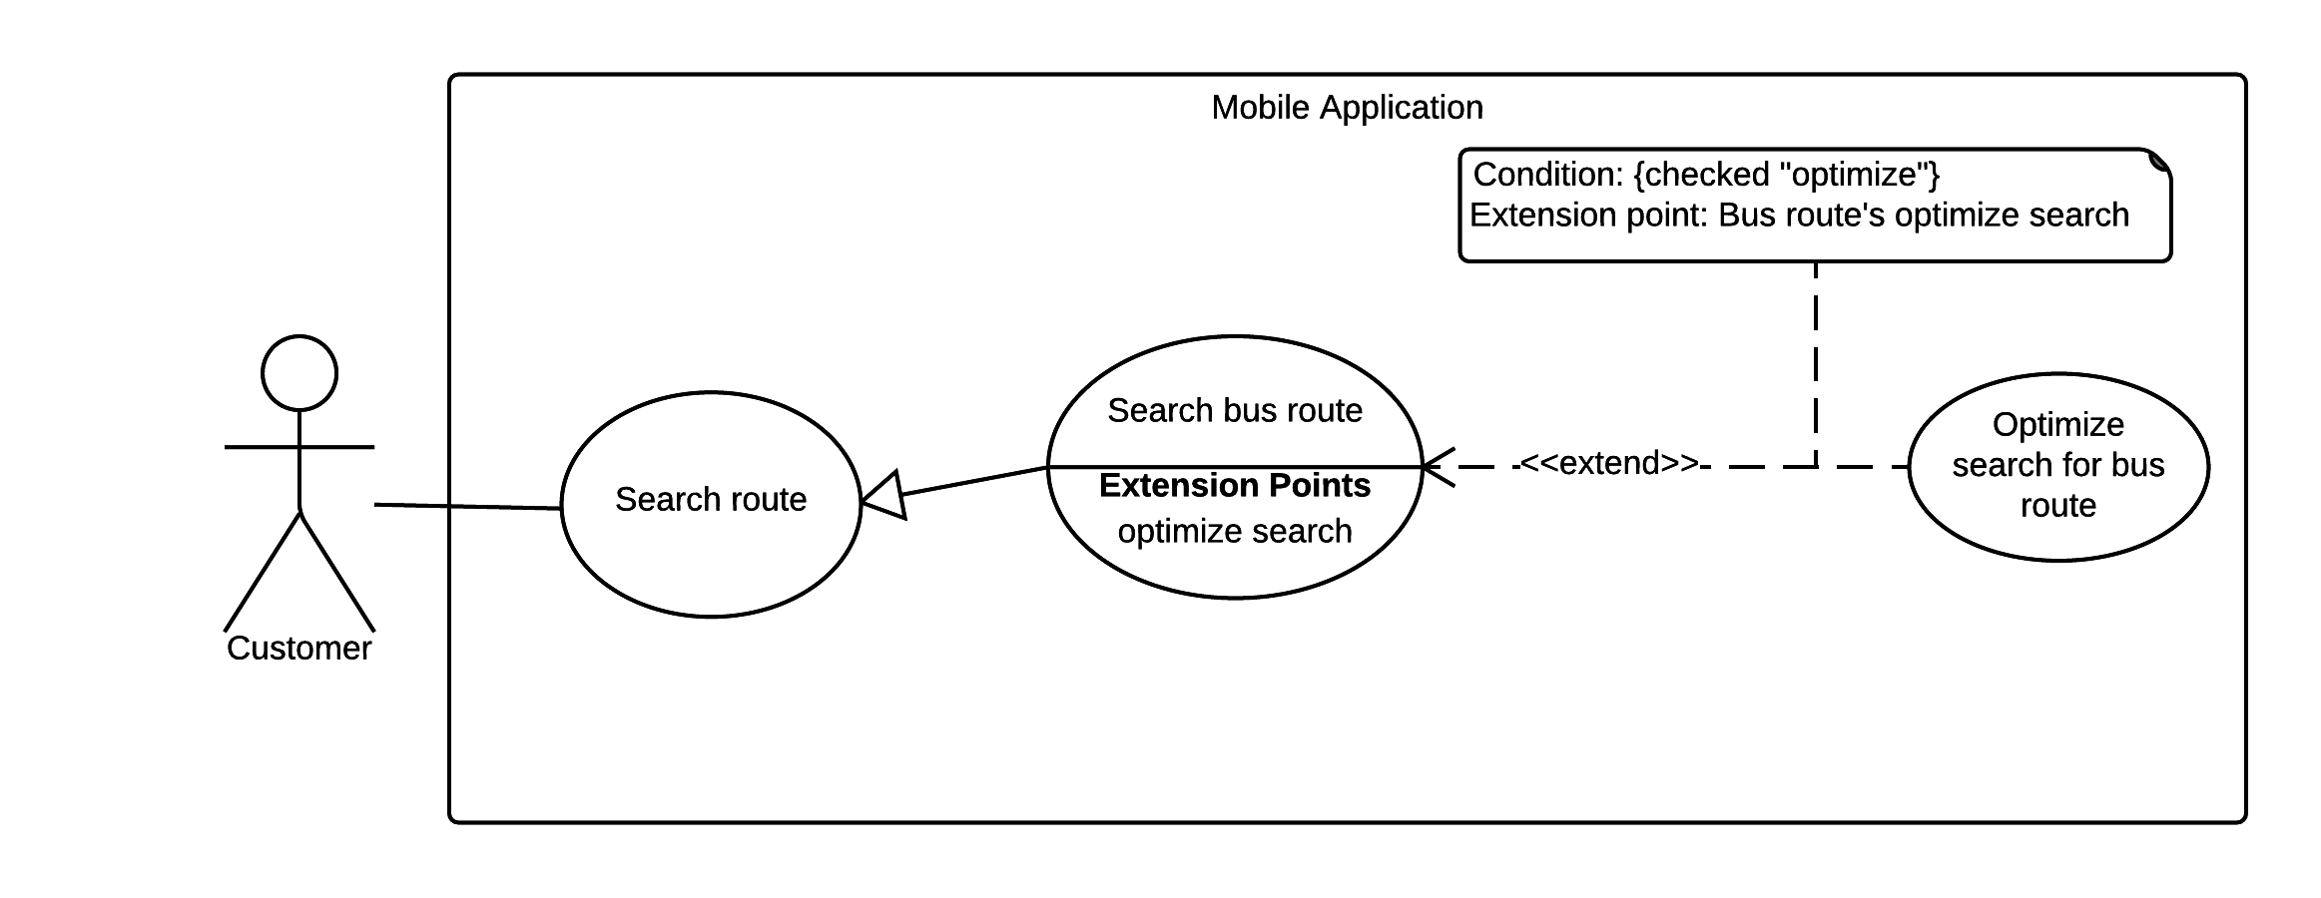

Figure 2 <Customer> Search Bus Route

|  |  |  |  |
| --- | --- | --- | --- |
| USE CASE – UC02 | | | |
| Use Case No. | UC02 | **Use Case Version** | 2.0 |
| Use Case Name | Search Bus Route | | |
| Author | NgoanTT | | |
| Date | 23/09/2015 | **Priority** | Normal |
| Actor:   * Customer   Summary:   * This use case allows customer search bus route thought some locations (from two to four).   Goal:   * The system will suggest a optimal paths for customer.   Triggers:   * Customer sends search command.   Preconditions:   * Customer send search route command. * Mobile must be connected to internet.   Post Conditions:   * Success: System draw route from start location to end location and show on map. * Fail: Show error message   Main Success Scenario:   |  |  |  | | --- | --- | --- | | Step | Actor Action | System Response | | 1 | Customer goes to search route view. | Display search route view including:   * Start location : text * End location : text | | 2 | Customer input start and end location. | Display new view with following information:   * Location : input text * Location with GPS * Location from history | | 3 | Customer chooses start and end location. | Input field will show location that customer has selected.  [Alternative 1]  [Exception 2] | | 4 | Customer can input departure time. | System will show calendar for customer selecting time. | | 5 | Customer can input two middle locations. | System will show text field for customer input location.  [Alternative 1] | | 6 | Customer can choose optimal option. | System will show checkbox for customer to select. | | 7 | Customer sends command search | System show list with some optimal paths. | | 8 | Customer chooses one path command. | System will drag path on map and show detail about it. |   Alternative Scenario:   |  |  |  | | --- | --- | --- | | Step | Actor Action | System Response | | 1 | Customer sends location from history. | System process and show location on map. |   Exceptions:   |  |  |  | | --- | --- | --- | | Step | Actor Action | System Response | | 1 | Mobile doesn’t have internet | Show error message that this device haven’t connected to internet yet. | | 2 | If start location or end location text field not input. | System show missing field message to customer. |   Relationships: N/A  Business Rules:   * The information is loaded from the system. * Using Google map. * Location must be in HCM city. | | | |

Table 2 Use case UC02 - <Customer> Search Bus Route

3.<Customer> Navigate Current Location On Map

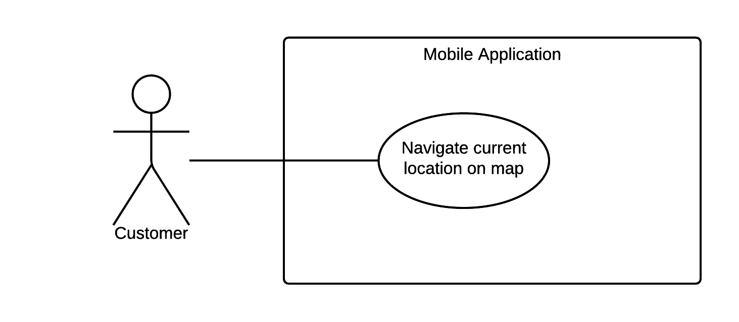

Figure 3 <Customer> Navigate Current Location On Map

|  |  |  |  |
| --- | --- | --- | --- |
| USE CASE – UC03 | | | |
| Use Case No. | UC03 | **Use Case Version** | 2.0 |
| Use Case Name | Navigate Current Location On Map | | |
| Author | NgoanTT | | |
| Date | 23/09/2015 | **Priority** | Normal |
| Actor:   * Customer   Summary:   * This use case allows customer search current location on map with GPS.   Goal:   * The system show current location on map and give detail information about location.   Triggers:   * Customer chooses GPS command.   Preconditions:   * GPS enable. * Mobile must be connected to internet.   Post Conditions:   * Success: Show location on map and detail information about it. * Fail: Show error message.   Main Success Scenario:   |  |  |  | | --- | --- | --- | | Step | Actor Action | System Response | | 1 | Customer sends current location command. | System will display that location on map and show information.  [Alternative 1] |   Alternative Scenario:   |  |  |  | | --- | --- | --- | | Step | Actor Action | System Response | | 1 | System does not found location on map. | System show message notify to customer cannot found location. |   Exceptions:   |  |  |  | | --- | --- | --- | | Step | Actor Action | System Response | | 1 | Mobile doesn’t have internet | Show error message that this device haven’t connected to internet yet. |   Relationships: N/A  Business Rules:   * Using Google map | | | |

Table 3 Use case UC03 - <Customer> Navigate Current Location On Map

4.<Customer> Search Motorbike Route

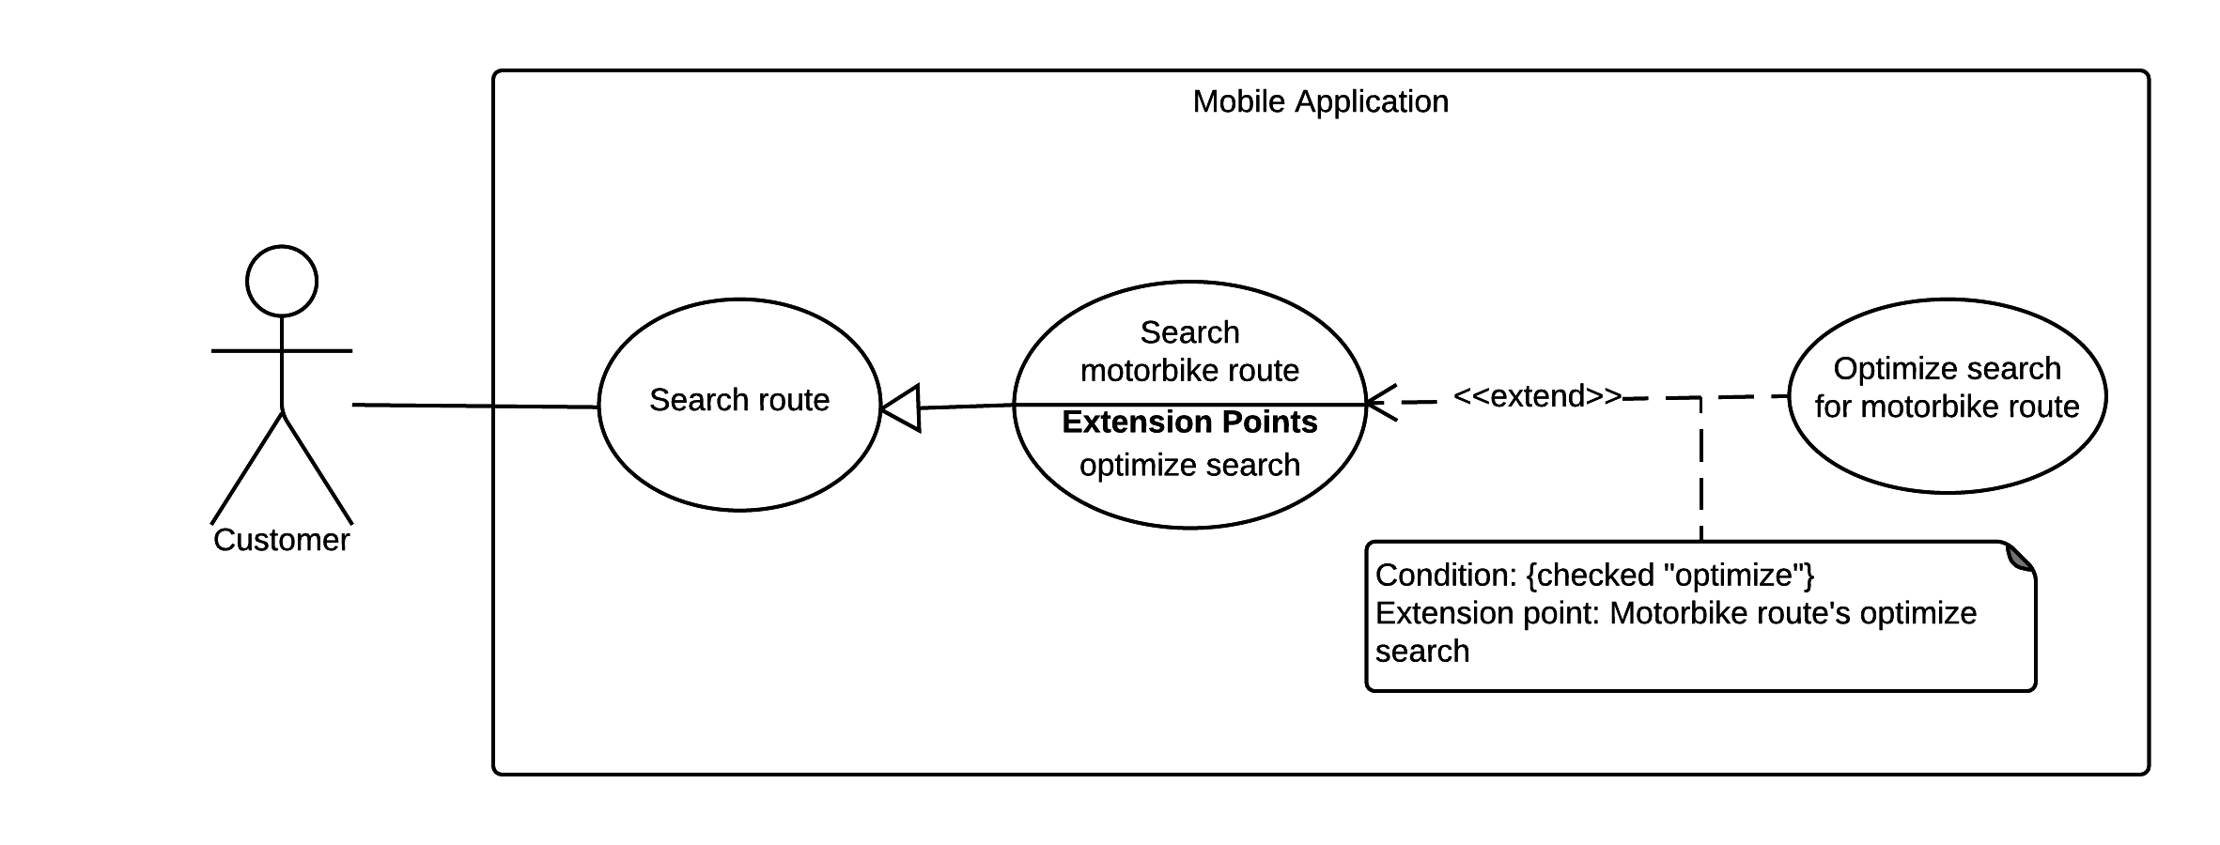

Figure 4 <Customer> Search Motorbike Route

|  |  |  |  |
| --- | --- | --- | --- |
| USE CASE – UC04 | | | |
| Use Case No. | UC04 | **Use Case Version** | 2.0 |
| Use Case Name | Search Motorbike Route | | |
| Author | NgoanTT | | |
| Date | 23/09/2015 | **Priority** | Normal |
| Actor:   * Customer   Summary:   * This use case allows customer search motorbike route thought some locations (from two to four).   Goal:   * The system will suggest a optimal path for customer.   Triggers:   * Customer sends search route command.   Preconditions:   * Customer sends command search. * Mobile must be connected to internet.   Post Conditions:   * Success: System draw route from start location to end location and show on map. * Fail: Show error message   Main Success Scenario:   |  |  |  | | --- | --- | --- | | Step | Actor Action | System Response | | 1 | Customer goes to search route view. | Display search route view including:   * Start location : text * End location : text | | 2 | Customer input start and end location. | Display new view with following information:   * Location : input text * Location with GPS * Location from history | | 3 | Customer chooses start and end location. | Input field will show location that customer has selected.  [Alternative 1]  [Exception 2] | | 4 | Customer can input two middle locations. | System will show text field for customer input location.  [Alternative 1] | | 5 | Customer can choose optimal option. | System will show checkbox for customer to select. | | 6 | Customer sends command search | System will drag path on map and show detail about it. |   Alternative Scenario:   |  |  |  | | --- | --- | --- | | Step | Actor Action | System Response | | 1 | Customer sends location from history. | System process and show location on map. |   Exceptions:   |  |  |  | | --- | --- | --- | | Step | Actor Action | System Response | | 1 | Mobile doesn’t have internet | Show error message that this device haven’t connected to internet yet. | | 2 | If start location or end location text field not input. | System show missing field message to customer. |   Relationships: N/A  Business Rules:   * When customer choice vehicle is motorbike. System will disable departs at. * The information is loaded from the system. * Using Google map for rendering route. * Using Google map API for searching route. * Location must be in HCM city. | | | |

Table 4 Use case UC04 - <Customer> Search Motorbike Route

5.<Customer> Reference Bus Route Detail

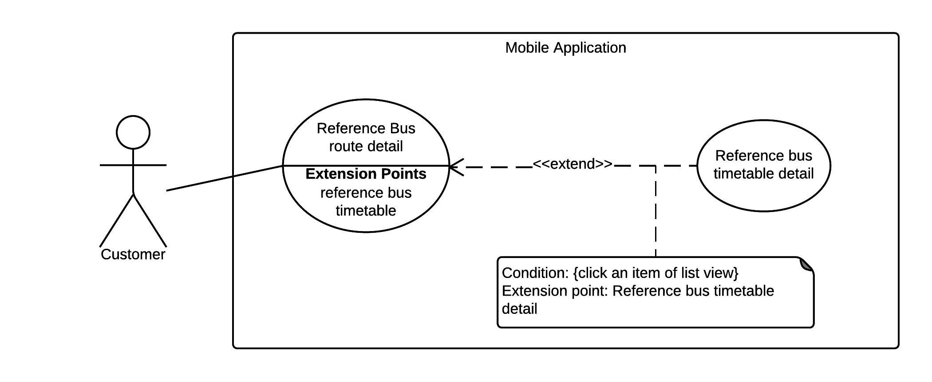

Figure 5 <Customer> Reference Bus Route Details

|  |  |  |  |
| --- | --- | --- | --- |
| USE CASE – UC05 | | | |
| Use Case No. | UC05 | **Use Case Version** | 2.0 |
| Use Case Name | Reference Bus Route Detail | | |
| Author | NgoanTT | | |
| Date | 23/09/2015 | **Priority** | Normal |
| Actor:   * Customer   Summary:   * This use case allows customer show detail all bus route.   Goal:   * The system display list bus route detail.   Triggers:   * Customer sends reference bus route detail command.   Preconditions:  Post Conditions:   * Success: System display list bus route detail on screen. * Fail:   Main Success Scenario:   |  |  |  | | --- | --- | --- | | Step | Actor Action | System Response | | 1 | Customer sends reference bus route command. | System will display list bus route include:   * Route number * Route name   [Alternative 1] |   Alternative Scenario:   |  |  |  | | --- | --- | --- | | Step | Actor Action | System Response | | 1 | System returns empty list. | Show synchronize data message to customer. |   Exceptions: N/A  Relationships: Reference Bus Timetable Detail  Business Rules:   * The information is loaded from local database. * Bus route just supported in HCM city. | | | |

Table 5 Use case UC05 - <Customer> Reference Bus Route Detail

6.<Customer> Reference Bus Timetable Detail



Figure 6 <Customer> Reference Bus Timetable Details

|  |  |  |  |
| --- | --- | --- | --- |
| USE CASE – UC06 | | | |
| Use Case No. | UC06 | **Use Case Version** | 2.0 |
| Use Case Name | Reference Bus Timetable Detail | | |
| Author | NgoanTT | | |
| Date | 23/09/2015 | **Priority** | Normal |
| Actor:   * Customer   Summary:   * This use case allows customer can show detail about timetable of a bus route.   Goal:   * The system will display timetable of bus route   Triggers:   * Customer chooses an item of list view.   Preconditions:   * System have list of bus route detail.   Post Conditions:   * Success: System display detail timetable of bus route. * Fail:   Main Success Scenario:   |  |  |  | | --- | --- | --- | | Step | Actor Action | System Response | | 1 | Customer choice an item of list view in reference bus route detail command. | - System will display detail timetable of bus route.  [Alternative 1] |   Alternative Scenario:   |  |  |  | | --- | --- | --- | | Step | Actor Action | System Response | | 1 | System returns empty list. | Show synchronize data message to customer. |   Exceptions: N/A  Relationships: N/A  Business Rules:   * The information is loaded from local database. * Bus route just supported in HCM city. | | | |

Table 6 Use case UC06 - <Customer> Reference Bus Timetable Detail

7.<Customer> Configuration Wear Setting

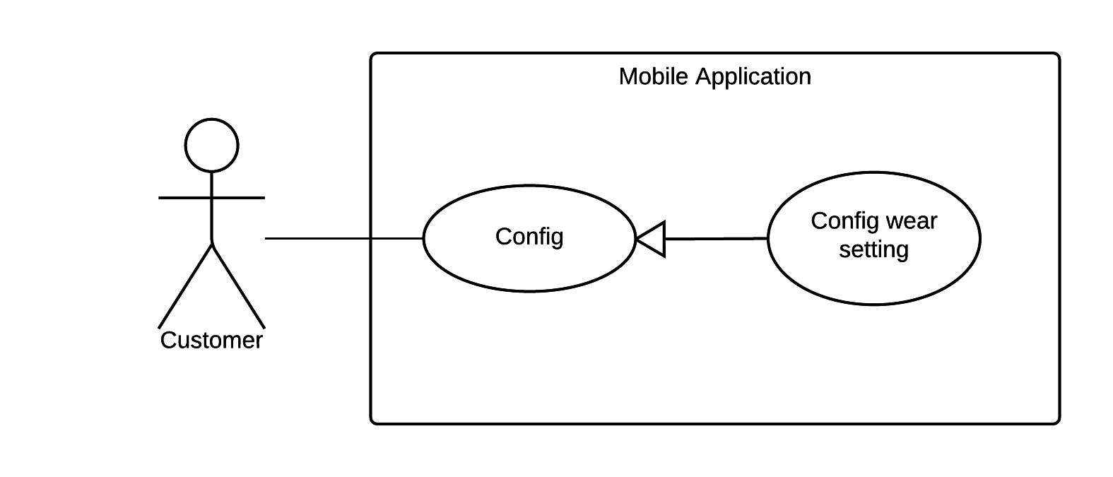

Figure 7 <Customer> Configuration Wear Setting

|  |  |  |  |
| --- | --- | --- | --- |
| USE CASE – UC07 | | | |
| Use Case No. | UC07 | **Use Case Version** | 2.0 |
| Use Case Name | Configuration Wear Setting | | |
| Author | NgoanTT | | |
| Date | 24/09/2015 | **Priority** | Normal |
| Actor:   * Customer   Summary:   * This use case allows customer can config time accurate time for getting GPS from wear.   Goal:   * The system set new time.   Triggers:   * Customer sends command set time.   Preconditions:  Post Conditions:   * Success: System set new time. * Fail: Show error message   Main Success Scenario:   |  |  |  | | --- | --- | --- | | Step | Actor Action | System Response | | 1 | Customer goes to config view | System display config view including:   * Set time: number | | 1 | Customer sends command to set new time. | System show successfully message  [Alternative 1] |   Alternative Scenario:   |  |  |  | | --- | --- | --- | | Step | Actor Action | System Response | | 1 | The time doesn’t change. | System shows message that no thing change. |   Exceptions: N/A  Relationships: N/A  Business Rules:   * Set default time get GPS is 3 second. | | | |

Table 7 Use case UC07 - <Customer> Configuration Wear Setting

7.<Customer> Synchronize with Wear

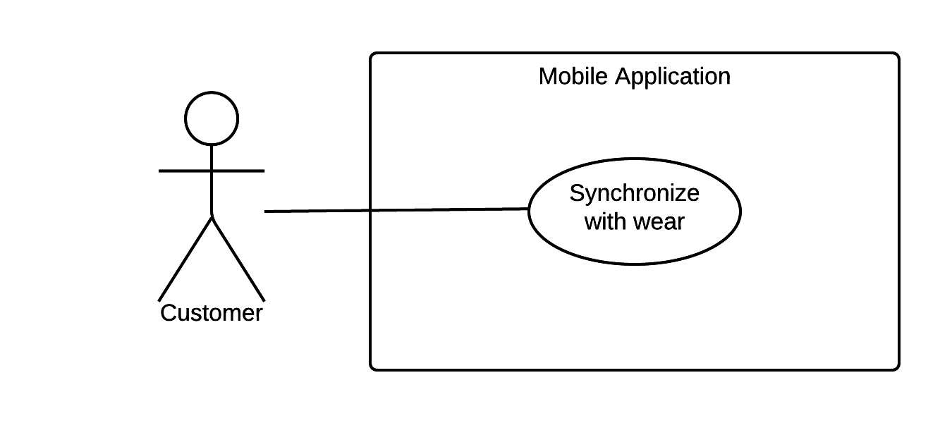

Figure 8 <Customer> Synchronize with Wear

|  |  |  |  |
| --- | --- | --- | --- |
| USE CASE – UC08 | | | |
| Use Case No. | UC08 | **Use Case Version** | 2.0 |
| Use Case Name | Synchronize with Wear | | |
| Author | NgoanTT | | |
| Date | 24/09/2015 | **Priority** | Normal |
| Actor:   * Customer   Summary:   * This use case allows customer can synchronize data between mobile and wear device.   Goal:   * Data have to synchronize between mobile and wear.   Triggers:   * Customer sends synchronize command.   Preconditions:   * Pair between mobile and wear device with [Android Wear app](https://play.google.com/store/apps/details?id=com.google.android.wearable.app). * Search route on mobile device and choice one route.   Post Conditions:   * Success: Wear application has data from mobile application. * Fail: show message warning.   Main Success Scenario:   |  |  |  | | --- | --- | --- | | Step | Actor Action | System Response | | 1 | Customer sends commands synchronize data. | - System process and show message notify to customer that synchronize successful.  [Exception 1] |   Alternative Scenario:   |  |  |  | | --- | --- | --- | | Step | Actor Action | System Response | |  |  |  |   Exceptions:   |  |  |  | | --- | --- | --- | | Step | Actor Action | System Response | | 1 | Customer sends commands synchronize data. | Show message notify to customer that synchronize fail. |   Relationships: N/A  Business Rules: N/A | | | |

Table 8 Use case UC08 - <Customer> Synchronize with Wear

9.<Customer> Synchronize Data with Server

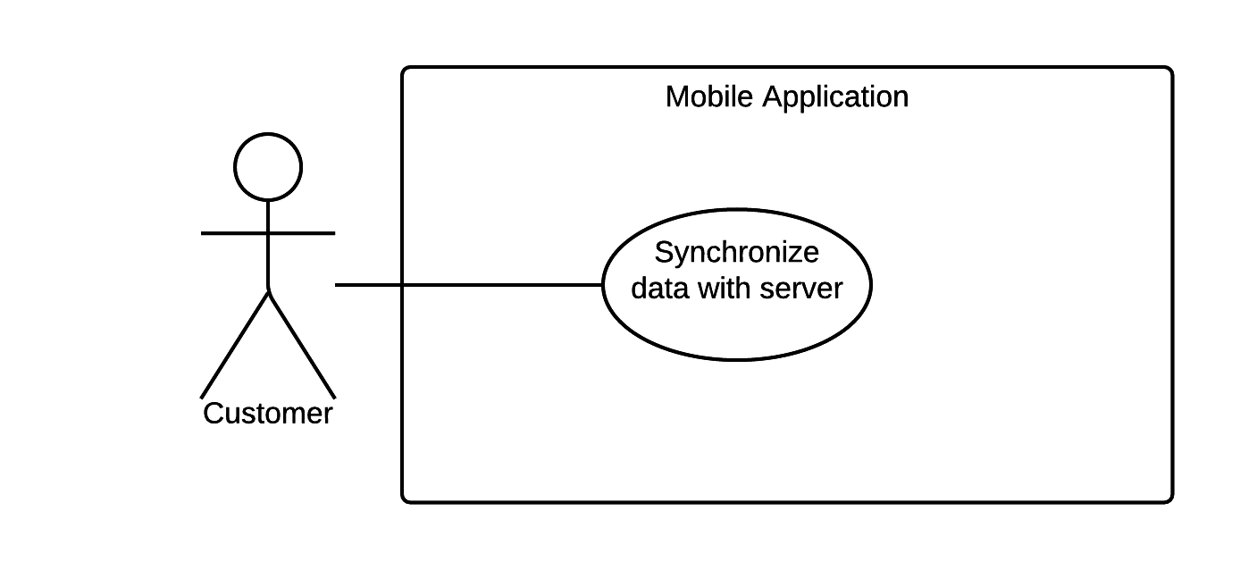

Figure 9 <Customer> Synchronize Data with Server

|  |  |  |  |
| --- | --- | --- | --- |
| USE CASE – UC9 | | | |
| Use Case No. | UC9 | **Use Case Version** | 2.0 |
| Use Case Name | Synchronize Data with Server | | |
| Author | NgoanTT | | |
| Date | 24/09/2015 | **Priority** | Normal |
| Actor:   * Customer   Summary:   * This use case allow customer synchronize data with server from mobile application.   Goal:   * Data must to synchronize between server and mobile.   Triggers:   * Customer sends synchronize command.   Preconditions:  Post Conditions:   * Success: Show synchronize data success message. * Fail: Show error message   Main Success Scenario:   |  |  |  | | --- | --- | --- | | Step | Actor Action | System Response | | 1 | Customer send commands synchronize data. | System process and show message to notify customer that synchronize data success.  [Exception 1] |   Alternative Scenario:   |  |  |  | | --- | --- | --- | | Step | Actor Action | System Response | |  |  |  |   Exceptions:   |  |  |  | | --- | --- | --- | | Step | Actor Action | System Response | | 1 | Customer send command synchronize data | Show message to notify customer that synchronize fail. |   Relationships: N/A  Business Rules: N/A | | | |

Table 9 Use case UC09 - <Customer> Synchronize Data with Server