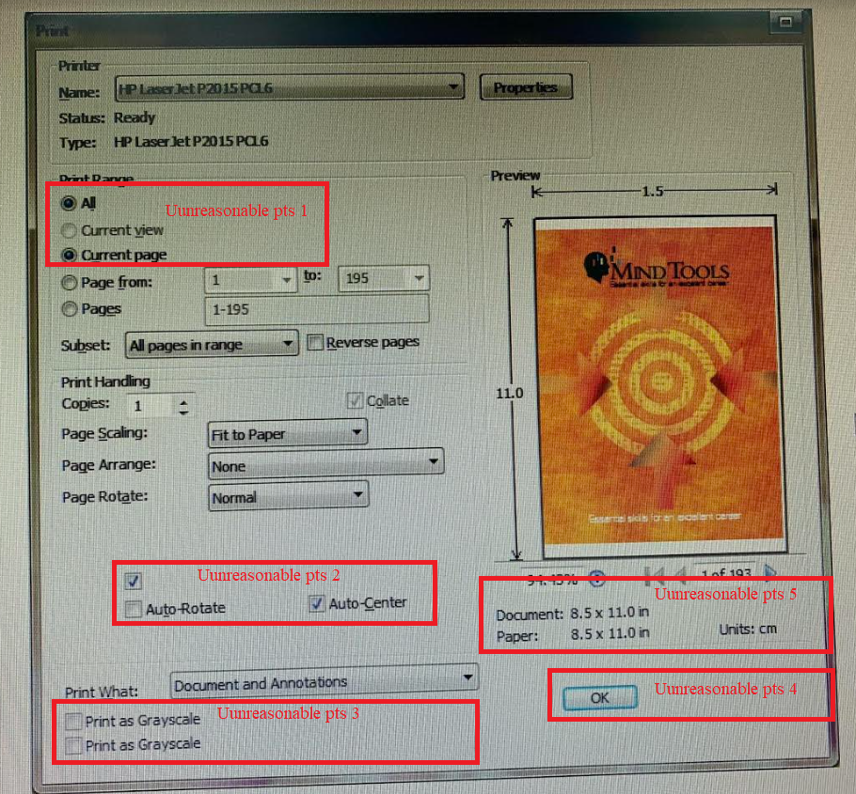

Uunreasonable pts 1: Print range: can only choose 1 option

Uunreasonable pts 2: Checkbox has no label

Uunreasonable pts 3: Duplicated “Print as Grayscale”

Uunreasonable pts 4: Button "Ok" is not in the correct position

Uunreasonable pts 5: “Units: cm” but displayed in the document and pager as in