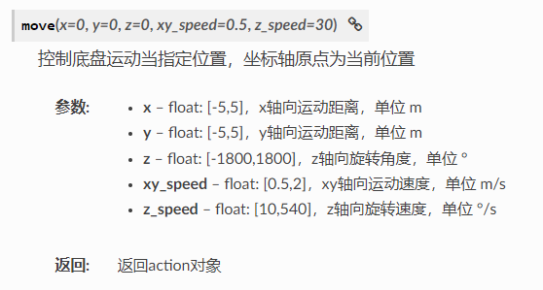

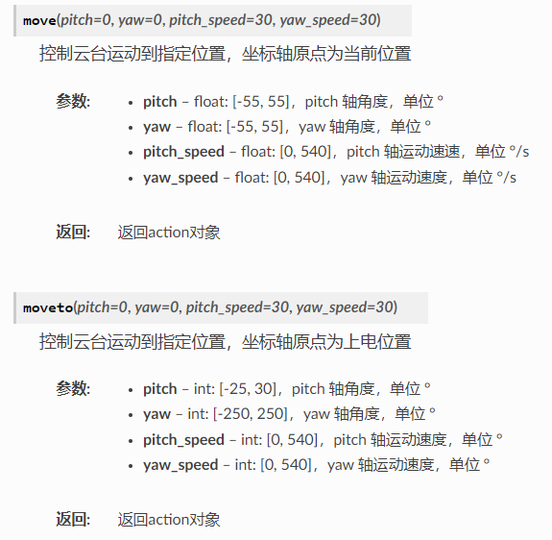

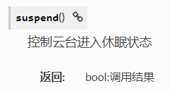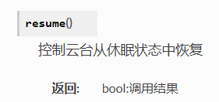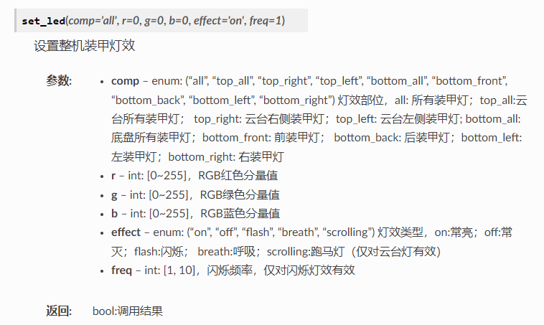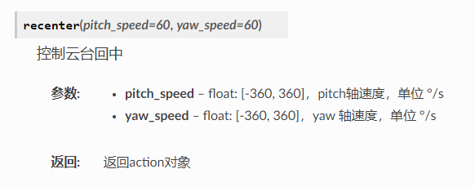

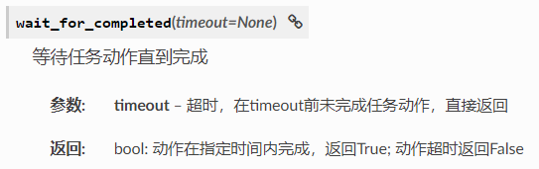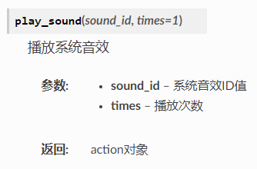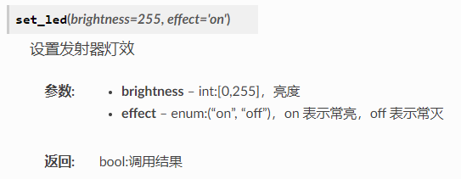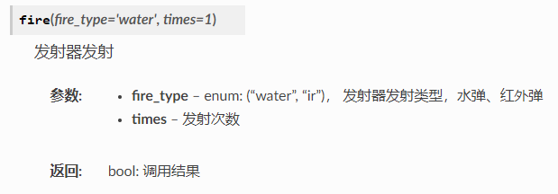

**SOUND_ID_ATTACK = 0x101**

**SOUND_ID_SHOOT = 0x102**

**SOUND_ID_SCANNING = 0x103**

**SOUND_ID_RECOGNIZED = 0x104**

**SOUND_ID_GIMBAL_MOVE = 0x105**

**SOUND_ID_COUNT_DOWN = 0x106**

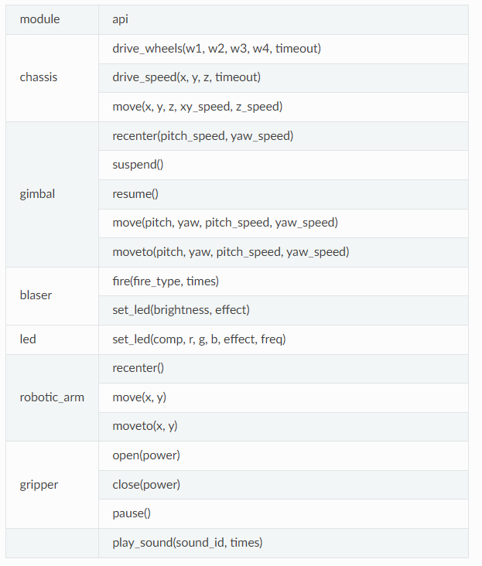

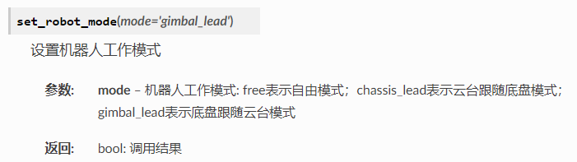

robot_group.set_group_robots_mode(mode='**模式**')#设置整机模式

robot_group.chassis.move(**X**, **Y**, **Z**, **XY速度**, **Z速度**) #设置底盘运动

robot_group.gimbal.moveto(**俯仰**, **航向**, **俯仰速度**, **航向速度**) #设置云台运动

robot_group.led.set_led(**LED位置**, **r**, **g**, **b**, **LED效果**) #设置LED

robot_group.blaster.fire(fire_type='**类型**', times=**次数**)#设置发射器发射

robot_group.blaster.set_led(brightness=**亮度**, effect='**开/关**') #设置发射器灯光

robot_group.play_sound(**音频ID**)

def task_6_start(robot_group): #编写动作函数

**程序段**

multi_robots.run([**EP组对象**,**动作函数**]) #执行动作函数

**在某些多机控制的场景下，用户可能需要单独控制群组中的某一台机器，RobomasterSDK也支持从群组中获取单机对象，从而进行单机控制。**

**用户可以通过 组对象 的 get_robot(robot_id) 方法获取到单机对象，从而进行单机控制，该方法的输入参数为相应机器的编号数字， 返回值为该单机对象。另外用户可以通过”组对象”的 robot_id_list 属性获取组内所有机器人的编号列表**

**for** drone_id **in** drone_group.robots_id_list:

drone_obj = drone_group.get_robot(drone_id)

drone_obj.flight.takeoff().wait_for_completed()

**2m**

**3m**

**P2**

**E9**

**0K**

**AA**

**4**

**2**

**1**

**QR**

**2N**

**5**

**3**

**0**

SOUND_ID_1C = 0x107

SOUND_ID_1C_SHARP = 0x108

SOUND_ID_1D = 0x109

SOUND_ID_1D_SHARP = 0x10A

SOUND_ID_1E = 0x10B

SOUND_ID_1F = 0x10C

SOUND_ID_1F_SHARP = 0x10D

SOUND_ID_1G = 0x10e

SOUND_ID_1A = 0x110

SOUND_ID_1A_SHARP = 0x111

SOUND_ID_1B = 0x112

SOUND_ID_2C = 0x113

SOUND_ID_2C_SHARP = 0x114

SOUND_ID_3D_SHARP = 0x122

SOUND_ID_3E = 0x123

SOUND_ID_3F = 0x124

SOUND_ID_3F_SHARP = 0x125

SOUND_ID_3G = 0x126

SOUND_ID_3G_SHARP = 0x127

SOUND_ID_3A = 0x128

SOUND_ID_3A_SHARP = 0x129

SOUND_ID_3B = 0x12A

SOUND_ID_2D = 0x115

SOUND_ID_2D_SHARP = 0x116

SOUND_ID_2E = 0x117

SOUND_ID_2F = 0x118

SOUND_ID_2F_SHARP = 0x119

SOUND_ID_2G = 0x11A

SOUND_ID_2G_SHARP = 0x11B

SOUND_ID_2A = 0x11C

SOUND_ID_2A_SHARP = 0x11D

SOUND_ID_2B = 0x11E

SOUND_ID_3C = 0x11F

SOUND_ID_3C_SHARP = 0x120

SOUND_ID_3D = 0x121

SOUND_ID_2C_SHARP = 0x114