**Coding Environment**

Python distribution 3.7.4; IDE - Spyder 3.6.6.

Code with comments in cells in radio_wave_test12.py and radio_wave_test3.py.

**Unknown**

Transmitter height above terrain – set to 0 in the program

Output for FSPL: receiver location unknown, assume output is a 3D array, where the first two dimensions refer to the row and column locations, the third dimension refers to the height

**Issue**

.pl file type unknown, the output file argument is ignored since the data required to be saved to output file is obtained from the run

Resolution argument is not required for the image generation case

**radio_wave_test12.py: for both FSPL and KED**

Test run CLI config (arguments with spaces):

*KED terrain.bil 5 1396 1689 max_height transmitter_x transmitter_y transmitter_h transmitter_freq ked.pl*

*ked terrain.bil 5 1396 1689 10 1200 1200 100 6000000 fspl.pl*

Outputs:

Two options for receiver height above terrain when max height is 10:

[ 5 10]

FSPL model free space loss table map for any receiver location and height, 3D array [1396, 1689, 2] in [y, x, height] depending on the receiver position. Result example:

[[[66.58635003 66.58635094]

[66.58273091 66.58273182]

[66.57911173 66.57911324]

...

[56.39869838 56.39997358]

[56.41424348 56.41552039]

[56.42976564 56.43104426]]]

KED model diffraction loss result example:

82.2071857533393

**radio_wave_test3.py: for Random Terrain Data Generator**

Generated image saved in .tiff format since .pl format unavailable;

Test using syntax

*RTDG terrain.bil resolution rows columns min_terrain_height max_terrain_height additional_para*

*RTDG terrain.bil 5 1396 1689 100 300 gen*

Output example:

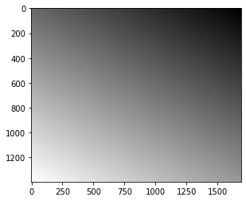

Test in previous path loss models:

FSPL model free space loss table map for any receiver location and height 3D array pl value distribution

[[[66.58689431 66.58683853]

[66.58327565 66.58321981]

[66.57964557 66.57959029]

...

...

[56.38001809 56.37938867]

[56.39537733 56.39475013]

[56.41071384 56.41008886]]]

KED model diffraction loss:

56.40418002939475