Company Name : A2Z Cleaning Solutions

For reference website : https://gcthree.com.au/

In website 4 pages

1. Home
2. Services
3. About
4. Contact

1.Home

🡺Slideshow of cleaning photos

🡺Why A2Z Cleaning

🡺Promotions and special offers

In this section we will offer a 7 days free cleaning services and other promotions available as

Per the cleaning services.

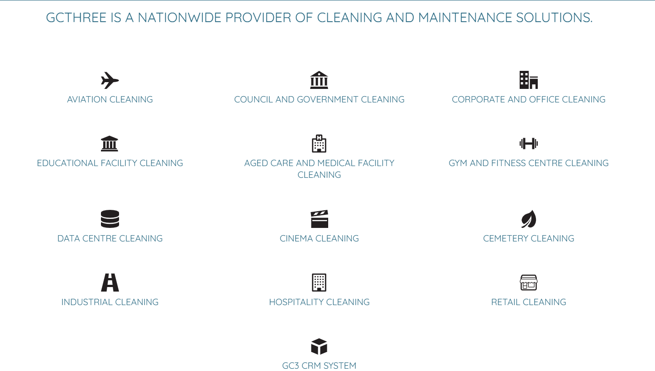

2. Services

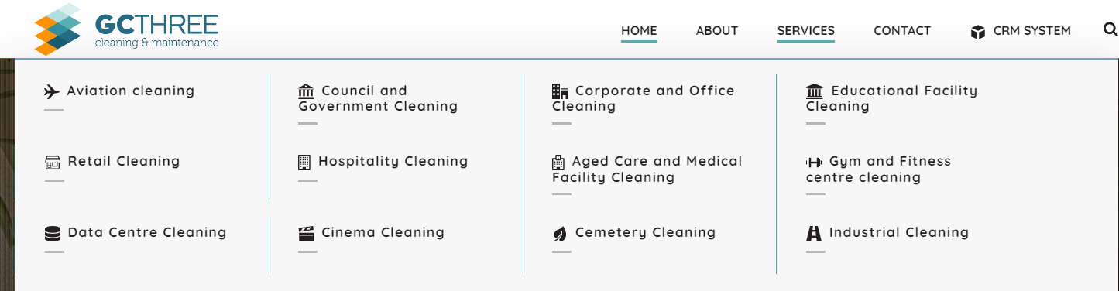

In this section if I click on the aviation cleaning it will redirect to the aviation content. Same as all one

3.Contact Us :

🡺 make as your expertise

4.About Us:

🡺 Add some photos

Welcome to [Your Company Name], your trusted partner in professional cleaning services. Founded with a commitment to excellence and customer satisfaction, we have been serving [Your Location] and surrounding areas with dedication and integrity.

At [Your Company Name], we understand the importance of a clean and healthy environment. Our mission is to provide top-quality cleaning solutions that exceed our clients' expectations while promoting a safe and hygienic space for families, businesses, and communities.

Our team consists of experienced professionals who are passionate about cleanliness and customer service. With years of industry expertise, we have perfected our cleaning techniques and utilize the latest tools and technologies to deliver exceptional results every time.

What sets us apart is our personalized approach to cleaning. We take the time to understand our clients' unique needs and preferences, tailoring our services to meet their specific requirements. Whether it's a one-time deep clean, regular maintenance, or specialized cleaning for commercial spaces, we have the expertise and resources to handle it all.

At [Your Company Name], we prioritize sustainability and eco-friendliness. We use environmentally safe products and practices to minimize our carbon footprint and ensure the health and well-being of our clients and the planet.

But beyond our commitment to cleanliness, it's our dedication to customer satisfaction that truly defines us. We believe in building long-lasting relationships with our clients based on trust, reliability, and open communication. Your satisfaction is our top priority, and we will go above and beyond to exceed your expectations.

Thank you for considering [Your Company Name] for your cleaning needs. We look forward to the opportunity to serve you and demonstrate why we are the preferred choice for professional cleaning services in [Your Location].