**Introduction**

In this simulated zombie apocalypse, we will show how fast the virus spreads as it causes the humans to turn into zombies. The variables such as bravery and aggression will determine the outcomes for humans preventing the zombie’s chance to win. Furthermore, the rate of infection will be plotted using monitors and text output for the user to know who wins in the zombie epidemic within a short period of time.

**Agents**

The agents in the model are people and zombies, whereby a person gets infected if they have encountered a zombie and gets bitten. The rate of zombie infection grows rapidly depending on how fast the zombies are attacking and how many there are; we used colour coding to identify which are the humans and zombies in the world. For example, the colour coded red shows zombies and colour coded blue shows humans.

The zombies are reflex agents that attack when a human is nearby. The initial starting position for the zombies is random and they move in random directions when the (Bwr) slider is used, until they find themselves located with a human where if hit (set zombie_hit zombie_hit + 1) they get infected and turned into zombie.

Humans are rational agents that make their choices based on their environment and actions taken in the moment. They can see zombies around them using a NetLogo primitive such as in-radius and in-cone which allows the humans to detect zombies who are within the vision cone radius.

**Outcomes**

We conducted two tests that will identify the different outcomes of the given conditions. Each values of the sliders in the test will be randomized in order to get different results.

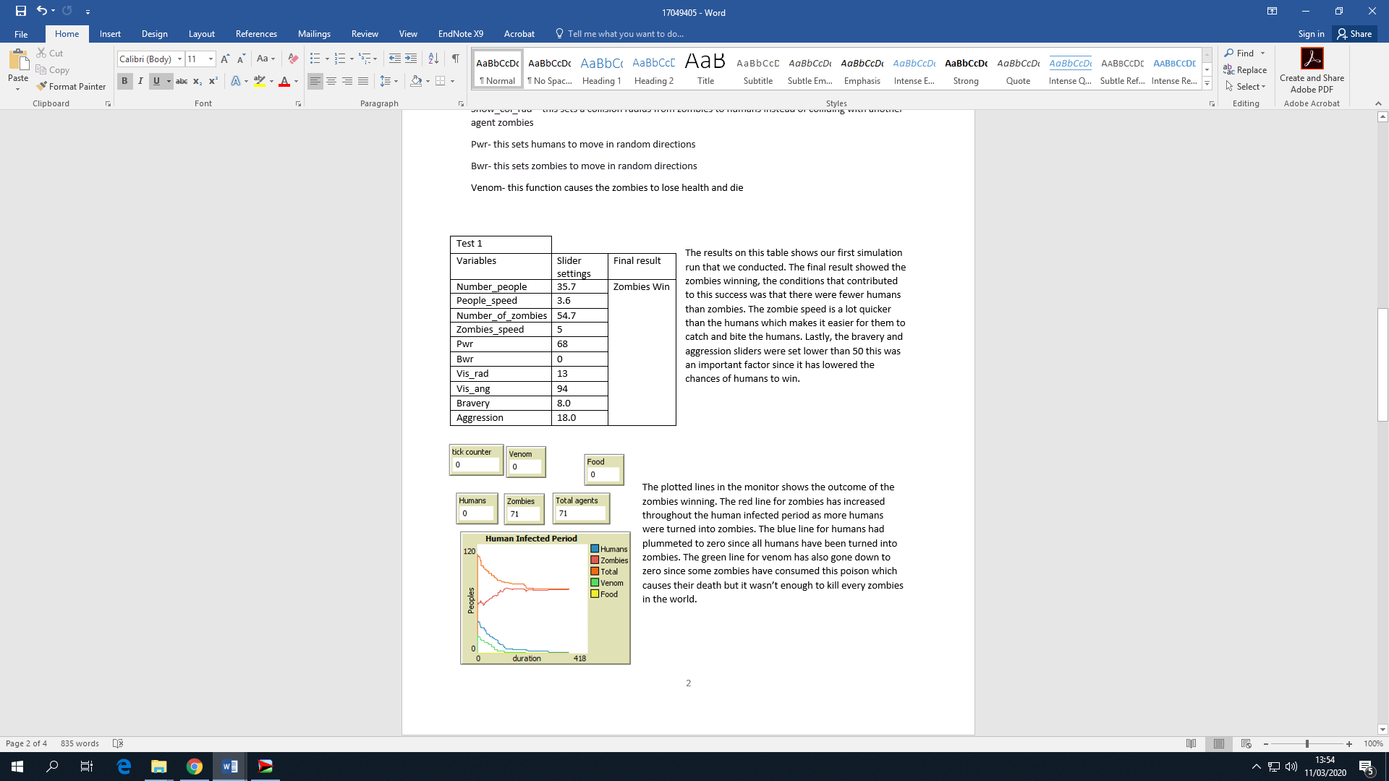

The results on this table shows our first simulation run that we conducted. The final result showed the zombies winning, the conditions that contributed to this success was that there were fewer humans than zombies. The zombie speed is a lot quicker than the humans which makes it easier for them to catch and bite the humans. Lastly, the bravery and aggression sliders were set lower than 50 this was an important factor since it has lowered the chances of humans to win.

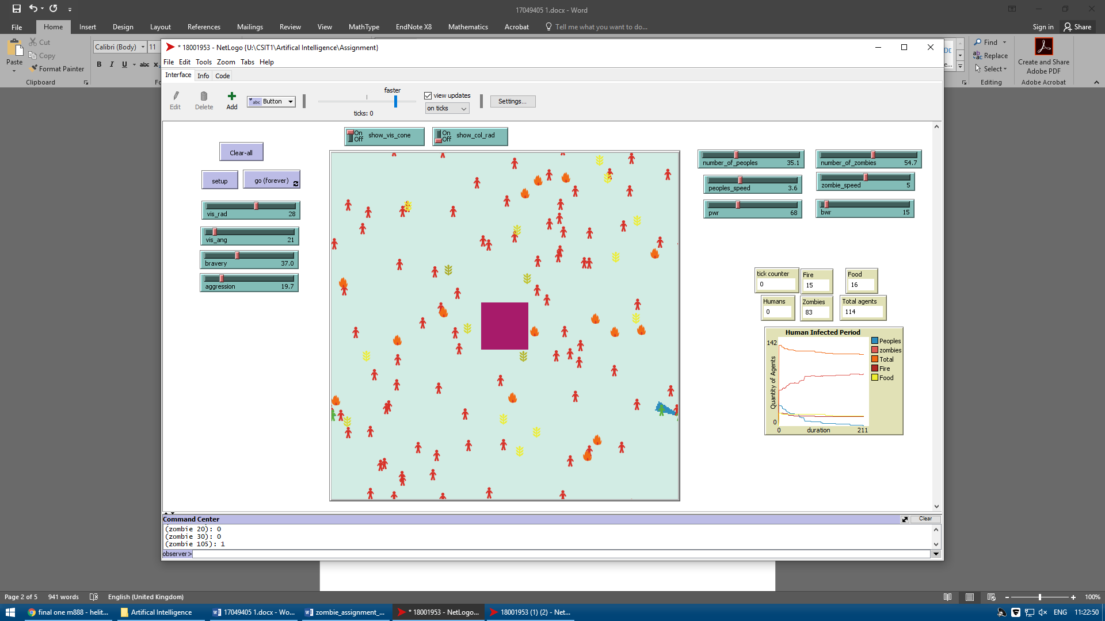The plotted lines in the monitor shows the outcome of the zombies winning. The pink line for zombies has increased throughout the human infected period as more humans were turned into zombies. The blue line for humans had plummeted to zero since all humans have been turned into zombies. The red line for fire has also gone down to 15 which causes zombies to die but it was insufficient as there were more zombies left in the world. The yellow line for food is meant to be consumed by humans in order to increase their health which could have contributed to them surviving longer than zombies. The fire and food variables are set to 20 at the start, due to the randomness in the simulation, the fire and food could have also been more than 0.

|  |
| --- |
| Test 2 |
| Variables | Slider settings | Final results |
| Number_People | 64.9 | Humans win |
| People_speed | 6.3 |  |
| Number_of_Zombies | 54.7 |  |
| Zombies_speed | 5 |  |
| Pwr | 68 |  |
| Bwr | 0 |  |
| Vis_rad | 13 |  |
| Vis_ang | 94 |  |
| Bravery | 50.0 |  |
| Aggression | 79.6 |  |

In our second simulation run. This time the humans have won against the zombies. We increased the human population, speed, bravery and aggression which was lower in the previous test 1. This conditions increased the chances of humans winning as they had an advantage in population and speed in order to outrun the zombies. Bravery < 100 and aggression was greater than > 100 which was coded to increase the chances of humans winning.

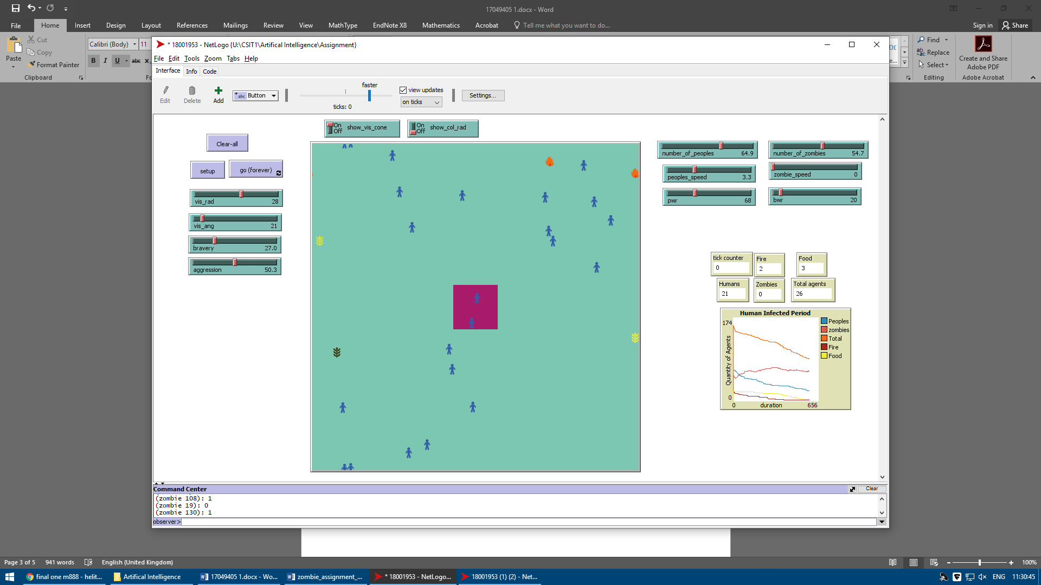

The plotted lines here shows the results of humans winning. The blue line for humans was no a steady line throughout the infection period since humans were infected and so the line dropped. On the other hand, the red line for zombies dropped to zero as more of them had died out from the fire and due to high aggression and high bravery made it possible for humans to outlive the zombies.

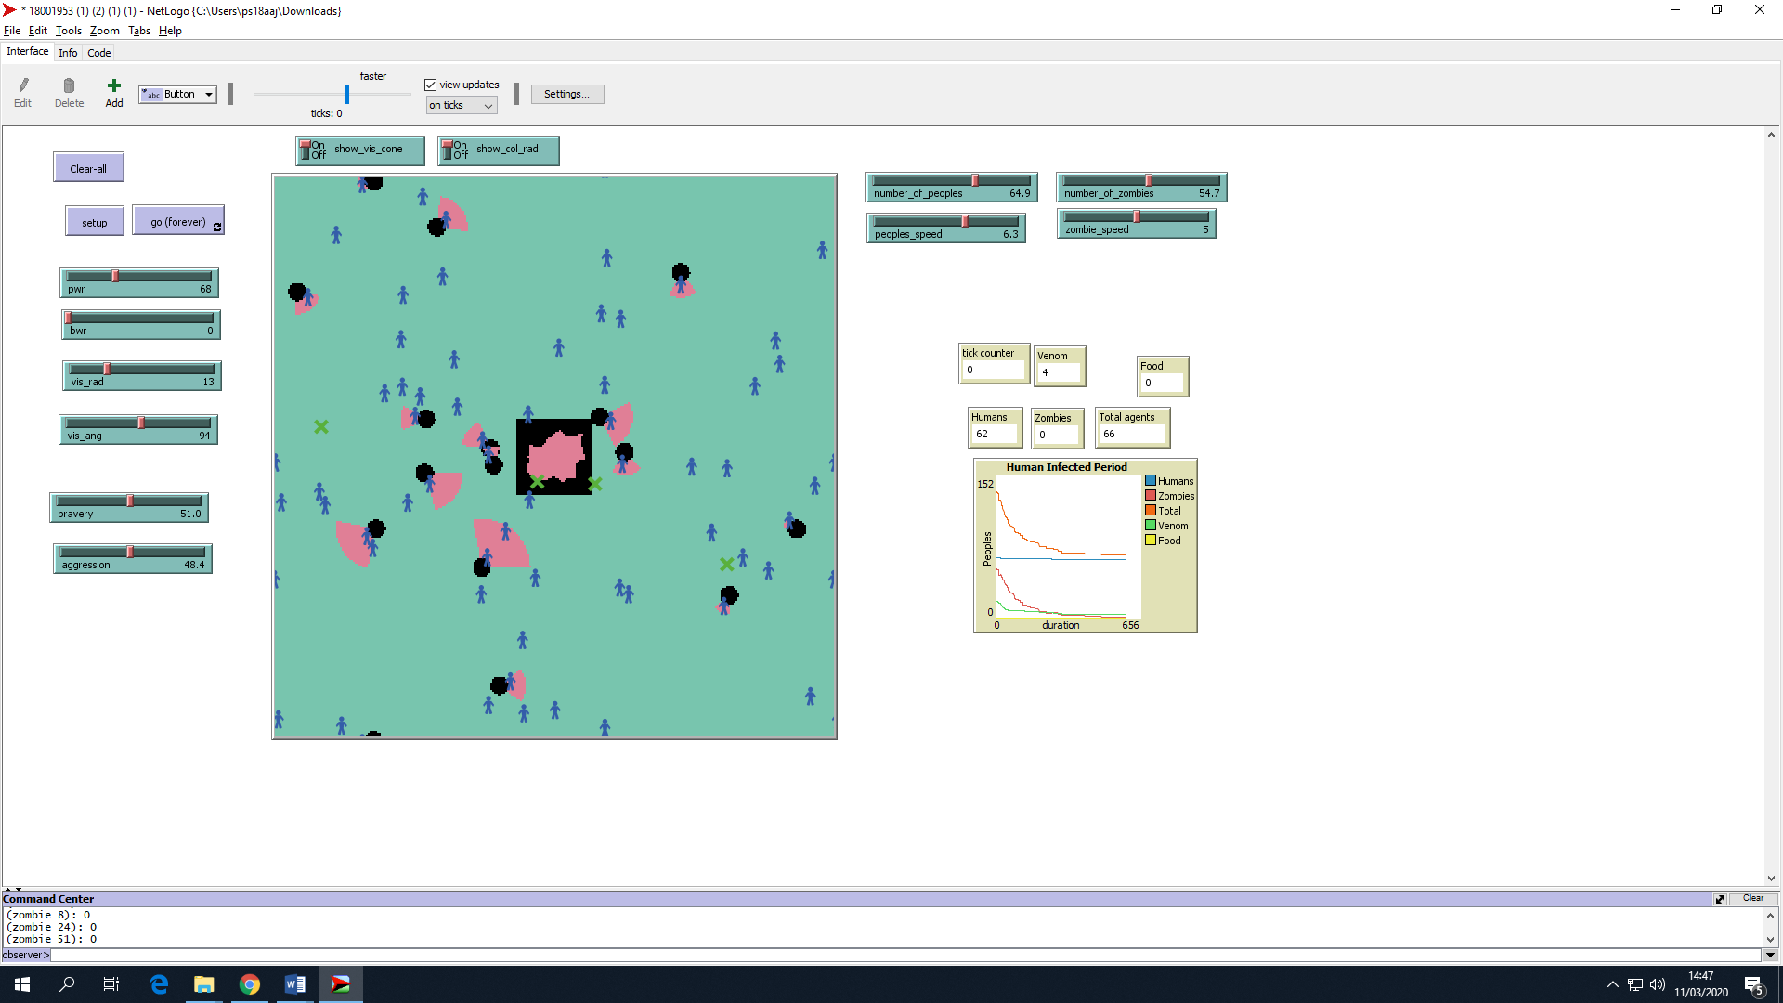

The setup button creates randomness in the simulation this automatically adjusts the slider settings in the simulation whenever we click on the button. We used this to create different scenarios as shown in the two test runs produced.

**Variables**

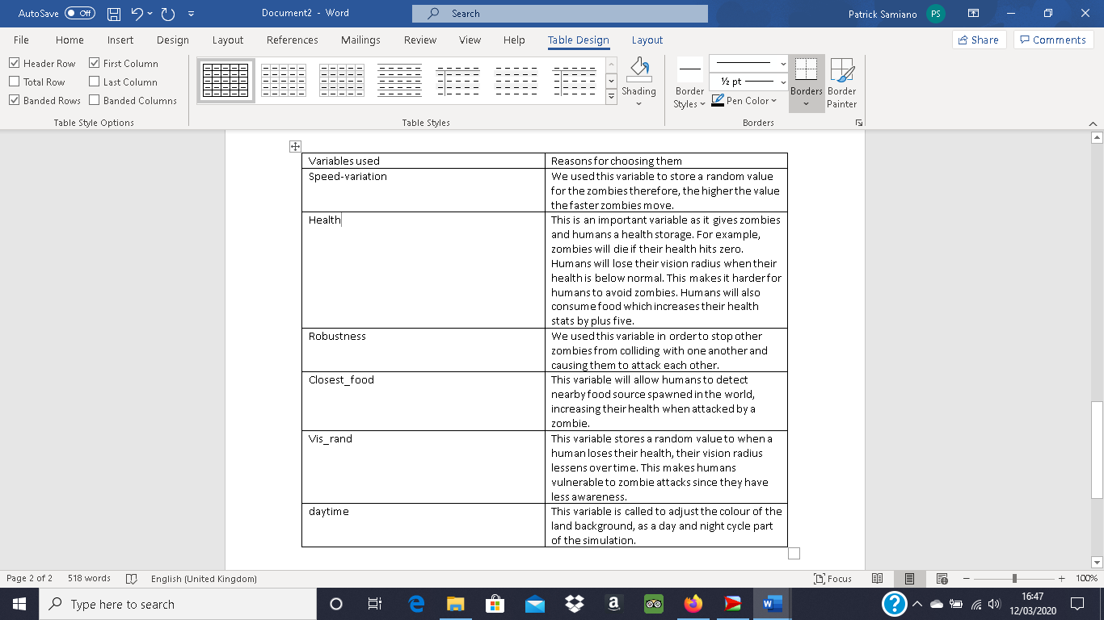For the simulation to work, we had to add in several global variables which will impact the outcome of the zombie apocalypse.

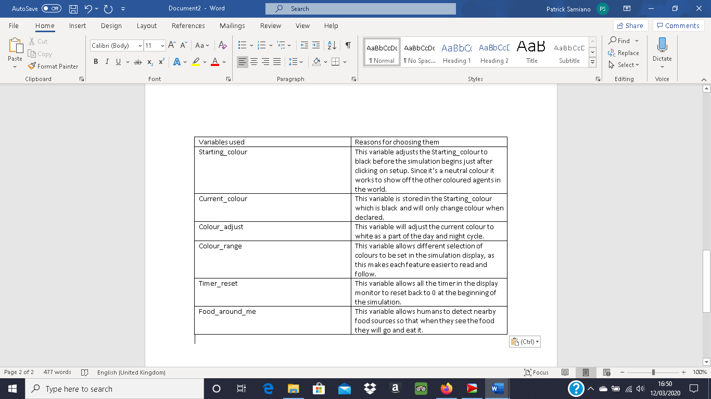**Conclusion**

As stated in the introduction, we wanted to show how fast the virus spreads depending on the conditions that were set. After running different results, we concluded that zombies will most likely die when the sliders for aggression and bravery is close to or above 50. We saw the humans winning every time this condition was met even though we gave zombies advantages such as, movement speed and higher population. The zombies would eventually lose numbers and due to consuming high traces of fire which depletes their health points. We also found out that during the simulation, zombies would get trapped inside the walls this was meant to contain zombies from escaping and roaming in the world however, humans would collide towards the walls causing zombies to break through. This was a random occurrence in the simulation since the spawn is always random therefore, there won’t always be zombies trapped inside. Since we found out that aggression and bravery played a big role in human survival, we also had chances where the sliders were set to low this ensured the zombies to win as they infect and turn humans into zombies in a short period of time. Food can also be found in the world so that humans can feed on it and survive longer but if aggression and bravery are low zombies will most likely win in the end.

**References:**

The present model was created by Helitha and Patrick. All references made are from studynet practicals for the butterfly model.

Studynet(2020). <https://herts.instructure.com/courses/57497/pages/practical-resources-number-2?module_item_id=882506> // Date Accessed: 11/03/2020

Studynet(2020). <https://herts.instructure.com/courses/57497/pages/practical-resources-number-3?module_item_id=882508> //Date Accessed: 11/03/2020

studynet(2020). <https://herts.instructure.com/courses/57497/pages/practical-resources-number-4?module_item_id=882510> // Date Accessed: 11/03/2020

studynet(2020). <https://herts.instructure.com/courses/57497/pages/practical-resources-number-5?module_item_id=882512> // Date Accessed: 11/03/2020