IE7275 Machine Learning and Data Analytics
Group Project 1:
Personalized Hybrid Recommendation System
for Amazon Video Games
Group 5:
Liam Campbell
Harshitkumar Brahmbhatt
Hemanth Karthik Devakivada

Table of Contents
1. Introduction
- Purpose of the Study
- Why Hybrid Recommendation?
2. Dataset Overview
- Source and Scope
- Key Fields
3. Data Cleaning and Preprocessing
- Data Quality Checks
- Implicit Feedback and Indexing
- Chronological Split and Evaluation Stages
- Item Text Construction
4. Exploratory Data Analysis (EDA) & Visualizations
- Rating Distribution
- Sparsity and User Activity
- Activity Over Time
- Popularity Drift
- Cold Start under the Timestamp Split
5. Methods
- Task and Evaluation Protocol
- Popularity Baseline
- Implicit ALS
- Neural Collaborative Filtering (NeuMF)
- TF-IDF Content Model
- Hybrid Models
- Recency Weighting
- Hyperparameter Tuning
6. Results
- Overall Test Performance
- Validation vs. Test
- Performance by History Length
- Statistical Significance
- Effect of Recency Weighting
- Hybrid Weight Tuning
- Accuracy, Coverage and Personalization
7. Key Findings & Discussion
- Recency Is the Strongest Signal
- Content Helps Most When Histories Are Short
- The Popularity Prior: Accuracy vs. Personalization
- Why NeuMF Underperformed
- The Cold-Start Ceiling
- Computational Cost
8. Conclusion & Future Work
- Limitations
- Future Work
References
Appendix: Reproducing the Results

1. Introduction
Online stores carry far more products than any shopper can browse. Recommender systems close that gap by ranking, for each person, the handful of items they are most likely to want next. In video games the problem is especially sharp: the catalog spans games, consoles, controllers, headsets and digital codes across several console generations, and what people buy shifts quickly as new hardware and big releases arrive.

1.1 Purpose of the Study
This project builds and compares personalized Top-10 recommenders for the Amazon Reviews 2023 Video Games dataset. For every user we rank the games and accessories they have not interacted with yet and check how many of their actual next interactions land in the top 10. We compare five approaches under one shared, leakage-safe evaluation protocol: a popularity baseline, implicit matrix factorization (ALS), Neural Collaborative Filtering (NeuMF), a TF-IDF content model, and a hybrid that blends collaborative and content scores, plus an extension of the hybrid that also adds a recent-popularity signal.

1.2 Why Hybrid Recommendation?
Collaborative filtering (CF) learns from who bought what: users with overlapping histories are assumed to share taste. It works well when histories are rich, but most shoppers leave only a few interactions behind. Content-based models instead compare product descriptions, so they can still say something useful about a user with one or two purchases. Hybrid recommenders combine the two (Burke, 2002). Our proposal set out three questions:
- Does combining product content with collaborative filtering improve Top-10 relevance (Precision@10, Recall@10, NDCG@10)?
- Is the gain largest for users with limited interaction histories?
- How do the models compare on computational cost and personalization?
The short answers, developed in the rest of this report: yes, the CF + content hybrid significantly beats ALS alone (+9% NDCG@10); yes, the relative gain is largest for users with 1–2 past interactions (+18%); and the most accurate model (the hybrid with a popularity prior) trades away much of its personalization to get there.

2. Dataset Overview

2.1 Source and Scope
We use Amazon Reviews 2023 from the McAuley Lab at UC San Diego (Hou et al., 2024), category Video_Games, in its 5-core form: every retained user and item has at least five interactions in the full data. The lab publishes an official chronological split with fixed absolute-timestamp cutoffs, which we use unchanged, so our numbers are comparable with other work on the same benchmark. Review interactions are joined with product metadata through the parent_asin product id.
Table 1. Dataset size by split (official absolute-timestamp split)
 | Train | Valid | Test | All
Interactions | 736,827 | 34,510 | 43,249 | 814,586
Users | 91,562 | 15,655 | 13,963 | 94,762
Items | 22,976 | 7,620 | 7,671 | 25,612
Time span | Oct 1999 – Aug 2021 | Aug 2021 – Jul 2022 | Jul 2022 – Sep 2023 | Oct 1999 – Sep 2023

The validation period starts on 11 Aug 2021 and the test period on 16 Jul 2022. These sizes match the counts the McAuley Lab publishes for this benchmark, which confirmed our download and loading were correct.

2.2 Key Fields
Interaction files (one row per review):
- user_id, parent_asin: who interacted with which product.
- rating: 1–5 stars. We use it only for exploration (see Section 3.2).
- timestamp: when the review was written, in milliseconds. This drives the split and our recency weighting.
Product metadata (one record per product):
- title, store, main_category, categories: what the product is, who sells it, and its category path (which carries platform information such as PlayStation 4).
- features, description: free-text bullet points and product description.
- details: a key-value dictionary, from which we keep descriptive keys such as Manufacturer, Brand, Platform and Rating.

3. Data Cleaning and Preprocessing
Before modelling, we checked the data for problems and turned it into the form every model consumes: an integer-indexed interaction table, the user-item matrix, and one text document per product.

3.1 Data Quality Checks
We checked the raw interaction files for missing values, ratings outside 1–5, duplicate (user, product) pairs, and rows whose timestamp falls outside their split's time window. All four counts were zero across all 814,586 rows. The official pipeline had already kept only the earliest of any repeated (user, product) pair, so no de-duplication was needed. The cleaning code still enforces these rules (keeping the earliest repeat), so it stays safe if the files ever change.

3.2 Implicit Feedback and Indexing
Ratings are heavily skewed toward 5 stars (Section 4.1), so they say little about how much someone liked a product relative to other products. The proposal's task is also to predict what a user will interact with next, not how many stars they will give. We therefore treat every review as a positive interaction, regardless of its rating. User and product ids are mapped once to consecutive integers over all three splits, so the same index always means the same user or product in every stage.

3.3 Chronological Split and Evaluation Stages
To mimic real deployment, models may only learn from the past. We build two evaluation stages from the official files:
- Validation stage (for tuning): models train on the train period and are scored on the valid period's interactions.
- Test stage (for the final numbers): each model is refit, with the settings chosen on validation, on train + valid, and evaluated once on the test period.
A model never sees a target interaction or anything time-stamped after its cutoff. Each user's own past items are removed from their candidate list, so models are rewarded only for predicting new interactions.
Some target interactions cannot be predicted by any model trained on the past: the user may have no history at all, or the product may never have appeared before the cutoff. These rows are removed from the targets and counted (Section 4.5).

3.4 Item Text Construction
For the content model, each product becomes one text document built from its title, store, categories, selected details, features and description. Missing fields simply contribute nothing. Every 5-core product has a metadata record, but some fields are often empty (Table 2).
Table 2. Share of the 25,612 products with each metadata field present
Title | Store | Categories | Details | Features | Description
100% | 99.5% | 96.6% | 97.1% | 87.1% | 73.4%

We also add short slug tokens for category and store values (for example cat_playstation_4). Platform information mostly lives in the category path, and a standard tokenizer would drop the "4" in "PlayStation 4", making PS4 and PS5 products look identical. The median product document has 205 words.

4. Exploratory Data Analysis (EDA) & Visualizations
This section explores the data before any modelling. Each finding below directly shaped a modelling or evaluation decision.

4.1 Rating Distribution
Almost two thirds of all reviews (63.8%) give 5 stars, and only 11% give 1 or 2. With so little spread, stars are a weak preference signal, which supports treating every review as an implicit positive and focusing on ranking rather than rating prediction.
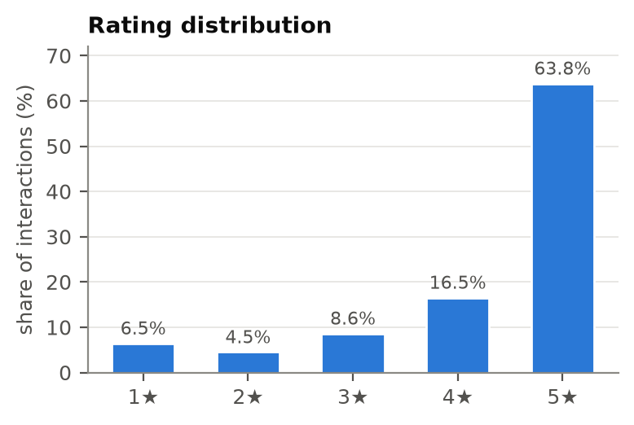
Figure 1. Rating distribution across all 814,586 interactions.

4.2 Sparsity and User Activity
The user-item matrix is extremely sparse: 94,762 users × 25,612 products with 814,586 interactions gives a density of 3.36 × 10⁻⁴, meaning 99.97% of all user-product pairs are empty. The typical user is light: the median user has 6 interactions in total (minimum 5, 90th percentile 14). A small group of heavy users have 20 or more. Products are similarly skewed (median 12 interactions, but the top 1% have over 340). Collaborative models therefore have very little signal for most users, which is the core motivation for adding product content.
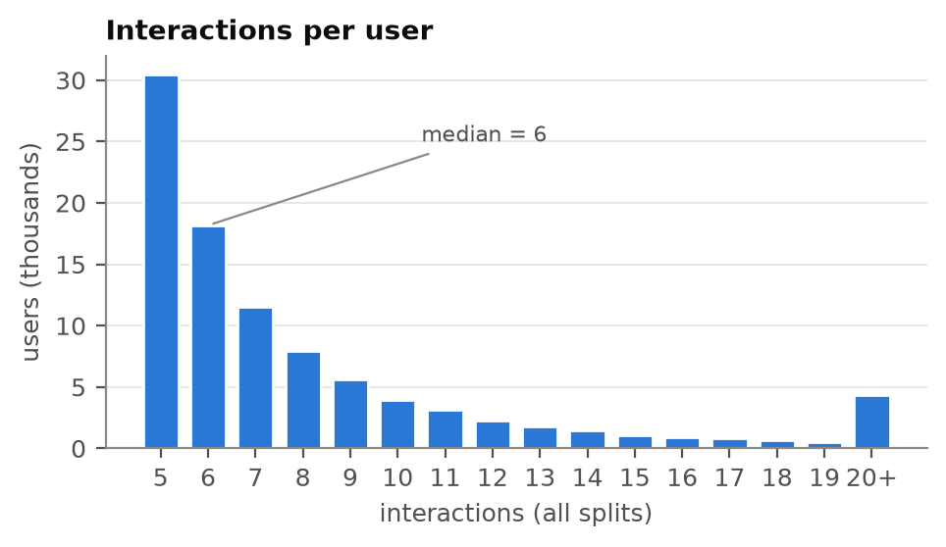
Figure 2. Number of users by total interactions (all splits, capped at 20+).

4.3 Activity Over Time
Review volume grows sharply after 2012, peaks around 2015, and declines afterwards. The validation and test periods are short and recent compared with the long training history: train covers about 22 years, while valid and test cover roughly one year each. Older interactions therefore make up most of what a model sees, even though they may describe products and tastes that are no longer current.
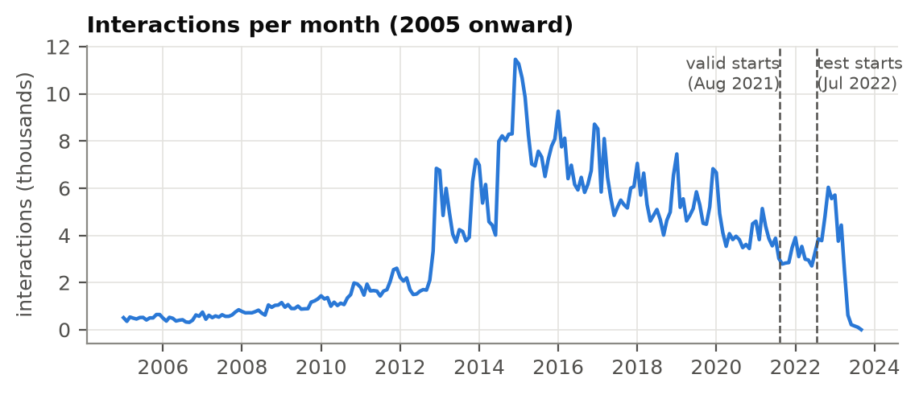
Figure 3. Interactions per month, with the official validation and test cutoffs marked.

4.4 Popularity Drift
The most-reviewed products in the training history are PS4- and Xbox One-era titles and accessories. The validation and test periods are dominated by Meta Quest 2, Pokémon, the PS5 DualSense controller, the PS5 console and the Switch OLED. The top-10 lists of the history and of the target periods share no items at all, in both stages. All-time popularity is therefore a poor guide to what people will want next, and this observation led us to add a recency weight to every model (Section 5.7).
Table 3. Five most-reviewed products: training history vs. test period
Rank | Train (Oct 1999 – Aug 2021) | Test (Jul 2022 – Sep 2023)
1 | amFilm Tempered Glass Screen Protector (Switch) | PlayStation DualSense Wireless Controller
2 | Skyrim VR – PlayStation 4 | Pokémon Scarlet – Nintendo Switch
3 | Grand Theft Auto V: Premium Edition – Xbox One | PlayStation 5 Console (PS5)
4 | PlayStation 4 500GB Console | SanDisk 128GB microSDXC Card for Switch
5 | Xbox Live Gold: 1 Month Membership | Xbox Elite Wireless Controller Series 2

4.5 Cold Start under the Timestamp Split
A large share of future interactions come from new users with no history, or go to new products that did not exist before the cutoff. No model trained on the past can rank these, so they are removed from the targets. In the test stage this leaves only 43.4% of target rows, from 10,049 users, that any model can possibly predict. This explains why all absolute scores in this report are small, and why we report confidence intervals rather than raw differences alone.
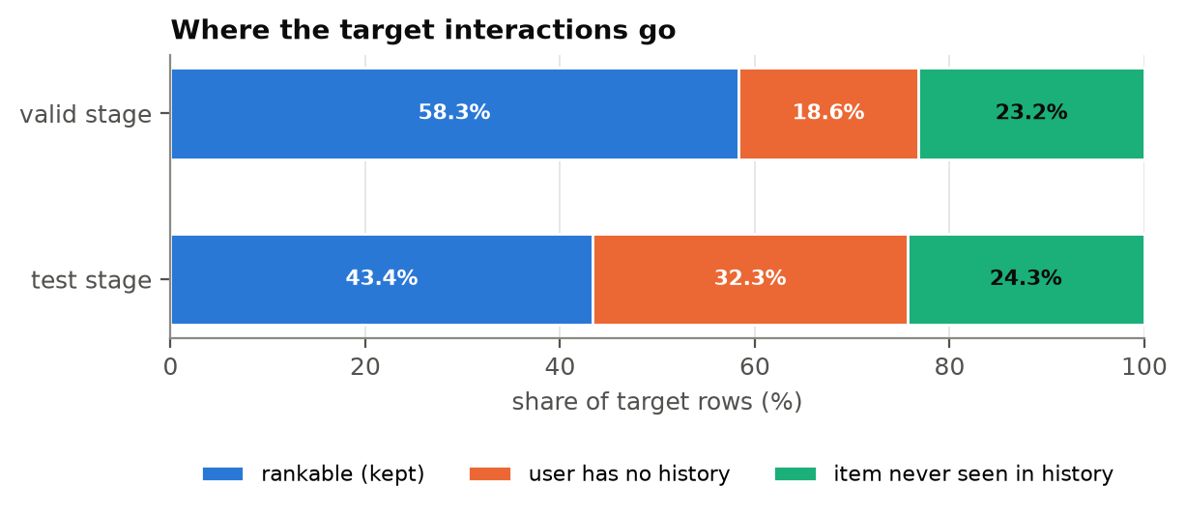
Figure 4. Share of target interactions that are rankable, from new users, or on new products.
Among the users who can be evaluated, short histories are common: 44% of test users have at most 4 past interactions (Table 4). This gives the proposal's "limited histories" question plenty of users in every bucket.
Table 4. Evaluated users by history length (interactions before the cutoff)
Stage | 1–2 | 3–4 | 5–9 | 10–19 | 20+ | Total
Validation | 1,660 | 3,694 | 3,984 | 1,472 | 593 | 11,403
Test | 1,250 | 3,191 | 3,729 | 1,340 | 539 | 10,049

5. Methods

5.1 Task and Evaluation Protocol
For each evaluated user, a model scores every candidate product: all products seen in the training history, minus the user's own past items. That is about 24,000 products in the test stage. We keep the top K = 10. We rank the full candidate set instead of sampling a few negatives, because sampled metrics can change which model looks best (Krichene & Rendle, 2020). All models go through exactly the same masking and ranking code, so differences come from the models alone.
Relevance is binary: a recommended product is a hit if the user interacted with it in the target period. We report:
- Precision@10: hits / 10. Recall@10: hits / number of target items. Hit Rate@10: share of users with at least one hit.
- NDCG@10 (Järvelin & Kekäläinen, 2002): rewards hits near the top of the list, normalized by the best achievable ranking. NDCG@10 is our main selection metric.
- Catalog coverage: share of candidate products recommended to at least one user. Personalization: 1 − the average overlap between two users' top-10 lists (0 means everyone gets the same list).
- Cost: wall-clock seconds to fit the model and to score all evaluated users, on an Apple M4 Pro laptop.
To decide whether one model really beats another, we compare per-user NDCG@10 on the same test users with a paired bootstrap 95% confidence interval (2,000 resamples; Efron & Tibshirani, 1994) and a paired t-test.

5.2 Popularity Baseline
Recommend the products with the most interactions, the same list for everyone (minus items the user already has). Besides the proposal's all-time version, we also count only the most recent w days before the cutoff and tune w on validation.

5.3 Implicit ALS (Matrix Factorization)
Alternating Least Squares for implicit feedback (Hu, Koren & Volinsky, 2008) learns a 128-dimensional vector for every user and product so that their dot product predicts whether the user interacted with the product. Observed pairs get a higher confidence than unobserved ones. We use the implicit library, in which the confidence of an observed pair is α × (its weight) and unobserved pairs have confidence 1. We also try BM25 weighting (Robertson & Zaragoza, 2009), which down-weights very active users and very popular products.

5.4 Neural Collaborative Filtering (NeuMF)
NeuMF (He et al., 2017) replaces the plain dot product with a neural network. A generalized matrix factorization branch (32-dimensional embeddings) and a multi-layer perceptron branch (64 → 32 → 16) are concatenated into one prediction layer. It is trained in PyTorch with binary cross-entropy on observed pairs plus four randomly sampled negative products per positive, resampled every epoch, using Adam (learning rate 0.001, batch size 4,096) on the laptop's GPU.

5.5 TF-IDF Content Model
Each product's text document (Section 3.4) is turned into a TF-IDF vector (Salton & Buckley, 1988) with English stop words removed, sublinear term frequency and a vocabulary of up to 50,000 terms. A user's profile is the weighted sum of the vectors of products in their history. Every candidate product is scored by its cosine similarity to that profile. Because it only needs product text, this model can match a user to products that few other people have interacted with.

5.6 Hybrid Models
The hybrid combines the ALS and content scores. Their raw scores live on very different scales, so for each user we first standardize every model's scores across all products (a z-score, written z(·)) and then blend:
score = (1 − β) · [ w · z(ALS) + (1 − w) · z(content) ] + β · z(popularity)
- w is the weight on collaborative filtering. It is either a fixed α, or a history-adaptive weight α · n / (n + k) that leans on content when a user's history length n is short.
- β = 0 gives the proposal's CF + content hybrid ("Hybrid").
- β > 0 adds a recent-popularity prior. We report this as an extension ("Hybrid + popularity"), since the proposal did not include it.
The components are trained once with their own tuned settings, and only the blend weights are tuned on validation.

5.7 Recency Weighting
Because of the popularity drift in Section 4.4, every learned model gets one extra setting, a half-life h in days. Each past interaction counts with weight
weight = 0.5 ^ (age in days / h)
so an interaction h days before the cutoff counts half as much as one made on the cutoff day, and h = 0 switches the weighting off (all interactions count equally). For ALS the weights scale the confidence, for the content model they weight the profile sum, and for NeuMF they weight each training example's loss (Ding & Li, 2005, apply the same idea to collaborative filtering).

5.8 Hyperparameter Tuning
Each model's settings were chosen on the validation stage only, by validation NDCG@10. The winning configuration was then refit on train + valid and evaluated on test exactly once. Grids were kept deliberately small to limit overfitting to the validation period.
Table 5. Settings searched on validation, and the configuration chosen
Model | Searched (fixed settings in brackets) | Chosen on validation
Popularity | window: all history, 7, 14, 30, 60, 90, 180, 365 days | last 180 days
ALS | α ∈ {10, 40}; weighting ∈ {binary, BM25}; half-life ∈ {off, 180, 365} d [128 factors, reg. 0.05, 20 iterations] | BM25, α = 10, half-life 180 d
Content (TF-IDF) | n-grams ∈ {1, 1–2}; half-life ∈ {off, 90, 365} d [50k terms, min_df 2] | 1–2-grams, half-life 90 d
NeuMF | epochs ∈ {2, 4, 6}; half-life ∈ {off, 180} d [GMF 32, MLP 64-32-16, 4 negatives] | 2 epochs, half-life 180 d
Hybrid | α ∈ {0.3, …, 0.9}; adaptive k ∈ {0, 1, 2, 5} [β = 0] | α = 0.7, fixed weight
Hybrid + popularity | α ∈ {0.4, …, 0.7}; k ∈ {0, 2}; β ∈ {0.1, …, 0.4} | α = 0.5, β = 0.3, fixed weight

6. Results

6.1 Overall Test Performance
Table 6 and Figure 5 give the final test-stage results for all 10,049 evaluated users. The Hybrid + popularity extension is best on every accuracy metric. The proposal's CF + content Hybrid is second, ahead of ALS, NeuMF, Popularity and Content.
Table 6. Test-stage accuracy (10,049 users, K = 10; best value in bold)
Model | Precision@10 | Recall@10 | NDCG@10 | Hit Rate@10
Popularity (last 180 days) | 0.0056 | 0.0302 | 0.0149 | 0.0535
ALS | 0.0055 | 0.0299 | 0.0187 | 0.0510
Content (TF-IDF) | 0.0029 | 0.0162 | 0.0099 | 0.0276
NeuMF | 0.0057 | 0.0303 | 0.0158 | 0.0548
Hybrid (CF + content) | 0.0061 | 0.0326 | 0.0204 | 0.0548
Hybrid + popularity | 0.0073 | 0.0412 | 0.0218 | 0.0686
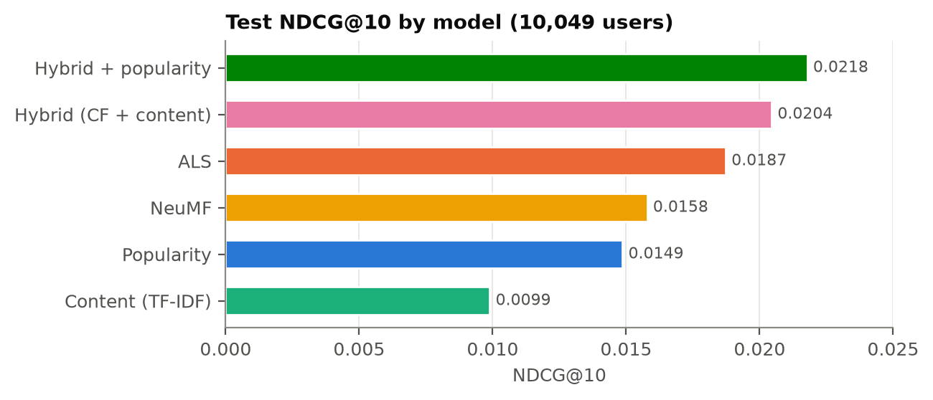
Figure 5. Test NDCG@10 by model.
The absolute numbers are small: about 2 hits per 100 recommendations for the best model. That is expected here. Most users have only one or two target items among roughly 24,000 candidates, and more than half of the test period's interactions cannot be predicted at all (Section 4.5).

6.2 Validation vs. Test
Comparing each model's validation and test NDCG@10 shows whether tuning overfit the validation period. The personalized models transfer well: ALS goes from 0.0186 to 0.0187 and the Hybrid from 0.0192 to 0.0204. The popularity-driven models lose ground (Popularity 0.0178 → 0.0149, Hybrid + popularity 0.0247 → 0.0218), because each period has its own hit products.
Table 7. NDCG@10 on the validation and test stages
 | Popularity | ALS | Content | NeuMF | Hybrid | Hybrid + pop.
Validation | 0.0178 | 0.0186 | 0.0088 | 0.0134 | 0.0192 | 0.0247
Test | 0.0149 | 0.0187 | 0.0099 | 0.0158 | 0.0204 | 0.0218

6.3 Performance by History Length
Figure 6 splits test NDCG@10 by how many past interactions each user had. This is the proposal's central question. The Hybrid beats ALS in every bucket, and its advantage is largest for users with only 1–2 past interactions (0.0189 vs. 0.0160, +18%), shrinking to +7–8% for users with 3–9 interactions. Popularity and NeuMF are surprisingly strong for the 1–2 bucket: when we know almost nothing about a user, "what is popular right now" is a hard baseline to beat. Hybrid + popularity combines both strengths and leads in four of the five buckets.
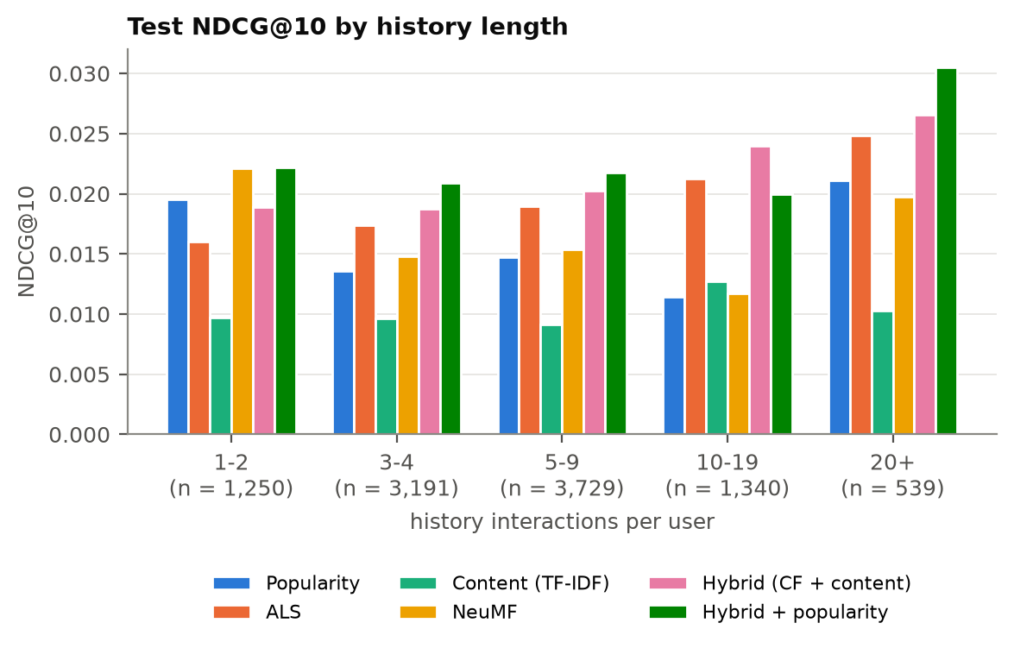
Figure 6. Test NDCG@10 by user history length (number of users in brackets).

6.4 Statistical Significance
Because the scores are small, we test each key comparison on the per-user NDCG@10 of the same 10,049 test users (Table 8). A difference counts as reliable when its 95% confidence interval excludes zero.
Table 8. Paired comparisons of test NDCG@10 (A − B)
A − B | Mean difference | 95% CI (bootstrap) | p (paired t-test) | Verdict
Hybrid − ALS | +0.0017 | [+0.0011, +0.0023] | 5.5 × 10⁻⁸ | Hybrid better
Hybrid − Content | +0.0106 | [+0.0085, +0.0126] | 2.0 × 10⁻²³ | Hybrid better
Hybrid + pop. − Hybrid | +0.0013 | [−0.0003, +0.0030] | 0.11 | not significant
Hybrid + pop. − Popularity | +0.0069 | [+0.0053, +0.0085] | 8.9 × 10⁻¹⁸ | Hybrid + pop. better
ALS − Popularity | +0.0039 | [+0.0017, +0.0061] | 0.0011 | ALS better
NeuMF − ALS | −0.0029 | [−0.0052, −0.0005] | 0.015 | NeuMF worse

The proposal's hybrid is a statistically significant improvement over both of its components. The popularity extension's further NDCG gain over the Hybrid is not significant on test, even though its Recall@10 (+26%) and Hit Rate@10 (+25%) gains are large.

6.5 Effect of Recency Weighting
Figure 7 compares each model's best validation score with and without recency weighting. Weighting recent interactions more improved every model, by far more than any classic setting such as the number of factors or the regularization strength: +57% for ALS, +37% for Content, +78% for NeuMF, and more than 3× for Popularity (last 180 days vs. all time).
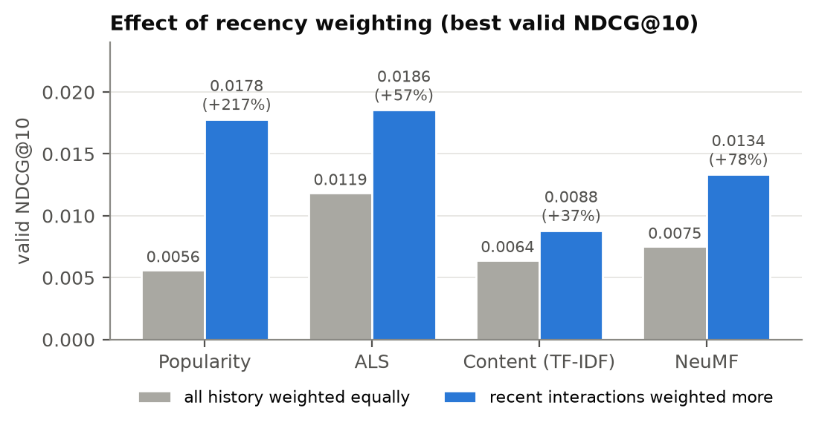
Figure 7. Best validation NDCG@10 with all history weighted equally vs. recent interactions weighted more.

6.6 Hybrid Weight Tuning
Figure 8 shows the Hybrid's validation score across blend weights. The best fixed weight is α = 0.7 (70% ALS, 30% content). It beats ALS alone across a wide range of α, so the result does not hinge on one lucky setting. The history-adaptive weight, which shifts weight toward content for short histories, was never better than a fixed α. That is an honest negative result: a simple fixed blend was enough. The Hybrid + popularity grid peaked at α = 0.5 with β = 0.3 (validation 0.0247).
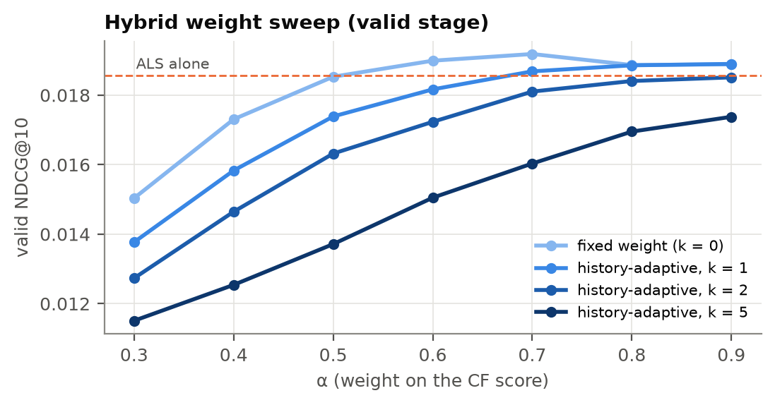
Figure 8. Validation NDCG@10 of the Hybrid by CF weight α, for a fixed weight and three history-adaptive variants.

6.7 Accuracy, Coverage and Personalization
Accuracy is not the only goal: a recommender that shows everyone the same ten products is not personal. Figure 9 and Table 9 show the trade-off. ALS, Content and the Hybrid give almost every user a different list (personalization ≈ 0.98–1.0). Popularity and NeuMF recommend nearly the same items to everyone and cover under 0.1% of the catalog. Hybrid + popularity sits in between: it is the most accurate model, but its personalization drops to 0.53.
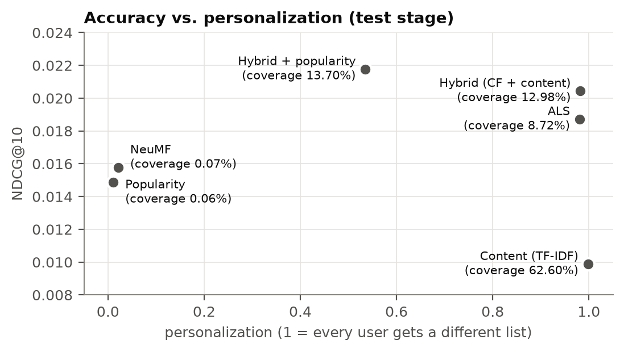
Figure 9. Test NDCG@10 against personalization; labels give catalog coverage.
Table 9. Test-stage diversity and cost (Apple M4 Pro laptop; NeuMF on the laptop GPU)
Model | Coverage | Personalization | Fit time (s) | Scoring time (s)
Popularity | 0.06% | 0.011 | < 0.1 | 1.4
ALS | 8.72% | 0.980 | 19.3 | 1.4
Content (TF-IDF) | 62.60% | 0.998 | 7.1 | 13.3
NeuMF | 0.07% | 0.021 | 4.8 | 6.0
Hybrid (CF + content) | 12.98% | 0.982 | 26.5 | 14.1
Hybrid + popularity | 13.70% | 0.535 | 28.7 | 15.1

7. Key Findings & Discussion

7.1 Recency Is the Strongest Signal
The single most important design choice in this project was not the model family but how much to trust old interactions. The video-game market turns over with each console generation, and the top products of the history never reappear among the top products of the target periods. Down-weighting old interactions with a half-life of 90–180 days improved every model by 37–78%, which is more than the gap between most of the models themselves. Any recommender for this kind of catalog should treat time as a first-class signal.

7.2 Content Helps Most When Histories Are Short
On its own, the TF-IDF content model is the least accurate, because similar text does not always mean a similar next purchase. Combined with ALS, though, it adds information that collaborative filtering lacks. The Hybrid beats ALS by +9% overall with a confidence interval well above zero, and by +18% for users with only 1–2 past interactions. This confirms the proposal's hypothesis that content is most useful when interaction histories are limited. Content also raises catalog coverage, from 8.7% for ALS to 13.0% for the Hybrid, so more of the catalog gets recommended at all.

7.3 The Popularity Prior: Accuracy vs. Personalization
Adding a small amount of recent popularity (β = 0.3) produced the most accurate model, with the largest gains in recall and hit rate. It helps exactly where collaborative filtering is weakest: users we know little about, during a period when a few blockbuster products dominate. The cost is personalization, which falls from 0.98 to 0.53. Table 10 shows what that means for one test user whose history was retro and PC gear (a NEOGEO Mini, a mechanical keyboard, a wireless mouse and a gaming headset).
Table 10. Top-3 recommendations for one example test user
Model | Top-3 recommendations
Popularity | Pokémon Legends: Arceus · Elden Ring (PS4) · Meta Quest 2
ALS | Logitech G640 mouse pad · Logitech G815 keyboard · Turtle Beach headset controller
Content (TF-IDF) | HyperX Cloud Flight S headset · HyperX Cloud Core headset · HyperX Cloud Flight headset
Hybrid (CF + content) | Logitech G640 mouse pad · Logitech G815 keyboard · HyperX Cloud Flight headset
Hybrid + popularity | Pokémon Legends: Arceus · Elden Ring (PS4) · Meta Quest 2

ALS and the Hybrid recognize the PC-peripheral pattern, and the content model sticks closely to headsets like the one the user bought. Hybrid + popularity, however, shows this user the same top three as plain Popularity. (None of the models predicted this user's actual next purchase, a Wii-to-HDMI adapter.) Whether that trade is worth it depends on the goal. For pure click-through accuracy the popularity prior wins; for a store that values discovery and personal relevance, the CF + content Hybrid is the better default. Since the NDCG difference between the two is not significant, we consider the Hybrid the more balanced recommendation, with the popularity prior a useful option for brand-new or very light users.

7.4 Why NeuMF Underperformed
NeuMF is significantly worse than the much simpler ALS (−0.0029 NDCG@10, CI excluding zero). Its best validation setting (2 epochs) produced almost identical lists for everyone (personalization 0.02, coverage 0.07%). In effect it learned a recency-weighted popularity ranking, which also explains why it does well for 1–2-interaction users and poorly elsewhere. Training longer made validation scores worse while training loss kept falling, a sign of overfitting on such sparse data. This agrees with Rendle et al. (2020), who found that a well-tuned dot-product model usually beats NCF's learned interaction function. More data per user, or a stronger negative-sampling and regularization search, would be needed to make the neural model pay off.

7.5 The Cold-Start Ceiling
Under the real chronological split, 32% of test interactions come from users with no history and a further 24% go to products released after the training cutoff. No model in this study can predict either group. A content model is the natural way to reach new products, because it needs only product text, which is available for new releases. Our protocol limits candidates to products already seen, so this capability is not measured here (see Future Work).

7.6 Computational Cost
All models train in under 30 seconds on a laptop. ALS is the best value: 19 s to fit, 1.4 s to score 10,049 users, and the strongest single model. The content model is cheap to fit but the most expensive to score (13 s), because it compares every user profile with every product's sparse text vector. The hybrids cost roughly the sum of their parts (about 27 s fit and 14–15 s scoring), a modest price for a 9–17% gain in NDCG@10 over ALS. Tuning the hybrid weights is cheap, because component scores are computed once per batch of users and only re-blended for each weight setting.

8. Conclusion & Future Work
We built and compared five recommendation approaches for Amazon video games under a strict chronological, full-ranking protocol. The proposal's hybrid, which blends ALS with TF-IDF product content, significantly outperformed each of its components, and its advantage was largest for users with very short histories, as the proposal predicted. Adding a recent-popularity prior gave the most accurate model overall, at a clear cost in personalization. Weighting recent interactions more was the single most effective change across all models, and the neural NCF model did not beat classic matrix factorization.

8.1 Limitations
- One dataset and one split. Results are for one category and one time period. Other categories or periods could rank the models differently.
- Single random seed. Each model was trained once. NeuMF on the laptop GPU is not bit-for-bit reproducible, so small NeuMF differences (below about 0.0005 NDCG) should be treated as noise.
- Small grids. Hyperparameter searches were deliberately small, so better settings may exist, especially for NeuMF.
- Ratings ignored. Treating every review as positive discards the difference between a 1-star and a 5-star review.
- Text features fit on all products. The TF-IDF vocabulary was built from the metadata of all products, including later ones. This uses product descriptions, not interactions, but it is a small simplification.

8.2 Future Work
- Recommend new products. Evaluate the content model on the 24% of test interactions that go to brand-new products, a capability collaborative filtering lacks.
- Multiple seeds. Repeat ALS and NeuMF with several seeds and report mean ± standard deviation.
- Use ratings as confidence. Feed star ratings (or only 4–5-star reviews) into ALS instead of treating all reviews equally.
- Stronger baselines and hybrids. Try item-kNN, EASE, or a feature-aware factorization model that learns product embeddings directly from the text.
- Richer text. Replace TF-IDF with pretrained language-model embeddings of product descriptions.

References
Anthropic. (2026). Claude (Opus 5.5) [Large language model], used through Claude Code. Used to help implement and test the code, run the experiments, and draft this report; all results were produced by the project code and checked by the team.
Burke, R. (2002). Hybrid recommender systems: Survey and experiments. User Modeling and User-Adapted Interaction, 12(4), 331–370. https://doi.org/10.1023/A:1021240730564
Ding, Y., & Li, X. (2005). Time weight collaborative filtering. In Proceedings of the 14th ACM International Conference on Information and Knowledge Management (CIKM) (pp. 485–492). https://doi.org/10.1145/1099554.1099689
Efron, B., & Tibshirani, R. J. (1994). An introduction to the bootstrap. Chapman & Hall/CRC. https://doi.org/10.1201/9780429246593
Frederickson, B. (2023). implicit: Fast Python collaborative filtering for implicit feedback datasets (Version 0.7) [Computer software]. https://github.com/benfred/implicit
He, X., Liao, L., Zhang, H., Nie, L., Hu, X., & Chua, T.-S. (2017). Neural collaborative filtering. In Proceedings of the 26th International Conference on World Wide Web (pp. 173–182). https://doi.org/10.1145/3038912.3052569
Hou, Y., Li, J., He, Z., Yan, A., Chen, X., & McAuley, J. (2024). Bridging language and items for retrieval and recommendation. arXiv preprint arXiv:2403.03952. https://arxiv.org/abs/2403.03952
Hu, Y., Koren, Y., & Volinsky, C. (2008). Collaborative filtering for implicit feedback datasets. In 2008 Eighth IEEE International Conference on Data Mining (pp. 263–272). https://doi.org/10.1109/ICDM.2008.22
Järvelin, K., & Kekäläinen, J. (2002). Cumulated gain-based evaluation of IR techniques. ACM Transactions on Information Systems, 20(4), 422–446. https://doi.org/10.1145/582415.582418
Krichene, W., & Rendle, S. (2020). On sampled metrics for item recommendation. In Proceedings of the 26th ACM SIGKDD International Conference on Knowledge Discovery & Data Mining (pp. 1748–1757). https://doi.org/10.1145/3394486.3403226
Paszke, A., et al. (2019). PyTorch: An imperative style, high-performance deep learning library. In Advances in Neural Information Processing Systems 32.
Pedregosa, F., et al. (2011). Scikit-learn: Machine learning in Python. Journal of Machine Learning Research, 12, 2825–2830.
Rendle, S., Krichene, W., Zhang, L., & Anderson, J. (2020). Neural collaborative filtering vs. matrix factorization revisited. In Fourteenth ACM Conference on Recommender Systems (RecSys) (pp. 240–248). https://doi.org/10.1145/3383313.3412488
Robertson, S., & Zaragoza, H. (2009). The probabilistic relevance framework: BM25 and beyond. Foundations and Trends in Information Retrieval. https://doi.org/10.1561/1500000019
Salton, G., & Buckley, C. (1988). Term-weighting approaches in automatic text retrieval. Information Processing & Management, 24(5), 513–523. https://doi.org/10.1016/0306-4573(88)90021-0

Appendix: Reproducing the Results
All code, configuration and result summaries are in the team repository: github.com/hr231/ie7275-amazon-video-game-recommender. With uv installed, the whole pipeline runs in about 15 minutes on an Apple M4 Pro laptop:
uv sync # Python 3.12 environment and all dependencies
uv run vgrec download # official split files and metadata (~117 MB)
uv run vgrec prepare # cleaning, id mapping, item text
make baseline models hybrids # tune on valid, refit, evaluate once on test
uv run vgrec report # summary, NDCG-by-history and significance tables
uv run python reports/make_figures.py # the figures in this report

Hyperparameter grids are in configs/experiment.toml. Per-model results are written to results/<model>/ (validation grid, chosen configuration and test metrics), and the notebooks 01_eda.ipynb and 02_results.ipynb reproduce the exploratory analysis and the results tables.

