

Case Study: Analyzing 30% Profit Dip at a Ride- Hailing Startup in India
Key Takeaways:

A steep rise in customer attrition, high cancellation rates, decreased active driver retention, and external cost pressures (particularly rising fuel prices and heightened competition) are the main causes of the 30% profit decline in the most recent quarter. Targeted, data-driven interventions in operations, product, and customer experience are needed to address these problems.
A Comprehensive Method for Profit Dip Analysis

1. Definition and Scope of the Problem
To reiterate the problem, there was a 30% decline in profits in Q4 that was not seen in previous periods.
Establish the following important metrics: ride volume, active drivers, quarterly revenue, expenses, profit margin, cancellation rates, customer retention/churn, and city-level breakdowns.

Data Gathering and Performance Evaluations
Examine a variety of KPIs from different cities and quarters:
Profit, revenue, ride volume, churn rate, and driver base are compared on a quarterly basis.
Analyze revenue declines, churn, driver retention, and cancellation rates by city, including Delhi, Mumbai, Bangalore, and Kolkata.
Operational metrics include wait times, cancellation rates, acceptance rates, and booking success rates.

Step-by-step analysis flowchart]

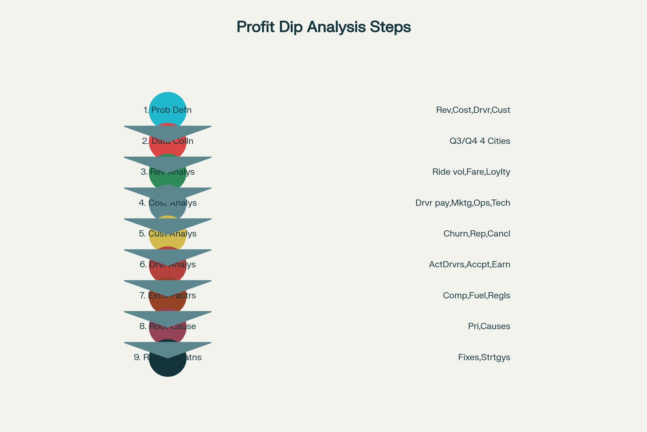

Step-by-Step Analysis Framework for Ride-Hailing Profit Investigation

Financial & Operational Deep Dive

 | Q2 2024 | Q3 2024 | Q4 2024
Revenue (₹ Cr) | 100 | 120 | 84
Profit (₹ Cr) | 15 | 24 | 10.5
Profit Margin | 15% | 20% | 12.5%
Churn Rate | 15% | 12% | 28%
Total Rides | 80 lakh | 96 lakh | 67.2 lakh
Active Drivers | 12,000 | 14,400 | 10,080

Key City Insights:

City | Revenue Drop % | Driver Retention % | Customer Churn % | Cancellation Rate %
Delhi | 25 | 70 | 25 | 35
Mumbai | 35 | 65 | 32 | 40
Bangalore | 30 | 68 | 28 | 32
Kolkata | 28 | 72 | 26 | 30
Cost Distribution:
Payouts to drivers were down 13.1%.
Spending on marketing went up by 20%. Fuel incentives rose by 70%.
Operations and technology saw modest increases. Customer Journey: 78% of bookings were successful, down from 92% The driver acceptance rate dropped from 85% to 65%.
The average wait time increased from eight to twelve minutes.
The cancellation rate increased from 20% to 34%.

Root Cause Analysis

Category | Primary Causes | Impact | Priority
External Factors | Fuel price hike, competitive price wars | 8 | High
Internal Factors | Poor driver retention strategy, app issues | 9 | Critical
Operational Issues | High cancellations, supply-demand mismatch | 9 | Critical
Technology Issues | App crashes, payment failures | 7 | Medium
Summary Table of Critical KPIs:

Metric | Q3 2024 | Q4 2024 | Change
Booking Success % | 92 | 78 | 15%
Driver Acceptance % | 85 | 65 | 20%
Avg Wait Time (min) | 8 | 12 | 50%
Cancellation Rate % | 20 | 34 | 70%
Revenue per Ride (₹) | 125 | 125 | No change

Analytical Dashboard

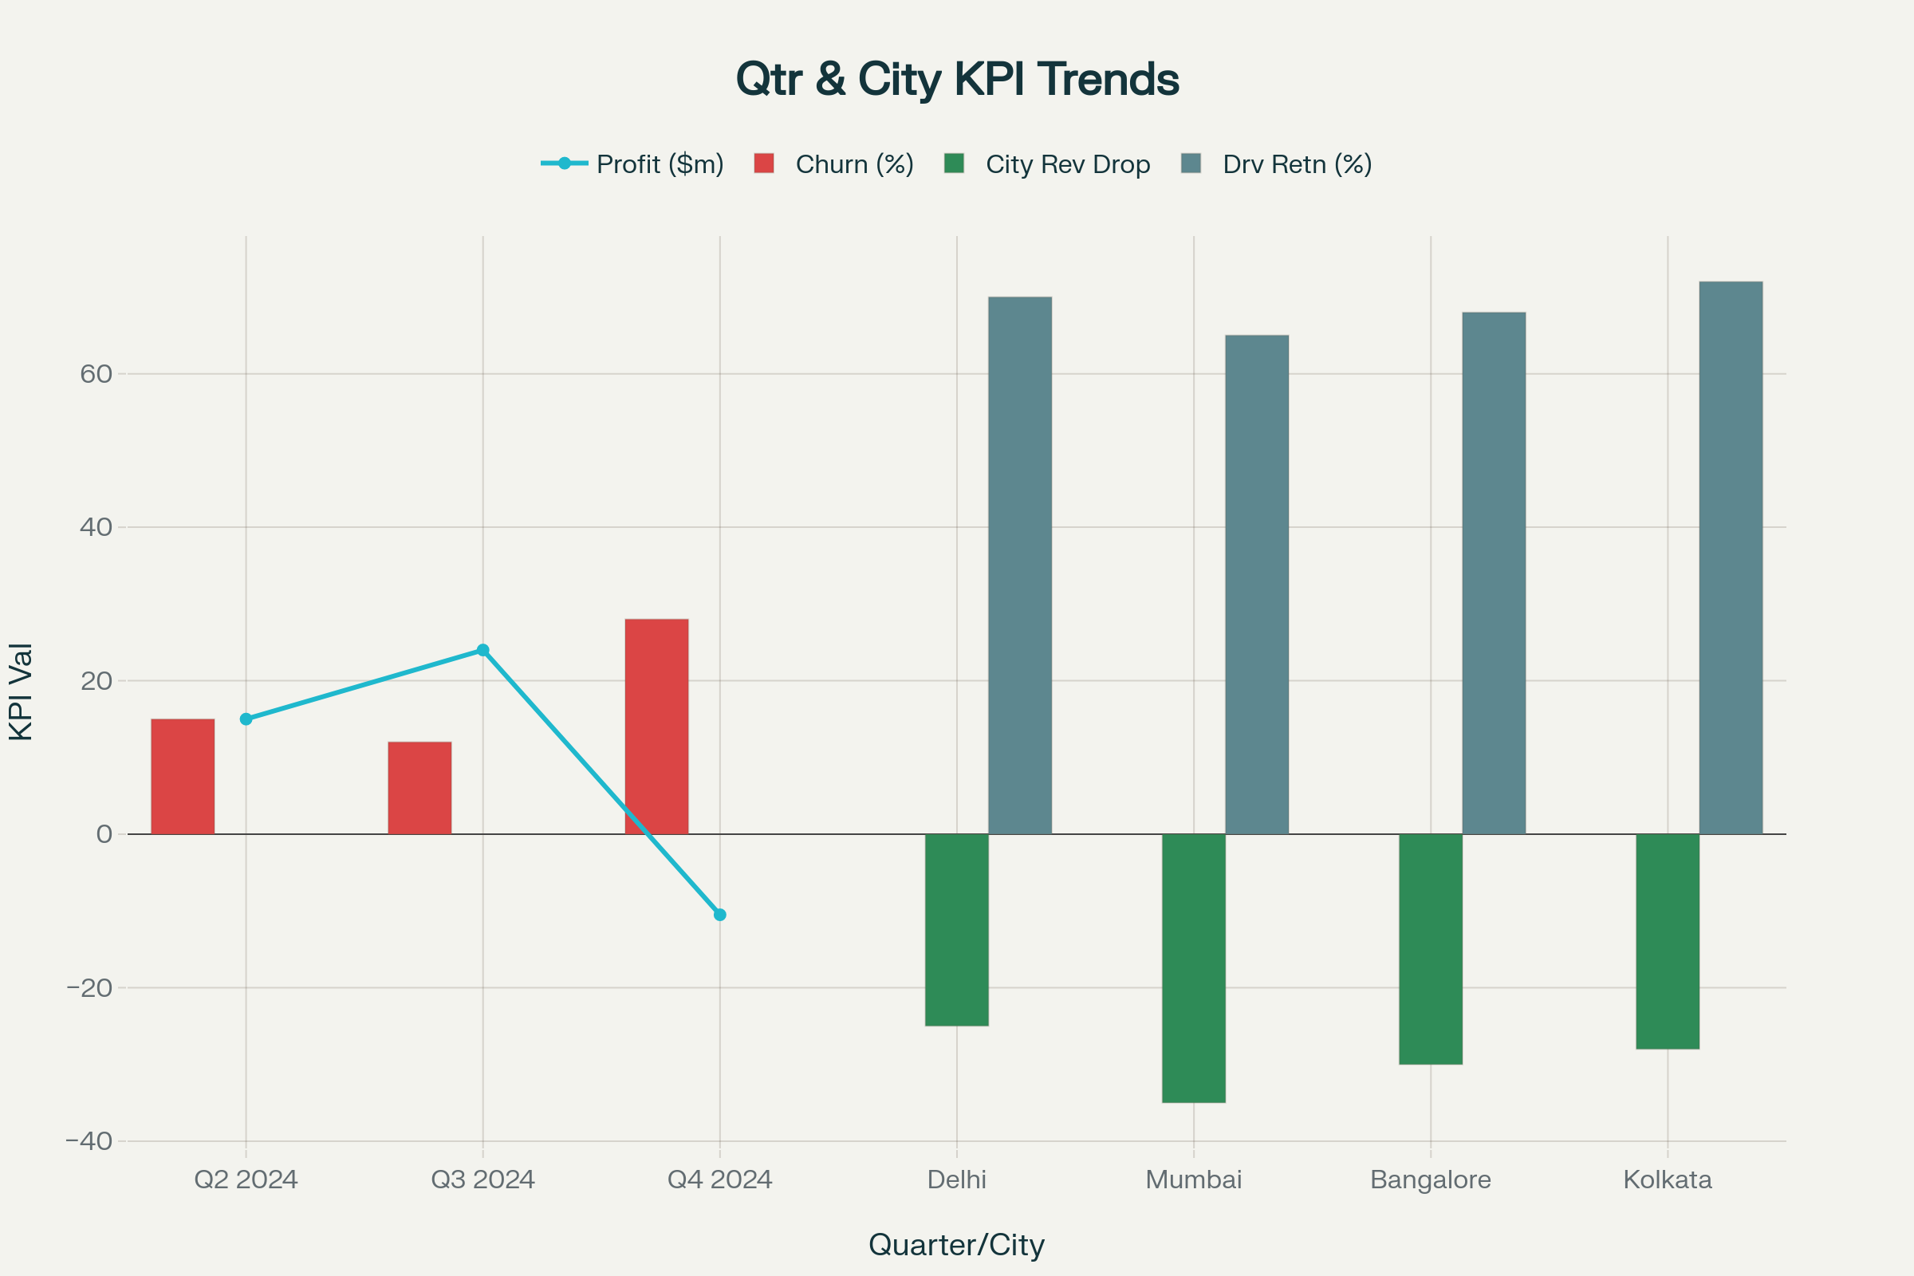

Dashboard of Startup Performance for Ride-Hailing: Important Metrics 30 Percent Profit Decline The dashboard displays:
decline in quarterly profits.
Comparison of city-wise revenue and churn Trends in driver retention and churn rates
changes in operational metrics (cancellations, wait times, and booking success)
Root Causes Found in
External: As fuel prices rise, driver take-home pay decreases; fierce competition in the market results in cheaper fares and more generous incentives elsewhere.
Internal: Driver morale is impacted by lower incentive budgets; there is a high rate of driver turnover, particularly in Bangalore and Mumbai; app/tech issues (crash, payment failure, longer booking times).
Operationally, customer discontent, surge pricing, and cancellation rates raise churn and lower ride volume.

Additional points of friction for the customer (delays, unsuccessful payments, low driver acceptance rates).

Recommendations: Short & Long Term Solutions

Short-Term 1 3 Months)

Stabilization of Service

Bring back targeted driver bonuses, especially for pooled or shared rides.
Reward dependable drivers and penalize frequent cancelers.

Increase Client Retention

Give churned riders comeback discounts.
For regular users, triple loyalty points or introduce "ride streak" incentives

Compete Vigorously in Unrest-plagued Cities
Mumbai/Bangalore temporary city-specific fare reductions to offset market share decline

Reduce Friction in the App's Path

Give priority to quick fixes for payment gateways and app crashes
Optimize matching algorithms and decrease booking time latency

Communication on Surge Pricing

To foster trust, provide alternative (non-surge) services or price protection plans along with transparent, incremental surge pricing
Consistently observe and react to surge feedback

Long-Term 6 12 Months)

Promote Supply-Side Changes

Try driver models with flat fees or SaaS-like features (test daily access fee in metropolitan cities)
Invest in fleet onboarding process enhancements and operational efficiency

Revamping the Loyalty Program

Tiers of loyalty programs with special advantages for loyal clients Silver and Gold levels)
Collaborate with nearby companies, provide special incentives, and run cross-promotions.

Investments in Technology and Products
Upgrade the systems for ride allocation and payments.
Increase the number of multimodal options available (e.g., integration with public transportation)

Comparative Evaluation
- Keep a close eye on rivals' incentive plans and prices, and make necessary adjustments
- to maintain a 5% margin.

Diversification and Growth

As part of growth plan 11-9, investigate EV fleet adoption, subscription models, and localization for Tier-2/Tier-3 cities.

Monitoring

KPI Target | Recommended Range
Cancellation Rate | 25% (daily per city)
Driver Acceptance Rate | 80% (daily per city)
Repeat Rider Rate | 75% (monthly per city)
Revenue per Ride | ≥ ₹125 ₹130
CSAT Satisfaction) | ≥4/5 (monthly, post-ride)
Operational Cost/Ride | <₹20
Price Gap vs Competitor | Within 5%
Dashboards on a daily, weekly, or monthly basis to monitor these metrics and modify levers as necessary.

Conclusion
The decline in profits is a complex issue that results from both external market forces and internal inefficiencies. Stabilizing driver supply, enhancing app dependability, providing clever incentives, and openly managing pricing strategies can all have an immediate impact. Long-term sustainable growth and profitability restoration depend on supply innovation, loyalty program redesign, tech investment, and strategic competitive benchmarking.
RESEARCH RESOURCES

https://assets.nextleap.app/submissions/ScalerAssignment-1-aa179156 37dd-46b1-af23 3f87b3e2a99 f.pdf
https://www.rodnav.com/customer-loyalty -programs-how-ride-hailing-apps-reward-frequent-riders/
https://www.yelowsoft.com/blog/ways-yelowsoft-helps-improve-customer-retention-for-taxi-businesse s/
https://www.valueships.com/post/surge-pricing
https://www.withorb.com/blog/surge-pricing
https://timesofindia.indiatimes.com/business/india-business/as-commissions-fall-flat-fee-reshapes-ride
-hailing/articleshow/122147391.cms
https://economictimes.com/tech/startups/increasing-competition-new-models-in-cab-hailing-space-a- boost-for-drivers/articleshow/108404022.cms
https://timesofindia.indiatimes.com/business/india-business/as-commissions-fall-indias-ride-hailing-fir ms-test-viability-of-flat-fee-economics/articleshow/122029891.cms
https://www.linkedin.com/pulse/driving-change-rise-ride-hailing-future-ubnme
https://peoplelogic.in/newsletter/driving-change-the-rise-of-ride-hailing-and-the-future-of-urban-tran sport-in-india

https://www.marketsandata.com/industry -reports/india-ride-hailing-market

