

Stitch Manager Pro

Complete User Manual

Version 16 • 2026 Edition

For Tailoring Shops, Boutiques & Fashion Designers

Powered by Swaroop Threads ERP © 2026

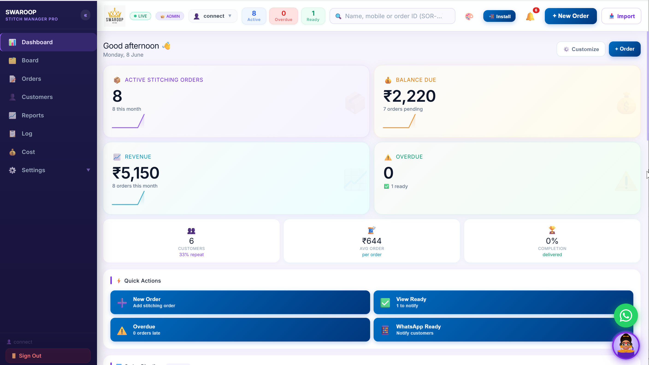

Table of Contents
Table of Contents 2
1. Product Overview 6
1.1 What is Stitching Manager Pro? 6
1.2 Key Benefits 6
1.3 Main Modules 6
1.4 User Roles 7
1.5 Business Workflow 7
1.6 Order Stages 7
2. Getting Started 8
2.1 Opening the Application 8
2.2 First-Time Registration 8
2.3 Signing In 9
2.4 Setting Up Your Shop Profile 9
2.5 Forgot Password 10
2.6 Installing as a Mobile App 10
3. Dashboard 11
3.1 Dashboard Overview 11
3.2 Summary Cards 12
3.3 Quick Actions 12

4. Board Module 13
4.1 What is the Board? 13
4.2 Order Stages on the Board 13
4.3 Moving an Order to the Next Stage 13
4.4 Understanding Order Cards 14
4.5 Filtering the Board 14
4.6 Mobile vs Desktop Board 14
5. Order Management 15
5.1 Creating a New Order 16
5.2 Saving an Order 17
5.3 Editing an Order 17
5.4 Deleting an Order 17
5.5 Recording a Payment 18
5.6 Searching for an Order 18
5.7 Filtering Orders (Orders List View) 18
5.8 Printing an Order Receipt 18
5.9 Importing Orders from Excel 19
6. Customer Management 20
6.1 Customer Module Overview 20
6.2 How Customers are Added 20
6.3 Viewing a Customer Profile 21
6.4 Editing a Customer 21
6.5 Saved Measurements 21
6.6 Loyalty Points 21
6.7 Creating a New Order for a Customer 22
6.8 Deleting a Customer 22
7. Measurement Management 23
7.1 Measurement Fields 23
7.2 Adding Measurements 23
7.3 Reusing Measurements 24
7.4 Custom Measurement Fields 24
7.5 Requiring Measurements 24
8. Cost Estimator Module 25
8.1 What is the Cost Estimator? 25
8.2 Creating a Cost Sheet 25
8.3 Material Expenses 25
8.4 Tailor Charges 26
8.5 Overhead Costs 26
8.6 Setting the Profit 26
8.7 The Live Summary Panel 27
8.8 Saving and Using a Cost Sheet 27
8.9 Worked Example 27
8.10 Cost Analytics 28
9. Reports Module 29
9.1 Reports Overview 29
9.2 Monthly P&L Report 29
9.3 Tailor Performance Report 29
9.4 Garment Analysis Report 29
9.5 Balance Aging Report 30
9.6 Customer Report 30
9.7 Pending Orders Report 30
9.8 Exporting Reports 30
9.9 Date Filters 30
10. Settings Module 31
10.1 Navigating Settings 31
10.2 Shop Profile 32
10.3 Rate Card 32
10.5 Users & Roles (Admin Only) 33
10.6 Loyalty Program 33
10.7 Account Settings 34
10.8 Bot / AI Chatbot (Admin Only) 34
10.9 Appearance (Theme) 34
11. User Roles & Permissions 35
11.1 Understanding Roles 35
11.2 Role Descriptions 35
11.3 Permissions Matrix 36
11.4 Custom Permissions 36
11.5 What Tailors See 36
12. Activity Log 37
12.1 What is the Activity Log? 37
12.2 What is Recorded? 38
12.3 Reading the Log 38
12.4 Searching the Log 38
13. Notification System 39
13.1 Notification Centre 39
13.2 Notification Badge 39
13.3 Acting on Notifications 39
13.4 Clearing Notifications 39
13.5 WhatsApp Notifications 39
14. Mobile Application Usage 40
14.1 Mobile-First Design 40
14.2 Installing on Your Phone 40
14.3 Mobile Navigation 40
14.4 Mobile Board 40
14.5 Mobile Order Form 41
14.6 Offline Usage 41
15. Best Practices 42
15.1 Daily Routine 42
15.2 Order Management Tips 42
15.3 Customer Relationship 42
15.4 Financial Management 43
15.5 Team Management 43
16. Frequently Asked Questions 44
16.1 Account & Login 44
16.2 Orders Error! Bookmark not defined.
16.3 Payments Error! Bookmark not defined.
16.4 Customers & Measurements 45
16.5 Cost Estimator 46
16.6 Reports Error! Bookmark not defined.
16.7 Settings & Configuration 46
16.8 Technical Questions 47
17. Troubleshooting 48
17.1 Login Issues 48
17.2 Order Issues 48
17.3 Payment Issues 49
17.4 Report Issues 49
17.5 Performance Issues 49
17.6 Print Issues 50
17.7 General Tips 50

1. Product Overview
📱 | Stitch Manager Pro  Your complete business management solution

1.1 What is Stitch Manager Pro?
Stitching Manager Pro is a professional, all-in-one business management software designed specifically for tailoring shops, boutiques, fashion designers, and stitching units. It helps you manage every aspect of your business — from taking orders and tracking production to managing customers, calculating costs, and generating reports — all in one place.
The software works on any device — your mobile phone, tablet, or desktop computer — without installing anything. Just open it in your browser and you're ready to go.

1.2 Key Benefits
- Never lose track of an order again — see every order's status at a glance
- Save customer measurements permanently — no more paper registers
- Know exactly how much profit you make on every garment
- Your entire team works from the same system — no confusion
- Works offline and can be installed like a phone app (PWA)
- Fully secure — each user has their own login with role-based access
- Built-in AI chatbot to answer customer questions automatically

1.3 Main Modules
Module | Description
📊 Dashboard | Live overview of orders, revenue, and key metrics
🗂️ Board | Visual Kanban board to track order progress through stages
📝 Orders | Create, edit, and manage all customer orders
👤 Customers | Customer profiles, measurements, and order history
📈 Reports | Detailed sales, tailor, and garment analysis reports
📋 Log | Complete audit trail of all actions in the system
💰 Cost Estimator | Calculate fabric, labour, overhead costs and set selling price
⚙️ Settings | Configure shop profile, users, rates, and preferences

1.4 User Roles
The system supports four built-in roles, each with different levels of access:
Role | Access Level
👑 Admin | Full access to everything — the shop owner or head manager
🏢 Manager | Can manage orders, customers, and payments. Cannot manage users
🛒 Sales | Can add and edit orders and customers. Limited financial access
✂️ Tailor | Can only see their assigned orders and update stage status

1.5 Business Workflow
Here is how a typical order flows through the system:
- Customer visits the shop → Order is created with measurements and delivery date
- Order appears in 'Received' column on the Board
- Fabric is cut → Tailor moves the order to 'Cutting'
- Stitching begins → Order moves to 'Stitching'
- Garment is ready → Order moves to 'Ready'
- Trial fitting (optional) → Order moves to 'Trial'
- Order collected → Order moves to 'Delivered'
- Payment received → Order moves to 'Paid ✓'

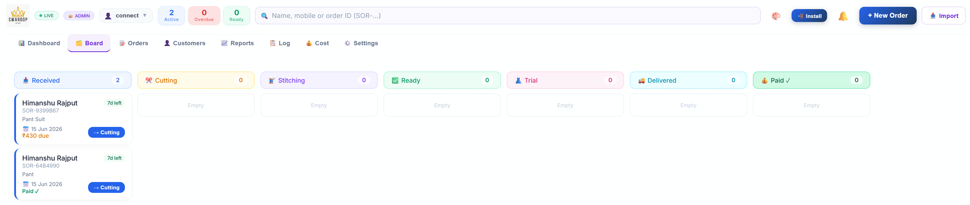

1.6 Order Stages
Stage | Meaning
📥 Received | Order has been taken from the customer
✂️ Cutting | Fabric is being cut as per measurements
🧵 Stitching | Garment is being stitched by the tailor
✅ Ready | Garment is ready for collection or trial
👗 Trial | Customer has come for a fitting/trial
🚚 Delivered | Order has been handed over to the customer
💰 Paid ✓ | Full payment has been received
💡 Tip: You can move an order to any stage at any time. The system automatically sends WhatsApp notifications when stages change.

2. Getting Started
🚀 | Getting Started  Set up your account in minutes

2.1 Opening the Application
Stitching Manager Pro runs in your web browser. Your service provider will give you a web address (URL) like:
https://stitch.himanshurajput.com/
You can open this on your phone, tablet, or computer. No installation is needed.
💡 Tip: For the best experience on your phone, tap the 'Install App' button when it appears. This adds the app to your home screen and it works just like a regular app.

2.2 First-Time Registration
The very first person to register automatically becomes the Admin. Follow these steps:
- Open the application URL in your browser
- You will see the login screen with the shop name and a sign-in form
- Click 'First time? Create account →' at the bottom of the form
- Enter your Email address and choose a Password (minimum 6 characters)
- Click 'Create Account'
- Check your email inbox for a confirmation email and click the link inside
- Return to the app and sign in with your email and password
⚠️ Note: The first person to register will automatically be assigned the Admin role. All other users who register afterwards will be given the Tailor role by default. The Admin can change their role later.

[ Screenshot: Login screen showing the sign-in form with email and password fields ]

2.3 Signing In

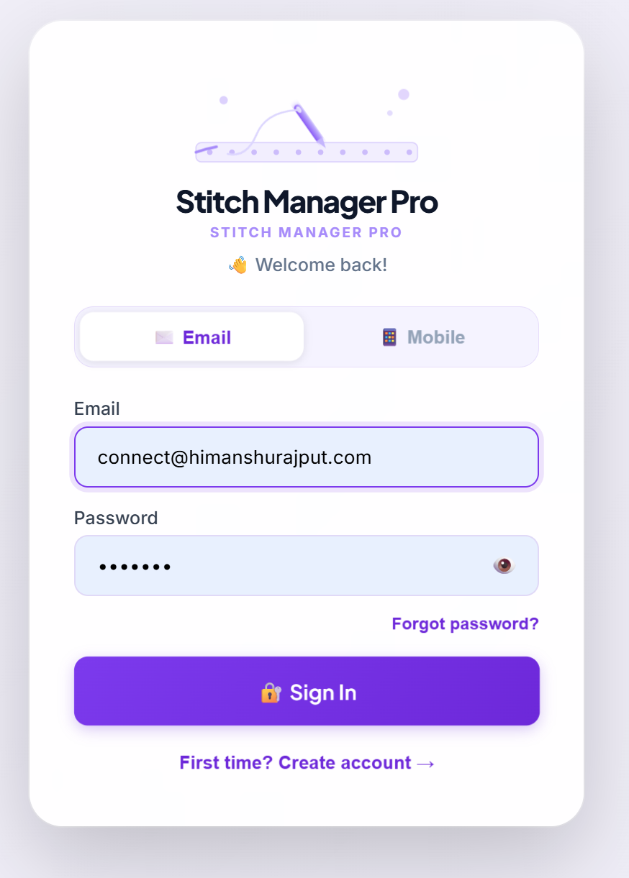
To sign in each time you use the app:
- Open the application URL
- Enter your Email and Password
- Click 'Sign In'
- You will be taken to the Dashboard (Admin) or Board (other roles)
There are two ways to sign in:
- Email Sign In — use your email address and password
- Mobile Sign In — use your 10-digit mobile number and password (only if Admin has added your mobile number)
💡 Tip: Click the eye icon (👁️) next to the Password field to show or hide your password as you type.

2.4 Setting Up Your Shop Profile
After your first login, go to Settings → Shop Profile and fill in your shop details:
- Shop Name — your business name as it will appear on receipts and reports
- Owner Name — the owner's full name
- Phone Number — your shop contact number
- WhatsApp Number — for customer notifications (can be same as phone)
- Email — your business email address
- Website — your website (optional)
- City — your city name
- Full Address — your complete shop address
- Upload Logo — click 'Upload Logo' to add your shop's logo (PNG or JPG)
- Click 'Save & Sync Shop Settings' to save
💡 Tip: Your shop name appears on all printed order receipts. Set it correctly before printing any receipts.

2.5 Forgot Password
If you forget your password:
- On the login screen, click 'Forgot password?'
- Enter the email address you registered with
- Click 'Send Reset Email'
- Check your inbox for the reset email and click the link
- Enter your new password and save

2.6 Installing as a Mobile App
Stitching Manager Pro can be installed on your phone like a regular app:
- On Android: Tap the menu button in Chrome, then 'Add to Home Screen' or tap the 'Install App' button in the app
- On iPhone: Tap the Share button in Safari, then 'Add to Home Screen'
💡 Tip: Installing the app means you can open it directly from your home screen without typing the URL every time. It also works better offline.

3. Dashboard
📊 | Dashboard  Your business at a glance

3.1 Dashboard Overview
The Dashboard is the first thing you see after logging in as Admin or Manager. It gives you a quick visual summary of your entire business — orders, revenue, and performance — all in one place.
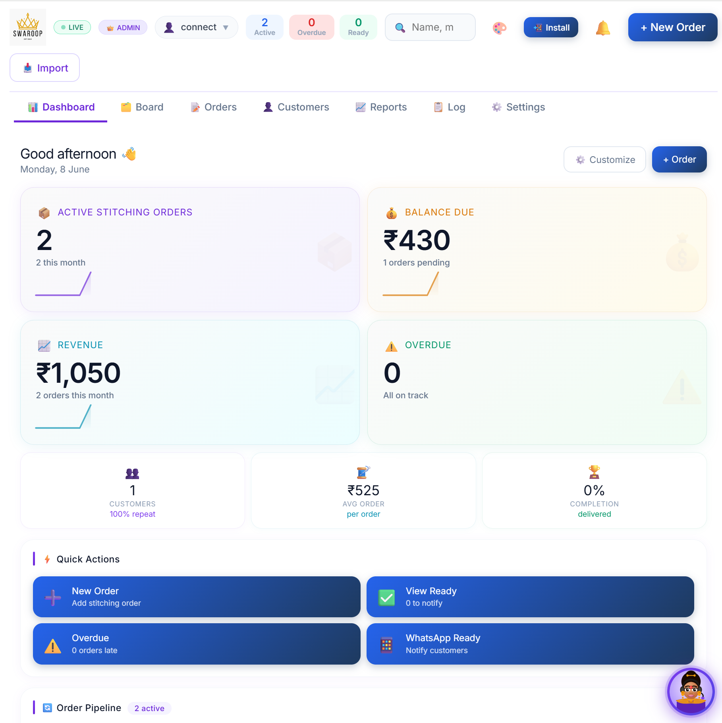

3.2 Summary Cards
At the top of the Dashboard, you will see coloured cards showing key numbers:
Card | What it shows
📦 Active Orders | Number of orders currently in progress (not yet fully paid)
⚠️ Overdue | Orders past their delivery date that are not yet delivered
✅ Ready | Orders that are stitched and ready for collection
💰 Today's Revenue | Total amount received as payment today
📥 Today's Orders | Number of new orders received today
👥 Total Customers | Total number of customers in your database

3.3 Quick Actions
From the Dashboard, you can quickly:
- Click '+ New Order' to create a new order immediately
- Click on any summary card to see related orders
- Click the notification bell 🔔 to see pending alerts
- Use the search bar at the top to find any order by name, mobile, or order ID
💡 Tip: The order search bar at the top works from any screen. Just type a customer's name or phone number to instantly find their order.

3.4 Notifications
The bell icon 🔔 at the top right shows alerts. Click it to see:
- Urgent Orders — orders that are overdue or ready for collection
- Stage Updates — when a tailor moves an order to a new stage
Unread notifications show a red number badge on the bell icon. Click 'Clear All' to dismiss all notifications.

4. Board Module
🗂️ | Board Module  Visual order tracking with Kanban workflow

4.1 What is the Board?
The Board is a visual way to see all your orders organised by their current production stage. Each stage is shown as a column, and each order appears as a card inside the column. At a glance, you can see exactly where every order stands in your workshop.
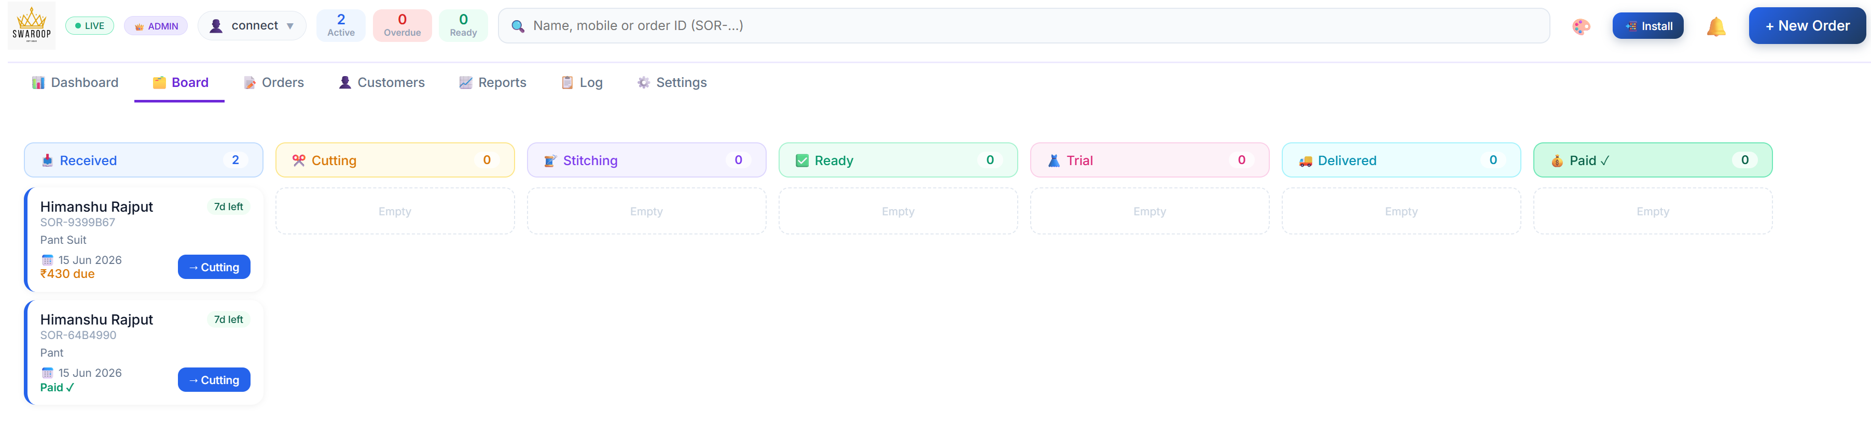

4.2 Order Stages on the Board
Orders flow from left to right through these stages:
- 📥 Received — New order just taken from customer
- ✂️ Cutting — Fabric is being cut
- 🧵 Stitching — Garment is being stitched
- ✅ Ready — Garment is finished and ready
- 👗 Trial — Customer is doing a fitting
- 🚚 Delivered — Given to the customer
- 💰 Paid ✓ — Full payment received

4.3 Moving an Order to the Next Stage
To advance an order to the next stage:
- Find the order card on the Board
- Tap or click the order card to open the order details
- Click the stage button (e.g., 'Move to Cutting') at the bottom of the order panel
- Confirm the stage change
Or, on the Board directly:
- Each order card shows a forward arrow (→) button
- Click it to move the order one stage forward
💡 Tip: When an order moves to 'Ready', the customer will automatically receive a WhatsApp message (if WhatsApp notifications are configured).
⚠️ Note: Only users with 'Change Stage' permission can move orders between stages. By default, this includes all roles including Tailor.

4.4 Understanding Order Cards
Each card on the Board shows:
- Order ID (e.g., SOR-240601-001)
- Customer name and mobile number
- Delivery date
- Total amount and balance due
- Assigned tailor name
- Number of garments
Cards that are overdue (past delivery date) are highlighted in red so you can spot them immediately.

4.5 Filtering the Board
At the top of the Board, you can filter orders by:
- Tailor — see only orders assigned to a specific tailor
- Date — filter by delivery date
- Search — search by customer name or order ID
💡 Tip: Use the tailor filter every morning to show each tailor only their assigned orders. This keeps the workshop organised.

4.6 Mobile vs Desktop Board

On desktop, all stage columns are shown side by side. On mobile, you see one column at a time with tabs to switch between stages — this makes it much easier to use on a small screen

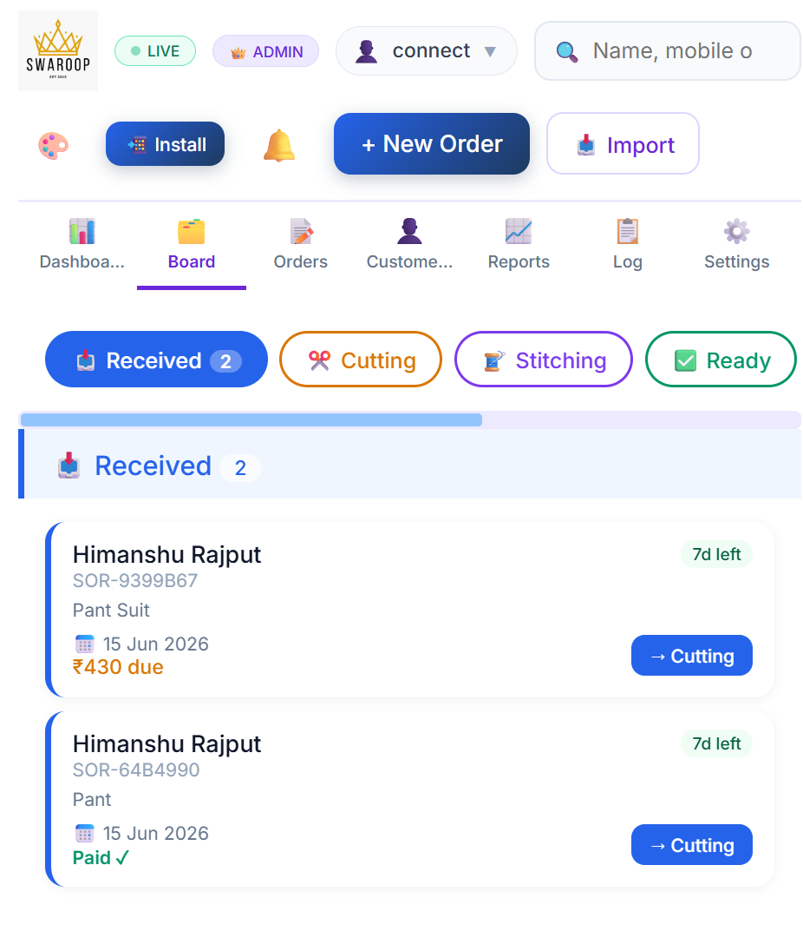

5. Order Management
📝 | Order Management  Create, edit and track every customer order

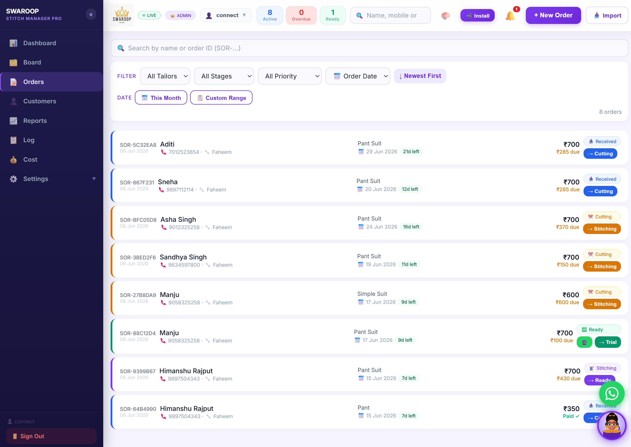

5.1 Creating a New Order
To create a new order, click the '+ New Order' button at the top right of the screen. You will see the New Order form. Fill in the following details:

Basic Information
Field | Description
Customer Name * | Full name of the customer (required)
Mobile Number * | 10-digit mobile number (required — used for WhatsApp notifications and finding customer history)
Delivery Date * | When the order should be ready (required)
Assigned Tailor | Which tailor will stitch this order (optional)
Special Instructions | Any special notes, e.g., 'Add embroidery on collar', 'Customer wants loose fitting'

Adding Garments
Every order must have at least one garment. Click 'Add Garment' and fill in:
Field | Description
Garment Type | Select from the rate card (e.g., Simple Suit, Blouse, Lehenga)
Lining | None / Simple / Half Lining / Full Lining
Quantity | Number of pieces (usually 1)
Rate | Auto-filled from Rate Card — you can change it if needed
Amount | Auto-calculated (Rate × Quantity)

Payment Details
Field | Description
Total Amount | Auto-calculated from all garments
Advance Paid | Amount received today as advance payment
Balance Due | Auto-calculated (Total minus Advance)

Measurements
If the customer has measurements already saved in the system, they will auto-fill. You can also enter new measurements directly on the order form. Fields include:
Length • Breast • Waist • Hip • Sleeve • Golayi • Front Neck • Back Neck • Teera • Mohri • Calf • Thighs • Aasan
💡 Tip: If a customer's measurements are already in the system from a previous order, they will automatically appear when you enter their mobile number. No need to re-measure.

5.2 Saving an Order
- After filling all required fields, click 'Create Order'
- The order is saved and a unique Order ID is generated (e.g., SOR-240601-001)
- The order appears on the Board in the 'Received' column
💡 Tip: Print the order receipt by opening the order and clicking the Print button. Give a copy to the customer as proof.

5.3 Editing an Order
- Find the order in the Orders list or on the Board
- Click on the order to open the Order Panel
- Click the '✏️ Edit' button
- Make your changes
- Click 'Save Changes'
⚠️ Note: Only users with 'Edit Order' permission (Admin, Manager, Sales) can edit orders. Tailors cannot edit orders.

5.4 Deleting an Order
- Open the order
- Click the '🗑️ Delete' button
- A confirmation dialog will appear — click 'Yes, Delete' to confirm
🔴 Important: Deleting an order is permanent and cannot be undone. The order is removed from the system completely.

5.5 Recording a Payment
- Open the order
- Click '💰 Record Payment'
- Enter the amount received
- Select payment mode (Cash / UPI / Card / Cheque)
- Add a note (optional)
- Click 'Save Payment'
The system will:
- Update the balance on the order
- Move the order to 'Paid ✓' stage if balance becomes zero
- Add loyalty points for the customer (if Loyalty Program is enabled)
⚠️ Note: Only Admin and Manager can record payments. Sales and Tailor roles cannot.

5.6 Searching for an Order
Use the search bar at the top of the screen. You can search by:
- Customer name
- Mobile number
- Order ID (e.g., SOR-240601-001)
- Tailor name

5.7 Filtering Orders (Orders List View)
In the Orders tab, you can filter orders by:
- Garment type (Suit, Blouse, Lehenga, etc.)
- Order status / stage
- Assigned tailor
- Date (This Month, Custom Range)
You can also export filtered orders to Excel for your records.

5.8 Printing an Order Receipt
- Open the order from the Board or Orders list
- Click the '🖨️ Print' button in the Order Panel
- Your browser's print dialog will open
- Select your printer and click Print
💡 Tip: The receipt shows the shop name, logo, customer details, garment list, measurements, and payment summary. Always give a receipt to the customer.

5.9 Importing Orders from Excel
To import a large number of orders at once from an Excel or CSV file:
- Click the '📥 Import' button in the top bar
- Download the sample template to see the correct column format
- Fill in your orders in the template
- Upload the file
- Review the preview and confirm the import

6. Customer Management
👤 | Customer Management  Build and manage your customer database

6.1 Customer Module Overview
The Customers module keeps a complete record of every customer — their contact details, measurements, order history, loyalty points, and notes. Over time, this becomes your most valuable business asset.
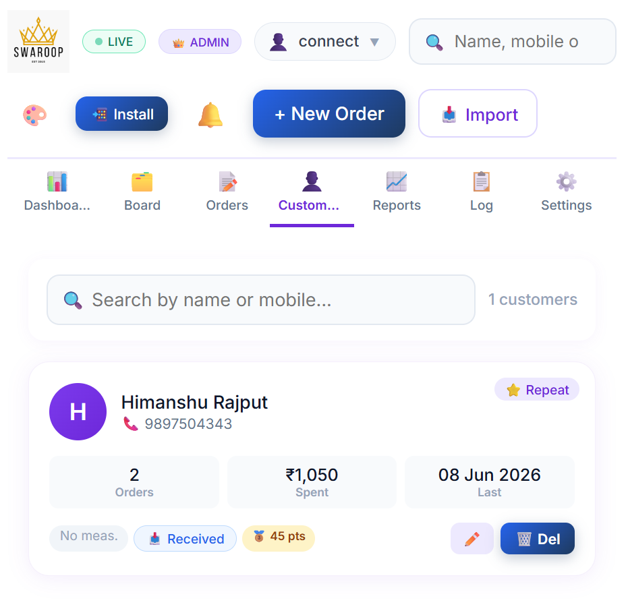

6.2 How Customers are Added
Customers are added automatically when you create a new order. You can also:
- Add a customer manually from the Customers screen
- Search for an existing customer to view their profile
💡 Tip: Every time you create an order, the system checks if the mobile number already exists. If yes, it links the order to the existing customer. If not, a new customer profile is created automatically.

6.3 Viewing a Customer Profile
- Go to the Customers tab from the sidebar
- Search by name or mobile number
- Click on a customer to open their full profile
The profile shows:
- Name, mobile, and contact information
- All previous orders and their status
- Saved measurements
- Total spent and loyalty points balance
- Loyalty tier (Bronze / Silver / Gold / Platinum)

6.4 Editing a customer
- Open the customer's profile
- Click 'Edit'
- Update the name, mobile, or notes
- Click 'Save'

6.5 Saved Measurements
When measurements are taken for any order, they are automatically saved to the customer's profile. Next time the same customer places an order, their measurements auto-fill. This means:
- No need to re-measure regular customers
- Measurements are always accurate and consistent
- You can view measurement history to see if anything has changed

6.6 Loyalty Points
The Loyalty Program rewards customers for their business:
Action | Reward
Earn Points | Customers earn 5 points for every ₹100 spent (configurable)
Order Bonus | 10 extra points when an order is created
Delivery Bonus | 20 extra points when an order is delivered
Redeem Points | Every 100 points = ₹10 discount on future orders
Tier | Required Points
🥉 Bronze | 0 – 499 points earned (all customers start here)
🥈 Silver | 500 – 1,999 points earned
🥇 Gold | 2,000 – 4,999 points earned
💎 Platinum | 5,000+ points earned
💡 Tip: Higher tier customers get special treatment. You can see a customer's tier on their profile and in the order panel.

6.7 Creating a New Order for a Customer
From a customer's profile, click 'New Order' to instantly create a new order with their details and measurements pre-filled.

6.8 Deleting a Customer
- Open the customer's profile
- Click 'Delete Customer'
- Confirm the deletion
🔴 Important: Deleting a customer also removes their measurements and loyalty history. Their past orders remain in the system.

7. Measurement Management
📏 | Measurements  Save and reuse customer measurements

7.1 Measurement Fields
The system supports the following measurement fields for each customer:
Field | Description
Length | Total length of the garment from shoulder to hem
Breast | Chest/bust measurement around the fullest part
Waist | Measurement around the natural waistline
Hip | Measurement around the fullest part of the hips
Sleeve | Length from shoulder to wrist
Golayi | Round measurement — varies by garment type
Front Neck | Depth of neckline at the front
Back Neck | Depth of neckline at the back
Teera | Width of the collar/neckline opening
Mohri | Cuff width at the wrist end
Calf | Measurement around the calf (for pants/salwar)
Thighs | Measurement around the thighs
Aasan | Seat measurement (for pants/salwar)

7.2 Adding Measurements
Measurements can be entered in two places:
- During Order Creation — scroll down to the Measurements section in the New Order form
- From Customer Profile — click on a customer and edit their measurements directly
- Take the customer's measurements with a measuring tape
- Enter each value in the corresponding field (in inches)
- Click Save
💡 Tip: Measurements are saved in inches by default. Be consistent — always measure the same way for the same customer.

7.3 Reusing Measurements
When creating a new order for a returning customer:
- Enter the customer's mobile number in the order form
- If the customer exists, their saved measurements auto-fill
- Review the measurements and update any that have changed
- The updated measurements are saved back to the customer profile

7.4 Custom Measurement Fields
Admin can add or remove measurement fields to match your specific needs:
- Go to Settings → Measurements
- Type a new field name (e.g., 'Knee Length') and click 'Add Field'
- To remove a field, click the ✕ next to it
⚠️ Note: Custom field changes apply to all new orders. Existing saved measurements are not affected.

7.5 Requiring Measurements
In Settings, you can turn on the 'Require Measurements' toggle. When enabled, the system will show a warning if an order is saved without measurements. This helps ensure no order is processed without taking measurements first.
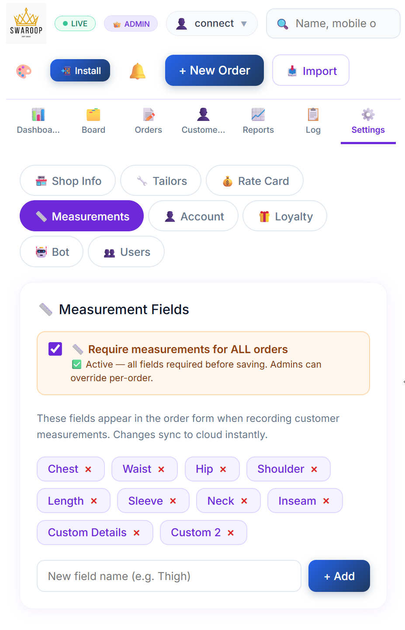

8. Cost Estimator Module
💰 | Cost Estimator  Know your costs and set the right price

8.1 What is the Cost Estimator?
The Cost Estimator helps you calculate the actual cost of stitching any garment — including fabric, accessories, tailor charges, and overheads. It then shows you your profit based on the selling price you set. This is an essential tool for pricing your work correctly.
💡 Tip: Always use the Cost Estimator before quoting a price to a customer. It ensures you never sell at a loss.

8.2 Creating a Cost Sheet
- Click '💰 Cost' in the left sidebar
- Click '+ New Cost Sheet'
- Fill in the Basic Information:
  - Cost Sheet Number — auto-generated (e.g., CS-20260601-123)
  - Date — today's date (auto-filled)
  - Customer Name and Mobile (optional)
  - Product Name — e.g., 'Silk Suit'
  - Category — e.g., 'Bridal', 'Casual', 'Formal'
  - Notes — any special remarks

8.3 Material Expenses
Click '+ Add Row' in the Material Expenses section to add each item:
Field | Description
Item Name | What you're buying (e.g., 'Silk Fabric', 'Buttons', 'Lace')
Quantity | How much (e.g., 2.5 for 2.5 metres)
Unit | Metre / Piece / Gram / Set etc.
Rate (₹) | Price per unit
Amount | Auto-calculated (Quantity × Rate)

Common material items:
- Fabric (main cloth) — e.g., 2.5 Metres @ ₹300 = ₹750
- Lining Fabric — e.g., 2 Metres @ ₹80 = ₹160
- Buttons — e.g., 8 Pieces @ ₹5 = ₹40
- Hooks — e.g., 4 Pieces @ ₹3 = ₹12
- Dori (drawstring) — e.g., 1 Metre @ ₹20 = ₹20
- Latkan (tassel) — e.g., 2 Pieces @ ₹25 = ₹50
- Embroidery/Stone Work — fixed amount e.g., ₹200
- Packing materials — e.g., ₹15

8.4 Tailor Charges
In the Tailor Charges section, add each tailor's contribution:
- Click '+ Add Tailor'
- Enter the Tailor's Name
- Enter the Charge amount (₹)
You can add multiple tailors if the work is split (e.g., one for cutting, one for stitching).

8.5 Overhead Costs
Overheads are the indirect costs of running your shop. Add them in the Overheads section:
- Electricity — allocated share of monthly electricity bill
- Machine Maintenance — monthly machine service cost divided by number of orders
- Rent Allocation — monthly rent ÷ average orders per month
- Staff Salary Allocation — non-tailor staff cost allocation
- Miscellaneous — any other costs
💡 Tip: To calculate per-order overhead: take your total monthly overhead and divide by the average number of orders per month. Add this fixed amount to every cost sheet.

8.6 Setting the Profit
Choose how you want to add profit:
- Percentage Mode — enter a profit percentage (e.g., 30%). The system calculates the profit amount automatically
- Fixed Amount Mode — enter a fixed profit amount in rupees

8.7 The Live Summary Panel
On the right side (or below on mobile), you will see the Live Summary Panel that updates as you type:
Line Item | Calculation
Material Cost | Total of all material expenses
Tailor Cost | Total of all tailor charges
Overhead Cost | Total of all overhead items
Total Expense | Material + Tailor + Overhead
Profit | Your profit amount
Final Selling Price | Total Expense + Profit
Profit Margin % | Profit as a percentage of Selling Price

8.8 Saving and Using a Cost Sheet
Two save options are available:
- '💾 Draft' — save as a draft to work on later
- '✅ Save Final' — save as the final, confirmed cost sheet
Once saved, you can:
- Print the cost sheet (opens a formatted print layout)
- Duplicate it for a similar garment
- Edit it if costs change

8.9 Worked Example
Item | Amount
Silk Fabric (2.5m @ ₹350) | ₹875
Lining (2m @ ₹80) | ₹160
Buttons (8 @ ₹5) | ₹40
Hooks (4 @ ₹3) | ₹12
Embroidery Work | ₹300
Tailor Charge | ₹600
Electricity Overhead | ₹30
Total Expense | ₹2,017
Profit (30%) | ₹605
Final Selling Price | ₹2,622
💡 Tip: Quote ₹2,700 to round up to a nice number while keeping your margin. The system gives you the base calculation — you decide the final price.

8.10 Cost Analytics
Click '📊 Analytics' in the Cost Estimator to see:
- Total revenue quoted vs total expenses
- Average profit percentage
- Tailor-wise cost breakdown
- Expense category breakdown (fabric, labour, overheads)
- Highest and lowest profit products

9. Reports Module
📈 | Reports Module  Analyse your business performance

9.1 Reports Overview
The Reports module provides detailed analysis of your business performance. Use it to understand your revenue, identify your best-selling garments, track tailor performance, and manage outstanding payments.
[ Screenshot: Reports screen showing tabs for Monthly P&L, Tailor Report, Garment Analysis, and more ]

9.2 Monthly P&L Report
The Monthly Profit & Loss report shows:
- Total orders received in the selected period
- Total revenue collected
- Outstanding balance (money not yet collected)
- Average order value
- Daily revenue chart for the month
To use:
- Select 'Monthly P&L' from the report tabs
- Choose the month and year
- Review the summary and chart
- Click 'Export Excel' to download the data

9.3 Tailor Performance Report
See how much work each tailor has handled:
- Number of orders completed per tailor
- Total value of orders assigned
- Average completion time
💡 Tip: Use this report to fairly distribute work and to decide on tailor bonuses or incentives.

9.4 Garment Analysis Report
Understand which garments are your most popular and profitable:
- Most ordered garment types
- Revenue by garment type
- Average price per garment

9.5 Balance Aging Report
Track outstanding payments — money that customers owe you:
- Orders with balance due
- Sorted by oldest outstanding balance first
- Customer name and contact for follow-up
💡 Tip: Review the aging report every week to follow up on pending payments. Click on any customer's order to record a payment.

9.6 Customer Report
Analyse your customer base:
- Top customers by total spending
- New customers this month
- Returning customer rate

9.7 Pending Orders Report
See all orders that are not yet complete:
- Overdue orders highlighted in red
- Orders by stage
- Estimated revenue when orders complete

9.8 Exporting Reports
All reports can be exported:
- 📊 Excel — download as a spreadsheet for detailed analysis
- 🖨️ Print — print directly from the browser
💡 Tip: Export your monthly report at the end of each month and save it for your records.

9.9 Date Filters
Use the filter buttons to select different time periods:
- This Month — current calendar month
- Custom Range — select any start and end date
- Filter by garment type, tailor, or order status

10. Settings Module
⚙️ | Settings Module  Configure your shop and system preferences

10.1 Navigating Settings
Click '⚙️ Settings' in the left sidebar to open Settings. On the left, you will see the Settings submenu with all available sections. Click any section name to go directly to it.
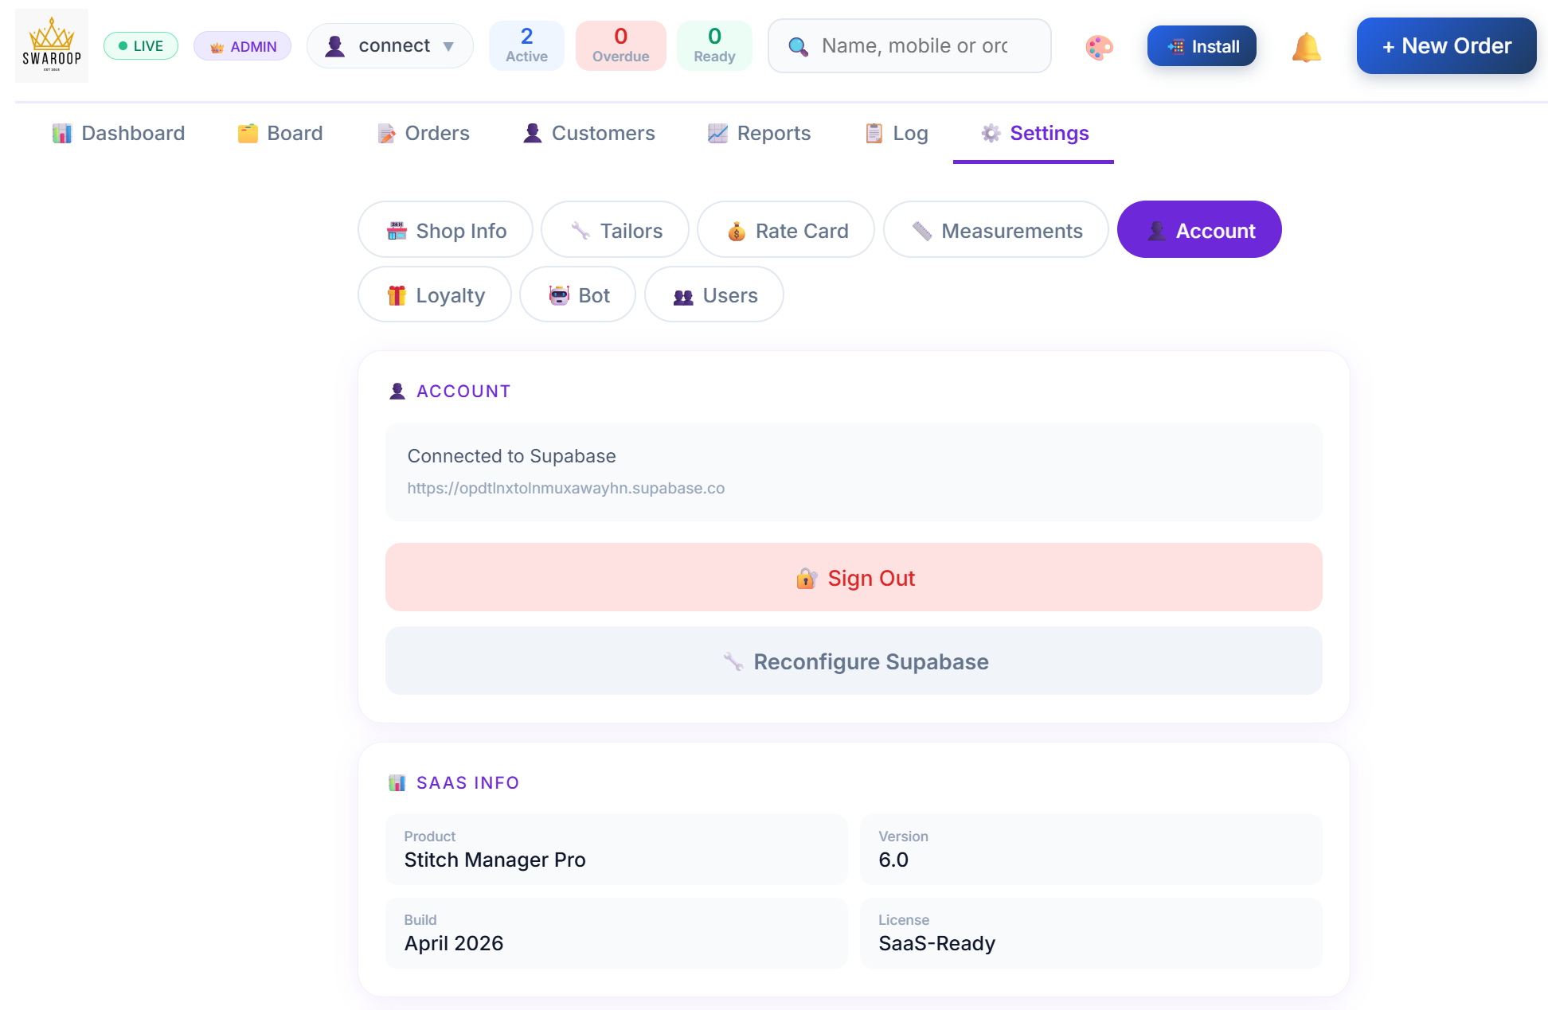

10.2 Shop Profile
Configure your shop's basic information:
- Shop Name — appears on all receipts and reports
- Owner Name — owner's full name
- Phone Number — shop contact number
- WhatsApp Number — for customer notifications
- Email and Website
- GST Number — for GST-registered shops
- City and Full Address
- Shop Logo — upload PNG or JPG (max 5MB)
💡 Tip: Your shop name and logo appear on every printed order receipt. Set these up correctly from day one.

10.3 Rate Card
The Rate Card is your pricing list. It has all garment types with three pricing tiers:
Tier | Description
Simple Lining (s) | Basic stitching with no lining
Half Lining (h) | Garment with half lining inside
Full Lining (f) | Garment with full lining inside

Default Rate Card (customise as needed):
Garment | Simple / Half / Full Lining
Pant Suit | ₹700 / ₹1,000 / ₹1,400
Pallazo Suit | ₹600 / ₹1,000 / ₹1,400
Simple Suit | ₹600 / ₹1,000 / ₹1,300
Simple Kurti | ₹400 / ₹600 / ₹900
Pant | ₹350 / ₹600 / ₹900
Simple Blouse | ₹800 / ₹850 / ₹1,500
Designer Blouse | ₹1,000 / ₹1,800 / ₹2,500
Lehenga | ₹1,200 / ₹1,800 / ₹2,500
Saree Fall/Piko | ₹120 (all tiers)
To update rates:
- Click 'Edit' next to any garment
- Change the Simple, Half Lining, and Full Lining prices
- Click 'Update'
- Changes are saved to the cloud and available on all devices

10.4 Tailors
Manage your list of tailors:
- To add a tailor: Type the tailor's name in the input field and click 'Add'
- To remove a tailor: Click the ✕ button next to their name
The tailor list appears as a dropdown when creating or editing orders. Each order can be assigned to one tailor.

10.5 Users & Roles (Admin Only)
This section lets you manage who can access the system and what they can do.

Adding a New User
- The new user must first register themselves using the app (create an account)
- Go to Settings → Users & Roles
- Find the user in the list (they will appear as 'Tailor' by default)
- Click 'Change Role' and select their correct role
- Click 'Save'

Changing a User's Role
- Find the user in the Users & Roles list
- Select the new role from the dropdown
- Click 'Update'

Adding a Mobile Number for Mobile Login
- Click the edit icon next to the user
- Enter their 10-digit mobile number
- Click 'Save'

10.6 Loyalty Program
Configure the customer loyalty rewards program:
Setting | Description
Enable/Disable | Turn the loyalty program on or off
Points per ₹100 spent | Default: 5 points for every ₹100
Order Bonus | Extra points when order is created (default: 10)
Delivery Bonus | Extra points when delivered (default: 20)
Redemption Rate | Default: ₹10 discount per 100 points
Minimum Redemption | Minimum points to redeem at once (default: 100)
Tier | Default Threshold
Silver Tier | Achieved at 500 points
Gold Tier | Achieved at 2,000 points
Platinum Tier | Achieved at 5,000 points

10.7 Account Settings
Each user can manage their own account in the Account section:
- Change Password — enter current password and new password
- Reconfigure Connection — if you need to connect to a different Supabase database

10.8 Bot / AI Chatbot (Admin Only)
Configure the built-in AI assistant that answers customer questions:
- Shop Hours — set your opening and closing times
- UPI ID — your payment UPI address
- Maps Link — Google Maps link to your shop
- Broadcast Message — a message shown to all chatbot users (for offers, announcements)
- Instagram Link — your Instagram profile link
💡 Tip: The chatbot can answer questions in Hindi (Hinglish) about your shop, pricing, services, and delivery times. Keep your shop information updated.

10.9 Appearance (Theme)
Click the 🎨 palette icon at the top right of the screen to change the colour theme of the app. Available themes include: Violet (default), Blue, Ocean, Teal, Green, Rose, Amber, and more.
💡 Tip: Your theme preference is saved on your device. Other users will not see your theme change.
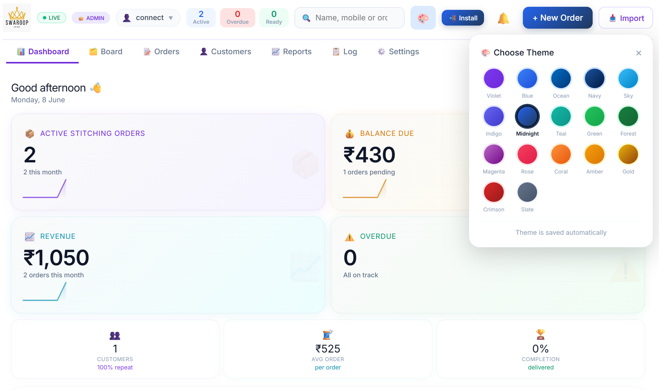

11. User Roles & Permissions
🔐 | Roles & Permissions  Control who can do what in your system

11.1 Understanding Roles
Every person who uses the system is assigned a role. The role determines what they can see and do. This protects your business data and ensures each team member only has the access they need.

11.2 Role Descriptions

👑 Admin
The shop owner or head manager. Has full access to everything in the system. Can create/edit/delete all orders, manage customers, record payments, view all reports, and manage users and roles.

🏢 Manager
A trusted senior staff member. Can do almost everything an Admin can, except manage users and roles. Cannot delete orders or customers.

🛒 Sales
A sales or front desk staff member. Can create and edit orders and manage customers, but cannot record payments or view financial reports.

✂️ Tailor
A tailor or production staff member. Can only see orders assigned to them and update the stage status. Cannot add, edit, or delete orders, and cannot see financial data.

11.3 Permissions Matrix
Permission | Admin | Manager | Sales | Tailor
Add New Orders | ✅ | ✅ | ✅ | ❌
Edit Orders | ✅ | ✅ | ✅ | ❌
Delete Orders | ✅ | ❌ | ❌ | ❌
Record Payments | ✅ | ✅ | ❌ | ❌
Edit Measurements | ✅ | ✅ | ✅ | ❌
Change Order Stage | ✅ | ✅ | ✅ | ✅
View Reports | ✅ | ✅ | ❌ | ❌
Manage Customers | ✅ | ✅ | ✅ | ❌
Delete Customers | ✅ | ❌ | ❌ | ❌
Manage Users & Roles | ✅ | ❌ | ❌ | ❌
View Dashboard | ✅ | ✅ | ❌ | ❌
View Activity Log | ✅ | ✅ | ❌ | ❌
Cost Estimator | ✅ | ✅ | ❌ | ❌

11.4 Custom Permissions
Admin can customise individual permissions for any user. For example, you can give a Sales staff member permission to record payments by:
- Going to Settings → Users & Roles
- Clicking on the user's role settings
- Toggling the specific permission on or off
- Clicking 'Save'
⚠️ Note: Custom permissions override the default role permissions. Use this carefully to grant exceptions.

11.5 What Tailors See
Tailor accounts see a simplified version of the system:
- Board view — showing all orders (they can filter to their own)
- Orders list — all active orders
- No Dashboard, Reports, Customers, Log, or Cost tabs
- Can only update the stage of orders — cannot edit any other details
💡 Tip: Create a Tailor account for each person in your workshop. They can update order stages from their own phone without seeing sensitive financial data.

12. Activity Log
📋 | Activity Log  Complete audit trail of all system actions

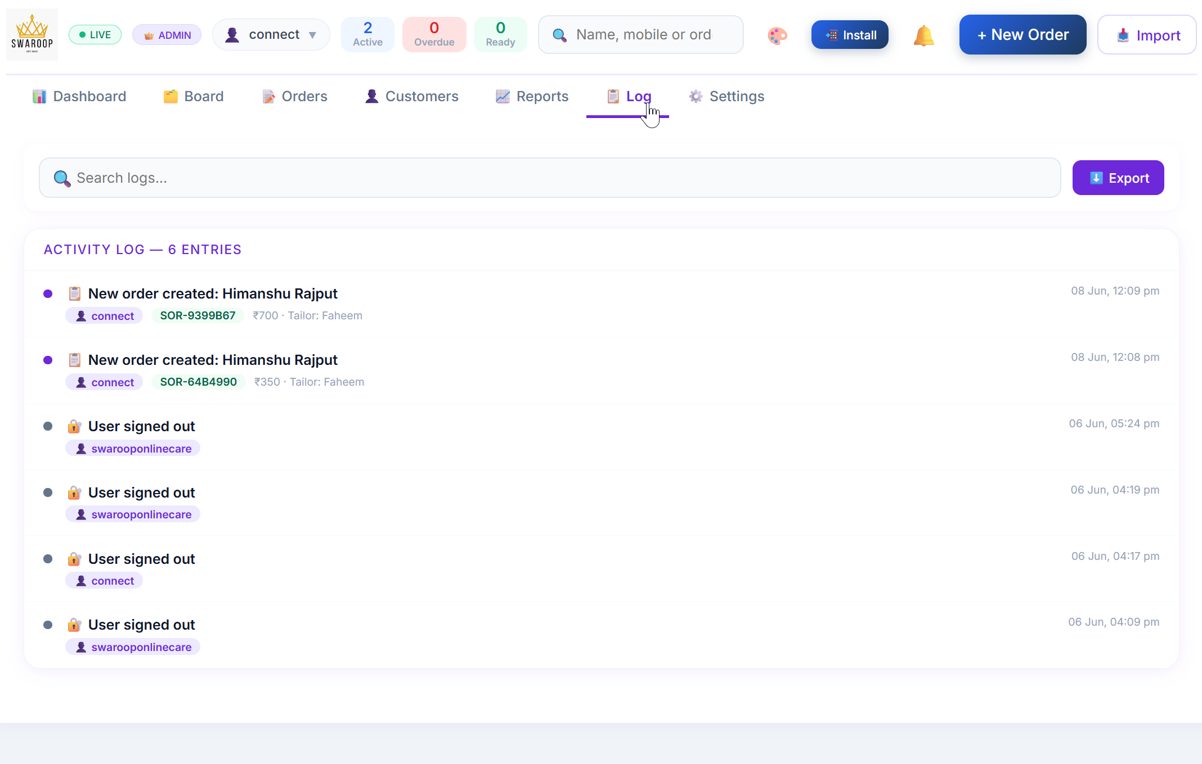

12.1 What is the Activity Log?
The Activity Log records every action taken in the system — who did what, and when. This is your business's complete audit trail and is essential for accountability and dispute resolution.

12.2 What is Recorded?
- Order created, edited, or deleted
- Payment recorded
- Order stage changed
- Customer added, edited, or deleted
- Settings changed
- User signed in or signed out
- Cost sheet created, updated, or deleted

12.3 Reading the Log
Each log entry shows:
- Date and time of the action
- User who performed the action (their email)
- What action was taken
- Related order ID (if applicable)
- Additional details

12.4 Searching the Log
Use the search box at the top of the Log screen to filter entries by:
- User email
- Action type
- Date
💡 Tip: If you notice an incorrect entry in an order and need to find out who made the change, search the Activity Log by the order ID.
⚠️ Note: The Activity Log is read-only. No one can edit or delete log entries, not even the Admin.

13. Notification System
🔔 | Notifications  Stay informed about important order updates

13.1 Notification Centre
Click the 🔔 bell icon at the top right to open the notification panel. It shows two types of alerts:
- ⚠️ Urgent Orders — orders that are overdue or have been ready too long
- 🔄 Stage Updates — when any user moves an order to a new stage

13.2 Notification Badge
When you have unread notifications, a red badge shows the count on the bell icon. This badge updates in real time.

13.3 Acting on Notifications
Click on any notification entry to jump directly to the related order. The notification panel will close and the order will open.

13.4 Clearing Notifications
Click 'Clear All' in the notification panel to dismiss all current notifications. This does not affect the orders themselves — it only clears the notification list.

13.5 WhatsApp Notifications
The system can automatically send WhatsApp messages to customers when:
- Their order is received and confirmed
- Their garment is ready for collection
- Payment is confirmed
WhatsApp messages are triggered by clicking the WhatsApp button on the order panel. They use pre-written templates personalised with the customer's name and order details.
💡 Tip: Save the WhatsApp message templates in the order panel. They include the customer's name, order ID, and relevant information automatically.

14. Mobile Application Usage
📱 | Mobile Usage  Use Stitching Manager Pro on any device

14.1 Mobile-First Design
Stitching Manager Pro is designed to work perfectly on mobile phones. Everything — from creating orders to checking the board — works just as well on a small screen as on a desktop.

14.2 Installing on Your Phone

Android
- Open the app URL in Chrome
- Tap the three-dot menu (⋮) in the top right
- Tap 'Add to Home Screen'
- Tap 'Add' to confirm

iPhone (iOS)
- Open the app URL in Safari
- Tap the Share button (box with arrow)
- Scroll down and tap 'Add to Home Screen'
- Tap 'Add' to confirm
💡 Tip: After installation, the app opens full-screen without the browser address bar — just like a native app. It also loads faster.

14.3 Mobile Navigation
On mobile, use the hamburger menu ☰ at the top left to open the sidebar navigation. Tap any menu item to navigate. Tap anywhere outside the sidebar to close it.

14.4 Mobile Board
On mobile, the Board shows one stage column at a time. Tap the stage tabs at the top (Received, Cutting, Stitching, etc.) to switch between stages. Each order card is large and easy to tap.

14.5 Mobile Order Form
Creating an order on mobile is the same as desktop. The form stacks vertically for easy scrolling. All fields work the same way.

14.6 Offline Usage
The app works even without internet for reading data. When your internet connection returns, all changes automatically sync to the cloud.
⚠️ Note: When offline, you cannot create new orders or make changes. The app shows an orange offline banner at the top when there is no internet connection.

15. Best Practices
⭐ | Best Practices  Get the most out of Stitching Manager Pro

15.1 Daily Routine

Morning
- Open the Dashboard to see your day's overview
- Check the Board for overdue orders (shown in red)
- Brief your tailors — show each tailor their assigned orders
- Check the 🔔 notification panel for any urgent alerts

Throughout the Day
- Create new orders as customers come in
- Update order stages as work progresses
- Record payments as they are received

End of Day
- Review the Board — confirm all stages are updated
- Check the Balance Aging report for follow-up payments
- Review new orders received today in the Dashboard

15.2 Order Management Tips
💡 Tip: Always enter the mobile number accurately. This is how the system identifies customers and links their order history.
💡 Tip: Use the Special Instructions field for anything unusual about the order — customer preferences, special stitching notes, or fitting issues.
💡 Tip: Set realistic delivery dates. Overdue orders are highlighted in red and create urgency — only mark them overdue if they truly are late.
💡 Tip: Assign each order to a specific tailor. This creates accountability and helps you track performance in the reports.

15.3 Customer Relationship
💡 Tip: Take measurements on the very first order and save them. You will never need to re-measure a customer who orders the same garment type again.
💡 Tip: Enable the Loyalty Program from day one. Customers who earn points are more likely to return.
💡 Tip: Use the customer profile notes field to record personal details — anniversary dates, size preferences, favourite colours. This level of personalisation builds loyalty.

15.4 Financial Management
💡 Tip: Use the Cost Estimator for every new garment type to make sure your pricing is correct.
💡 Tip: Always record advance payment when taking an order — even a small amount creates commitment from the customer.
💡 Tip: Review the Balance Aging report weekly. Call customers with large outstanding balances before they become problematic.
💡 Tip: Export your monthly P&L report and save it. This is your business record.

15.5 Team Management
💡 Tip: Create individual accounts for each tailor. They can update their own order stages, which saves you time.
💡 Tip: Never share the Admin password. If a team member leaves, go to Users & Roles and remove their access.
💡 Tip: The Activity Log shows you exactly what each team member has done. Use it for weekly team reviews.

16. Frequently Asked Questions
❓ | FAQ  Answers to the most common questions

16.1 Account & Login
Q: I forgot my password. What do I do?
A: On the login screen, click 'Forgot password?', enter your email address, and click 'Send Reset Email'. You will receive an email with a link to set a new password. The link is valid for 24 hours.
Q: Can I use the same account on multiple devices?
A: Yes. You can sign in to the same account on your phone, tablet, and computer simultaneously. All data is stored in the cloud and stays in sync.
Q: My login is not working even though my password is correct.
A: Make sure you are using the correct email address. Check that Caps Lock is not on. If the problem persists, use the 'Forgot Password' option to reset your password.
Q: How do I add a new staff member to the system?
A: Ask the new staff member to register themselves using the app URL. They will start with the 'Tailor' role. Go to Settings → Users & Roles to change their role to Manager or Sales if needed.
Q: Can a user have two different roles?
A: No, each user has one role at a time. However, Admin can customise individual permissions to give a user specific extra abilities beyond their default role.

16.2 Orders
Q: I accidentally created a duplicate order. What should I do?
A: Open the duplicate order and click 'Delete'. Only Admin can delete orders. If you are not Admin, ask your Admin to delete it.
Q: Can I change the delivery date of an order after it has been created?
A: Yes. Open the order, click 'Edit', change the delivery date, and click 'Save Changes'. Any user with Edit Order permission (Admin, Manager, Sales) can do this.
Q: How do I move an order from 'Stitching' back to 'Cutting' if something was wrong?
A: Open the order panel, scroll to the stage buttons, and you can change the stage to any stage. There is no restriction on going backwards.
Q: What is the difference between 'Ready' and 'Trial'?
A: 'Ready' means the garment is fully finished. 'Trial' means the customer has come in for a fitting. Use 'Trial' before 'Ready' if you always do a fitting before the final handover.
Q: Can I assign an order to more than one tailor?
A: Currently, each order can be assigned to one tailor. If multiple tailors work on one order, assign it to the main tailor responsible.
Q: Can I print an order receipt?
A: Yes. Open the order from the Board or Orders list, click the '🖨️ Print' button in the order panel, and use your browser to print.
Q: An order is showing as 'Overdue' but the delivery date is correct. Is there a problem?
A: No — 'Overdue' means the delivery date has passed and the order has not yet been delivered. Advance the order to 'Delivered' or 'Paid ✓' once it is done.
Q: Can I search for all orders of one customer?
A: Yes. Go to the Customers tab, find the customer, and open their profile. You will see all their orders listed there.

16.3 Payments
Q: Can I record multiple partial payments for one order?
A: Yes. Each time you record a payment, it is added to the order's payment history. The balance updates automatically after each payment.
Q: A customer paid but the balance is still showing. What happened?
A: Make sure you clicked 'Save Payment' after entering the amount. Also check that the payment amount was entered correctly (numbers only, no ₹ symbol).
Q: Can I undo a payment that was recorded by mistake?
A: You can edit the order and adjust the advance amount. However, you cannot delete individual payment records. Contact your service provider if you need a payment reversed.
Q: Who can record payments?
A: Admin and Manager roles can record payments. Sales and Tailor roles cannot.

16.4 Customers & Measurements
Q: A customer's measurements are not auto-filling when I create a new order.
A: Make sure you are entering the same mobile number that was used when their measurements were first saved. The system matches customers by mobile number.
Q: I want to update a customer's measurements. How do I do that?
A: Open the customer's profile in the Customers tab and click 'Edit Measurements'. Or, when creating a new order, update the measurements in the order form — they will save to the customer profile.
Q: Can I delete a customer from the system?
A: Yes. Open the customer profile and click 'Delete Customer'. Only Admin can delete customers. Note that this only deletes the customer record — their past orders remain in the system.
Q: How many measurement fields can I add?
A: You can add unlimited custom measurement fields in Settings → Measurements. The default fields cover all common measurements.

16.5 Cost Estimator
Q: My cost sheet is not saving. What should I do?
A: Make sure the 'Product Name' field is filled in — it is required. All other fields are optional. Click 'Save Final' or '💾 Draft' to save.
Q: Can I use the same cost sheet for multiple orders?
A: Yes. Open the cost sheet and click the 'Duplicate' button to create a copy. You can then adjust quantities or prices for the new order.
Q: The profit percentage does not look right.
A: Check that all your costs are entered correctly. The profit percentage is calculated as: (Profit ÷ Final Selling Price) × 100. In Percentage Mode, the profit is calculated on top of the total expense.

16.6 Reports
Q: Reports are not loading or are showing no data.
A: Make sure you are Admin or Manager — Tailor and Sales roles cannot view reports. Also check that there are orders in the selected date range.
Q: Can I export reports to Excel?
A: Yes. Every report has an 'Export Excel' button. Click it to download the report as an Excel file.
Q: The monthly report is showing different numbers than I expected.
A: Reports are based on order creation date. Check that the correct month is selected. Some orders may have been created in a different month.

16.7 Settings & Configuration
Q: I changed the Rate Card but old orders still show the old rate.
A: Rate Card changes only apply to new orders. Existing orders keep the rates that were set when they were created.
Q: Can I change the order stages? Can I add a custom stage?
A: The stages are fixed (Received, Cutting, Stitching, Ready, Trial, Delivered, Paid). Custom stages are not available in the current version.
Q: My shop name is not showing on printed receipts.
A: Go to Settings → Shop Profile, enter your shop name, and click 'Save & Sync'. The name should appear on all receipts after this.
Q: Can I use the app in Hindi?
A: The app interface is in English, but the AI chatbot supports Hinglish (Hindi written in English letters). Order-related communications via WhatsApp can be in Hindi.

16.8 Technical Questions
Q: Does the app work without internet?
A: You can view existing data without internet, but you cannot create or edit orders offline. The app shows a red/orange banner when there is no internet connection.
Q: Is my data secure?
A: Yes. All data is stored in your private Supabase database. Every user must log in to access any data. Sensitive data is never stored in plain text.
Q: Can multiple people use the app at the same time?
A: Yes. The app supports multiple simultaneous users. When one user makes a change, others will see it when they refresh or navigate to that page.
Q: The app is running slowly. What can I do?
A: Try refreshing the browser page. On mobile, close other apps running in the background. Make sure you have a stable internet connection. If the problem persists, clear your browser cache.
Q: Can I access the app on an iPhone?
A: Yes. The app works on all modern browsers including Safari on iPhone and Chrome on Android. For the best experience, install it as a PWA (Add to Home Screen).

17. Troubleshooting
🔧 | Troubleshooting  Solutions to common problems

17.1 Login Issues

Cannot Log In
Symptoms: Password not accepted, error message on login
- Check that you are using the correct email address (exactly as registered)
- Make sure Caps Lock is not on
- Use 'Forgot Password' to reset your password
- Check your internet connection — login requires internet
- Try opening the app in a private/incognito browser window

App Shows Loading Screen but Never Opens
Symptoms: Spinning loader, app does not load
- Refresh the browser page (press F5 or Ctrl+R)
- Check your internet connection
- Clear browser cache and cookies (Settings → History → Clear browsing data)
- Try opening in a different browser
- Contact your service provider if the issue persists

Mobile Login Not Working
Symptoms: Mobile number is not accepted
- Make sure your Admin has added your mobile number in Settings → Users & Roles
- Enter only 10 digits without country code or spaces
- Confirm the mobile number matches exactly what Admin entered

17.2 Order Issues

Orders Not Showing on Board
Symptoms: Board appears empty or some orders missing
- Check if a filter is active (tailor filter, date filter). Click 'Clear Filters' to reset
- Make sure the correct stage tab is selected on mobile
- Refresh the page to sync latest data
- Check your internet connection

Cannot Create a New Order
Symptoms: Button is greyed out or error message appears
- Check your role — Tailor role cannot create new orders
- Make sure all required fields are filled (Name, Mobile, Delivery Date, at least one garment)
- Check your internet connection — creating orders requires internet

Measurements Not Auto-Filling
Symptoms: Previous customer's measurements not appearing
- Verify the mobile number entered matches exactly what was used before
- Check the customer profile to confirm measurements are saved
- Measurements only auto-fill if the customer already has them saved

17.3 Payment Issues

Payment Recorded but Balance Not Updating
Symptoms: Balance still shows the old amount after payment
- Refresh the page
- Re-open the order to see the updated balance
- Make sure the payment was actually saved (click 'Save Payment')

17.4 Report Issues

Reports Showing No Data
Symptoms: Reports are empty or show zero
- Confirm your role is Admin or Manager (Tailor/Sales cannot view reports)
- Check the date filter — make sure the selected period has orders
- Try changing to 'Monthly' view and selecting the current month

17.5 Performance Issues

App Running Slowly
Symptoms: Pages take long to load, buttons are slow
- Check internet connection speed
- Refresh the browser page
- Close other browser tabs to free up memory
- On mobile, restart the app
- Clear browser cache (browser Settings → Privacy → Clear Cache)

17.6 Print Issues

Order Receipt Not Printing Correctly
Symptoms: Receipt is cut off, missing information, or format is wrong
- Make sure the shop name is set in Settings → Shop Profile
- In the browser print dialog, set 'Margins' to 'Default' or 'Minimum'
- Set 'Scale' to 100% in the print settings
- Enable 'Background graphics' in print settings to show colours

17.7 General Tips
💡 Tip: If something unexpected happens, try refreshing the page first. Most temporary issues are resolved by a simple refresh.
💡 Tip: Keep your browser updated to the latest version for the best performance.
💡 Tip: If an error message appears, note down the exact text and contact your service provider — it helps them diagnose the problem faster.
📞 Need More Help?
Contact your Stitching Manager Pro service provider for technical support. When reporting an issue, please include:

E-Mail: connect@himanshurajput.com
WhatsApp: +919897504343

